Let’s First Understand all the variables provided within the Graduation dataset: -
AGE ->Age x
ETR ->Central exposed to risk for age x last birthday
DEATHS ->Number of deaths recorded at age x last birthday
CRUDE ->Crude mortality rate for age x last birthday
GRADUATED ->Graduated mortality rate for age x last birthday
EXPECTED ->Expected number of deaths at age x last birthday based on the graduated rates Individual
ZX ->standardised deviation for age x

Expected Deliverables along with justified solutions: -
1) Read in the data file as a data table & fill in the entries for the CRUDE column in your table.
Soln
#Importing the Graduation.csv dataset
Grad=read.table("C:/Users/Priyanshu Mehta/OneDrive/Desktop/SRM proj/Graduation.csv",header=T)
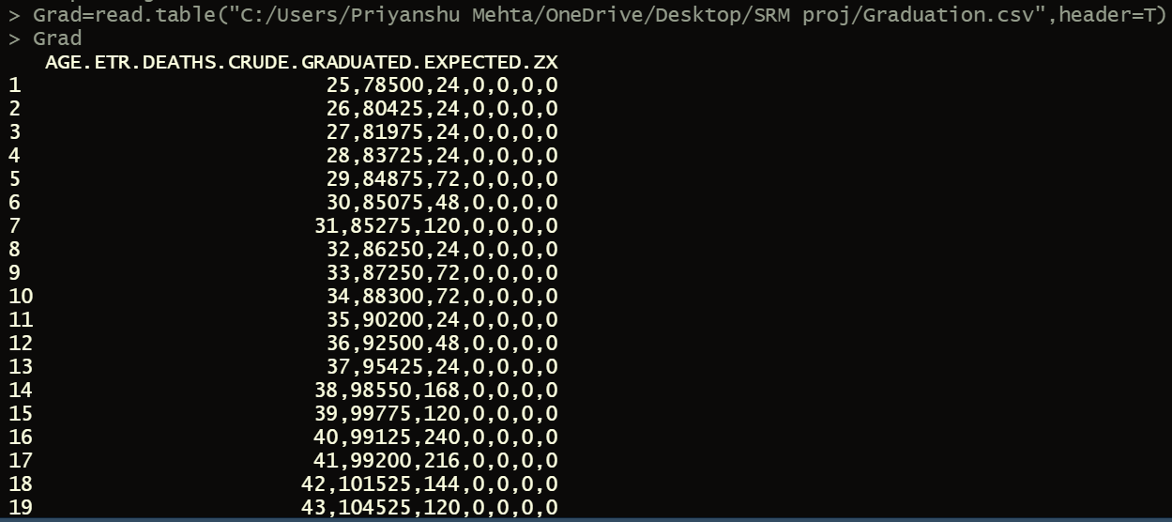
As it is explicitly visible that this is not the correct format of importing and working on a given dataset. The output shows all the values in a single cell and so we use the "sep" function to separate the columns by commas instead of spaces.

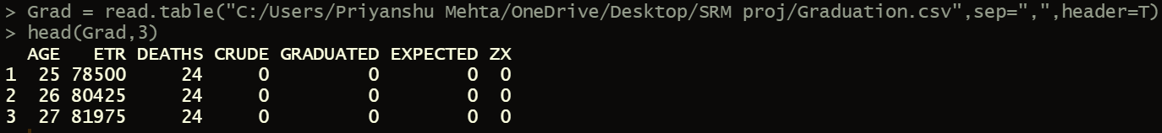
Improvised representation of the above!
Upon printing certain basic EDA functions, we realize that columns - {CRUDE, GRADUATED, EXPECTED and ZX} consist of no values and so we must compute and fill the same.
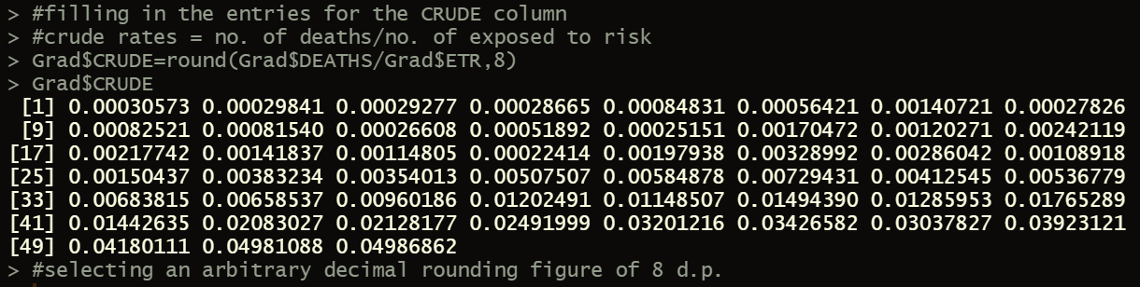
The above snippet consists of the Crude rate formula i.e., no. of deaths/no. of exposed to risk along with the computed output. Also, since the output consisted way too many decimal places and so we consisted it up to the limit of 8 d.p.

2) Use Gompertz law to fill entries in the GRADUATED column in the data.
Soln
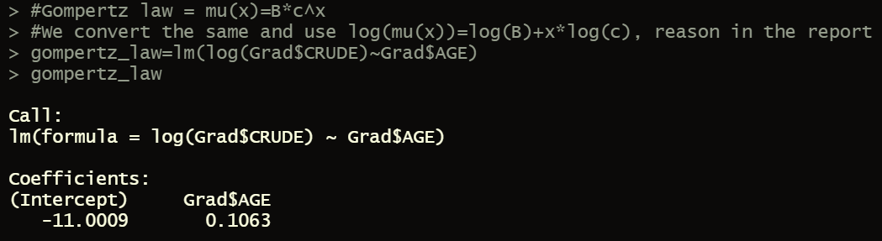
It is important that we first establish a relationship between the variables and execute the same through a linear regression so that the coefficients [constant terms] could be obtained.
Also Gompertz law => μ= Bc^x
So, we take log of the above equation to form a linear relationship between variables x and log μ(x) with intercept parameter log B and slope log C.
Moreover from the linear model formed, we understand that AGE is the regressor(independent variable) whereas CRUDE the dependent variable.
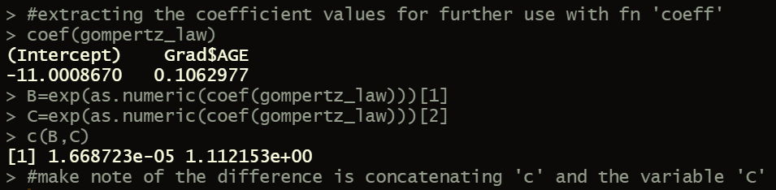
We further extract coefficient values so that the values of B and C could be found. However, as.numeric must be used so that just the numerical info can be extracted with later on appling the exponential function. All of this can be evidently witnessed in the above snippet.
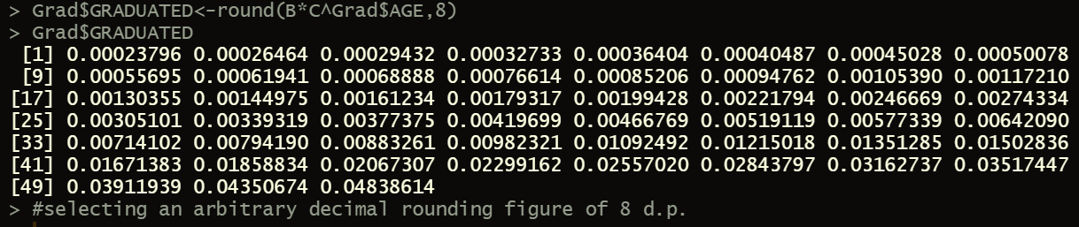
Finally Graduated rates are found with being rounded up to an arbitrarily selected decimal place of ‘8’.

3) Check for smoothness by applying the third differences to the crude and graduated rates and comment on your results.
Soln
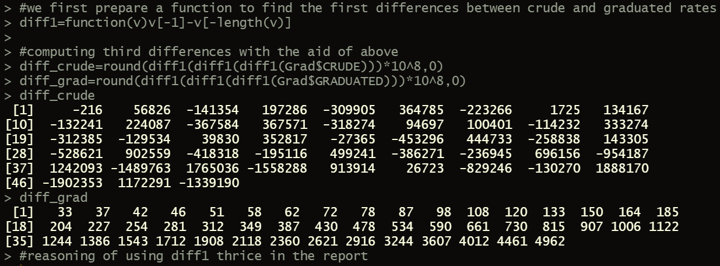
We initially computed the first difference along with the aid of a function since that would help us get the values once the first rate as well the late rate [element] is removed.

Now, we simply execute the diff1 function thrice for each of the rates so that 1 difference is eliminated each time.
The above snippet shows the respective difference rates computed.

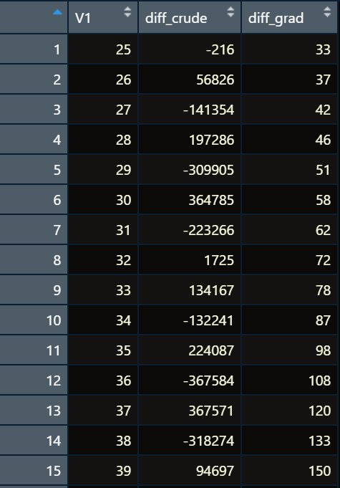

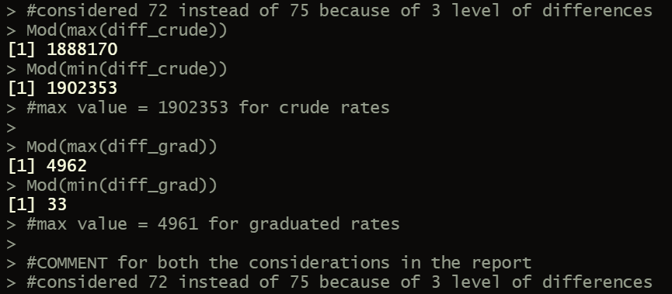

Binding together [combining] the difference values of crude and graduation along with age for better representation. Code for the same as follows: -
> cbind(Grad$AGE[Grad$AGE<=72],diff_crude,diff_grad)
R as we know will number the rows in the table automatically when we display but row numbers won’t match the actual ages. We thus include ages as our first column as can be seen above.
Also, we took ages only till 72 since each level of differencing would have scrapped off one age.

COMMENT: -
We can see from the table snippet that third differences of the crude rates are much larger in magnitude i.e. go upto Max 1902353 and furthermore progress irrationally with complete randomness.
In contrary, third differences of graduated rates are relatively quite small with max going only till 4962 with this being achieved post regular progress. There was a difference in both observations since the latter included simple parametric formula with just two parameters.

4) Calculate the values in EXPECTED and ZX values in the table. Hence, perform a chi-squared test to check goodness of fit between DEATHS and EXPECTED. You should specify the degrees of freedom used.
Soln: -
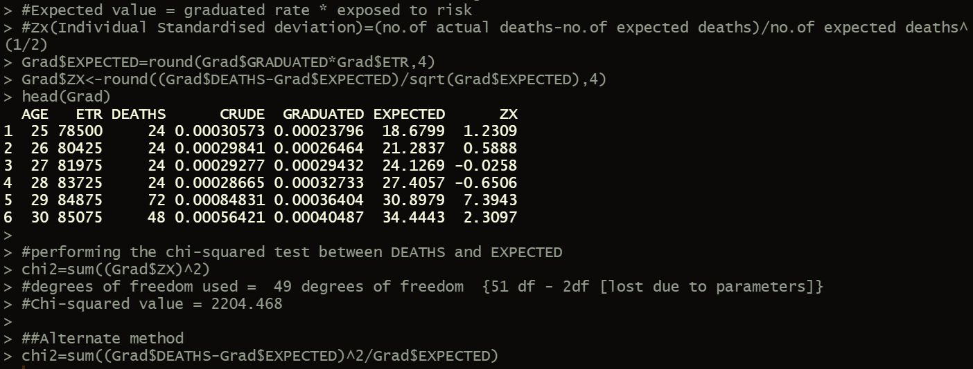
Let’s first look at the formulae for: -
# Expected value = graduated rate * exposed to risk
Zx (Individual Standardised deviation) =(no.of actual deaths-no.of expected deaths)/no.of expected deaths^(1/2)
Using the above specified formulae, the expected and graduated rates are found with being rounded to 4 d.p.

Next, we perform the chi-squared test with two alternative methods – one considering the computed std. deviation whereas the other from the first principles.
Lastly, both of the methods give us a Chi-squared value of 2204.468 with 49 degrees of freedom [2 lost due to inclusion of parameters.]

5)
a. Perform the standardised deviations test on the individual deviations, and comment on the –
i. Overall shape
ii. Absolute deviations
iii. Outliers
iv. Symmetry
v. Final conclusion about Null hypothesis

Soln: -
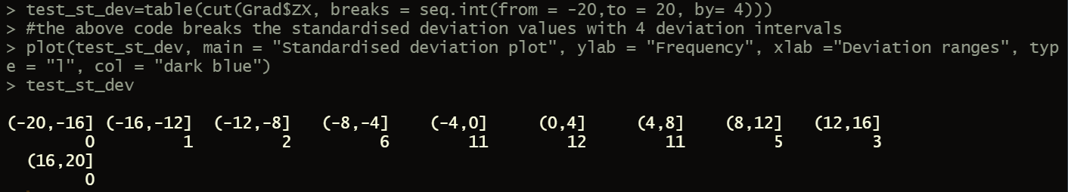
The above stated code helps us compute the standardised deviation test wherein the values are dichotomised into 10 partitions with 4 deviation intervals which are namely –
{All the ranges in mod form} (0,4); (4,8); (8,12); (12,16); (16,20)
Following is a graphical representation of the same for ease with commenting-
##COMMENT: -
#I. The graph is quite dispersed relative to a standard normal dist. graph, with several values higher than magnitude of 10.
#II. The values of the absolute deviations are pretty high as compared to the expected value.
#III. The lower bound is approx. -2 and the upper bound is approx. 6. IQR is 8.
#Also, there are a couple of outliers on the lower side but none on the upper side.
#IV. The Graph is positively skewed. It looks like it is centred about 2.
#V. The graduated rates do not represent the underlying mortality rates with accuracy.

5) b. Perform the Signs test and give your conclusion
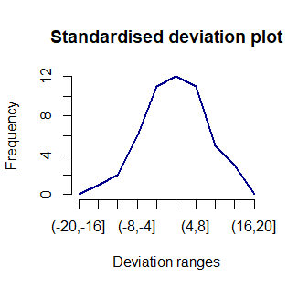
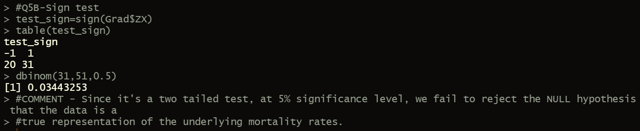
The code is a comprehensive representation of all that was done in R.
Dbinom is a distribution function and random generation function used for the binomial distribution with parameters SIZE and PROB.

These are the signs for each individually standardised deviation.
The snippet itself consists of the comment.
Conclusion – The test fails to reject the Null Hypothesis.

5) c. Perform the Cumulative deviations test for the entire age range and give your conclusion.
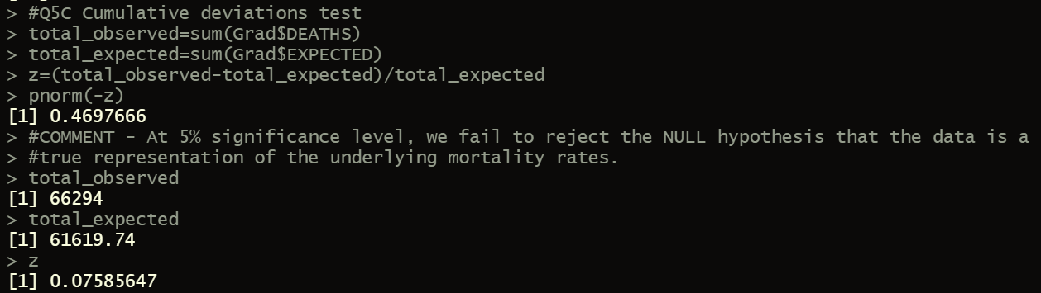
Next, we look at the Cumulative deviations test which can detect overall goodness of fit of the data.
It addresses the problem of the inability of the chi-squared test to detect a large positive or negative cumulative deviation over part (or the whole) of the age range.
The above snippet thus consists of all the individual values found to run the cumulative deviations test.

Conclusion – The test fails to reject the Null Hypothesis.

5) d. Perform the Serial correlations test and give your conclusion. (12)
Serial correlations test as such is one of the most computationally intense method existing amongst all the tests carried out so far.
This test is primarily done to check for clumping of deviations of the same sign which is an issue that will not be picked up by a chi-squared test. Also, If clumping is present, then the graduation will have the wrong shape.
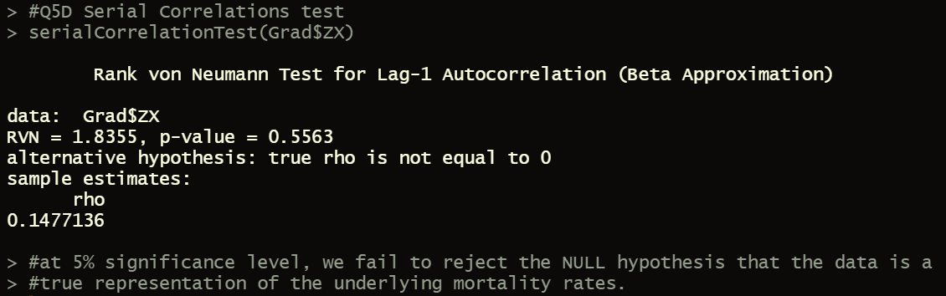
Library “EnvStats” was something that was a pre-requisite to be installed before conducting this test with a Lag-1 Autocorrelation.
Conclusion – The test fails to reject the Null Hypothesis.

THANK YOU!

