SIMRAN R. SHARMA

Air India: Market Failure in Public Undertakings

Roll No.: 414

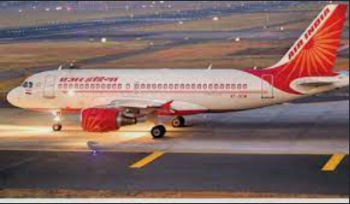
Table of Contents

- INTRIODUCTION

- HISTORY OF AIR INDIA

- AIR INDIA AND ITS MERGERS

- THE PRIVATIZATION BATTLE

- STAR ALLIANCE MEMBERSHIP

- AIR INDIA AND INDIAN AIRLINES

- WHAT HAPPENED?

- AIR INDIA AND ITS SPV

- WHAT IS AN SPV?

- AIR INDIA’S DEBT

- AIR INDIA AND THE VAJPAYEE GOVERNMENT MOVES

- THE REVIVAL

- TATA THE ORIGINAL PARENT

- CONCLUSION

AIR INDIA

Introduction

Air India, headquartered at New Delhi is the flag carrier airline of India. It was founded by J. R. D. Tata as Tata Airlines in 1932. Tata himself flew its first single-engine de Havilland Puss Moth, carrying air mail from Karachi's Drigh Road Aerodrome to Bombay's Juhu aerodrome and later continuing to Madras.
By 1939 routes had been extended to Trivandrum, Delhi, Colombo, Lahore, and intermediate points. Post-World War 2, in 1946, it transitioned into a public limited company and was renamed Air India. Two years hence, in order to inaugurate international services between Bombay and Cairo, Geneva, and London, Air-India International Limited was formed.
In 1953 all Indian airlines were nationalized, creating two sectors- one for domestic service, named Indian Airlines Corporation (merging Air-India Limited with six lesser lines), and one for international service, Air-India International Corporation which was abbreviated to Air-India in 1962. To gain a competitive advantage in computerized reservation searches, the airline removed the hyphen from its name in 2005 to become Air India.
On 21 February 1960, it took delivery of its first Boeing 707 named Gauri Shankar and became the first Asian airline to induct a jet aircraft in its fleet.
In 1994 the struggle began with privatization of the airlines being permitted. Air India struggled to hold on to its edge and competitive advantage. Eve though there were significant losses in market share it held onto its over populated workforce.
The losses began to be recorded in 2007. They merged with Indian Airlines later in the year to form National Aviation Company of India Ltd. (NACIL) which was renamed Air India in 2010.
They accumulated huge debt accruing to billions of dollars over the next ten years, the government therefore began to look into privatizing the company.
The Government of India, completed the sale, and is now owned by Talace Private Limited.
Air India operates a fleet of Airbus and Boeing aircraft serving 102 domestic and international destinations. Air India has the third largest domestic market share at 10.9%. Over 60 international destinations are served by Air India across four continents. The airline became the 27th member of Star Alliance on 11 July 2014.

History of Air India

J. R. D. Tata founded Tata Airlines in 1932 as a division of Tata Sons Ltd. Which is now Tata Group. After World War II, regular commercial service in India went back to normal, Tata Airlines changing its name to Air India and becoming a public limited company on the 29th of July 1946.
On the 8th of June 1948, Air India introduced a regular service from Bombay to London, and two years later, Air India started regular flights to Nairobi. Air India inaugurated services to Tokyo, Bangkok, Hong Kong and Singapore in 1954, with the delivery of its first L-1049 Super Constellations.
In 1960, with the introduction of the first Boeing 707-420 aircraft, Air India started using jets, and two years later, in June 1962, it became the world’s first all-jet airline and moved its officed to downtown Bombay in 1970.
May 28, 1997 marks the date when Air India came online, its official website being www.airindia.com. Later on, on the 1st of November, a major global alliance tied Air India and Air France.
In January 2020, the Indian government approved a new proposal to divest 100% stake in Air India, which will be followed by the Expression of Interest (EoI) document to be issued.

Air India and its mergers

As said earlier, in 2007, Air India and Indian Airlines were merged under Air India Limited. It also took delivery of its first Boeing 777 aircraft and was invited to be a part of the Start Alliance.
Air India and Indian Airlines in 2006–07 had combined losses of ₹7.7 billion (US$100 million) and after the merger, it went up to ₹72 billion (US$960 million) by March 2009. Two months later in July State Bank of India was appointed to prepare a road map for the recovery of the airline. In order to finance the debt, the airline sold a couple for its assets for a sum of $18.75 million.
Two years in March 2011 Air India had accumulated a debt of ₹426 billion (US$5.7 billion) and an operating loss of ₹220 billion (US$2.9 billion). It was now ₹429 billion (US$5.7 billion) from the government.
In August 2011, the invitation to join Star Alliance was suspended as a result of its failure to meet the minimum standards for the membership. The government pumped ₹32 billion (US$420 million) into Air India in March 2012.
In 2012, a study commissioned by the Corporate Affairs Ministry recommended that Air India should be partly privatized. In May 2012, the carrier invited offers from banks to raise up $800 million via external commercial borrowing and bridge financing.
In May 2012, the airline was fined $80,000 by the US Transportation Department for failing to post customer service and tarmac delay contingency plans on its website and adequately inform passengers about its optional fees.

The Privatization Battle
In 2013, the then-Civil Aviation Minister Ajit Singh stated privatization was the key to the airline's survival. Although the opposition led by BJP and CPI(PM) slammed the government.
The Indian government planned to delay equity infusion of ₹300 billion (US$4.0 billion) that was slated to be infused into the airline slowly over a period of eight years. In January of the same year Air India made up part of its debt by selling and leasing back the newly acquired Boeing 787 Dreamliners.
In March 2013, the airline posted its first positive EBITDA after almost six years and 20% growth in its operating revenue since the previous financial year.

Star Alliance Membership

Air India became the 27th member of Star Alliance on 11 July 2014. In August 2015, in order to raise $300 million in external commercial borrowing to meet working capital requirements it signed an agreement with Citibank and State Bank of India to raise $300 million in external commercial borrowing to meet working capital requirements.

Privatization

The Government of India approved the privatization of Air India, on 28 June 2017. The Government in March 2018, issued an Expression of Interest (EOI) to sell 76% stake of Air India, along with low-cost airline Air India Express, and a 50% stake of AISATS, a ground handling joint venture with Singapore Airport Terminal Services (SATS).
The new owner would be ladled with a debt of ₹33,392 crore (US$4.4 billion) with a bid to be submitted by mid-May which is probably the reason why no private firms showed any interest in the debt burdened company at all.
Now, the government decided to sell a 100% of the company and its budget carrier Air India Express as well as 50% shares of AISATS and started the preparations for it in late 2019.
In order to make the sale more lucrative this time, the government has already decreased nearly ₹30,000 crore (US$4.0 billion) of debts and liabilities in a Special Purpose Vehicle (SPV).
Finally, on 8 October 2021, Air India, along with its low-cost carrier Air India Express and fifty percent of AISATS, a ground handling company, were sold for ₹18,000 crore (US$2.4 billion) to Talace Private Limited, a Tata Sons' SPV.[80][81] On 27 January 2022, the airline was officially handed over to Tata Group.

Air India and Indian Airlines

The merger was the essence of the word flop. Following the merger Air India reported a marginal profit of ₹15 crores and Indian Airlines reported a profit of ₹50 crores. In the following two years Air India reported losses while Indian airlines reported profits. In 2006-07 Air India posted a loss of ₹448 crore while Indian Airlines posted a loss of ₹241 crore. In the first year following the merger, the new entity posted a loss of ₹2,226 crores.
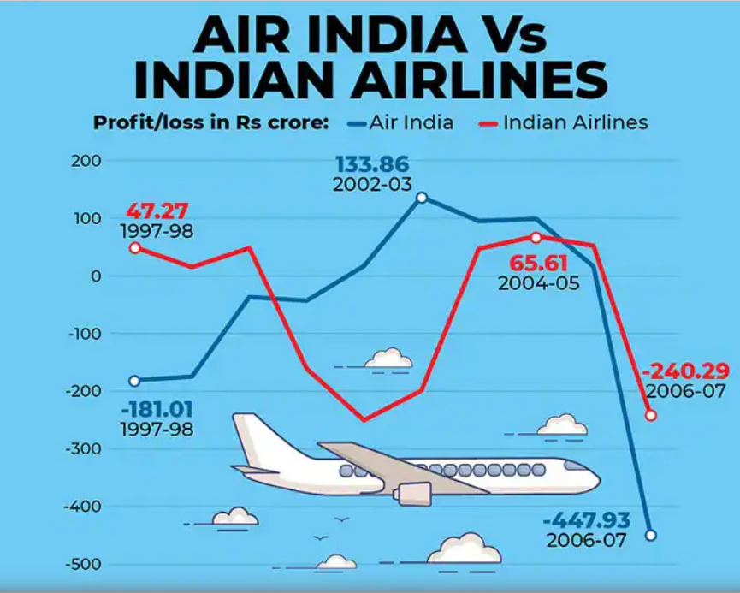

What Happened?

Faulty decisions on aircraft purchases, self-interest of CMDs, failed marriage with IA, among reasons for Air India’s downfall.
According to management guru Peter F Drucker, the root cause of an organization’s crisis is, “Doing right things but fruitlessly.”
- Too Much and Too Little
Do not spend more than what you have is a basic wisdom imparted to us globally by literally everyone. But Air India somehow seemed to have missed its memo. It placed an order for a large number of Boeing aircrafts it did not need, the number was at an original of 10 which was then bumped up to an 11 as if the 10 was not abundant already. In his book Not just an accountant, ex-CAG (Comptroller and Audit General) Vinod Rai describes how Air India’s board of directors had originally placed an LOI on Airbus for 10 MCLR (A330) aircraft. Reading between the lines, it appears that the Boeing order was placed with the tacit approval of the then PM as a quid pro quo for waiver of NRC (Nuclear Regulatory Commission) action against India by the US Congress. Air India did not have a boastful amount of working capita but a sufficient ad discreet amount which was obliterated by these unnecessary (in terms of running the company) purchases.

- Bungled Designs
The long haul B777 and B747 aircraft had “vanity first class cabin” that was rarely filled. What this means is they were not even functioning at a break-even point. Capacity for meeting even cash operating costs went beyond 130 per cent. Moreover, they have a mindless policy of deploying humongous gas guzzlers for short domestic flights which was scarcely a very prudent and practical policy. This added to its operating losses by an estimated ₹350-400 crore per year.

- Lack Of Efficiency
Inability to offer direct non-stop flights from major growth centers: Air India, for example, simply forced passengers going from Kerala to the Middle East or from Bengaluru to the US to travel via Mumbai/Delhi, adding 8-16 hours to total travel time. Nobody wants to pay huge air flight bills and still end up wasting large hours.

- Heterogeneity Of Fleet
Air India’s fleet was not familiar with the blueprint and design and maneuvering of the Boeing 737s which was orders for Air India Express. They were always trained and skilled in handling Airbuses since Indian Airlines as well as Air India had historically used Airbus (A-319/320/321) fleet for short-haul services. Adding Boeing 737s for short-haul flights added to inventory costs and further training of the crew.

- Forced (Failed) Marriage
I am referring to the marriage between Air India and Indian Airlines. This marriage however was only an empty shell in its essence. They were zero synergies. The union emerged to increase efficiency and blend their workforce. However, their resources, aircraft, men, material and machines remained divided.

- The High Costs
Air India employees had a strong union culminating in higher salaries and perks for them. The unions of pilots and AMEs demanded US equivalent salaries in rupees. However, air India had a huge and idle workforce thus this robbed them of their cost edge.

- New Look Old Attitude
The change brought in by liberalization of the airline industry post 2005 meant all flagrant wastages of monopoly times had to go. The reactive management style (instead of proactive) ensured Air India was poorly placed to face the challenges of liberalization. Lack of customer focus, bad financial management, and arrogance of unionized employees made things even worse.

- We Don’t Want Change
The change brought in by the liberalization of the airline industry in 2005 was not met well. This meant all wastages must be cut and optimization should be initiated across all divisions. But why go along with rules that hurt now however are better in the long run when one can simply flout them. The management instead of swimming better to keep up with the tide however sank in it in the most spectacular way.

- Greed At The Highest Level
From 1994 to 1999, Air India plummeted into losses from being a top player in its plain to a shell of a company it once was. The irony lies in the fact the company made losses when the competition scenario was abysmal, nay non-existent. Air India’s CMDs only pursued their own goals during this time — handsome increases in flying “shortfall allowance” for their clan, generous incentives for AMEs, postdated incentive deals with GSAs (general sales agents) in London, etc.

- Poor Asset Management
As we know air India has made unnecessary purchases of aircrafts. But not only that the assets however were poorly managed too. Due to the huge amounts of debt accrued in billions of dollars these assets were sadly sold for a fraction of their original amount.
Air India and Its SPV

The Centre in order to facilitate strategic disinvestment of Air India has given tax exemption on transfer of assets by the national carrier to the SPV Air India Assets Holding Limited (AIAHL).
The Central Board of Direct Taxes (CBDT) said that there will not be any TDS cut in case of transfer of goods & immovable property to the SPV. It further said that Air India will not be considered as "seller" for the purpose of TCS deduction related to transfer of goods to Air India Assets Holding Limited.
The CBDT notification informed that any transfer of capital assets under the plan approved by the government from the national carrier to the SPV will not be regarded as transfer for the purpose of income tax.

What Is An SPV?

A special purpose vehicle, also called a special purpose entity (SPE), is a subsidiary created by a parent company to isolate financial risk. Its legal status as a separate company makes its obligations secure even if the parent company goes bankrupt. For this reason, a special purpose vehicle is sometimes called a bankruptcy-remote entity.
Basically, a safety net for debtholders and lenders in case the parent company is compromised.

Air India’s Debt

“Most of Air India’s loans were overdue. One option was to issue government guaranteed bonds but that could take us several years to make repayments. Where the loans are not due yet, banks would be required to enter into a fresh contract with the SPV, which they may not want to do since it doesn't house a lot of assets. Therefore, the money sought from Parliament will help us make all settlements and clean-up the airline,” said the senior government official. He added that this would mean that banks, most of which are public sector ones, will soon receive their payments.
The special purpose vehicle, known as Air India Assets Holding Limited, will receive the equity infusion from the government. It will then proceed to make settlements. When asked if this would be done within this fiscal, the official replied, “Yes”.
As on August 31, 2021 the airline had a total debt of ₹61,562 crore. Of this amount, TATA group took over ₹15,300 crore and the rest of the amount (₹46,000 crore) was transferred to an SPV, AI Asset Holding Ltd (AIAHL).
AIAHL also held Air India's non-core assets such as stake in Hotel Corp of India (HCIL), paintings and artifacts and immovable properties.
In an interview with PTI, Tuhin Kanta Pandey, Secretary, Department of Investment and Public Asset Management (DIPAM), which ran the Air India privatization process, said Parliament had last month given nod for spending of ₹62,057 crore towards equity infusion in AIAHL for repayment of dues and liabilities of Air India. Of this amount, approximately ₹61,131 crore has been utilized to repay all debts and other liabilities such as fuel to oil companies.
"The interest outgo on the debt and other liabilities was very high and it was decided to square off the debt now."
To summarize- the debt was ₹61,562 crore of which ₹46,000 crore was transferred to AIAHL. It also had ₹15,000 crore excess liabilities towards unpaid fuel bills and other operational creditors.
"Both excess debt and excess current liabilities whatever was remaining with the government, about Rs 61,131 crore, have been cleared," Pandey said.
Whatever was to be borne by the government that the government has squared off rather than paying it off later... we found that it is carrying higher rate of interest. It wasn't worthwhile to retain it and pay it off later.
"If we take it to AIAHL and pay it later we have to pay higher rate of interest. So, we have chosen to square it off straight away," he said.
TATA had the highest winning bid of ₹18,000 crore. They paid ₹2,700 in cash and took over ₹15,300 crore of Air India’s debt.
The deal also includes sale of Air India Express and ground handling arm AISATS.
Tata Group has already refinanced its Rs 15,300 crore debt in Air India and brought in new lenders. Tatas beat the Rs 15,100-crore offer by a consortium led by SpiceJet promoter.

Air India and The Vajpayee Government Moves

The Vajpayee government believed in letting a company run its course and providing a helping hand when required. It wanted to disinvest from private sectors in order to enhance quality and also increase the standard of living in the long run. It was a strong believer of the gradual withdrawal of the government from non-strategic areas.
Recommendations by the Ramakrishna Committee in 1998 were made which suggested disinvestment of Air India during the previous NDA government. However, it was always delayed which resulted in its humongous debt today.

The revival
It was an original plan to use taxpayers’ money to finance Air India’s unnecessary debt burden. But fortunately, it was recognized that depriving funds for welfare projects and infrastructure development was not correct on the governments part.

TATA The Original Parent

The airline began its journey under the Tatas 90 years ago before the government nationalized the sector in 1953.
In a tweet, department of investment and public asset management secretary Tuhin Kanta Pandey said: “The strategic disinvestment transaction of Air India successfully concluded today with transfer of 100 per cent shares of Air India to M/s Talace Pvt Ltd along with management control.” He added a new board, led by the strategic partner, has taken AI’s charge.
Tata Sons chairman N Chandrasekaran said they are totally delighted that this process is complete. “We are very happy to have Air India back in the Tata fold. We look forward to working with everyone.”
Talace Pvt Ltd, a wholly-owned subsidiary of Tata Sons, gets 100% equity shares of AI and AI Express. It will also get the government’s 50% stake in ground-handling company AISATS.
TATA’s are the new owners of the debt laden formal national carrier Air India. The national carrier has finally made its way back to its original address. Surprisingly, efforts to privatize this carrier was initiated in 2000-01 as addressed earlier, by the Vajpayee government.
This eventually bore fruit 20 years later with the Centre rendering control and declaring TATA Sons Pvt. Ltd. as the official owner of Air India.

A look at Air India’s report from the past 4 years
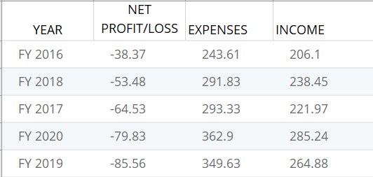

As we can see its expenses every year outweighed it income.

Conclusion

Air India was in the dawn of its time a good player and carrier. It put India on the map by acting as its brand ambassador. Air India catered to the elite but also the stranded. However, it took a downhill slope in the past two decades. Almost every effort to revive the company was a failure, mergers led to losses and loans led to even more losses.
There is no particular thing that caused the national carrier’s downfall but a mixture of poor management, lack of efficiency and productivity and a harsh stance towards change brewed together that was its cumulative bungle.
According to me Air India was and is a spectacular brand and privatization before it ran into losses would have been ideal. The nationalization was understandable but the reins slowly could have been let loose.
the synergies between Air India and Indian Airlines could have been enhanced. This was a fragmented union. Their division did not lead to specialization.
Privatization was suggested earlier but to no avail. The process kept getting delayed till the company was old for a fraction of its price including its assets. However, in the end the sale was manage well and so was the debt of the company. All in all it was a process to get here but they finally did.

