Roll no: -709
1.
Money Control Newsletter: Based on market data for 28-04-2022
Market Action
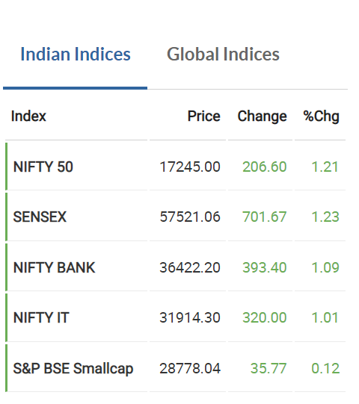
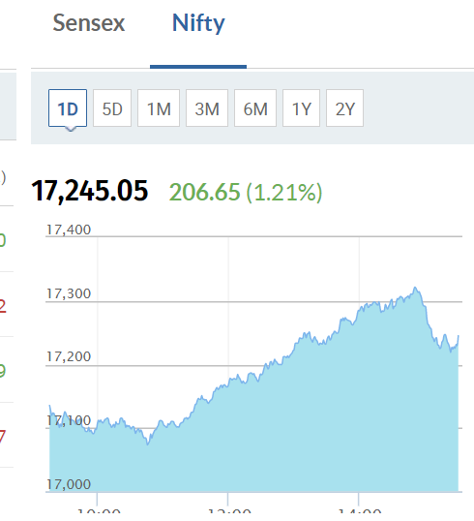

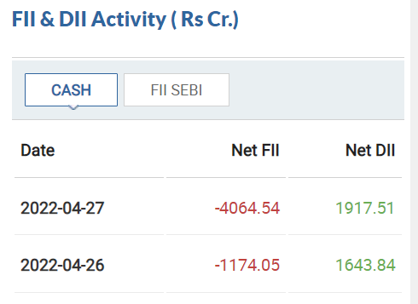
The markets rose around 1.21% today. This can be seen in the day’s chart as well.
The foreign institutional investors were net sellers.
Domestic institutional investors continued to be net buyers.
There was net selling overall when we consider DII and FII investments and both selling and buying increased from 26/04/22

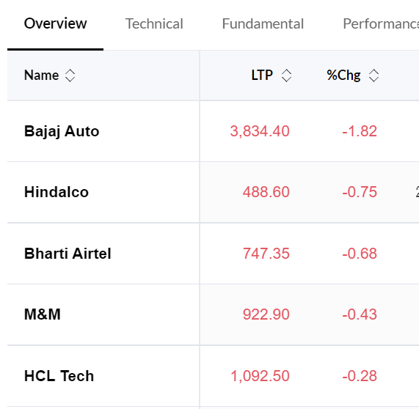
Top 5 Nifty losers
These are the Nifty 50 stocks that fell the most today with the maximum fall being around 1.82% for Bajaj Auto followed by Hindalco and Bharti airtel.

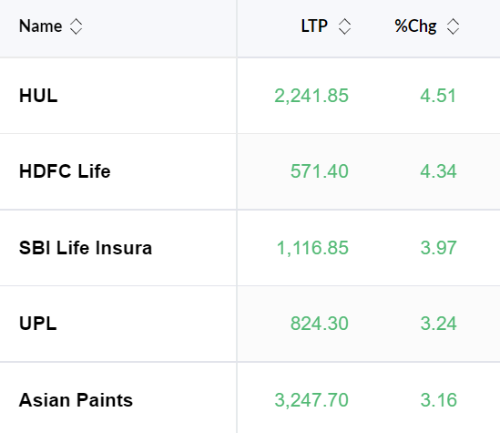
Top 5 Nifty Gainers
These are the stocks from Nifty 50 which gained the most today. The highest gain was 4.51% for HUL
As we can see even the lowest in the top 5 gain was around 3.16% while the highest fall was only around 1.82%.
Since advances were more than the declines, overall, the index rose during the day.
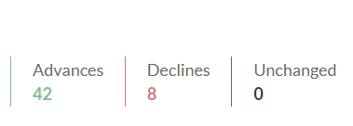

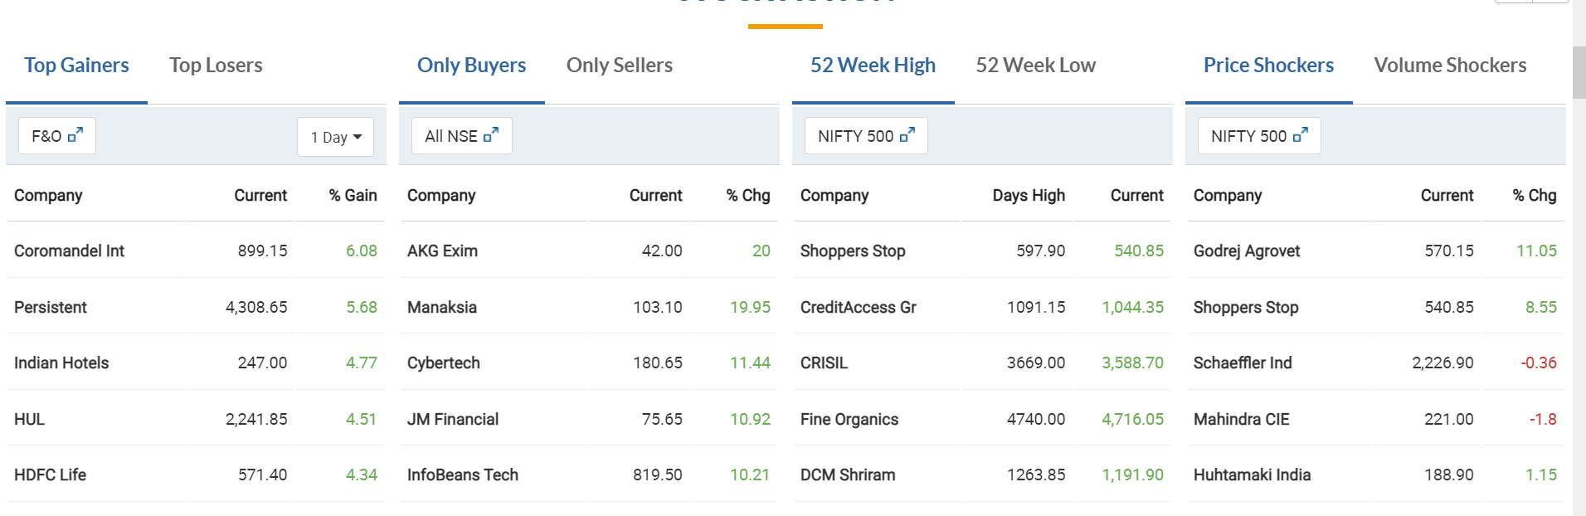
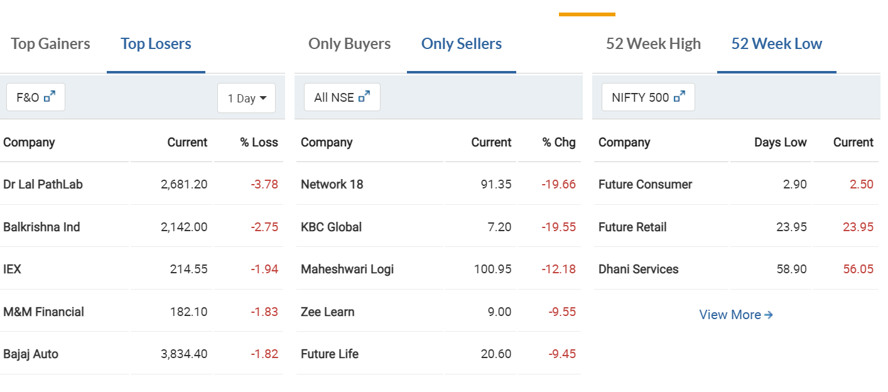
Stock Action
This data presents the general stock action today. This includes those stocks which were the top gainers and losers overall, 52-week highs and lows as well as only buyers and only sellers
We can notice that the percentage change in top losers is much less than that in top gainers which contributes to the rise of the markets.
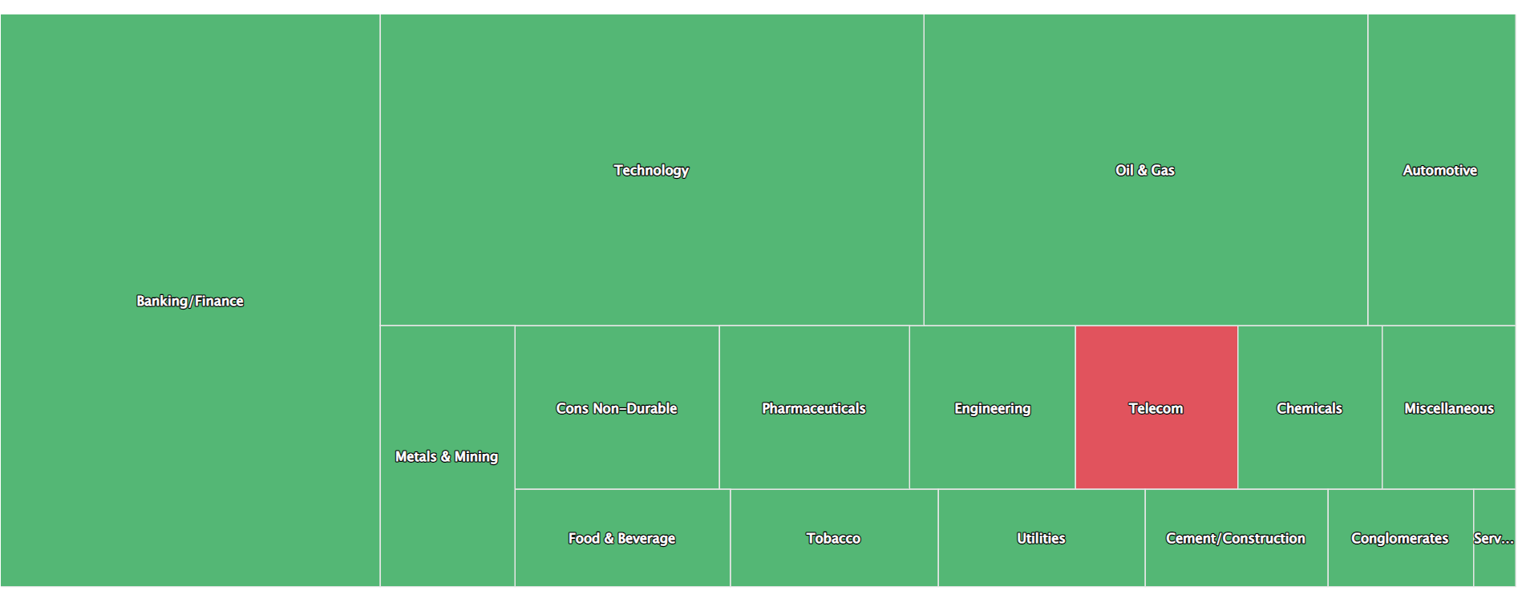
Sectoral Performance
This heatmap provides the data for the sectors which contributed the most to the markets rise today.
Banking/Finance, IT and Oil and Gas sectors were the best performing sectors for the day.
Only Telecom sector saw a fall, all the sectors saw a rise and hence a rise in overall markets.
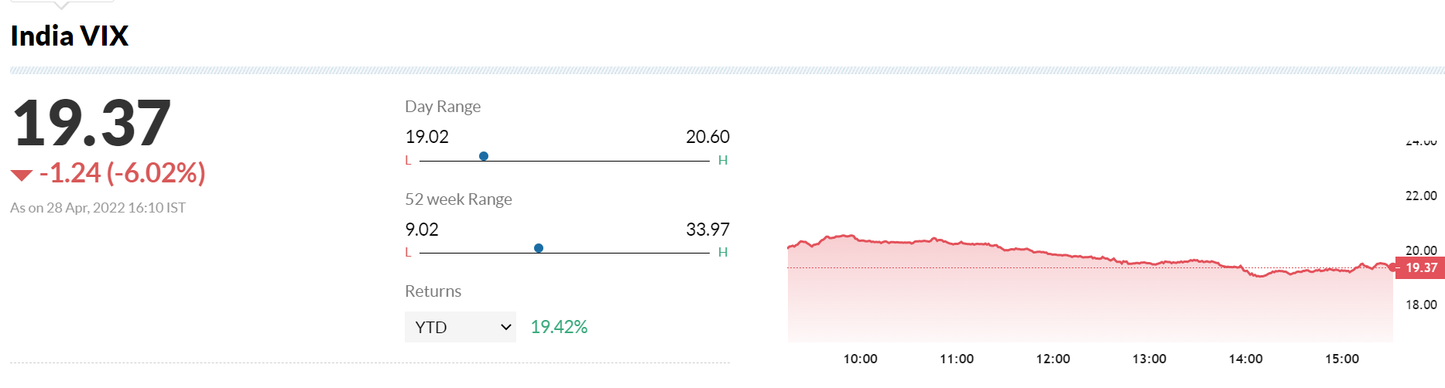
India Vix index fell as compared to yesterday, but the range still suggests some uncertainty setting in and points at the anxiety in the markets.

2.
a. According to Institutional fund flow data, the Foreign Institutional investors (FIIs) dominated the markets today (28.04.22) and there was net selling.
b. The change in the fear index, India Vix is -6.02% today but its still in the range of 18-20 which suggests there is uncertainty setting in the market and investors and traders are showing anxiety.
c. HUL, HDFC Life, SBI Life, UPL and Asian Paints were the top gainers in the Nifty 50 index today and they influenced the move in the market.
d. Banking and finance, Technology and Oil and Gas are the top performing sectors for the day. The best stocks were AU small finance, SBI and Axis bank from banking sector, HDFC life and SBI life from Finance sector, Infosys and Mindtree from IT, Adani Total Gas and IOC from oil and gas
e. The worst performing sectors was Telecom. The worst performing stock was Bharti Airtel

3.
52 WEEK high stocks
- KPR Mill
- Narayan Hrudayala
- Titan Company
- Adani Green Energy
- Tata Power Co
Selection criteria:
- Chart beginning from the bottom left of the screen and ending at the top right of the screen
- Size of the candles is small
- No circuits (blank candles) on the chart
- No big dips in the middle of the chart
- Smooth shape (upward trend) on the chart

4.
High Candle Date | Buy Price | Sell Price | Low Candle Date | PnL (Points)
28-Dec-98 | 89.3 | 77.6 | 09-Aug-99 | -11.7 | The first date is not the high candle date. It is the first candle of the stock and the opening price
11-Mar-02 | 21.85 | 471.15 | 08-Jun-15 | 449.3
30-Oct-17 | 832.8 |  |  |  | Trade Open
DOW Theory for Bata P/L:

