ASSIGNMENT
FOOD_INSPECTION =read.csv(file.choose())
#1)#eploratotaty data analysis
dim(FOOD_INSPECTION)
head(FOOD_INSPECTION)
str(FOOD_INSPECTION)

OUTPUT :-
dim(FOOD_INSPECTION)
[1] 222961 17
>str(FOOD_INSPECTION)
'data.frame': 222961 obs. of 17 variables:
$ Inspection.ID : int 2522880 2522846 2522840 2522830 2522831 2522819 2522805 2522800 2522852 2522785 ...
$ DBA.Name : chr "MI LINDO MEXICO MARKET, LLC" "WILDBERRY PANCAKE AND CAFE" "THE REVELER" "LIFEWAY KEFIR SHOP" ...
$ AKA.Name : chr "MI LINDO MEXICO MARKET, LLC" "WILDBERRY" "THE REVELER" "LIFEWAY" ...
$ License.. : int 2469282 2560035 39845 2262479 1804509 2797687 1300963 2786251 2528322 2543316 ...
$ Facility.Type : chr "Restaurant" "Restaurant" "Restaurant" "Mobile Food Preparer" ...
$ Risk : chr "Risk 1 (High)" "Risk 1 (High)" "Risk 1 (High)" "Risk 2 (Medium)" ...
$ Address : chr "538 W PERSHING RD " "196 E PEARSON ST " "1954-1958 W ROSCOE ST " "324 N LEAVITT ST " ...
$ City : chr "CHICAGO" "CHICAGO" "CHICAGO" "CHICAGO" ...
$ State : chr "IL" "IL" "IL" "IL" ...
$ Zip : int 60609 60611 60657 60612 60612 60659 60644 60652 60644 60609 ...
$ Inspection.Date: chr "07/19/2021" "07/19/2021" "07/16/2021" "07/16/2021" ...
$ Inspection.Type: chr "Canvass Re-Inspection" "Complaint Re-Inspection" "Canvass Re-Inspection" "Canvass" ...
$ Results : chr "Pass" "Pass" "Pass w/ Conditions" "Out of Business" ...
$ Violations : chr "" "56. ADEQUATE VENTILATION & LIGHTING; DESIGNATED AREAS USED - Comments: FOUND HEAVY DUST BUILDUP ON CEILING VENT"| __truncated__ "10. ADEQUATE HANDWASHING SINKS PROPERLY SUPPLIED AND ACCESSIBLE - Comments: 5-204.11- NOTED NO HANDWASHING SIN"| __truncated__ "" ...
$ Latitude : num 41.8 41.9 41.9 41.9 41.9 ...
$ Longitude : num -87.6 -87.6 -87.7 -87.7 -87.7 ...
$ Location : chr "(-87.64008848891073, 41.82364451194088)" "(-87.62203547561978, 41.897721501377255)" "(-87.67818416456056, 41.943328037206484)" "(-87.68184949426895, 41.88743405025222)" ...

## 2)first 6 record
View(FOOD_INSPECTION[1:6,])
OUTPUT :-
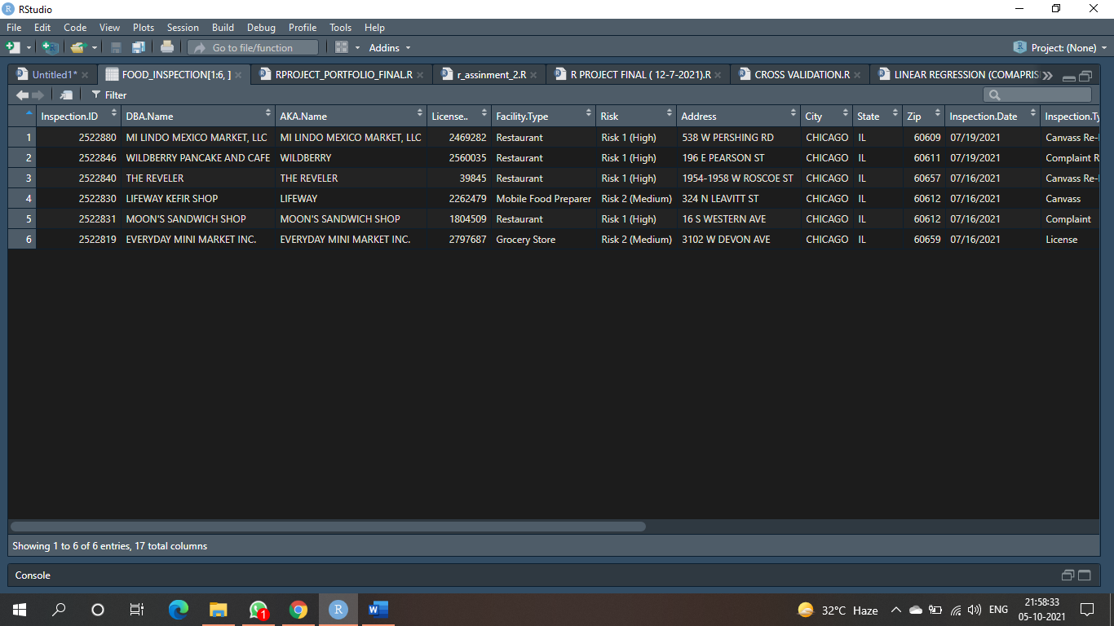

#3)FIRST 10 RECORD
View(FOOD_INSPECTION[1:10])
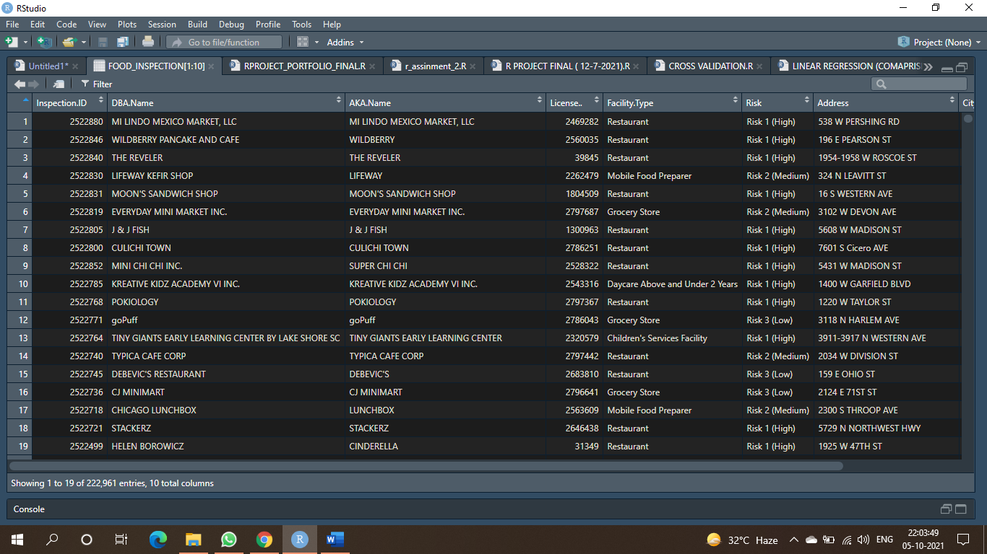

dim(FOOD_INSPECTION)
dim(FOOD_INSPECTION)
[1] 222961 17

5)structure of the data
str(FOOD_INSPECTION)

output:-
str(FOOD_INSPECTION)
'data.frame': 222961 obs. of 17 variables:
$ Inspection.ID : int 2522880 2522846 2522840 2522830 2522831 2522819 2522805 2522800 2522852 2522785 ...
$ DBA.Name : chr "MI LINDO MEXICO MARKET, LLC" "WILDBERRY PANCAKE AND CAFE" "THE REVELER" "LIFEWAY KEFIR SHOP" ...
$ AKA.Name : chr "MI LINDO MEXICO MARKET, LLC" "WILDBERRY" "THE REVELER" "LIFEWAY" ...
$ License.. : int 2469282 2560035 39845 2262479 1804509 2797687 1300963 2786251 2528322 2543316 ...
$ Facility.Type : chr "Restaurant" "Restaurant" "Restaurant" "Mobile Food Preparer" ...
$ Risk : chr "Risk 1 (High)" "Risk 1 (High)" "Risk 1 (High)" "Risk 2 (Medium)" ...
$ Address : chr "538 W PERSHING RD " "196 E PEARSON ST " "1954-1958 W ROSCOE ST " "324 N LEAVITT ST " ...
$ City : chr "CHICAGO" "CHICAGO" "CHICAGO" "CHICAGO" ...
$ State : chr "IL" "IL" "IL" "IL" ...
$ Zip : int 60609 60611 60657 60612 60612 60659 60644 60652 60644 60609 ...
$ Inspection.Date: chr "07/19/2021" "07/19/2021" "07/16/2021" "07/16/2021" ...
$ Inspection.Type: chr "Canvass Re-Inspection" "Complaint Re-Inspection" "Canvass Re-Inspection" "Canvass" ...
$ Results : chr "Pass" "Pass" "Pass w/ Conditions" "Out of Business" ...
$ Violations : chr "" "56. ADEQUATE VENTILATION & LIGHTING; DESIGNATED AREAS USED - Comments: FOUND HEAVY DUST BUILDUP ON CEILING VENT"| __truncated__ "10. ADEQUATE HANDWASHING SINKS PROPERLY SUPPLIED AND ACCESSIBLE - Comments: 5-204.11- NOTED NO HANDWASHING SIN"| __truncated__ "" ...
$ Latitude : num 41.8 41.9 41.9 41.9 41.9 ...
$ Longitude : num -87.6 -87.6 -87.7 -87.7 -87.7 ...
$ Location : chr "(-87.64008848891073, 41.82364451194088)" "(-87.62203547561978, 41.897721501377255)" "(-87.67818416456056, 41.943328037206484)" "(-87.68184949426895, 41.88743405025222)" ...

#6) name of column
colnames(FOOD_INSPECTION)
output :-
colnames(FOOD_INSPECTION)
[1] "Inspection.ID" "DBA.Name" "AKA.Name"
[4] "License.." "Facility.Type" "Risk"
[7] "Address" "City" "State"
[10] "Zip" "Inspection.Date" "Inspection.Type"
[13] "Results" "Violations" "Latitude"
[16] "Longitude" "Location"
#7_summary fot numeric columns
summary(FOOD_INSPECTION)

output :-
summary(FOOD_INSPECTION)
Inspection.ID DBA.Name AKA.Name
Min. : 44247 Length:222961 Length:222961
1st Qu.:1202271 Class :character Class :character
Median :1559535 Mode :character Mode :character
Mean :1563010
3rd Qu.:2150436
Max. :2522918

License.. Facility.Type Risk
Min. : 0 Length:222961 Length:222961
1st Qu.:1271831 Class :character Class :character
Median :2003576 Mode :character Mode :character
Mean :1643747
3rd Qu.:2290123
Max. :9999999
NA's :17
Address City State
Length:222961 Length:222961 Length:222961
Class :character Class :character Class :character
Mode :character Mode :character Mode :character

Zip Inspection.Date Inspection.Type
Min. :10014 Length:222961 Length:222961
1st Qu.:60614 Class :character Class :character
Median :60625 Mode :character Mode :character
Mean :60629
3rd Qu.:60643
Max. :60827
NA's :52
Results Violations Latitude
Length:222961 Length:222961 Min. :41.64
Class :character Class :character 1st Qu.:41.83
Mode :character Mode :character Median :41.89
Mean :41.88
3rd Qu.:41.94
Max. :42.02
NA's :760
Longitude Location
Min. :-87.91 Length:222961
1st Qu.:-87.71 Class :character
Median :-87.67 Mode :character
Mean :-87.68
3rd Qu.:-87.64
Max. :-87.53
NA's :760
##11)display of inspecation id and facility type
m=data.frame(FOOD_INSPECTION$Inspection.ID,FOOD_INSPECTION$Facility.Type)
head(m)
output :-
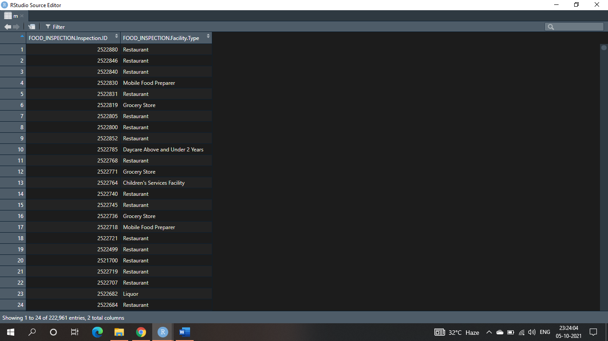
#14)row in dat frame
nrow(FOOD_INSPECTION)
- > nrow(FOOD_INSPECTION)
- [1] 222961
# 15)number of missing value colume wise

sum(is.na(FOOD_INSPECTION$Inspection.ID))
sum(is.na(FOOD_INSPECTION$DBA.Name))
sum(is.na(FOOD_INSPECTION$AKA.Name))
sum(is.na(FOOD_INSPECTION$License..))
sum(is.na(FOOD_INSPECTION$Facility.Type))
sum(is.na(FOOD_INSPECTION$Risk))
sum(is.na(FOOD_INSPECTION$Address))
sum(is.na(FOOD_INSPECTION$City))
sum(is.na(FOOD_INSPECTION$State))
sum(is.na(FOOD_INSPECTION$Zip))
sum(is.na(FOOD_INSPECTION$Inspection.Date))
sum(is.na(FOOD_INSPECTION$Inspection.Type))
sum(is.na(FOOD_INSPECTION$Results))
sum(is.na(FOOD_INSPECTION$Violations))
sum(is.na(FOOD_INSPECTION$Latitude))
sum(is.na(FOOD_INSPECTION$Longitude))
sum(is.na(FOOD_INSPECTION$Location))

output :=
#14)row in dat frame
> nrow(FOOD_INSPECTION)
[1] 222961
> sum(is.na(FOOD_INSPECTION$Inspection.ID))
[1] 0
> sum(is.na(FOOD_INSPECTION$DBA.Name))
[1] 0
> sum(is.na(FOOD_INSPECTION$AKA.Name))
[1] 0
> sum(is.na(FOOD_INSPECTION$License..))
[1] 17
> sum(is.na(FOOD_INSPECTION$Facility.Type))
[1] 0
> sum(is.na(FOOD_INSPECTION$Risk))
[1] 0
> sum(is.na(FOOD_INSPECTION$Address))
[1] 0
> sum(is.na(FOOD_INSPECTION$City))
[1] 0
> sum(is.na(FOOD_INSPECTION$State))
[1] 0
> sum(is.na(FOOD_INSPECTION$Zip))
[1] 52
> sum(is.na(FOOD_INSPECTION$Inspection.Date))
[1] 0
> sum(is.na(FOOD_INSPECTION$Inspection.Type))
[1] 0
> sum(is.na(FOOD_INSPECTION$Results))
[1] 0
> sum(is.na(FOOD_INSPECTION$Violations))
[1] 0
> sum(is.na(FOOD_INSPECTION$Latitude
+ ))
[1] 760
> sum(is.na(FOOD_INSPECTION$Latitude))
[1] 760
> sum(is.na(FOOD_INSPECTION$Longitude))
[1] 760
> sum(is.na(FOOD_INSPECTION$Location))
[1] 0

#17 )histrogram for latiude and longitude

hist(FOOD_INSPECTION$Latitude)
hist(FOOD_INSPECTION$Longitude)

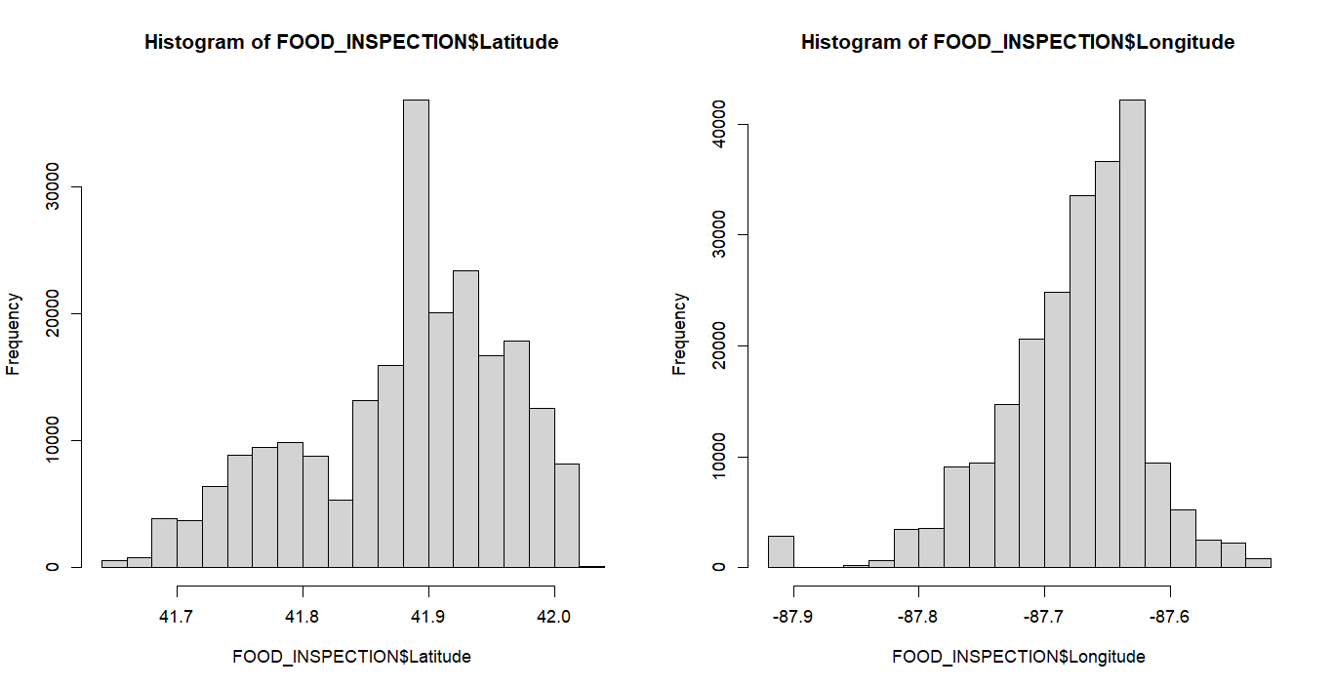

## 18) replacig missing value of lattitude AND LONGITUDE
sum(is.na(FOOD_INSPECTION$Latitude))
FOOD_INSPECTION$Latitude[is.na(FOOD_INSPECTION$Latitude)]<-mean(FOOD_INSPECTION$Latitude,na.rm = TRUE)
sum(is.na(FOOD_INSPECTION$Latitude))

#output :-
sum(is.na(FOOD_INSPECTION$Latitude))
[1] 760
FOOD_INSPECTION$Latitude[is.na(FOOD_INSPECTION$Latitude)]<-mean(FOOD_INSPECTION$Latitude,na.rm = TRUE)
> sum(is.na(FOOD_INSPECTION$Latitude))
[1] 0

sum(is.na(FOOD_INSPECTION$Longitude))
FOOD_INSPECTION$Longitude[is.na(FOOD_INSPECTION$Longitude)]<- mean(FOOD_INSPECTION$Longitude,na.rm = TRUE)
sum(is.na(FOOD_INSPECTION$Longitude))

#output :-
> sum(is.na(FOOD_INSPECTION$Longitude))
[1] 760
> FOOD_INSPECTION$Longitude[is.na(FOOD_INSPECTION$Longitude)]<- mean(FOOD_INSPECTION$Longitude,na.rm = TRUE)
> sum(is.na(FOOD_INSPECTION$Longitude))
[1] 0
>

##19)total p. of duplicated

sum(duplicated(FOOD_INSPECTION$Inspection.ID))
sum(duplicated(FOOD_INSPECTION$DBA.Name))
sum(duplicated(FOOD_INSPECTION$AKA.Name))
sum(duplicated(FOOD_INSPECTION$License..))
sum(duplicated(FOOD_INSPECTION$Facility.Type))
sum(duplicated(FOOD_INSPECTION$Risk))
sum(duplicated(FOOD_INSPECTION$Address))
sum(duplicated(FOOD_INSPECTION$City))
sum(duplicated(FOOD_INSPECTION$Zip))
sum(duplicated(FOOD_INSPECTION$Inspection.Type))
sum(duplicated(FOOD_INSPECTION$Violations))
sum(duplicated(FOOD_INSPECTION$Latitude))
sum(duplicated(FOOD_INSPECTION$Longitude))

output :-

##19)total p. of duplicated

sum(duplicated(FOOD_INSPECTION$Inspection.ID))
sum(duplicated(FOOD_INSPECTION$DBA.Name))
sum(duplicated(FOOD_INSPECTION$AKA.Name))
sum(duplicated(FOOD_INSPECTION$License..))
sum(duplicated(FOOD_INSPECTION$Facility.Type))
sum(duplicated(FOOD_INSPECTION$Risk))
sum(duplicated(FOOD_INSPECTION$Address))
sum(duplicated(FOOD_INSPECTION$City))
sum(duplicated(FOOD_INSPECTION$Zip))
sum(duplicated(FOOD_INSPECTION$Inspection.Type))
sum(duplicated(FOOD_INSPECTION$Violations))
sum(duplicated(FOOD_INSPECTION$Latitude))
sum(duplicated(FOOD_INSPECTION$Longitude))

output :-
sum(duplicated(FOOD_INSPECTION$Risk))
[1] 222956
> sum(duplicated(FOOD_INSPECTION$Inspection.ID))
[1] 0
> sum(duplicated(FOOD_INSPECTION$DBA.Name))
[1] 193696
> sum(duplicated(FOOD_INSPECTION$AKA.Name))
[1] 195127
> sum(duplicated(FOOD_INSPECTION$License..))
[1] 183054
> sum(duplicated(FOOD_INSPECTION$Facility.Type))
[1] 222458
> sum(duplicated(FOOD_INSPECTION$Risk))
[1] 222956
> sum(duplicated(FOOD_INSPECTION$Address))
[1] 204257
> sum(duplicated(FOOD_INSPECTION$City))
[1] 222887
> sum(duplicated(FOOD_INSPECTION$Zip))
[1] 222847
> sum(duplicated(FOOD_INSPECTION$Inspection.Type))
[1] 222850
> sum(duplicated(FOOD_INSPECTION$Violations))
[1] 60689
> sum(duplicated(FOOD_INSPECTION$Latitude))
[1] 205562
> sum(duplicated(FOOD_INSPECTION$Longitude))
[1] 205562

#20
library(tidyverse)
library(dplyr)
FOOD_INSPECTION %>% group_by(Risk)%>%count(Results)
