IAQS
BUSINESS ECONOMICS RESEARCH PROJECT
ANALYSIS OF CONSUMPTION
OF MCD BURGERS IN
THE STATE OF MAHARASHTRA, INDIA
Roll Number: 343
Name: Ms. Juilee Jayade



INDEX

1. INTRODUCTION 3
1.1. About this document 3
1.2. Objective of the survey 3
1.3. About the product 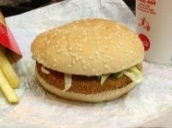 3
1.4. Disclaimer 4
2. ECONOMIC ANALYSIS 5
2.1. Product Analysis 5
2.2. Product Pricing 6
2.3. Availability 7
2.4. Utility 7
2.5. SWOT Analysis 8
2.6. Demand Analysis – Survey 9
2.7. Market Analysis 10
2.8. Supply Analysis 11
2.9. Price Elasticity 13
2.10. Income Analysis 14
2.11. Conclusion 15
3. BIBLIOGRAPHY 16

INTRODUCTION

About this document

This document is a project report for the project titled ‘Economic Analysis of the consumption pattern for the product ‘McDonald's burgers’ in the region of Maharashtra state, India.

Objective of the survey

The survey was conducted in a controlled group of people via an online mode. About 75 people responded to the online survey. The age group was between 13 years and 50 years. The survey respondents predominantly belong to the West and Central regions of Maharashtra state. The survey respondents represent a diverse income group with income ranging from less than 30,000 Indian rupees to 1 lac 20,000 Indian rupees per month. The respodents were requested to provide details about their monthly consumption of McDonald's a.k.a McD burgers.
An attempt was also made to predict consumer behaviour via this survey by asking a few general questions on the respondents’ monthly usage pattern.

About the product

McDonald's is an American fast food company, founded in 1940, in California, the United States of America. It is the world’s largest restaurant chain by revenue.
Celebrating over 12 years of leadership in food service retailing in India, McDonald's now has a network of over 160 restaurants across the country, with its first restaurant launch way back in 1996.
According to a few analyst reports, McD with their tagline ‘i’m loving it’,
McD has over 320 million customers in India of which atleast 30 million belong to the surveyed region.
In the region of this survey, McD has more than 100 restaurants in all key cities of Maharashtra. They also operate Drive-In facilities on major highways in the state and have been running their takeaway and online ordering business model well during the pandemic situation after the state’s directive to close down restaurants.
McD is the most popular brand well known and has become synonymous with burgers and French fries although they offer a range of other products like McMeal, beverages, ice creams, breakfast menu, Chicken dishes like nuggets, etc.
India has a vast population which consumes only vegetarian food and therefore, the vegetarian burger happens to be one of the most consumed eatables in McD restaurants in India.

Disclaimer

This survey has been conducted for academic purpose only and the data collected from participants should be treated accordingly in good faith. The personal identifiable information of the participants like name, email addresses and contact numbers shall not be shared further to maintain their data privacy.

ECONOMIC ANALYSIS
Based on the analysis of this product in the specified market and the survey conducted, the following economic analysis has been performed:

Product Analysis

Product features
McD is primarily known for its burgers. A burger, as an eatable product, has a both commercial and pscychological appeal to consumers of all age ranges. A burger can be consumed as an individual item alongwith other side dishes like fries or cola, but it can be consumed as a quick, meal even in cases where a person is busy enough to grab a quick bite which fills his or her hunger pangs, is easy to carry and economical to purchase.
In the McD product range, there are 9 types of products, however, burgers were the first product launched by the firm in the early 1950s and since have become the most popular eatable product worldwide. The McD name is synonymous with burgers.
McD burgers are available in 2 sizes: the regular size and the Big Mac and the following types are available:
- McVeggie Burger
- McSpicy Paneer Burger
- Mc Spicy Chicken burger
- Mc Chicken Burger
- Fillet o Fish burger
- Mac Maharaja burger
The availability and type of burgers differ from region to region as per the marketing strategy, however, the product specification and branding are nearly the same across the region and internationally. This ensures a consistent customer experience worldwide.

Product Pricing
McD has used the following pricing strategies worldwide:
The aim is to use prices to maximize profit margins and sales volume. McDonald’s uses a combination of the following pricing strategies:

- Bundle pricing strategy
- Psychological pricing strategy

In the bundle pricing strategy, McDonald’s has a meal combination, or combo, as they term it, so that the individual prices do not deter customers from purchasing the side products of their choice. For example, customers can purchase a Happy Meal or an Extra Value Meal to save money.
On the other hand, in psychological pricing, McD uses a strategy similar to what the footwear brand, Bata has been leveraging. For example, a burger is priced at 112.99 instead of 113, which is the nearest value. This makes the customer feel that they are paying Rs 112 and not 113, and therefore, the psychological impact of a slightly cheaper product, the prices of the products in Maharashtra are as follows:
McD Burger Type  (Available in Maharashtra) | Price in Indian Rupees  (without taxes)
McChicken Burger | ₹112
McSpicy Chicken Burger | ₹159
McVeggie Burger | ₹118
McSpicy Paneer Burger | ₹159
Fish-O-Filet Burger | ₹138
McAloo Tikki burger | ₹48
Veg Maharaja Mac | ₹200

Availability
McD stores are available and easily accessible in all main cities and towns of Maharashtra and across all state and national highway eateries in Maharashtra.
McD stores are highly accessible and consumer friendly because they are:
- convenient to locate due to the grand and focussed advertising
- easy to access
- offer the same staff experience due to the high quality of standardisation and focus on customer experience and service
- facilities like Drive Ins, takeaways, valet parking, etc
- consumer experience is standardised, thereby, avoiding any delays due to lack of familiarity for regular consumers

Utility
The main target customer for McDonald's includes parents with young children, young children, business customers, and teenagers.
The USP of McDonald's is Quality, Service, Cleanliness & Value for money which means they focus on providing our customers high quality products, served quickly with a smile, in a clean and pleasant environment at an affordable price.

SWOT Analysis
SWOT stands for Strengths-Weaknesses-Opportunities-Threats. This has been performed considering other fast food restaurants that offer a similar product, namely, burgers in this case.
The SWOT Analysis clearly indicates that while McD remains a popular brand in the mind of its customers, it needs to orient itself with the changing world environment, particularly, in the arena of sustainability and immunity development by disease prevention, in post COVID times.

Demand Analysis – Survey
The nature and pattern of demand drawn for the product McD burgers confirmed the principles of the demand curve, namely, the higher the price, the lower the demand and vice versa.
The Demand Curve for McD burgers drawn for the surveyed participants is depicted as follows:
The x axis represents number of burgers demanded
The y axis represents the price at which the burgers are demanded

The price of a burger ranges from Rs 40 to Rs 200 without taxes. The surveyed participants were asked for the quantity of burgers they would consume in a month if the price was in the range of Rs 40 to Rs 140. The survey confirms that McD burgers are a popular choice among the participants and the consumption would increase in direct proportion to the reduction in price.

Market Analysis

Overview-
The region for which this survey has been conducted, namely, Maharashtra state in India, has been a modern, progressive state and is the second most populous state in India with a population of about 13 crores. Mumbai, the capital city, is also the financial capital of India.
This state enjoys a significant higher income group individuals due to the access to job opportunities.
With a busy international airport, a large industrial base and a large young population, both resident as well as national and international visitors, Maharashtra has mover 4 lakh registered restaurants and a thriving food business with over 2 lakh smaller eateries.
McD is a leading name internationally in the fast food market segment. In India and Maharashtra in particular, McD, although a late entrant in the Indian fast food market, has had to operate in the following market conditions:
- Highly Price sensitive market
- Wide availability, options and penetration of Indian traditional fast food
- Perception of international brands among locals

Market for burgers
India’s fast food market is estimated to be at rupees 4236 million . India is to witness a compounded growth rate at 23% per annum. McD is set to increase its reach to towns of India , thus boosting demand for burgers.

Market share
Currently the market share of fast food services is less than 5% of the total food chain services.
GST
5% GST is levied on food services by the Government of India .

Economic Indicators -The Big Mac Index
This index tells a lot about the economy, it says if the currency is at its right level. Since Maharaja Mac is one of the most popular burgers. Recent survey indicated that Indian rupee was undervalued by 18%. How many burgers does one currency buy is compared to that of US dollars and purchasing power parity is found. Thus, the consumption of this one burger has a significant impact on our economy.

Government policies
As a Hindu nation, McD abides by the Halal meat law and is completely Halal certified.

Supply Analysis
From the perspective of the product range, which is burgers for the scope of this survey, the supply competitive landscape is as follows:
Substitute analysis
Supplier Name | Product similarity | Demand comparison with McD burgers
Burger King | - Features, taste proximity  - Price  - Availability  - International spread  - Local spread | Near equal demand as Mcd burgers
KFC – Kentucky Fried Chicken | - International spread  - Local spread | Lower demand compared to McD burgers
Local brands – Jumbo King | - Taste suited to local needs  - Less geographical penetration  - Store experience not standardised | Lower demand compared to McD

The following graph depicts the penetration of McD in the surveyed market with respect to its substitute products:
Complementary products
The survey respondents indicated that they would like to have the following along with McD (complementary) burgers, namely, Fries, Ice Cream, Coke, etc,
The following graph indicates that fries are the most consumed complementary item alongwith McD burgers: 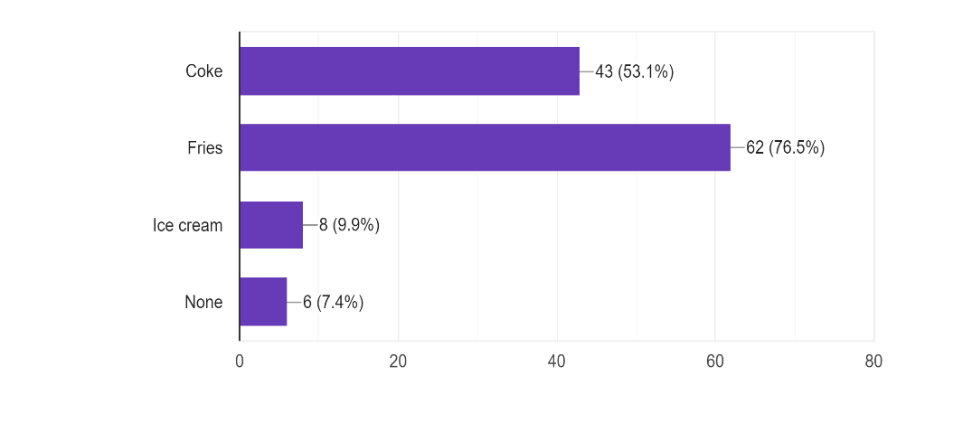

Price Elasticity

Price elasticity tells us how much the demand changes with change in price i.e. the percentage change in quantity demanded compared to the percentage change in price.
The price elasticity graph is inelastic at the following price ranges as indicated in the table below:
This was an interesting observation as the price elasticity curve is generally directly proportional to the change in price.

Income Analysis
The Income analysis was performed for the surveyed participants to study the pattern of burger consumption for various income groups. The analysis clearly indicates that the said consumption increases as the income range increases.

Conclusion

This survey enabled me to deep dive into consumer behaviour analysis of a product that I was consuming frequently myself. As a young student, this survey helped me get a good insight into various economic aspects of an internationally known brand and its consumption in the surveyed region, which I, myself belong to.
It was interesting to have a real view of how consumers quickly reduce consumption with increase in the price, thus giving a demand curve, which, as students, we are being taught in theory as well.
It is also evident to note how the people of low income group consume less number of burgers than the ones in high income group.
The survey reiterated the McD mission statement “I’m loving it” by the fact that surveyed respondents that represented most common income groups, almost all age groups and diverse caste or religious groups, unanimously rated McD burgers as their top choice among all burger brands. The reasons quoted were its price , availability and convenience.

BIBLIOGRAPHY

The content of this project report is the personal view of the author by self experience and with recent references to the following internet sites:

- https://www.assignmentpoint.com/business/marketing-analysis-on-mcdonalds.html
- https://www.investopedia.com/terms/d/demand-curve.asp
- https://en.wikipedia.org/wiki/McVeggie
- http://panmore.com/mcdonalds-marketing-mix-4ps-analysis
- https://nicelocal.in/maharashtra/restaurants/mcdonalds-93d5/

APPENDIX
The data hyperlink and object is as follows -
Project Report IAQS -- Economics - McD Burgers consumption in Maharashtra-v1.0-Data sheet.xlsx

