SRM Project
Kshitij Srivastava
431

Q1 Read in the data file as a data table & fill in the entries for the CRUDE column in your table.

Q2) Use Gompertz law to fill entries in the GRADUATED column in the data.

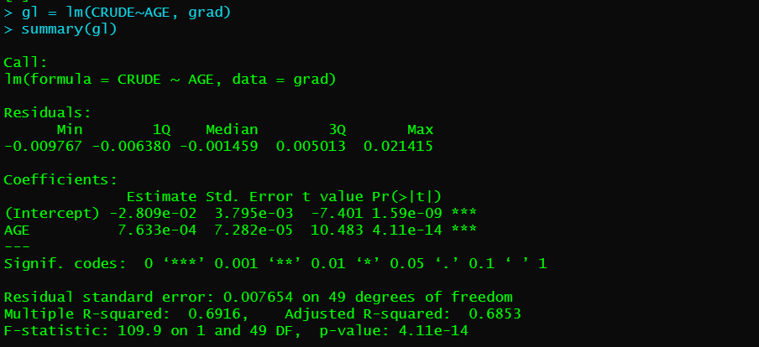
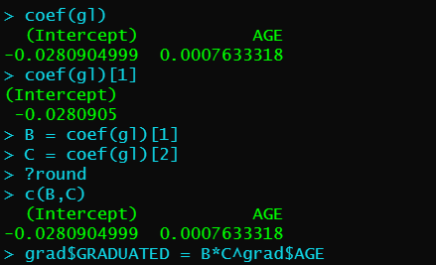

Q3) Check for smoothness by applying the third differences to the crude and graduated rates and comment on your results.

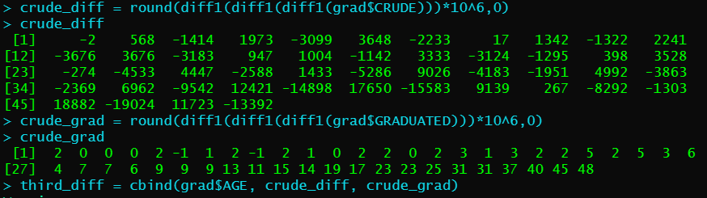
The third differences of the crude rates are much greater in magnitude than the graduated rates.
We can see that from the table that the third differences of the crude rates are much larger in magnitude (max = 19024) and progress is irrational.
This is to be expected, since they are calculated directly from the deaths, which include significant random elements.
The third differences of the graduated rates are all very small and progress regularly.
This is to be expected, since they have been smoothened using a simple parametric formula with just two parameters.

Q4) Calculate the values in EXPECTED and ZX values in the table. Hence, perform a chi-squared test to check goodness of fit between DEATHS and EXPECTED. You should specify the degrees of freedom used.

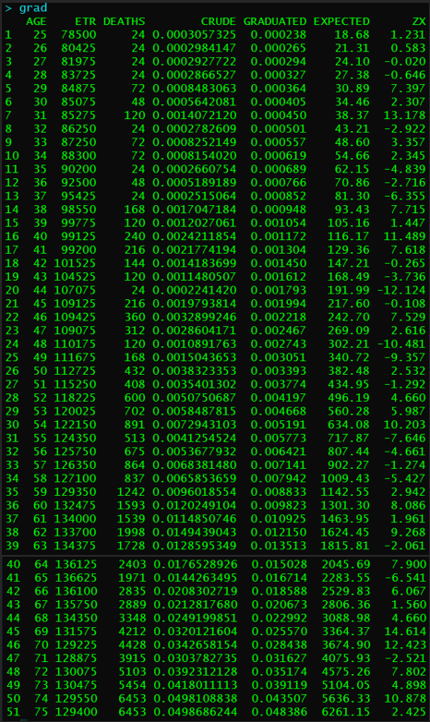
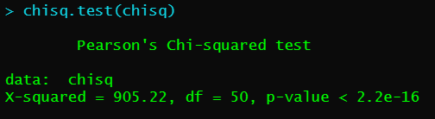
Null hypothesis: The graduated rates are the true underlying mortality rates
Alternate hypothesis: Mortality Rate is not consistent with the set of Graduated Mortality Rates
DOF = 50
Since p value < 0.05, we reject the null hypothesis at 5% level of significance, and conclude that the graduated rates are not in line with the actual mortality rates.

Q5)
a. Perform the standardised deviations test on the individual deviations, and comment on the-
i. Overall shape
ii. Absolute deviations
iii. Outliers
iv. Symmetry
v. Final conclusion about Null hypothesis

b. Perform the Signs test and give your conclusion
(Hint : Since m is large, you may use the normal approximation along with continuity correction for this test. You may look up the function qnorm and pnorm in R for this)
c. Perform the Cumulative deviations test for the entire age range and give your conclusion.
d. Perform the Serial correlations test and give your conclusion

- Individualised standard deviations test
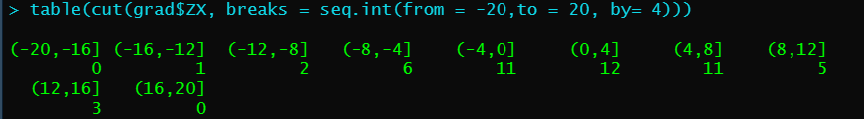
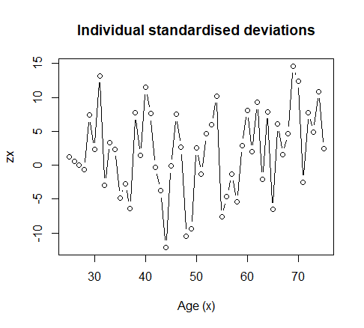

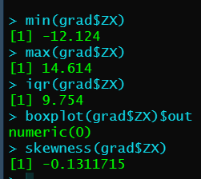
- The graph is much wider a standard normal graph, with several values higher than 10.
- The values of the absolute deviations are much higher relative to the expected value.
- The lower bound is -12.124 and the upper bound is 14.614. IQR is 9.754. There are no outliers.
- The Graph is negatively skewed.
- The graduated rates do not represent the underlying mortality rates with accuracy.
b) Signs test
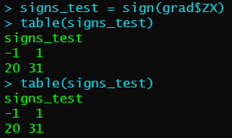

H0: There is no bias in the data.
H1: There is bias in the data
We fail to reject the null hypothesis that the data is a true representation of the underlying mortality rates.

c) Cumulative deviations test
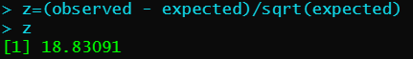
H0: Graduated rates are not biased.
H1: Graduated rates are biased.

We reject the null hypothesis and conclude that the graduated rates are biased.
d) Serial Correlations Test
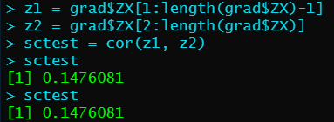
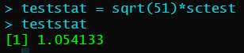
H0: Grouping of signs is absent.
H1: Grouping of signs is present
At 5% significance level test statistic is 1.6449
Therefore, we fail to reject the null hypothesis.

