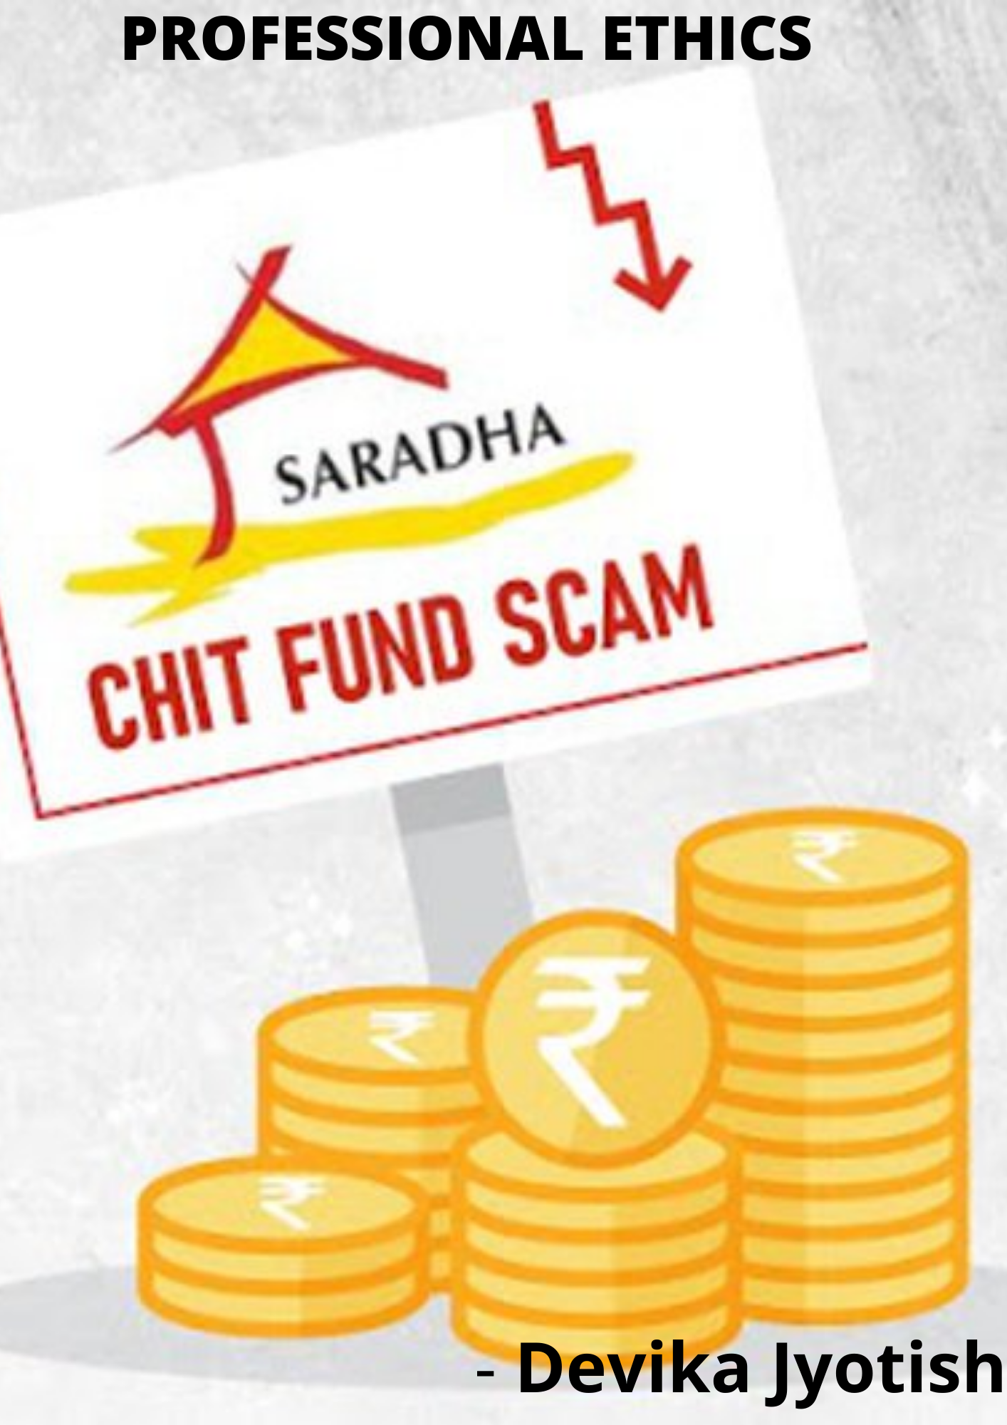
FINANCIAL SCAMS IN INDIA – SARADHA SCAM

S.R No. | TABLE OF CONTENTS
1 | INTRODUCTION
2 | TIMELINE OF OPERATIONS AND THE SCAM
3 | CASE FINDINGS / FACTS OF CASE
4 | CURRENT VERDICT OF THE CASE
5 | ANALYSIS IN OWN WORDS (FACTORS OR PEOPLE RESPONSIBLE)
6 | RECOMMENDATIONS
7 | CONCLUSIONS
8 | SOURCE

INTRODUCTION
To understand the saradha scam lets first look at what a Ponzi scheme or a collective investment scheme (CIS) is?
A Ponzi scheme or CIS gives an investor returns that are much higher than the normal industry average which attracts a lot of people in desire of making more and more money or higher returns. a Ponzi scheme is an investment fraud that basically pays existing investors with funds received from the new investors. once the number of new investments begin to decline or when the inflow of money is lower than the outflows the Ponzi scheme begins to fail which basically suggests that for a Ponzi scheme to survive it requires a constant flow of new money. When a company runs a Ponzi scheme its initial motive is to gain trust once that is gained people invest more and more money which could mean people investing their entire savings and losing it since eventually a Ponzi scheme will fail. Few instances of Ponzi schemes are multi-level marketing, pyramid schemes, lottery and unregulated chit funds. A Ponzi scheme basically plays with the investors psychology since it offers a much higher return than the normal rate and they become successful in gaining investor confidence at an early stage.
Sradha scam is a classic example of a Ponzi scheme where businessman sudipto sen set up the saradha group and launched collective investment scheme where the saradha group formed a group of companies to lure small investors with a promise of high return.
Moving forward let’s understand how saradha operated:
Let’s understand why Sudipto Sen named his company saradha group
Sarada Devi was the wife of famous spiritual guru Sri Sri Ramkrishna Dev (Swami Vivekananda ‘s spiritual guru). she is a highly revered spiritual icon not only in West Bengal but also in whole of India and even world. The cheats have used the name of Mother Sarada so that ordinary people put faith on the fund. The group collected money through agents with high commissions ranging from 15 to 20 percent and even 40% in some cases of the funds mobilized by them. They agreed to pay back unusually high returns. If a person invests Rs.1 lakh for 14 years he/she might get Rs.10 lakh by 14 years which was next to impossible by normal any other deposits (observed from field investigation). The same could fetch maximum Rs.3.50 to 4.00 lakh in case of a Bank or Post office deposit. On the other hand, sometimes the investors were allured by promising flat or land in return of their deposits.
Due to the exorbitant commission the number of agents rose to thousands and even lakhs. Saradha began by issuing secured debentures and redeemable preferential bonds to the public in violation of SEBI rules that bar companies from raising capital from more than 50 people without issuing a proper prospectus and balance sheet. Companies must also have SEBI permission to operate, and must get their accounts audited. After SEBI raised a flag in 2009, the Group diversified, opening 239 companies, and building a complex corporate structure. Through schemes involving tourism packages, forward travel and hotel booking, timeshare credit transfer, real estate, infrastructure finance, and motorcycle manufacturing, the group collected around Rs 200 to Rs 300 billion from over 1.7 million depositors before it collapsed in April 2013.
TIMELINE OF OPERATIONS AND THE SCAM
- In 2011, saradha group bought global automobiles, a heavily indebted motorcycle company. For CSR activities they donated motor cycles to Kolkata police.
- The group also invested in football clubs like Mohan Bagan and sponsored Durga puja.
- Started in 2006 with promises of astronomical returns in Ponzi schemes. They started building brands by buying and selling media channels
- Used means of companies for money laundering
- Collected money by using secured debentures and redeemable preferential bonds
- Violated section 67 of the companies act
- Sebi challenged them for the first time in 2009
- After which 300 new companies were created
- SEBI persisted and in 2010 saradhas method of raising funds changed. They used collective investments schemes like tourism packages, real estate fund launched in the name of chit fund
- In 2012, SEBI identified that the group operated in CIS and not Chit fund
- Saradha group started trading in stock market and siphoned off the proceeds
- Scam summoned up to Rs 2460 crore and 80% is still unpaid to the depositors.

CASE FINDINGS / FACTS OF CASE
By 2009, politicians in West Bengal begun discussing Saradhas alleged fraudulent ways. In 2012, SEBI, which was already watching the Group, asked it to stop accepting money from investors until it got the regulator ‘s permission. Alarm bells started to ring in January 2013, when for the first time, the Group ‘s cash inflow was lower than its outflow — another classic event in a Ponzi scheme.
By April 2013, the scheme had collapsed, and investors and agents lodged hundreds of complaints with the Bidhannagar Police. Sudipto Sen fled West Bengal after writing an 18-page letter, in which he accused several politicians of arm-twisting him into making poor investments that led the company to collapse. An FIR was registered, and Sen was arrested along with his associate Debjani Mukherjee in Sonmarg on April 20, 2013.
Investigations found the company had laundered investments in locations such as Dubai, South Africa and Singapore. Mamata Banerjee ‘s government set up a Special Investigation Team (SIT) to probe the case after clubbing all the FIRs. Around the same time, the CBI began investigations in Assam after the state government handed over the probe to it. Based on state police FIRs, the Enforcement Directorate registered cases of alleged money laundering, and arrested several people.
In May 2014, the Supreme Court transferred all cases to the CBI, given the inter-state nature of the alleged scam. The SIT, which had by now conducted a year-long probe, had to hand over to the CBI all case papers, evidence, and the accused it had arrested.
Along with his brand, Sen had worked on building political relations. He had acquired media organisations and invested in the Bengali film industry. Actor and TMC MP Shatabdi Roy and former Bollywood hero and Rajya Sabha member Mithun Chakraborty were Saradhas brand ambassadors. Then TMC MP Kunal Ghosh was appointed CEO of the media group in which Saradha invested Rs 988 crore and hired close to 1,500 journalists. By 2013 it was running eight newspapers in five languages. Ghosh was said to be drawing a salary of Rs 16 lakh per month. Another then TMC MP, Srinjoy Bose, was involved in the Group ‘s media operations. Then West Bengal Transport Minister Madan Mitra headed the Group ‘s employees ‘union. Saradha gifted patrol motorcycles to Kolkata Police. The government deployed and distributed ambulances and motorcycles sponsored by Saradha in Naxalism-hit areas of the state. The Group allegedly also had connections with Congress leader and former union minister Matang Sinh, and the Assam BJP leader Himanta Biswa Sarma, who was then in the Congress. The ED questioned Sarma‘s wife Rinki in February 2015 for accepting money from the Saradha Group to run advertisements on her TV channel in Assam. The agency also questioned TMC MP Arpita Ghosh in the case. The CBI questioned over a dozen TMC MLAs and MPs, and arrested Srinjoy Bose, Madan Mitra and Kunal Ghosh. Among those questioned were then TMC vice president and former West Bengal DGP Rajat Majumdar, Trinamool Youth Congress chief Shankudeb Panda, and MPs Satabdi Roy and Tapas Paul. Mukul Roy, who was once among Mamata‘s closest confidants and is now with the BJP, was also questioned, as were the Assamese singer and filmmaker Sadananda Gogoi and former Odisha advocate general Ashok Mohanty. Former Assam DGP Shankar Barua committed suicide after CBI questioned him and searched his house.
CURRENT VERDICT OF THE CASE
The supreme court on Tuesday posted a contempt case filed by the CBI against former Kolkata police chief Rajeev Kumar and the others in connection with the saradha chit fund scam case. The CBI had filed the contempt plea on Feb 4, 2019 against Mr. Kumar, former state chief secretary Malay Kumar De and DGP Virendra. CBI accused them of noncooperation.
Moreover, Special court granted interim bail to TMC’s(Trinamool Congress ) Kunal Ghosh in saradha chit fund case. The special CBI court directed Ghosh to furnish a bail Bond of Rs.20000.
Furthermore, Calcutta HC granted bail to Debjani Mukherjee who was accused in the multi crore Saradha chit fund scam and was ordered bailed on furnishing a bond of Rs 2 lakh however she will still continue to remain behind bars since she is yet to obtain bail in the pending cases against her.

ANALYSIS IN OWN WORDS (FACTORS OR PEOPLE RESPONSIBLE)
Scams like saradha occur because of lack of financial knowledge among the people. If individuals of the country are given proper financial knowledge which suggests that abnormal returns like in case of the saradha chit funds is not possible scams like this will not occur. According to me common man is at fault. Moreover, its not just that the government should provide knowledge to people so that they are educated and they make informed decisions.
Moreover because of faith of people on saradha devi this scam grew bigger suggesting that people should stop blindly trusting people in the name of faith and God.
RECOMMENDATIONS
What should investors do to prevent chit fund scam?
- Check for the credibility and creditworthiness of the company and its promoters.
- Warn people about fraudulent companies & report them to concerned authorities.
- opt for state-run chit companies and go with firms with a long record and financially sound promoters.
- Understand the difference between Organised chit fund schemes which are required to register with the Registrar or Firms, Societies and Chits and money circulation schemes.
- Invest in a scheme with no incentives for subscribers to bring in more people to the scheme.
- Implementation of easy-to-use web-based Chit Fund Management system (CFMS)

CONCLUSION
One of the ways in which one can avoid getting in such a messy situation is to differentiate between a regulated and organized chit fund from an unregulated and unorganized chit fund. Awareness should be raised among people before making their choice and decision of choosing a chit fund scheme.
The concept of investing in chit funds is not inherently bad. A chit fund is a good savings option for small investors. In a nutshell, the benefits of chit funds can be higher rates of interest, funds available for emergency and secured funds. Before investing in a chit fund, a person must make sure that there is an immediate need for funds in the near future which he may not be able to get from his bank. Investing in chit funds is advisable when comparable institutional savings and loan products are not available. But at all times, the credibility and trustworthiness of the investment company and its promoters should be checked. The reason for people, tending to avoid chit funds today may be because of the fact that some unscrupulous people have misused the basic objective of chit funds and misappropriated the money of the investors, which have led to some of the biggest financial scams in the country. Some of the precautions that investors can take before investing in chit funds include complete checking for the credibility and creditworthiness of the company and its promoters beforehand, opting for state-run chit companies and going with firms with a long record and financially sound promoters, understanding the different laws which give protection to investors investing in chit funds, implementing easy-to-use web-based Chit Fund Management system (CFMS) etc.

SOURCE:
https://www.thehindu.com/news/cities/kolkata/saradha-chit-fund-scam-sc-defers-hearing-on-cbi-plea-to-quiz-wb-ex-police-commissioner-rajeev-kumar/article33912334.ece

https://economictimes.indiatimes.com/news/politics-and-nation/special-court-grants-interim-bail-to-tmcs-kunal-ghosh-in-saradha-chit-fund-case/articleshow/86066723.cms
https://www.indigolearn.com/blogs/Top-5-Financial-Scams-in-India/b218399bd14e4473907fdaa165b20f94
https://www.deccanherald.com/content/601025/collective-investment-schemes-why-we.html

