ABT Project
Atharva Padwal
Roll No. 703

Q1.
Money control Newsletter:

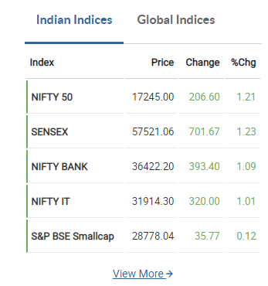

Date: 28th April 2022
This figure shows that all markets have risen by a small percentage in today’s session. Percentage change in the markets are all close to 1%.

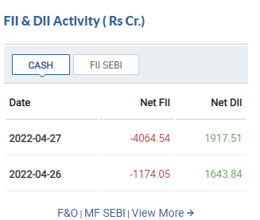
This figure shows that on 27th April 2022, There is large selling by the FIIs and a comparatively smaller amount of buying by the DIIs. This suggests that the market was dominated by retail investors.

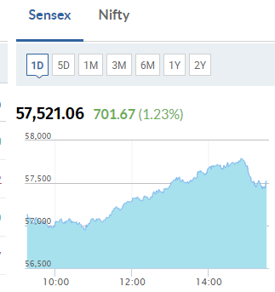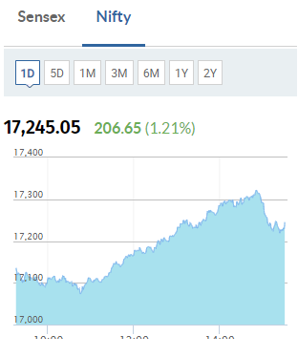

These 2 graphs show a similar trend of buying at later half of the trading session.

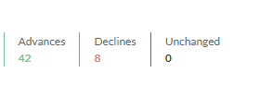
Nifty 50 statistic here shows that 42 stocks advanced today while 8 declined.

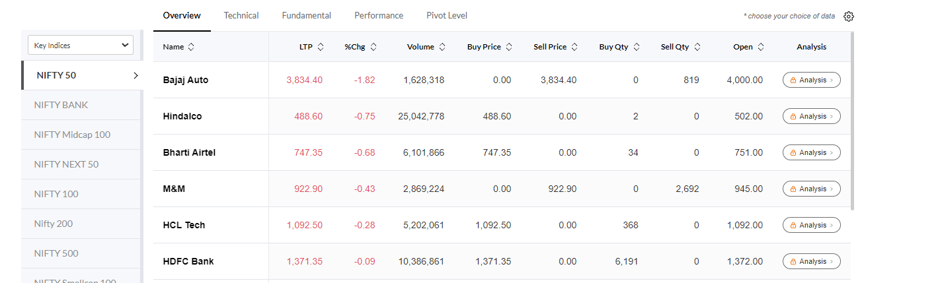
These are the top 5 losers from Nifty 50. Only 1 stock has declined more than 1%.

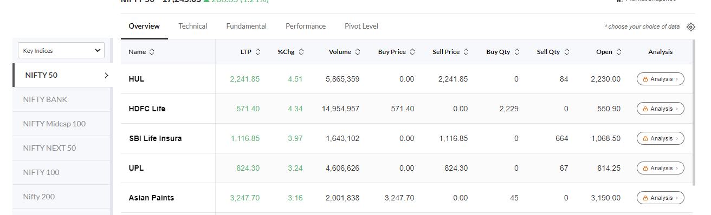
These are the top 5 gainers of Nifty 50.

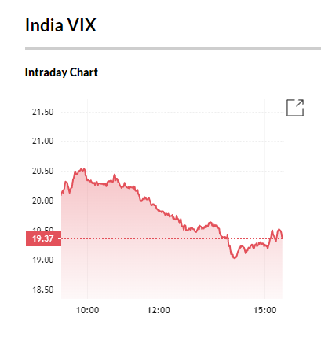
Since India VIX fell below 20, uncertainty in the market is still setting in. There is still a constant emotion of uncertainty in the market.

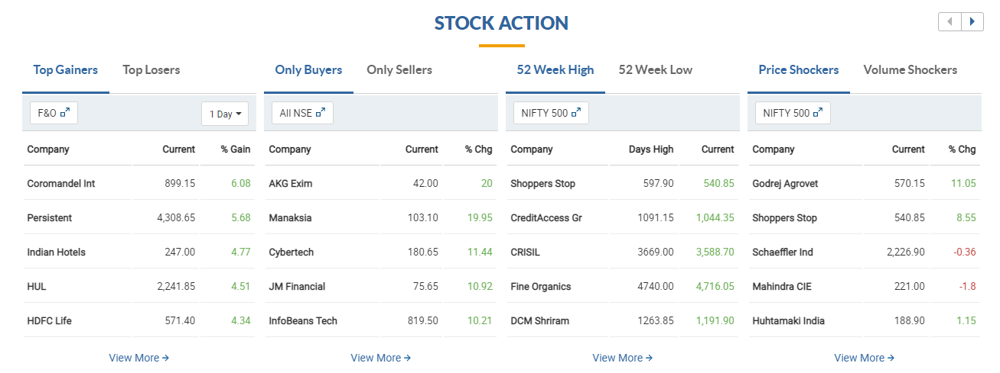
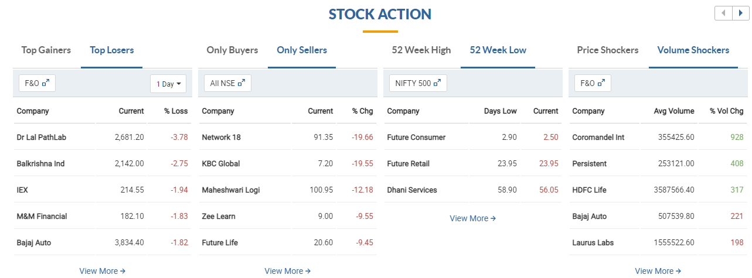
The two images above show the stock action on 27th April 2022.

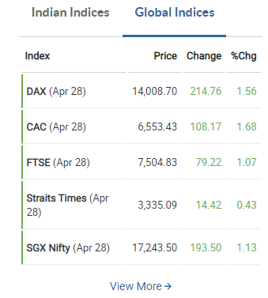
Global indices on 28th April show a similar rise to the Indian markets around the world. 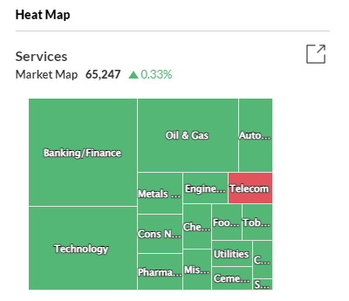
This market heat map shows how only the telecom sector shows a decline on 28th April 2022.
Q2.
a) The market is driven by retail investors. Since the market rose by 1% and there was a higher net negative FII activity over net positive DII activity, retail investor rose the market.
b) The net change in fear index, aka, India VIX is about -0.7 points. This suggests slightly higher trust in the market but still an overall uncertainty revolving market conditions.
c) HUL, HDFC Life and SBI life are the top 3 gainers in the market. Bajaj auto is the top loser in the market. Overall the market has seen a steady rise with 42 advances and 8 declines.

d) The top performing sector is Nifty FMCG. Top performing stocks in this sector are HUL, United Breweries, P&G and Marico.
e) The worst performing sector is Nifty Media. Worst performing stocks in this sector are Network 18, TV18 Broadcast and TV TodayNetwork.

Q3.
52 week high stocks that match the qualification criteria are:
- Adani Green energy
- Hindalco
- ONGC
- Sunpharma
- Narayan Hrudalaya
- Adani Enterprises
- Gravitas

Qualification Criteria for screening stocks based on 52wk Highs are listed here. The first criteria is that the chart of the stock should go from bottom left of the screen to top right. The second criteria is that the size of the candles should be small. Then, there should be no circuit breaks in the past year in the chart we are seeing. There should be no big dip in the middle of the screen/chart. The last criteria is that the chart should have an overall smooth shape based on the uptrend it has witnessed in the past year.

Q4.
Dow theory PnL for Bata India.
