- A
- A
- D
- D
- Ans
- Cash flow= 2500-1500-[(2500-1500)*40%}=600
- NPV=600(1-0.2)=480
- iii) If the supplier allows to pay them at date 2 then the new NPV= 2500*V1 -1500*V2 – 400*V
= 720
The NPV will increase
- The ratios used to measure the efficience of the business are
- Inventory turnover ratio (DIO)
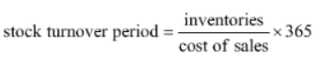

- Trade Receivable turnover Ratio (DSO)
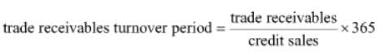

- Payable Turnover Ratio (DPO)
These are used as the analyze the time it takes for the raw material to be converted to finished product and then to cash. These help in calculating the cash conversion cycle of the company.
- Limitations of ratio analysis are
- As they are based on historical data getting an idea of the probable happenings in the future is hard.
- They are directly based on the accounts maintained. If the accounting methods of companies are different then comparison is not possible.
- It doesn’t take into various external factors like pandemics, inflations, recessions.
- Ratio analysis is only a beginning and gives just a fraction of information needed for decision-making. So, to have a comprehensive analysis of financial statements, ratios should be used along with other methods of analysis.
- If the company has changed its accounting policies and procedures, this may significantly affect financial reporting. In this case, the key financial metrics utilized in ratio analysis are altered and the financial results recorded after the change are not comparable to the results recorded prior to the change. It is up to the analyst to be up to date with changes to accounting policies. Changes made are generally found in the notes to the financial statements section.
- (i) All companies are exposed to systematic risk because they are all exposed to the market. However, some companies are more exposed to the market than others and therefore are exposed to a greater proportion of the systematic risk in the market.
- When beta>1 : The stock has previously amplified the return of the whole market.
- When beta<1 : The stock’s performance was counter-cyclical, hence offsetting the market experience.
- When beta is close to zero: The stock has provided a more stable return as compared to the market as a whole.

(ii) B(geared) = B(Ungeared) x (1+ D/E(1-t))
Geared beta=1.1
Debt to equity ratio=1:2
Tax Rate=30%
Therefore, for new geared data, we need ungeared data first.
$1.1=B\left(Ungeared\right)*\left(1+\left(\frac{1}{2}\right)\left(1-0.3\right)\right)$
$B\left(Ungeared\right)=\frac{1.1}{\left(1+\left(\frac{1}{2}\right)\left(1-0.3\right)\right)}$
=0.815
Now,
$Geared Beta=(0.815)(1+(\frac{2}{2})(1-0.3)$
Hence, New Geared Beta= 1.385

- Given
NPV= 10
IRR=21%
Cost of cap (i)=10%
Initial investment= 100

List of cash flows
-100
X positive cash flow
10 = -100+ x(1+10%)^-1
110=x(1.1)^-1
X=121
The second cash flow is 121

If i=11%
- NPV= -100+121(1.11)^-1
= 9.009
- IRR remains constant as the cashflows don’t change
- (i)
- Systematic Risk is the risk of losing investments due to large scale factors, such as political risk and macroeconomic risk, that affect the performance of the overall market.

- Specific Risk is the risk of losing an investment due to company or industry related issues. Unlike systematic risk, an investor can only mitigate against unsystematic risk through diversification.

(ii)

Systematic Risk | Specific Risk
- Risk that an investor takes by investing by just investing in Equities | - Risk that an investor takes by investing in my company
- This is a risk that all companies in a Market will be exposed to | - Any risk that my company is specifically exposed to is known as Specific Risk
- E.g. Business Cycle (Recession / Boom) | - E.g. Debt Structure
- (i) Beta is a numeric value that measures the fluctuations of a stock to changes in the overall stock market. In simple words, beta can be used to measure the volatility of a stock.
Formula= $\frac{Covariance of the individual Company}{Variance of the market}$
(ii) Beta can be determined using the formula i.e dividing the Covariance of the individual company’s returns by Variance of the Market returns.
(iii) A beta of 1 means that the stock is strongly correlated to the market and hence moves with the same pace of the market. Whereas, A stock with a beta of -1 means that the stock is inversely correlated to the market. I think that investing in a stock with either beta is equally risky. However personally, I would invest in a stock with beta -1.
(iv) Treasury Bills and Government issued Bonds are some financial instruments that have zero beta value.
- Answer
- Cost of equity= risk free rate of return +equity premium derived*beta
= 7%+5%*1.5%
= 14.5%
Cost of debt = 9%*(1 − tax rate)
=6.75%
WACC= (6.75%0.5)+14.5%(0.5))
=10.625%
- Required return to equity=
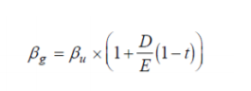

- To find beta ungeared
1.5=βu*(1+$\frac{1}{1}(1-25\%)$
βu= 0.857143
New cost of equity = Risk-free rate + Ungeared beta * Equity risk premium
= 7% + 0.857143 * 5%
= 11.29%
- (i) At IRR, present value of cash outflow= present value of cash inflow, hence
cost of
Project = 40,000*2.855(cumulative discounting factor for 4 years at IRR)
=1,14,200
(ii) cost of capital = (160000/121509)^1/4 -1
=7.129%
(iii) profitability index at cost of capital= 1.064
1.064= present value of cash inflow at cost of capital/114200
Present value of cash inflow at cost of capital = 121509
Net present value at cost of project = 121509- 114200= 7309
(iv) cost of capital payback period= 114200/40000 = 2.855 Ans (i)
- Current Ratio- One of the liquidity ratios that can measure a company’s ability to pay its short-term loans. To achieve a high current ratio, Companies require high current assets and/or low current liabilities or short-term loans.
- The Debtors Turnover Ratio shows how quickly the credit sales are converted into the cash. This ratio measures the efficiency of a firm in managing and collecting the credit issued to the customers.

(ii) A high turnover ratio indicates the company has a low amount of inventory for sale, which may cause it to lose potential sales. Since this is the case, I think we should judge the company’s ability to pay its short-term loans using quick ratio because it takes into account the inventory the company holds.
Q15.
(a)
(b) On increase of the company gearing, WACC remains constant. Since cost of debt is cheaper than cost of equity, the latter increases just as much so as to offset the increased proportion of the cheaper debt.
The Modigliani Miller proposition states that for companies with equal earnings, the WACC remains the same irrespective of the gearing.
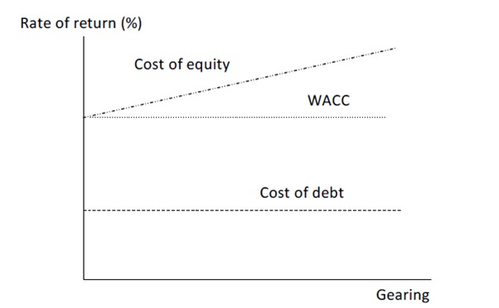
- First irrelevance proposition –
• Market value of the firm is independent of its capital gearing structure
Assumptions –
• Debt is risk free
• No taxes
• No agency costs
• Unlimited personal and corporate borrowing at same rate of interest
• No information asymmetry

- Beta is a measure of volatility of a security.

(i) Rf = 6%
Equity Risk Premium = 5%
Beta = 1.4
Cost of Equity (Ke) = Rf + B(Equity Risk Premium)
= 6% + 1.4(5%)
Cost of Equity (Ke) = 13%

(ii) Market cap = 100mn
Debt/Equity Ratio = 0.5/0.5 = 1
Geared Beta= $Ungeared Beta*(1+(\frac{Debt}{Equity Ratio})*(1-Tax)]$
= 1.4*[1+1*0.7]
= 2.38
(iii) New Ke = Rf + Geared Beta*(Equity Risk Premium)
= 6% + 2.38(5%)
= 17.9%

