Macro Economics Assignment 1
MCQ’s
- C
- C
- C
- C
- C
- C
- D
- D
- D
- D
- D
- C
- D
- D
- C
- B
- C
Question-Answers

- Net Domestic Income (NDI) =Operating surplus + Compensation of employees+ Mixed Income of the self employed
=10000+24000+28000 = Rs 62000 crore

- Gross Domestic Income (GDI) = NDI + Depreciation
=62000+1700
=Rs 63700 crore
- Net National income (NNI) = NDI + Net factor income from Abroad
=62000-300 = Rs 61700 crore

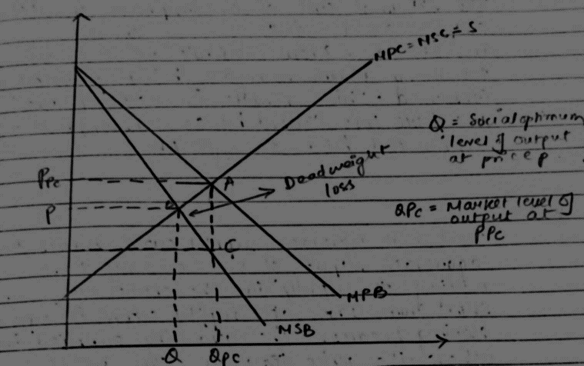

Plastic usage causes Marginal Social cost (MSC) to be above the Marginal Private cost curve (MPC) because plastic causes harm to the environment and has social cost attached to it.
The plastic when consumed by 3rd party eg. animals, they may die. Therefore, there to keep the water bodies, areas, roads clean, there is marginal external cost that rises, these help the areas to be neater and protect the 3rd parties from consumption of plastic.
∴MSB of plastic consumption is lower than MPB. When externalities are not considered, markets will have an equilibrium at PPC and QPC.
The external cost of the consumptions leads to an output above the socially optimum level. Dead weight welfare loss is created because of overconsumption and overproduction of plastic which is represented by triangle ABC.
- The short run agg. Supply curve represents the agg. output of an economy that the firms are willing to supply in the short run. It is upward sloping curve, the reason being the increasing quantity supplied with the increase in prices. In the short run, the firms have fixed factors of production mostly the capital because wages in the short run are not flexible because the employees/workers cannot renegotiate their wages in the short run with respect to changes in price level. Thus, in the short run, higher prices are associated with higher output.

- (i)The cost that the third party (who is not involved either in consumption or production process) faces because of an economic transaction between two parties is known as negative externality. It is also known as external cost.
Eg: Consumption of cigarettes will cause health problems to the one who is consuming it, so when the go to work, their productivity will get affected (get reduced), because of which the firm increases their cost of production which will lead to higher prices of the goods and services which will lead to reduced standard of living of workers.
(ii) Govt. can implement higher level of indirect tax on consumption of tobacco. And it is necessary to make people aware about the negative effects of consumption on health, so for this it has to organise various campaigns, increase the no. of advertisements on social media,etc.
(iii)
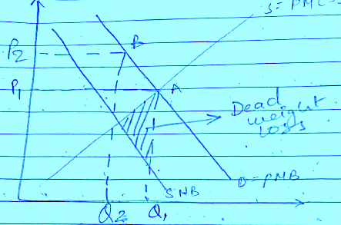
- Actual economic growth is calculated by the annual percentage change in a country’s real national output (GDP). Whereas the potential economic growth is measured by the estimated annual change in a country’s potential level of national output and is also referred to as trend growth
- The 3 ways of measuring National Income are:
- Expenditure Method – In this method, all the cashflows relating to expenditure needed to fund the purchases to produce the goods/services are added.
Formula:
GDP=Consumer expenditure(C)+Investment expenditure(I) + Government expenditure(G) + Income from exports(X)- Import expenditure(M)

- Output Method – In this method, the value of all goods and services produced in the year is added up. It is also known as value added method. This method gives rise to the problem of double counting.

- Income Method – In this method, all the factor incomes are added eg: wages, salaries, rent, interest and profit that is received during the production in the country

