Portfolio Theory and Security Analysis
Assignment 1

Unit-2

- A
- D
- D
- C
- A
- C
- B
- C

Willingness | Ability
An investor's willingness to bear risk is based primarily on the investor's attitudes and beliefs about investments.  Investor's willingness to take on investment risk  is high but the investor's ability to take on risk is low, the low ability to take on  investment risk will prevail in the adviser's assessment. | An investor's ability to bear risk depends on financial circumstances.  Ability is high but willingness is low, the adviser may attempt to  educate the investor about investment risk and correct any misconceptions that may  be contributing to the investor's low stated willingness to take on investment risk.

Major components of an IPS are: -

1.Introduction Describes the client.

2.Statement of Purpose-The intentions of the IPS.

3.Statement of Duties and Responsibilities of the client, the asset custodian, and the investment managers.

4.Procedures-Related to keeping the IPS updated and responding to unforeseen events.

5.Investment Objectives - The client's investment needs, specified in terms of required return and risk tolerance.

6.Investment Constraints-Factors that may hinder the ability to meet investment objectives; typically categorized as time horizon, taxes, liquidity, legal and regulatory, and unique needs.

7.Investment Guidelines for example, whether leverage, derivatives, or specific kinds of assets are allowed.

8. Evaluation and Review-Related to feedback on investment results.

9.Appendices-May specify the portfolio's strategic asset allocation (policy portfolio) or the portfolio's rebalancing policy.

Liquidity
The IPS should detail the likely withdrawal of funds from the portfolio. For institutions, there could be rules around this, like spending requirements in the case of endowment funds. When a client has a known liquidity requirement, the portfolio manager should allocate a portion of the portfolio to cover this liability by ensuring that the allocated assets can quickly be converted to cash whenever the obligation needs to be met. Allocating to a bond that has a maturity profile which matches the liability time horizon is an often-used strategy.

Time Horizon
The IPS should state the time horizon over which the client is investing. Illiquid or risky assets may be unsuitable for an investor with a short time horizon as they may not have sufficient time to recover from investment losses.

Tax Concerns
Different investors will have different tax status. The tax status should be stated in the IPS. Often, tax regimes will treat capital gains and income differently. Capital gains may be subject to a lower tax rate payable only when they are realized rather than when they are received. In this instance, there is a time value of money benefit to deferring tax. A taxable investor may, for example, wish to hold a portfolio which emphasizes capital gains over dividend income. A tax-exempt investor, on the other hand, may be relatively indifferent to the two.

Legal and Regulatory Factors
The IPS should outline any applicable legal or regulatory restrictions. In some countries, pension funds are subject to restrictions on their portfolio composition. In the case of individuals, they may have access to privileged information on a particular listed company by virtue of directorship and as such are restricted from trading on that company ahead of the release of company financial results.

Unique Circumstances
The IPS should also cover any unique circumstances that are applicable. A client may have religious or ethical objections to investing in particular stocks or sectors. These types of considerations are often referred to as ESG (environment, social, governance) factors and investing in accordance with ESG factors is referred to as SRI (socially responsible investing).

- Environmental, social, and governance (ESG) criteria are a set of standards for a company’s operations that socially conscious investors use to screen potential investments.
A client may have religious or ethical objections to investing in particular stocks or sectors. These types of considerations are often referred to as ESG (environment, social, governance) factors and investing in accordance with ESG factors is referred to as SRI (socially responsible investing).

- Diversification ratio =
$$Risk of equally weighted portfolio÷Risk of randomly selected stocks$$
= 324%%/625%%
=0.5184

14)

15) A Defined benefit plan will guarantee an income for the employees upon retirement for life. In the case of a defined benefit plan, the employer provides a guaranteed specific amount of pension to the employer based on a certain factor, including the employee’s salary and their years of service within the organization.
The employees themselves mainly finance a defined contribution plan. However, an employer may also make a matching contribution to the plan to a certain extent.

Unit-4
- D
- D
- A
- A
- D
- B
- C
- B
- A
- A

- 5 forces that determine industry competition: -

1. Rivalry among existing competitors.
Rivalry increases when many firms of relatively equal size compete within an industry. Slow growth leads to competition as firms fight for market share, and high fixed costs lead to price decreases as firms try to operate at full capacity.

2. Threat of entry.
Industries that have significant barriers to entry
will find it easier to maintain premium pricing costly to enter the steel or oil production industries. Those industries have large identify factors that discourage new entrants, such as economies of scale, barriers to entry and thus less competition from newcomers. An analyst should
because they limit the prices firms can charge by increasing the elasticity of

3. Threat of substitutes.
Substitute products limit the profit potential of an industry
profit margins. The more differentiated the products are within an industry, the patents protect a producer from competition in the markets for patented drugs less price competition there will be.

4. Power of buyers.
Buyers' ability to bargain for lower prices or higher quality
influences industry profitability. Bargaining by governments and ever-larger health care providers have put downward pressure even on patented drugs.

5. Power of suppliers,
Suppliers' ability to raise prices or limit supply influences
industry profitability. Suppliers are more powerful if there are just a few of them and their products are scarce.

Macroeconomic Influences
Cyclical or structural trends may have significant effects on the demand for an industry’s products or services. An industry’s sales and profitability may be impacted by gross domestic product, interest rates, credit availability, and/or inflation.

Technological Influences
New technologies create new or improved products that can radically change an industry and change how other industries use the products to conduct their operations.

Demographic Influences
Changes in population size, the distribution of age and gender, and other demographic characteristics may have significant effects on economic growth and the amount and types of goods and services consumed.

Governmental Influences
Governments may have a significant influence on industries through their ability to control tax rates and their status as major purchasers of goods and services from a range of industries. Governments may also exert their influence indirectly by empowering other regulatory or self-regulatory organizations to govern the affairs of an industry.

Social Influences
Societal changes involving how people work, spend their money, enjoy their leisure time, and conduct other aspects of their lives can significantly affect the sales of various industries.

Stock split
In a stock split, a company gives its shareholders X number of shares for every Y number of shares that are owned.
Reverse stock split
A reverse stock split is the opposite of a stock split. In a reverse stock split, a company reduces the number of shares outstanding by a set multiple.
A reverse stock split results in an increase in the price per share but does not affect a company’s market value or shareholders’ total cost basis

Share repurchase
In a share repurchase, the company uses cash to buy back its own shares. Once repurchased, the shares do not participate in subsequent voting or dividend issues. The shares are also not considered when computing the earnings per share.
A share repurchase is viewed as equivalent to the payment of cash dividends of equal value in terms of the effect on shareholder’s wealth, all other things being equal. It sends the message that the share may be undervalued. It can also be preferred to cash dividends when tax rates on dividends exceed tax rates on capital gains.

Cash dividend
A company pays regular cash dividends whenever it distributes a share of its profits in cash to its shareholders based on a regular dividend payment schedule..
Consistent cash dividend pay-outs send a positive signal to the markets, indicating that the company is growing and should continue to grow and pay dividends in the future.

Extra dividend
A company may also issue a dividend outside of the usual schedule to supplement the regular cash dividend with an extra payment. This is called an extra dividend or special dividend.

Stock dividend
Stock dividends refer to all dividend payments that are not in the form of cash. In these instances, a company chooses to distribute profits in the form of additional shares instead of using cash. When a company pays stock dividends, the total number of shares outstanding will increase but share value remains the same. stock dividends are not relevant for valuation.

- FCFE is a measure of equity capital usage, FCFE is a measure of how much cash is available to the equity shareholders of a company after all expenses, reinvestment, and debt are paid.



Q16 and Q17

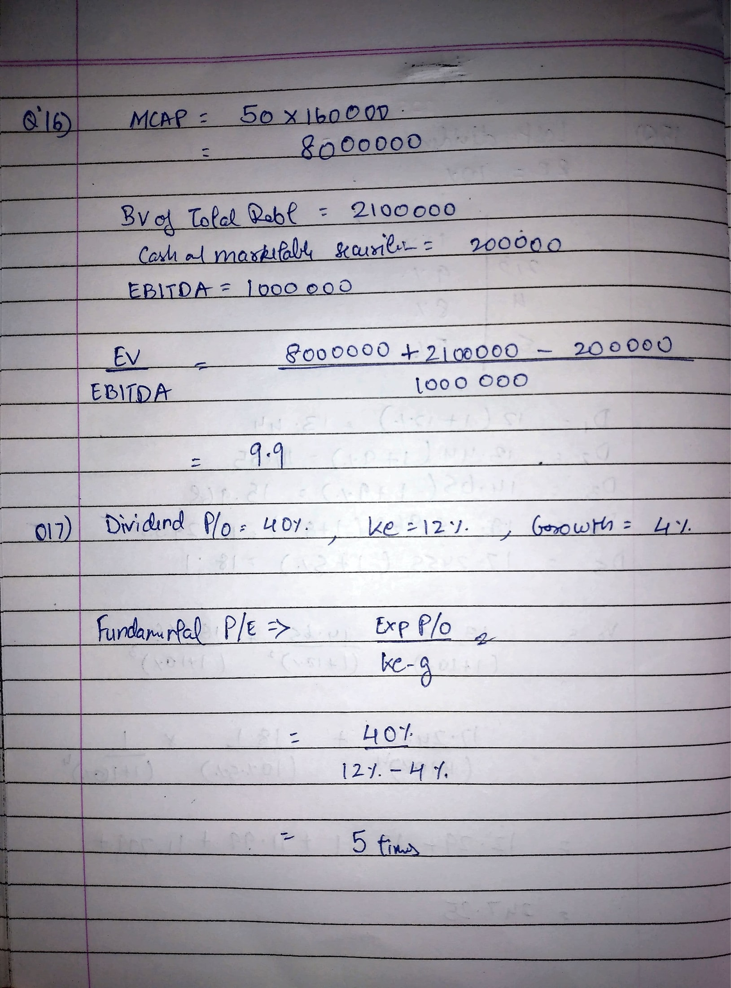

Unit-3
Q1.


Q2.


Q3.


