AKSHITA BAJPAI
FY -A
Roll no. 6
R – Assignment

Question 1
set.seed(10221)
a=rlnorm(1000,5,2.5)
quantile(a)
qlnorm(c(0,.25,.5,.75,1),5,2.5)

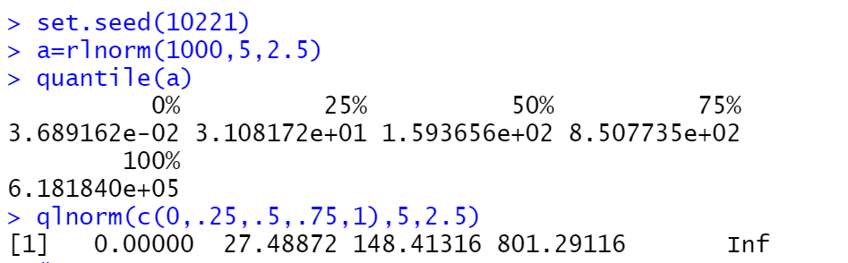

Question 2
#a
model1 = lm(mpg ~ - 1 ,
data = mtcars)
#b
model_2= lm(mpg ~ wt,
data = mtcars)
#c
model 3 = lm(mpg ~ log(wt)+log(disp),
data = mtcars)
plot(model_2)
"e"
plot(mtcars$wt,mtcars$mpg,xlab = "wt",main = "fitted line")
abline(model_2,col = "red")

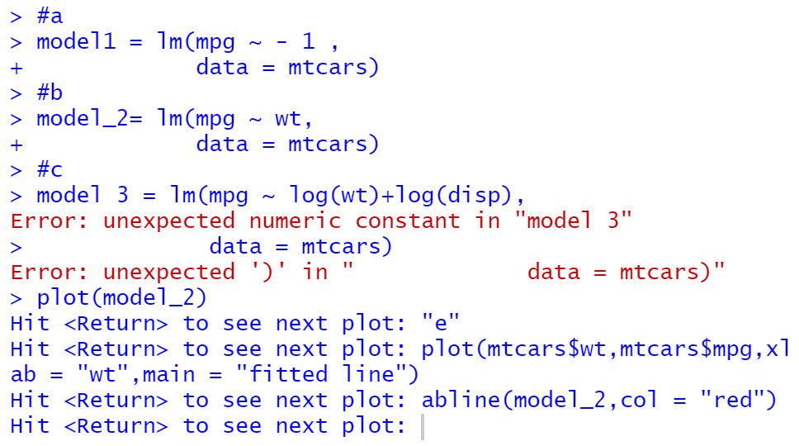

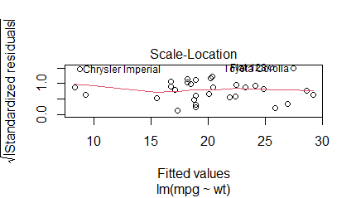

Question 3
set.seed(2919)
s = rnorm(100,5,2.5)
quantile(s)
qnorm(c(0,.25,.5,.75,1),5,2.5)
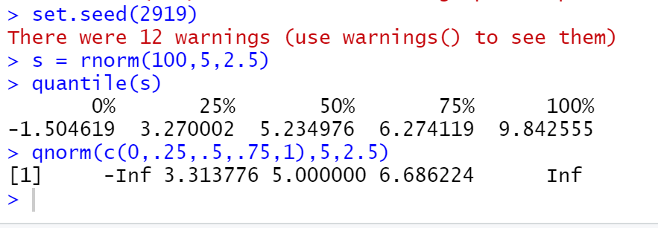

Question 4
X=c(0,1,2,3,4,5,6)
oi=c(739280,185309,23349,1937,114,1,3)
sum(oi)
lambda=sum(X*oi)/sum(oi)
prob=dpois(c(0:6),lambda)
ei=oi*prob
ei
ci=sum((oi-ei)^2/ei)
chisq.test(oi,correct=,F)
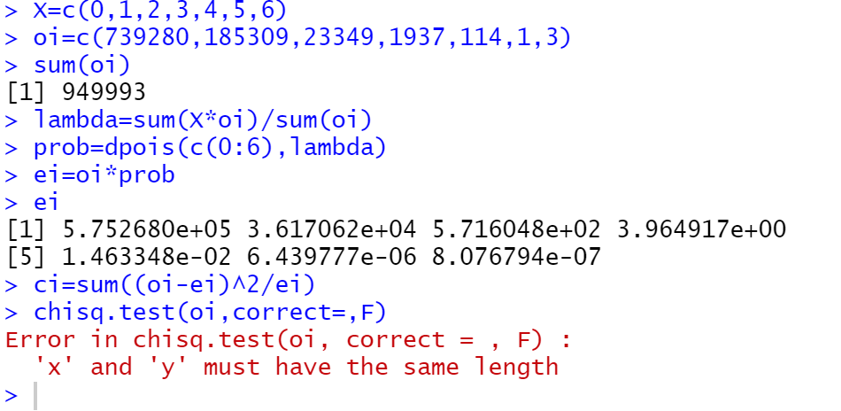
Question 5
library(MASS)
Animal.data = Animals
Animal.data
?Animals

" #a . The average brain and body weights for animals
can be interpreted by the correlation between them."

Pearson.r = cor(Animal.data , method = "pearson")
print(Pearson.r)
" There is a very weak negative correlation between them"

#b
Pearson.r.log = cor(log(Animal.data))
print(Pearson.r.log)
" If the log relation between these two variables are studied , then they have a strong positive
correlation"
#c
" H0 : p(row) = 0.6
H1 : p(row) > 0.6"

cor.test(Animal.data$body , Animal.data$brain , method = "pearson")
fisher.test(Animal.data$body , Animal.data$brain , )

#d
" H0: mu(body) = mu(brain)
H1 : mu(body) > mu(brain)"

t.test(Animal.data$body , Animal.data$brain,alternative = "greater" , var.equal = T , paired = T)

" the p-value is 0.1232 . As this is greater than 0.05 we do not have sufficient evidence
to reject H0"

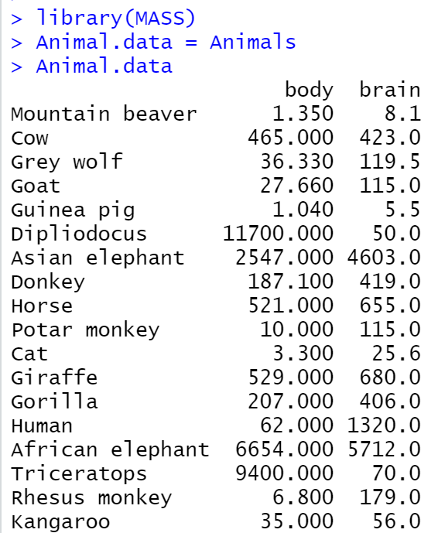
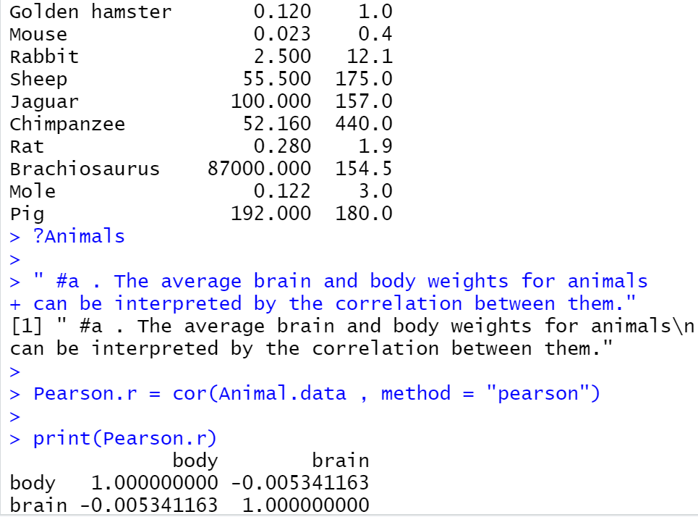

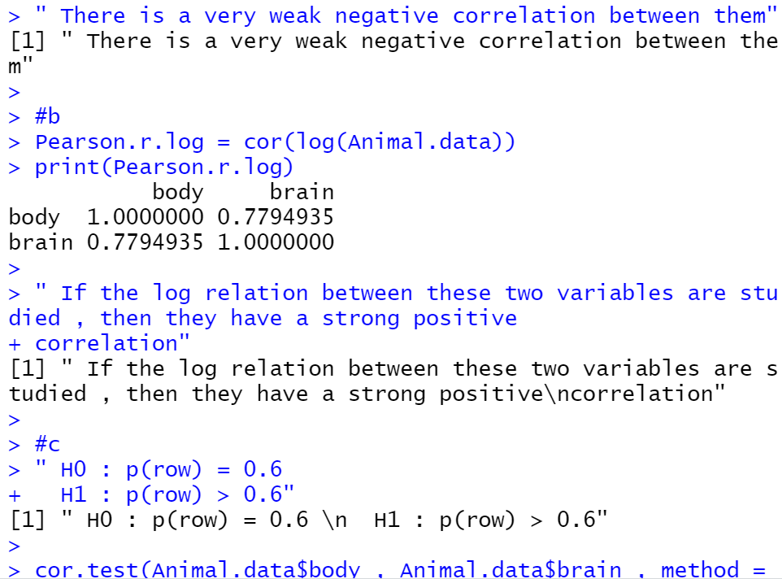
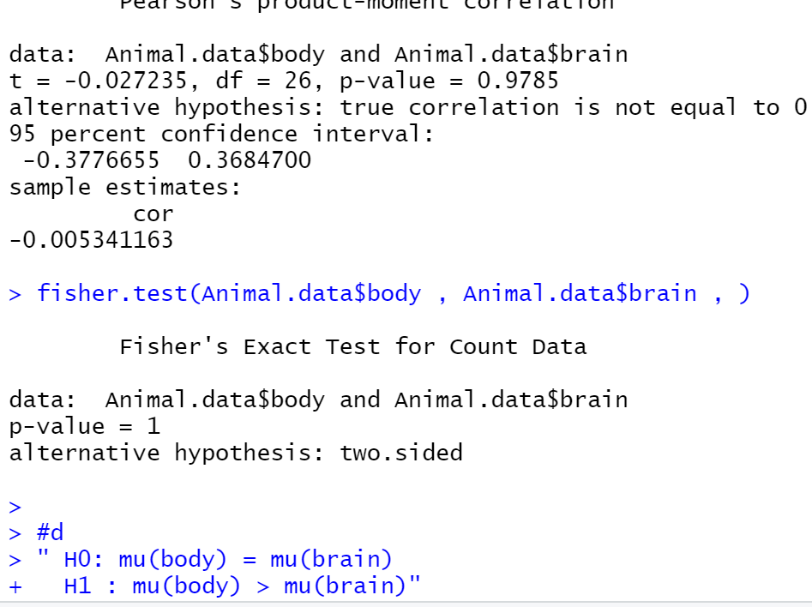
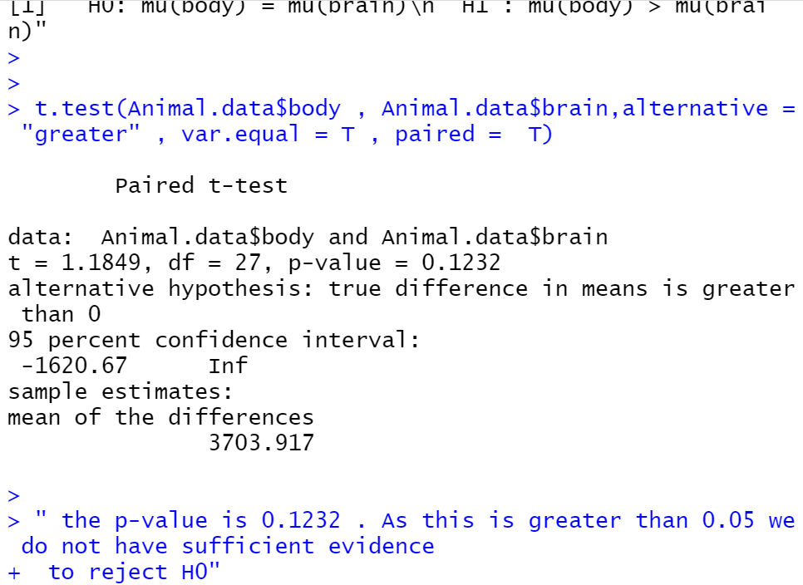

Question 6
matr=matrix(c(40,20,10,30,35,15,30,45,25),nrow = 3, ncol = 3,byrow = T)
rownames(matr)=c("ssc","graduate","pg")
colnames(matr)=c("a","b","c")
matr
a=rowSums(matr)
a
a[1]
b=colSums(matr)
b
ei=(a*b)/250
ei
chisq.test(matr,correct = F)
