commodity price risk management


Prepared for
Investment Committee Meeting

October 29, 2021

Prepared by
Treasury head

XYZ steel manufacturer ltd.
Letter of Transmittal

Treasury Head
XYZ steel manufacturer ltd
123 Main St
City, State 12345

October 29, 2021

Investment committee
XYZ steel manufacturer ltd
City, State 1235

Dear Committee Members,
This report includes detailed documents covering aspects of hedging and the need for the same.
Report covers the aspects of what is the ideal plan for implementation of the Hedging program in a time bound manner, type of derivatives that can be used for commodity price risk management and the points to be considered when deciding on the type. and the benefits of hedging to the company.
Highlighting the roles and responsibilities of senior management and Key documentation requirements for executing the hedging framework .

If you have any further questions or would like to go over any of the data, please don’t hesitate to reach out to me or anyone on my team that you worked with. I can be reached on by email at Mr.X@xyzcompany.com. Thank you for the opportunity, and we hope you find the results of this research as successful as we do.
Sincerely,

[signature]
PG
17
Bibliography

16
14
11
Letter of Transmittal
Executive Summary

Benefits of Hedging Commodity Price Risk

Introduction
Key documentation requirements

Types of Derivatives for commodity price risk management

Key Parameters to Consider for Hedging

Commodity Price Risk Hedging

Key components of Hedging program implementation
Table of Contents

1

3
4
8

EXECUTIVE SUMMARY

The value chain analysis provides the summary of the need to hedge price risk . In this analysis a firm identifies its primary and support activities that add value to its final product and then analyze these activities to reduce costs, increase profitability or increase differentiation . Primary activities for a steel manufacturer involves use of gas as an input for the raw material conversion process .

Based on treasury department’s review of the current business levels, the company faces high price risk emanating from the uncertainty around oil and gas prices. And Sharp fluctuations in commodity prices affect production costs, product pricing, earnings and credit availability. This price volatility makes it imperative for an entity to effectively manage its financial performance and profitability.

Although cost management by fixing prices is an important driver to manage prices, the gradual shift from the above only cost managed approach to a combination of risk and cost based approach is the real game changer. Hedging instruments like futures, swap and options play a big part in offsetting risk on commodity price fluctuations.
Introduction

At many of the enterprise risk management meetings, financial risk management became an important discussion point at the Board of Directors and senior management level due to the emergence of additional risks upon expanding business into new geographies, establishing trade relations with overseas buyers and suppliers and managing liquidity and cost of debt through effective funding and investment strategies.
The treasury department for a corporate is a dedicated unit separate from the traditional financial & accounts department which manage these financial risks and supply chain costs for the institution

Treasury management activities may be distinctly divided between the financial risk management and financial supply chain management.

- The objective of the financial risk management function of a corporate treasury is to “protect and preserve” the value generated from the underlying business against external market forces such as:
• Changes in the interest rates in the domestic or overseas geographies.
• Foreign currency movements that impact an entity’s Gain/ loss on foreign exchange transaction .
• Commodity price fluctuations that may affect the price of the commodity procured, maintained as inventory (raw material or finished goods) or sold to overseas parties or even on domestic transactions .

- The objective of the financial supply chain management function of a corporate treasury is to “ensure adequate liquidity” to the underlying business functions either through cash or through the utilization of short term or long term debt facilities.

Key components of Hedging program implementation strategy

- The most important element with respect to risk management is to establish and assess the Risk Appetite of the entity. Risk appetite can be defined as the ‘the amount and type of risk that an organisation is willing to take in order to meet their strategic

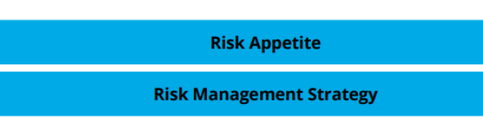
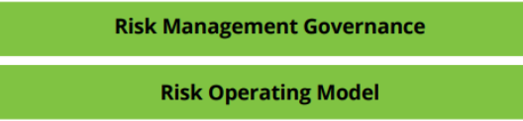

Objectives’. It establishes the tolerance that the Board of Directors is willing to accept with respect to the impact of risk on the entity’s top-line (i.e. revenue) and bottom-line (i.e. EBITDA).

Upon establishing the risk appetite, the Risk Management Strategy is set .It’s the plan that encompasses the strategic plan to address the aforementioned financial risks affecting the entity based on the level of impact it has on the Company’s financial performance .

The lifecycle cannot be established without having an effective Risk Management Governance by way of oversight by the necessary senior management and Board of Directors of the entity coupled with policies, guidelines and mandates which have been established for executing the risk management strategy within the appetite established by the entity’s Board of Directors.

The execution of the risk management strategy depends on the manner in which the Risk Operating Model has been established within the entity i.e. processes for executing the strategy (manual or automated), responsibilities and activities thrusted on the personnel, controls established for monitoring and flagging instances of potential breaches to the risk management strategy and most importantly, the information required to measure, monitor and report the effectiveness of the risk management strategy to the Board of Directors and senior management of the entity.
Keeping the above pillars in mind, a typical financial risk management process involves these following steps:

- Exposure identification and recognition –
To assess which elements of the business value chain of the entity is affected by the specific area of financial risk i.e. interest rate changes, commodity price or foreign currency fluctuations. This helps establish the transactional information within the value chain that is exposed to the specific financial risk.

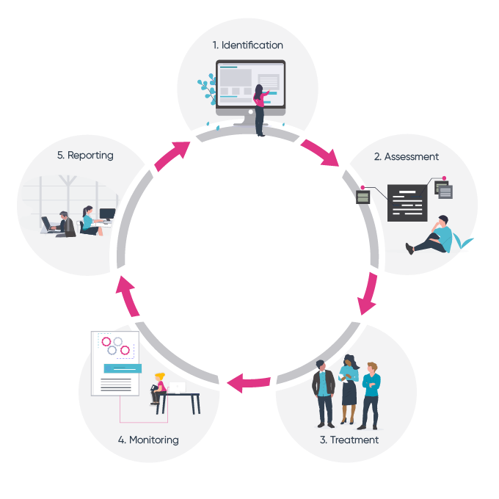
- Exposure aggregation and consolidation –
The combined transaction value that is exposed to the specific financial risk.
To identify a company’s true economic exposure, start by determining the natural offsets across businesses to ensure that hedging activities don’t actually increase it. Typically, the critical task of identifying and aggregating exposure to risk on a company-wide basis involves compiling a global risk “book” (similar to those used by financial and other trading institutions) to see the big picture—the different elements of risk—on a consistent basis.

Companies should hedge only exposures that pose a material risk to their financial health or threaten their strategic plans.
That assessment whether the risk in material or not would require managers to develop a profile of probable cash flows—a profile that reflects a company-wide calculation of risk exposures and sources of cash. Managers should then compare the company’s cash needs with the cash flow profile to quantify the likelihood of a cash shortfall.

- Hedging transaction execution –
Once the total value of exposure to a financial risk has been ascertained, the corporate treasury identifies a financial instrument that can be used to hedge or offset the impact of the exposure to the financial risk. The execution cycle typically involves entering into a derivative contract with a financial counterparty (either an exchange ,OTC or a bank) and settling the contract upon maturity of the contract.

Companies need to explore all available options to hedge their commodity exposure at the lowest possible cost. Doing so requires regularly evaluating hedging instruments, such as swaps, futures, options, and structured products, such as collars, all of which are available through brokers and financial intermediaries. Companies may also investigate simpler solutions, such as directly engaging with their feedstock suppliers to fix commodity prices through long-term contractual agreements. Finally, companies can leverage advanced analytics and hedging algorithms to optimize the timing of hedging decisions.

- Risk mitigation/ performance assessment –
this assessment demonstrates the degree of success of the implementation of the financial risk management strategy based on the manner and level of meeting the desired financial risk management objective.

Some of the common ways of mitigating risk include:

- Accepting the risk of the project, which means understanding the risk it poses but realizing that the benefits outweigh the negative outcomes of the risk
- Avoiding the risk in the project, where company simply do not participate in an activity that could lead to potential risk
- Controlling the risk, where company mitigate the risk by reducing the likelihood of its occurrence to reduce the impact beforehand
- Transferring the risk, where organizations get a third party involved (such as insurance) to take responsibility for the risk in case it occurs

- Monitoring / Performance assessment –
It is important to keep in mind that risk management is a continuous cycle rather than a linear path. Since every organisation will always face unknowns, the risks you have identified must be monitored on a regular basis.

Whoever owns the risk will be responsible for tracking it over time and ensuring that the wider business is kept appraised of any changes. What might appear as a low probability risk one month could quickly develop into a business-critical threat in the next. The trick is to ensure the lines of communication are kept open so that there are no surprises down the line.

- Reporting –
Reporting at each of the four stages above is a core part of driving decision making in effective risk management. This exercise should help to provide rationale behind any changes or updates made, as well as clarify if existing strategies are doing the right job.

The reporting framework should be defined at an early point in the risk management process by focusing on report content, format and the frequency of production. It should also be shared across all key stakeholders to maintain an integrated approach and ensure consistency.

- Bringing it all together through automation
There is nothing that will derail your risk management process quicker than siloed risk activities, which is why automation is a must. Enterprise risk management software not only helps to streamline each stage of the risk lifecycle but it can also facilitate greater awareness and accountability for risk across your organisation.
From real-time visibility of all current business risks to tracking trends over time, the benefits of risk technology are far-reaching. By formalising the risk management process through robust infrastructure, businesses can become much more resilient and adaptable in the face of change.

Commodity Price Risk Hedging

Companies are assessed by shareholders and investors on the basis of how strong their hedging strategy is. Derivative instruments such as forwards, futures, swaps and options are examples of some of the instruments used by companies to mitigate the risk and hedge the physical positions/asset. Hedging can be performed by taking a long or short position against the asset or physical product. In both cases the hedge will offset the loss of rising & falling markets and will protect the company from having diminished margins.

Key Parameters to Consider for Hedging

Hedging performed in an efficient way can lead to real value addition to the company, but there are risks associated which should be carefully considered and monitored.

Value chain analysis is typically defined as ‘a process where a firm identifies its primary and support activities that add value to its final product and then analyze these activities to reduce costs, increase profitability or increase differentiation’. However, in the case of commodity price risk management, prior to undertaking the hedging activities, it is important for the Company to understand its value chain with respect to its exposure to commodity price fluctuations i.e. on the procurement and storage of its raw materials to the storage and sale of finished goods.

Taking the example of steel manufacturing company’s value chain with respect to fluctuations in gas prices. The below diagram shows XYZ steel manufacturing company’s value chain .

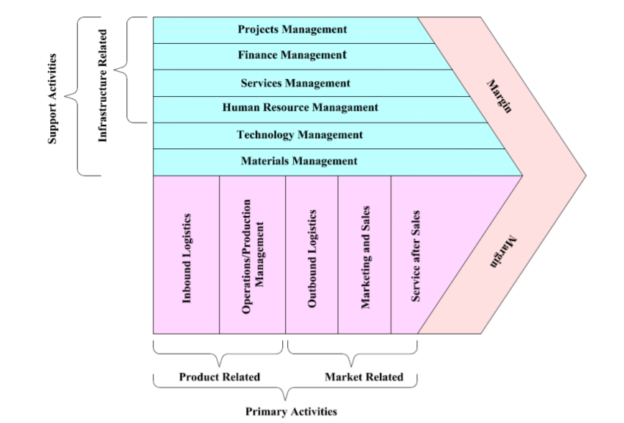

( Primary activities are those activities, directly involved in the conversion process of basic raw materials into final output/products including the receipt of basic raw materials from suppliers and marketing of output/ products to customers. This activity uses gas as an input for the raw material conversion process )

The value chain analysis provides the summary of the need to hedge price risk however, given regional market dynamics, additional parameters are required so as to assess the ability to hedge the price risk of the commodity under considerations.
Parameters:

- Available markets/ indices:
Trading markets (exchange-based/ over-the-counter) available for hedging the price risk of the commodity in India or in special cases, in international markets as well as the feasibility of each market to complement the exposure profile of the Company for hedge consideration.

- Hedging instruments:
Hedging instruments available within each of the identified trading markets (futures/ options/ swaps etc...) as well as the feasibility of each hedging instrument to complement the exposure profile of the Company for hedge consideration.
Here corporates considers’ the payoff of the hedging instrument. Depending on the compatibility of the commodity and the magnitude of hedge payoff corporates usually select the product.

- Exchange trading volumes:
Trading volumes prevalent in such hedging instruments at the identified exchange trading markets so as to assess the Company’s exposure vis-àvis liquidity and risks thereon.
Additionally, the liquidity of the traded derivative product becomes an important parameter for a corporate. A highly liquid product – that is a derivative product displaying significant trading volumes on the exchange will be cheaper and easier to execute. Corporates will also look at domestic exchanges for similar liquid instruments. There are cost and no currency risk advantages for corporates using domestic exchanges.

- Pricing considerations:
Price discovery methodology and quality of the underlying commodity of the derivative offered by the exchange along with the trading units so as to align with the Company’s pricing mechanism and benchmark price without creating additional basis and other risks.

- Margin requirements:
Margin requirements pertaining to initial margin and variation margins based on the contract size and volatility of the prices of the underlying commodity under consideration.

- Regulatory considerations:
Regulatory guidelines applicable for undertaking hedges for the selected hedge market (such as any commodity exchange) and hedging instruments.

- Liquidity management and working capital are of paramount importance for corporates. A company’s business plan becomes difficult to sustain when it depends largely on working capital. Hence outlay of capital and cost of hedging is one of the most important factors for corporates selecting these derivative products.

Types of Derivatives for commodity price risk management

There are various financial instruments, also known as derivatives, which can be used to hedge commodity price risk. Broadly, these instruments consist of futures, forward contracts, options and swaps. The following paragraphs provide a brief overview of the key characteristics of these instruments .

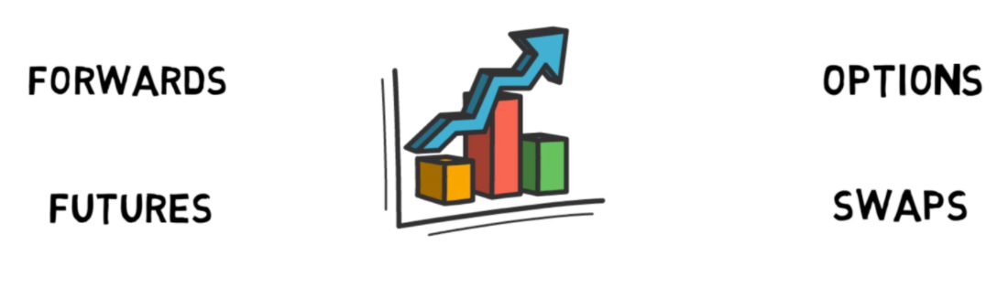

- Futures:
A futures contract is a legal agreement, generally prescribed by a futures exchange, to buy or sell a particular commodity or financial instrument at a predetermined price at a specified time in the future. Futures contract executed in commodity exchanges can be physically settled upon contract maturity or is cash settled (as mandated by the commodity exchange). The pay-off structure is linear with respect to the market price at the time of settlement.

- Commodity futures contracts are regulated and traded on exchanges and therefore standardized in terms of the quantity and characteristics of the underlying commodity. The first centralized market for commodity futures can be traced back to the early eighteenth century, when rice futures were traded at the Dojima Rice Exchange in Osaka.
Today, commodity futures are traded on numerous exchanges around the world, including the Chicago Mercantile Exchange, the Dalian Commodity Exchange, the London Metal Exchange, the Mumbai-based Multi Commodity Exchange of India, the São Paulobased Brasil Bolsa Balcão, the South African Futures Exchange and many more.

- Although futures contracts are based on a future sale of a commodity, they are typically cash settled and rarely end in physical delivery. Therefore, market participants in the commodity futures trade are not necessarily commodity producers or buyers looking to hedge price risk, but often investors from outside the commodity space who aim at making a profit from transactions, taking advantage of commodity price movements. Futures cover a wide range of commodities in agriculture, raw materials, metals and energy. Due to the emergence of financial futures, which are based on financial assets and indices such as stocks, treasury bills, interest rates or exchange rates rather than commodities, trade in commodity futures today constitutes a relatively small share of the entire futures market.

- Forward:
Forward contracts are similar to futures in that they are based on the agreement of a future sale of a commodity:

  - The main difference between the two instruments is that forward contracts are not standardized and generally traded over the counter rather than on exchanges. This means that the transaction costs for hedging price risk using forward contracts can be higher than for futures. The terms of forward contracts are negotiated between parties on over-the-counter markets in a decentralized manner. Therefore, forward contracts can be customized to fit the specific needs of contract parties. For instance, the parties involved can agree on a fixed price for the sale of a commodity or a future reference price and stipulate other individual contract characteristics.

  - there is no clearing house involved, forward contracts carry the risk of default by one of the contract parties. Furthermore, forward contracts typically result in physical delivery, rather than being closed out before expiration. Thus, forward contracts are often used by physical commodity traders to hedge price risk. The market for commodity forward contracts is very heterogeneous and ranges from large power purchase agreements between power generators and buyers, to agreements between farmers and traders of agricultural commodities, such as cocoa or sugar.

- Options:
Options are instruments that allow buyers and sellers of a commodity to lock in a minimum price and maximum price, respectively .
- The buyer of an option pays the counterparty a premium for the right to buy or sell the underlying commodity at a pre-specified price (“strike price”) on or before an expiration date. Call options give the holder the right to buy the underlying commodity, while put options represent the right to sell the underlying commodity

- Options entail no obligation to buy or sell a commodity and, if they are not used, the premium is the only cost to the holders. Options are traded both on exchanges and on the over-the-counter market. Exchange-traded commodity options often have a commodity futures contract, rather than a physical commodity, as the underlying asset.

- Swaps:
Commodity swaps are financial instruments where contract parties exchange cash flows that are based on the price of an underlying commodity.

- Swaps are often used by commodity consumers to lock in commodity prices over the medium to long term. For instance, a steel manufacturer can use swap agreements to hedge the risk of rising gas prices. Under such an agreement, if the gas price increases beyond the pre-specified price the steel company receives a payment equivalent to the price difference for a notional gas quantity stipulated in the contract. In case of a decrease in the price of gas , the steel manufacturing company pays an amount equal to the difference in price. In both cases, the steel manufacturing company is guaranteed a fixed gas price and has used the swap agreement to hedge price risk.
- Commodity swaps are generally sold on the over-the-counter market and not traded on exchanges. As with futures and options, commodity swaps account for a relatively small share of the market, while the majority of swap contracts are based on other assets or indices, such as interest rates or exchange rates.

Like all insurance products, financial instruments carry costs, which need to be carefully weighed against their potential benefits. In this regard, it should be noted that the purpose of financial instruments in the context of risk management is to mitigate exposure to price risk rather than to speculate on potential favourable price movements.

Benefits of Hedging Commodity Price Risk

- Cash flow benefits:
Working capital is the essence of any business and managing cash flow is a challenge for almost every company. Business owners as a result stay vigilant in order to keep the business financially viable. Fluctuating commodity prices especially on a significant part of the value chain can cause cash flow fluctuations in the business. Hence, forecasting and protecting future cash flows become vitally important. Difficulties in liquidity as a result force the company to undertake short-term financing arrangements to address the liquidity deficit – which increases the costs to the company.

- One of the advantages of hedging commodity price risk is the ability to minimize cash flow fluctuations attributed by commodity price movements. Hedging insulates the company from such volatile price movements, and is poised to stabilize cash flow volatility by creating an offsetting impact in case of commodity price fluctuations – with the aim to almost achieve a zero-sum game for the commodity exposures covered under that hedge.

- Cost benefits:
Hedging the commodity price risk using exchange traded derivative contracts tends to lower the cost of hedging as compared to undertaking an over-the-counter derivative contract for the purpose of hedging – especially where the traded derivative contract is highly liquid.
This is essential for those companies that do not have the necessary ability to pass on the costs of commodity price fluctuation and hedges on to the customer – due to competition and other market pressures.

- Enhanced price stability:
Creating price stability is an obvious advantage hedging cash flows offers. The benefits manifest in two ways. For goods that are imported for sale, it lowers volatility in the cost of goods sold (COGS). For goods that are sold in foreign markets, hedging offers the ability to maintain a stable price in local currency, increasing competitiveness with local firms. Both can raise the present value of future earnings. These effects have two broader implications.

  - the company's brand and reputation benefits from the ability of customers to rely on price stability, this advantage can lead to enhanced long-term supplier relationships.
  - competitive advantages are experienced, especially if other players in the market do not hedge their sources and have to reprice more often.

- Higher corporate valuations:
A study on corporate hedging and value showed that derivative users have valuations that are 6.7-7.8% higher than non-user firms . Some research has indicated that hedging firms usually are better able to meet or exceed analyst's expectations.
Higher valuations enhance a company's acquisitions, sales and divestitures capacity.

- Reduced taxation :
There are two benefits that hedging has on taxation. The first is tax convexity. that firms can expect to reduce their tax liability from reduced income volatility through hedging. The second contribution is the effect of increased debt capacity and the tax deductibility of interest.

- New market entry:
Expansion into new markets, whether developed or emerging economies, carries with it increased exposure to foreign exchange volatility. While regions such as China, Brazil, India, Mexico and the Philippines offer large and growing populations, their respective currencies are usually quite volatile. To ensure that revenue forecasts and projections are not sunk by adverse currency moves, long-term hedging solutions are indicated.

Key documentation requirements for executing the commodity price risk and hedging framework .

Company is required to maintain the following documentations:

- Commodity price risk policy –
The commodity price risk policy provides the principles and guidelines for the Company to facilitate its commodity hedging activities. This is usually signed-off by the Board of Directors of the Company. Salient features of the policy include:

- The risk appetite of the Company with respect to commodity price risk i.e. the degree of risk the Company is willing to expose its business margins to commodity fluctuations – this also determines the required hedge ratio to be maintained by the Company

- Risk management principles of the Company i.e. the salient philosophy and guidelines for facilitating the commodity hedging activities .

- Authorized markets and hedging instruments i.e. the acceptable hedging markets (ex. List of exchanges) and hedging instruments (ex. Futures and options) that the Company has authorized to undertake in its hedging activities.

- Standard operating procedures –
Key operating guidelines for undertaking the hedging activities which are supplemented with the internal controls maintained within the Company.

- Reporting framework –
reports to be provided to various levels of the Company’s management with respect to the exposures, hedges, hedge performance and other aspects required from the Company’s commodity price risk and hedging framework.

Bibliography

https://unctad.org/system/files/official-document/cimem2d46_en.pdf

https://www.ideagen.com/thought-leadership/blog/5-critical-steps-to-a-watertight-risk-management-process

https://www.invensislearning.com/blog/risk-management-process-steps/

https://www.commoditypriceriskmanagement.com/whitepapers/Strategic-Benefits-of-Hedging.pdf

https://www.makeuseof.com/tag/writing-professional-reports-documents/

https://www.deloitte.com/content/dam/Deloitte/in/Documents/risk/in-risk-overview-of-commodity-noexp.PDF

Risk Silo is often used attributed when risks are managed separately instead of in an integrated way.

