SAHIL SHAH - 420

STATISTICAL RISK MODELLING

R CODES WITH OUTPUT, EXPLANATION AND COMMENTS

“data=read.table('Graduation(1).csv' , header=TRUE , sep=',')

data$CRUDE<-data$DEATHS/data$ETR”

Reading data using read.table function with headers as true and separator as “,” after setting the required directory.
Crude Data = deaths/ETR

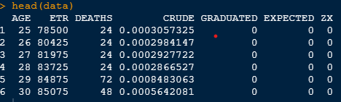

“ gompertz<-lm(log(data$CRUDE)~data$AGE)
gompertz
coef(gompertz)
B=exp(as.numeric(coef(gompertz)))[1]
C=exp(as.numeric(coef(gompertz)))[2]
c(B,C)
data$GRADUATED<-round(B*C^data$AGE,6)
plot(data$AGE,data$CRUDE, xlab="Age",ylab="Mortality rate",main="Crude and graduated rates" , pch=10)
lines(data$AGE,data$GRADUATED , col='red') ”
Used Gompertz law to fill the graduated column using the lm function.
Used coef function and as.numeric function to find parameters B and C.
Using round function to rounding off the graduated column to 6 decimal palces.
B = 1.668727e-05
C = 1.112153e+00

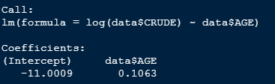

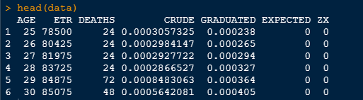
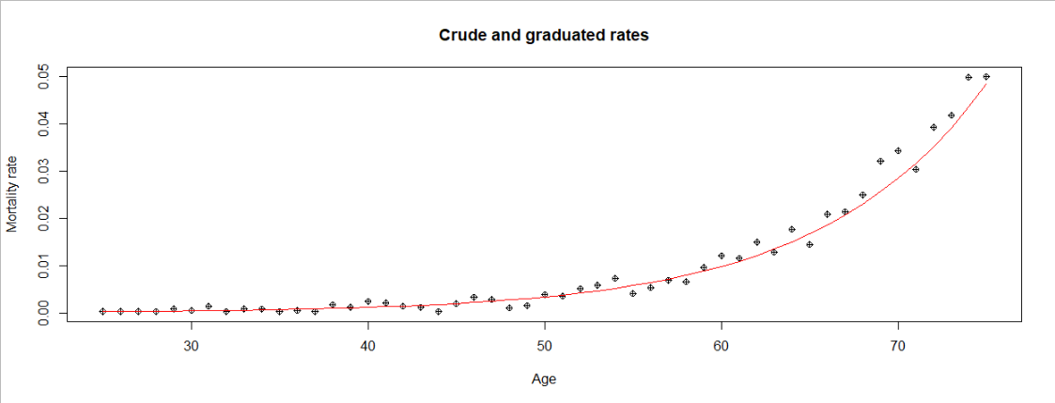

“diff1<-function(v)v[-1]-v[-length(v)]
diff_crude=round(diff1(diff1(diff1(data$CRUDE)))*10^6,0)
diff_grad=round(diff1(diff1(diff1(data$GRADUATED)))*10^6,0)
plot(data$AGE,data$CRUDE, xlab="Age",ylab="Mortality rate",main="Crude and graduated rates" , pch=10)
lines(data$AGE,data$GRADUATED,col="red")
smoothness_df = data.frame("Age" = data[data$AGE <= 72,"AGE"],diff_crude,diff_grad)
smoothness_df”

Using diff function to check for smoothness by applying 3rd differences to graduated and crude rates.
The criteria used to check for smoothness is generally that the 3rd differences should be small in magnitude and progress regularly.
In the above data frame the 3rd differences of crude rates are much larger in magnitude and progress erratically.
However the magnitude of 3rd differences of the graduated rates are very small and progress regularly.
Thus graduated rates computed by fitting Gompertz Law are smooth and that is exactly what’s desired.

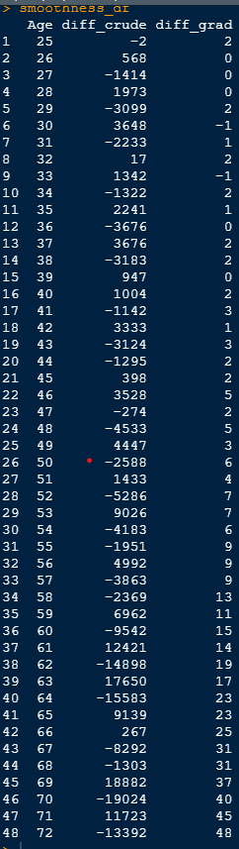

“data$EXPECTED<-round(data$GRADUATED*data$ETR,2)
data$ZX<-round((data$DEATHS-data$EXPECTED)/sqrt(data$EXPECTED),2)
head(data)
plot(data$AGE,data$ZX,type="b",xlab="Age (x)", ylab="zx",main="Individual standardised deviations")
data$prob = data$EXPECTED/sum(data$EXPECTED)
head(data)
a=chisq.test(data$DEATHS,data$prob) ”
Calculated Expected rates and Zx and rounded both the numbers to 2 decimal places using round function.
Then conducted a $χ^{2}$ test using chisq.test function.
Looking at the $χ^{2}$test we can conclude that the Graduation is not OK as the p.value=0.2774 which is greater than 0.05.
H0 of a $χ^{2}$ test is that the the Graduation is OK
H1 states that the graudation is not OK.
As the p.value is greater than 0.05 we have sufficient evidence to reject H0 and hence the graduation is not OK.

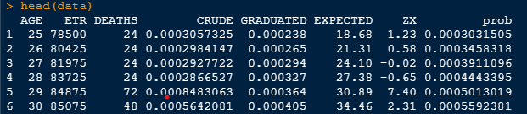

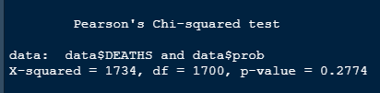

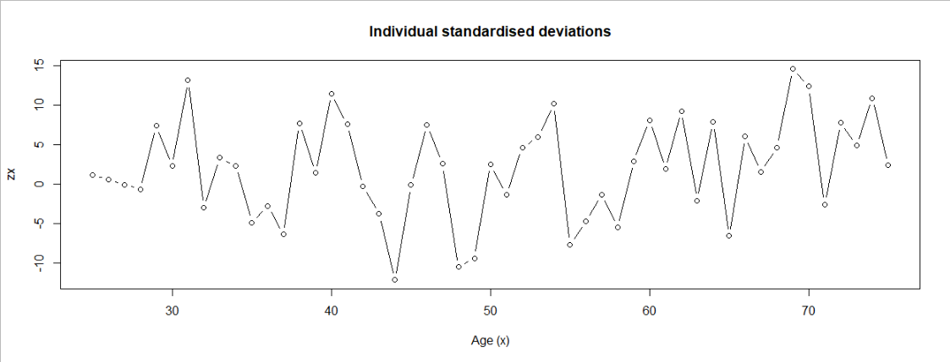
Deficiencies of the chi-squared test
The $χ^{2}$ test will fail to detect several defects that could be of considerable financial importance.

(a) There could be a few large deviations offset by a lot of very small deviations. In other words, the $χ^{2}$ test could be satisfied although the data do not satisfy the distributional assumptions that underlie it. This is, in essence, because the $χ^{2}$ test statistic summarizes a lot of information in a single figure.
(b) The graduation might be biased above or below the data by a small amount. The $χ^{2}$statistic can often fail to detect consistent bias if it is small, but we should still wish to avoid it.
(c) Even if the graduation is not biased as a whole, there could be significant groups of consecutive ages (called runs or clumps) over which it is biased up or down. This is still to be avoided.

“binning_var = c(-Inf, -3, -2, -1, 0, 1, 2, 3, Inf)
testing_table = data.frame(data$ZX, bin=cut(data$ZX, binning_var, include.lowest=TRUE))
prop.table(table(testing_table$bin))
stand_dev_test = data.frame(Bins = levels(unique(testing_table$bin)), Expected = c(0, 0.02, 0.14, 0.34, 0.34, 0.14, 0.02, 0), Observed = round(as.numeric(prop.table(table(testing_table$bin))), 3))
stand_dev_test = stand_dev_test %>% mutate(Expected = Expected * 51, Observed = Observed * 51)
chisq.test(stand_dev_test$Expected, stand_dev_test$Observerd, correct = T)”

STANDARDISED DEVIATIONS TEST

We can use standardized deviations test to look for the defect (a) of $χ^{2}test$.
Created intervals of 1 from -3 to +3 under binning_var.
Then made a testing table and a probability table using prop.table function.
Then made a new dataframe with observed and expected probability in the columns.
Then conducted a $χ^{2}$test using chisq.test function.

OVERALL SHAPE - The data shows that it is negatively skewed and has more values on the tail.

ABSOLUTE DEVIATIONS – The data is overgraduated and shows existence of duplicates as the absolute deviations are too big. This is proved by the fact that there are less than 50% values lying in the (-2/3 to 2/3) bin.

OUTLIERS – Too many outliers are present as close to 20% of the data lies in the (-infinity to -3) bin and 40% of the data lies in the (3 to Infinity) bin. Showing that the data has approximately 60% outliers.

SYMMETRY – The number of positive and the number of negative deviations are not close to 50% rather there are only 20 negative and 31 positive deviations. This shows that observed mortality rates do not conform to the model with the rates assumed in the graduation. The data shows nature of discrepancy.

H0 of a $χ^{2}$ test is that the the Graduation is OK
H1 states that the graduation is not OK.
$χ^{2}$test gives a p.value of less than 0.05 and as mentioned above as the p.value was very low we have insufficient evidence to reject H0 and therefore the Graduation is OK.

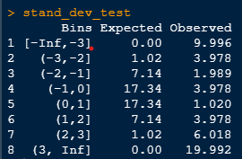

“data$signs = ifelse(data$GRADUATED>data$CRUDE,1,0)
head(data)
tail(data)
sum(data$signs)
p=2*pbinom(20,51,0.5)”

SIGNS TEST
It checks for defect (b) of $χ^{2}$ test.
It is a 2 tailed test and therefore 2 is multiplied to the p.value.
H0 : Data is biased
H1 : Data is not biased
As the p.value = 0.16 which is greater than 0.05 we have insufficient evidence to reject H0 . Hence data is not biased.

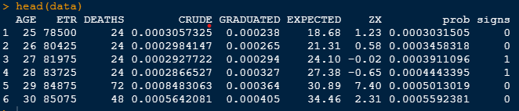

“(sum(data$DEATHS)-sum(data$EXPECTED))/(sqrt(sum(data$EXPECTED)))”

CUMULATIVE DEVIATIONS TEST

It checks cumulations of positive and negative groups.
Test statistic = 18.831
H0: Graduation rates are OK
H1: Graduation rates are too low
As test statistic is greater than 1.96 we have sufficient evidence to reject H0 and conclude that Graduation rates are too low.

“z1=data$ZX[1:length(data$ZX)-1]
z2=data$ZX[2:length(data$ZX)]
a=cor(z1,z2)
a
a*sqrt(51)”

SERIAL CORRELATIONS TEST

It detects clumping of signs of deviations
It is a 1 sided test.
As a = r_j =0.1477 we can conclude that Z_x has similar values.
H0 : No grouping of signs
H1 : Grouping of signs
As test statistic is 1.05 which is less than 1.649 we have insufficient evidence to reject H0. Therefore there is no evidence of grouping of signs .

FINAL OUTPUT OF DATA
