- Earned premium
- Damage caused to another vehicle when hit by insured’s vehicle
- Types of cover in motor insurance:
• By fire explosion self ignition or lightning
• By burglary housebreaking or theft
• By riot and strike
• By earthquake (fire and shock damage)
• By flood typhoon hurricane storm tempest inundation cyclone hailstorm frost
• By accidental external means
• By malicious act
• By terrorist activity
• Whilst in transit by road rail inland-waterway lift elevator or air
• By landslide rockslide
- Add-on coverages in motor insurance:
- No claim bonus(NCB) protection cover
- Road side assistance
- Loss of personal belongings
- Key replacement
- Return of invoice
- Engine protection cover
- Tyre protection cover
- Consumables cover
- Health insurance cover:
- Ambulatory patient services (outpatient care you get without being admitted to a hospital)
- Emergency services
- Hospitalization (like surgery and overnight stays)
- Pregnancy, maternity, and newborn care (both before and after birth)
- Mental health and substance use disorder services, including behavioral health treatment (this includes counseling and psychotherapy) (2017)
- Prescription drugs
- Rehabilitative and habilitative services and devices (services and devices to help people with injuries, disabilities, or chronic conditions gain or recover mental and physical skills)
- Laboratory services
- Preventive and wellness services and chronic disease management
- Pediatric services, including oral and vision care (but adult dental and vision coverage aren’t essential health benefits)

- Underwriting factors:
- Travel insurance
• Age
• Trip cost
• Trip length
• Destination
• Departure window - The amount of time between the date travel is booked and the
date insureds depart on their trip
• Departure Month
• Number of destinations
- Marine insurance
- Names and brief details of vessels covered
- Value of vessels
- Period of cover
- Deduction for brokerage, etc.
- Class and type of cover
- General condition
- Fire insurance
• Age
• Trip cost
• Trip length
• Destination
• Departure window - The amount of time between the date travel is
booked and the date insureds depart on their trip
• Departure Month
• Number of destinations
- Motor insurance
• Age
• Trip cost
• Trip length
• Destination
• Departure window - The amount of time between the date travel is booked and the
date insureds depart on their trip
• Departure Month
• Number of destinations

- Not covered factors in:
- Health insurance
- elective or cosmetic procedures
- beauty treatments
- Fertility treatments
- off-label prescriptions
- New technology in product or services
- Travel insurance
- Warfare
- Pre-existing ailments
- Sporting injury during travel
- Pregnancy
- When the tour operator cancels trip
- Marine insurance
- Wilful, planned or intentional misconduct
- Strike, rioting, war
- Poor packaging quality of the cargo
- Delays
- General leakage or wear and tear of the cargo
- Financial distress or insolvency of the shipping line
- Removal of wreck
- Motor insurance
- Third party liabilities
- Insured driving drunk
- Driving without license
- Add-ons not bought
- Consequential damages
- Insurance fraud- Insurance fraud is an illegal act on the part of either the buyer or seller of an insurance contract. Insurance fraud from the issuer includes selling policies from non-existent companies, failing to submit premiums, and churning policies to create more commissions.
- Ways of committing frauds-
Soft Fraud:
• Exaggerating damages/loss
• Deliberate or subtle lagging of claims resolution
Hard Fraud:
• Staging the occurrence of incidents
• Medical claims fraud

- Health insurance fraud-
- Insurer : ICICI Lombard General Insurance Company
- Insured : Darbari Lal Dhawan
- Claim lodged on 11.08.2016
- As per the claimant the Insured died on 25.07. 2016.
- Period Of Insurance policy: from 2016-2021.
- Detailed Description of the Death: Car accident.
- After social media forensic analysis , it was found that the insured had died before July 2016.
- The family’s facebook accounts were checked and they found posts indicating the loss of Darbari Lal on various dates before July 2016. One post also indicated his death in 2012.
- ICICI detected the false claim and refused the payout
- Underwriting factors in health insurance-
• Age
• Sum Insured
• Demography
• Medical Condition
• Gender
• Policy Type
- Coverages in insurance-
- Travel insurance-
• Trip Cancellation: Reimbursement of costs previously paid, and not otherwise
refunded, for a trip canceled prior to departure.
• Trip Interruption: Reimbursement of additional costs, or of unused prepaid costs (e.g.,
excursions, hotel, etc.), incurred due to returning from a trip earlier than expected.
• Travel Delay: Reimbursement of costs incurred because travel did not occur at the time
expected.
• Baggage Damage or Loss: Payments to replace personal items damaged or lost while
on a trip.
• Baggage Delay: Reimbursement of additional costs incurred to replace personal items
that did not arrive at the intended destination when expected.
• Emergency Medical or Dental: Reimbursement of unexpected medical costs incurred
due to injury or illness while traveling.
• Emergency Evacuation: Providing specialized transportation (e.g., air ambulance),
typically in response to a medical emergency or severe medical need.
• Repatriation of Remains: Providing transport for an insured who dies during travel
from the travel destination to a family-designated funeral home.
• Rental Car Collision Damage: Reimbursement of amounts paid to a rental car agency
due to damage to, or loss of, a rental car.
- Marine insurance-
•Fire , explosion
•Contact with water
•Breakage
•Accident
•Derailment of conveyance
•Theft
•Pilferage
•Non-delivery
- Another characteristic of travel insurance is the potential overlap with other insurance products. For example, automobile insurance may provide rental car collision damage insurance, home owner insurance may cover lost or damaged baggage, and health insurance may cover emergency costs while traveling. Even in cases where a traditional policy may provide a benefit, travel insurance remains distinctive because it only covers exposures related to travel, and usually tied to a specific trip.
- History of marine insurance-
•Lloyd's Coffee House
• From 1961,in Lombard street , the coffeehouse became a place to discuss marine affairs
•Edward Llyod started giving out news –sheet . They pooled their money for insurance against risk
connected with the sea.
•The need for underwriting led to formation of Llyod’s of London.

•Contrary to popular belief, Lloyd’s of London was not the first group of people to offer a maritime
commerce. The first form of marine insurance dates back to year 3000 BC when Chinese merchants
dispersed their shipments amongst several vessels so as to abridge the possibility of damage to the
products. The earliest account of insurance came in the form of ‘bottomry’ , a monetary payment
that protects traders from debt if merchandise is lost or damaged.
Types of marine insurance-
•Time policy – the policy provides coverage upto a specified time
•Mixed policy - this policy combines time policy and voyage policy and
covers voyages taken between specific destinations during a specific time
period.
•Valued policy - under this policy the value of the cargo being transported is
mentioned beforehand which specifies the coverage level of the plan. In
case of loss of cargo, the value mentioned in the policy is paid as claim
•Unvalued policy – when the value of the cargo is not determined
beforehand, it is called an unvalued policy. Under this policy, the loss
suffered would be estimated when the loss happens.

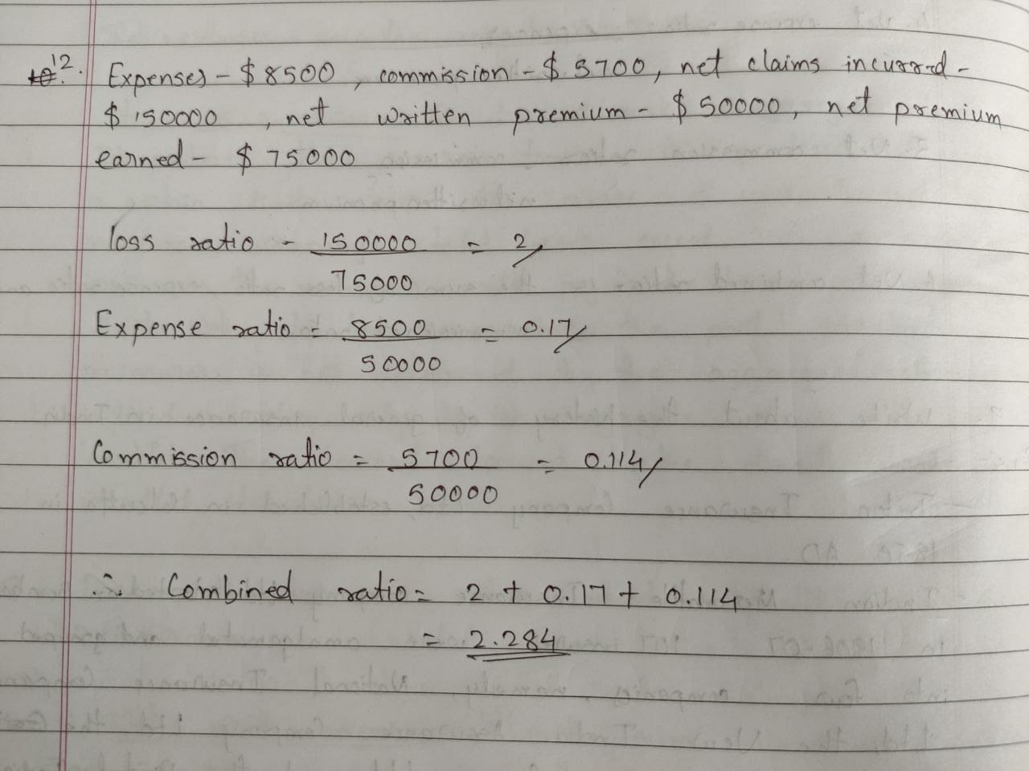

- Crop insurance- Crop insurance is a means of protecting the agriculturist against financial losses due to uncertainties that may arise from crop failure/ losses arising from named or all unforeseen perils beyond their control.
- Covers in crop insurance-
•Localized calamities

•Sowing/ planting/ germination risk

•Standing crop loss – non-preventable risks such as hail storm, dry spells, flood, cyclone

•Post harvest losses
- Exclusions in crop insurance-
•Losses arising out of war, nuclear risks
•Malicious damage and other preventable risk arising out of negligence by the farmer or the
manpower employed by the farmer
•Burning of the crop by order of a public authority
•Damage caused by birds or animals
•Ionizing radiations or contamination by nuclear waste
•Harvested crops bundled and heaped before threshing
- Underwriting factor for credit insurance-
- Geographical location
- Character, reputation, and lifestyle of applicant
- Claims history
- Implementation of safety precautions by the applicant
- Previous criminal convictions
- Nature and particulars of liability

- Engineering insurance- Engineering insurance refers to the insurance that provides economic safeguard to the risks faced by the ongoing construction project, installation project, and machines and equipment in project operation. Product categories: Depending on the project, it can be divided into construction project all risks insurance and installation project all risks insuranc; depending on the attribute of the object, it can be divided into project all risks insuranc, and machinery breakdown insurance

