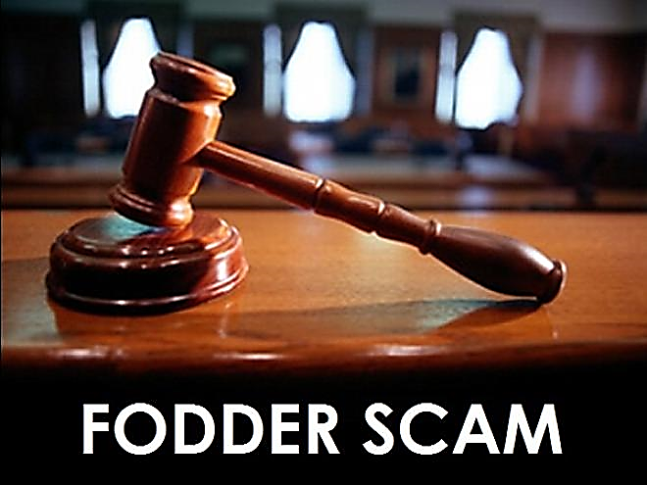

CASE STUDY REPORT

  - Professional ethics PROJECT

  - BRIJESH GUPTA
  - 712
  - gbrijesh2001@gmail.com

TABLE OF CONTENT
PG.NO | PARTICULARS
2 | INTRODUCTION
3 | TIMELINE OF THE EVENTS
4 | CASE FINDINGS / FACTS OF CASE
5 | CURRENT VERDICT OF THE CASE
6 | ANALYSIS OF THE CASE
7 | RECOMMENDATIONS
8 | CONCLUSION
INTRODUCTION

- A scam is a dishonest or fraudulent scheme that attempts to take money or something of value from people. It is a confidence trick that dishonest groups, individuals, or companies perform.

- Financial scams have been a danger since finance first emerged as an economic activity. To this day, the prospect of easy money using deception, fraud, or any illicit means attracts criminals who think they can get away with it.

- Investment scams have been a common type for ages. People are lured by the promise of easy returns, only to lose everything. Some are local and relatively small; others are enormous and even international in scale. Banking scams are also a danger, having been around in some form or another since the first banks came into existence.

- Corruption and scams are common when it comes to India, be it a politician, a cooperate, or a bureaucrat every year somebody o the other is indulged in malpractices or embezzlement.

- After having an overview on scams and its few types now lets a have detail study of a very interesting type of scam that took place in late 90’s, “THE FODDER SCAM”.

- It was in the year 1996 in January, the Animal Husbandry Department was encrypting and making fake bills that were sent to non-existent companies to pretend that those were real transactions, the companies asking for fodder from the department and the department selling the fodder.

- However, in reality, all of it was nothing but a scam going on behind the curtains until a raid took place on the offices of the Animal Husbandry Department in Chaabis.

- The Comptroller and Auditor General of that time, Mr. T.N. Chaturvedi was suspicious that some sort of money laundering was taking place as he noticed delays in submissions of monthly accounts of the Bihar treasury in 1985 but still the scam was busted in 1996.

TIMELINE OF THE EVENTS

CASE FINDINGS / FACTS OF CASE

- Considering the involvement of various officials and politicians, the state police of Bihar was no longer fit to conduct an investigation and the Supreme Court ordered a CBI probe in the matter.

- The case became news for the world as the CBI got involved and a charge sheet named the then Chief Minister of Bihar, Lalu Prasad Yadav. During the investigations, CBI filed a submission to the High Court against some officials for not allowing access to documents that could unravel the involvement of a big name from politics. After a hustle, the investigation by CBI continued and Lalu Prasad Yadav was found to be linked with the scam.

- In May 1997, CBI started requesting the federally appointed Governor of the state to prosecute the CM but as soon as this came out, a businessman named Harish Khandelwal who was an accused in the case was found dead on train tracks with a note attached reading that he was being coerced by the CBI to turn witness for the prosecution.

- However, CBI denied this and kept on with the investigations. In July 1997, Lalu being scared, resigned from the position of Chief Minister of Bihar and gave his position to his wife, Rabri Devi, and surrendered to the CBI.

- This tenure of Rabri Devi wasn't long-lasting as another case of Disproportionate Assets was registered against Lalu in 1998 and Rabri Devi too was named as a co-accused.

- After the case against Lalu, his party Janata Dal started pressuring him to leave his post as the party's chief. Later, he formed his party in Rashtriya Janata Dal.

- However, Rabri Devi was granted bail, Lalu wasn't. In 2001, Bihar was bifurcated into two, Bihar and Jharkhand, 39 out of 61 cases were transferred to the new state, Jharkhand.

- The supreme court transferred Lalu's cases to Jharkhand High Court. Nine years later. In 2012, a charge sheet was filed against 44 people related to the fodder scam, Lalu's name was on the list including former CM of Bihar, Jagannath Mishra.

CURRENT VERDICT OF THE CASE

- More than 500 accused have been convicted and awarded punishments by various courts. Some of the most prominent convicts include former CM of Bihar Lalu Prasad, former Member of Parliament Rabindra Kumar Rana and former Member of Legislative Assembly Dhruv Bhagat.

- On 30 September 2013, a Special CBI Court in Ranchi convicted Lalu Prasad Yadav and Jagannath Mishra along with 44 others in the case. Thirty-seven people were taken into judicial custody.

- The court has announced a sentence of five years and four years for Lalu and Jagannath Mishra, respectively. Lalu Prasad Yadav was finally adjudged for illegally withdrawing Rs. 37.7 crore in the 1st Fodder Scam Case out of the 6 cases filed against him and was sentenced to 5 years of imprisonment and a fine of 25 lakhs. Not just this but he also was barred from contesting elections for 11 years. However, he got bail for the 37.7 crore Chaibasa scam within a few days.

- In 2018, Lalu was condemned for another Chaibasa treasury for fraudulent withdrawals of Rs.3.13 crore during 1995-1996 but was granted bail for the same in October 2020 by the Jharkhand High Court treasury.

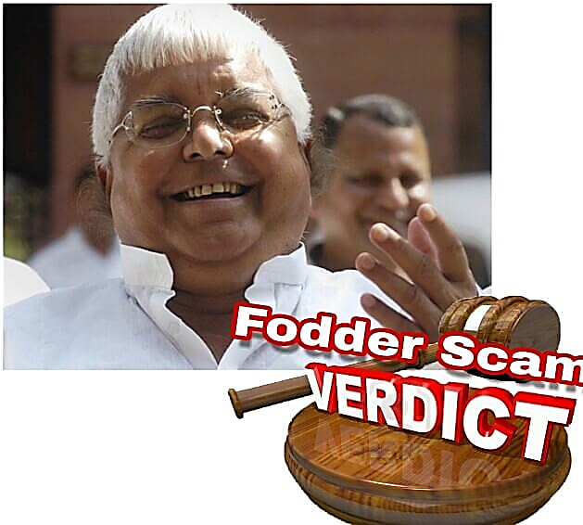

ANALYSIS OF THE CASE

- Analyzing the procedure of Fodder Scam and how it managed to run for so long without being caught is one of the underrated scams in India.

- Greed drove us to be the leading species on our planet. But greed often takes over one’s conscience. How could a few be so immersed in the amassing and expanding their personal, already huge wealth that they can mercilessly forget about fellow humans dying of hunger, because of their very greed? Could someone use the very power that his fellow people gave them to take all their money and fill up his own pockets?

- The former chief minister of one of the poorest states in the already poverty-stricken India did do so. Lalu Prasad Yadav, who was the chief minister of Bihar from 1990- 1997, and his aides’ committed frauds that filled their pockets with the taxpayers’ hard-earned money. The money that they embezzled would have catered to the cattle industry, to help poor farmers earn a living, which in turn would feed the hungry and poor India of the 1990s.

- The Fodder Scam involved hundreds of millions of dollars in alleged fraudulent reimbursements from the treasury of Bihar state for fodder, medicines and husbandry supplies for non-existent livestock. Crores of rupees was embezzled by the chief minister of the state of Bihar and his aides. The theft lasted years. The scam was uncovered in 1996. The scandal led to the end of Lalu's reign as Chief Minister.


RECOMMENDATIONS

- With the outbreak of the Fodder scam, the following ethical issues on the part of the Government, Regulatory bodies, media and industry came into the forefront. The scam involves big heads and with the involvement of big political parties it gave rise to some Unethical issues which are as follows:

- Spirit of Collective responsibility is not conserved: An ethics of co-responsibility is required and can only be implemented through mechanisms well beyond the legal system.

- Personal greed puts business ethics at stake. Lalu Yadav was the mastermind of this whole scam and his personal greed made him do all the unethical things.

- The two basic fundamentals of politicians i: e Fair utilizing the appropriates resources and transparency was completely kept aside to enjoy the false fruits.

- Wrong use of power leads to a great turmoil:

- Lalu Yadav all being the Chief Minister, tried to influence the government officials by all means. Those who didn’t get influenced they were either get transferred or removed from their positions.

- Misuse of public Funds

CONCLUSION

- Lulu Yadav was in a dilemma whether he should disclose the name of every main conspirator of the theme, or should he wait for his fellow mates having a reputed position in the coalition government and corporate world to help him to get out.
- In the end the scam proclaimed and accused about 298 people in 35 fodder scam cases. 62 peoples got Convicted in fodder scam and are jailed due to several reasons and remaining criminals are yet to be sentenced. But unfortunately, Lalu Yadav the prime convicted person got bail from apex court of India.
- Lalu Yadav is the only politician on whom the Look Saba debated for an entire session as the official agenda. Government Employees became more responsible

- The fodder scam that broke out in 1996 involved the apparent misappropriate of nearly Rs 950 Cr from the treasury of Bihar government. The fodder scam became symbolic of eructation corruption and crystallization of politics in India especially in the state of Bihar & Jharkhand.

I hope that the information rendered and the complete overview on “THE FODDER SCAM” was useful and I appreciate the faith placed in me to create a report from start to finish.

SOURCES:
https://en.wikipedia.org/wiki/Fodder_Scam
https://www.youthkiawaaz.com/2018/01/what-really-is-the-fodder-scam-heres-everything-you-need-to-know/
https://www.timesnownews.com/india/article/what-is-fodder-scam-chara-ghotala-all-about-fodder-scam-that-sent-lalu-prasad-yadav-behind-bars-animal-husbandry-cbi-bihar-corruption-explained/192141
https://www.indianmirror.com/indian-industries/indian-scams/fodderscam.html
https://economictimes.indiatimes.com/topic/fodder-scam



