Colgate:
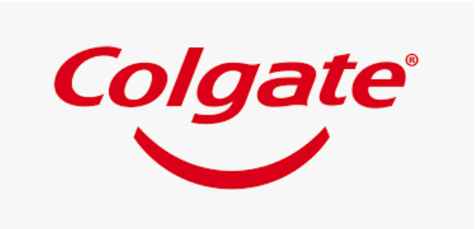
NAME: Simran Ramaswamy Sharma
ROLL NO.: 27
TOPIC: Colgate
TOPIC
Introduction
A Brief History
Target Audience
Competition
Colgate the Company
Stock Chart
Colgate Acquisition
Economic Analysis
Demand Curve
Determinants of demand
Income Elasticity of demand
Covid-19 Impact on Colgate
Societal Contributions during pandemic
Colgate-Palmolive SCM
Vision and Core values
Supply chain structure
Detailed SCM
Improvement through SCM
Determinants of supply
Improving Productivity
Colgate Advertisement Strategy
SWOT Analysis
Inference from questionnaire and study
Bibliography

INTRODUCTION:
Colgate-Palmolive as it comes to the surprise of what I suppose are may Indians including me is an American multinational consumer products company. This means, it specializes in the production of various commodities such as household products, soaps, shower gels, oral care products and more.
It houses its headquarters on Park Avenue in Midtown Manhattan, New York City.
It operates at a global level and runs business in over 200 countries and union territories with impressive strategic innovation and a stellar marketing mix.
Colgate-Palmolive (India) Limited is India's leading provider of scientifically proven oral care products. The range includes toothpastes, toothpowder, toothbrushes, and mouthwashes under the 'Colgate' brand. Moreover, it has a specialized range of dental therapies under the banner of Colgate Oral Pharmaceuticals.
Colgate-Palmolive (India) Ltd was incorporated in the year 1937.

A BRIEF HISTORY OF THE COMPANY:
William Coalgate founded Colgate in 1806. His main goal at the time was to produce starch, soap and candles. He owned a small shop in New York City. In 1820 as Colgate began to expand its main products became soap and starch. After his death in 1857 the shop became known as Colgate and Company. Following his death Samuel Coalgate ran the business and added more products including perfume and perfumed soap. Finally, Colgate launched its toothpaste in a jar in 1873. Around 1896 Colgate partnered up with numerous other companies. This caused them to produce many other products to add to the companies. Colgate wanted to globally expand. They were able to do so by partnering with different companies thereby increasing their rate of success.
As being the number company with the best toothpaste, Colgate continued to expand their toothpaste and came out with the first white strips for teeth and also made battery powered tooth brushes.

TARGET AUDIENCES:
The main business strategy for this brand is caring for a particular target audience, global teamwork and continuous improvement.
Colgate and Company has many target consumers and a variety of different products for a range of ages. Colgate offers a complete set of products which includes products for children to aid in expanding their target market.
The audience that Colgate is targeting towards men and women ages 18-34 who is currently married with children, six years old or younger. Colgate has a wide range of products so it is hard to concentrate on a single target audience.
The chief target audience for Colgate is “young bustling family” in the middle-class zone.
Colgate is sold almost everywhere, ranging from gas stations to supermarkets to medical shops. Colgate does most of its advertising through television commercials. Some other advertisements include magazine ads, the radio, ads that are placed in dentist offices, billboards, and on the side of buses. With the success of Colgate, it has been voted the “Most Trusted Brand” in the country for over many years.

COMPETITION:
Colgate operates globally and faces intense global competition. They have a huge target audience and therefore a lot of competition along with it. Colgate-Palmolive's top competitors include Essity, Dabur, GSK, Estee Lauder, Unilever, Kimberly-Clark, Procter & Gamble and Johnson & Johnson.
Colgate’s top competitors and the reason behind its tough competition:
Crest: Owing to their main focus on mouth hygiene, Crest is regarded as one of the top Colgate competitors.
Sensodyne: Owing to their main focus on sensitivity, Sensodyne is indeed a top Colgate competitor.
Pepsodent: Owing to their wide presence is seen worldwide and its partnership with FDI World Dental Association, Pepsodent is a top Colgate competitor.
Close up: Owing to their popularity, Close up is a top Colgate competitor.
Oral-B: Owing to their continuous product innovation, Oral-B is regarded as one of the top Colgate competitors.
Dabur: Owing to their multiple features of strengthening the teeth, and gums, Dabur is considered as one of the top Colgate competitors.
Patanjali: The various products of Patanjali are carefully prepared using natural components of Ayurvedic and Herbal. Even the Swadeshi products have played an important role in their success. As Patanjali is a fastest growing company, it is one of top Colgate competitors.

COLGATE THE COMPANY:
Colgate is a 200-year-old company which has been the leading brand with better product quality among its competitors. Colgate Palmolive is a worldwide producer and distributor of household, healthcare and personal care products. It is a global leader in the oral care hygiene market, with a market share of 42.1% in the global toothpaste market and 32.3% in the manual toothbrush market. It is a $15.6 billion global company and sells their products in about 200 countries. Its estimated annual revenue is $7.5 billion. The products of this company mainly focus to improve the life of the customers. The company has about 34,500 employees working worldwide who share a commitment to bring out safe and effective products.
Oral care accounted for about 16 percent of the fast-moving consumer goods market in India. Within the segment, Colgate occupied almost 53 percent of the market in 2017.

STOCK CHART:
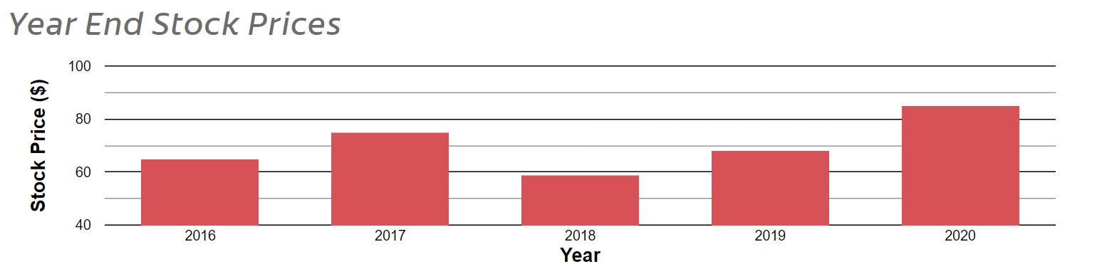

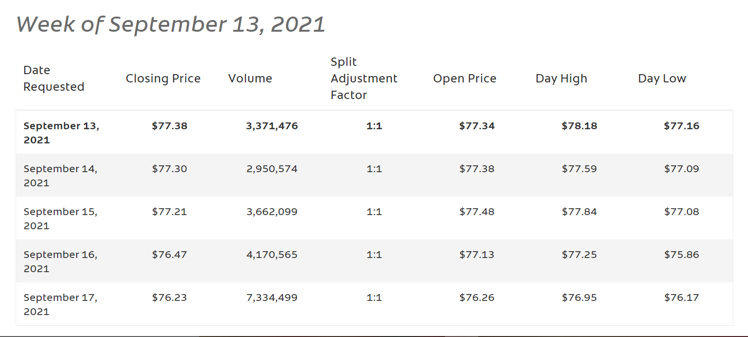

COLGATE ACQUISITIONS:
23 January 2020 | Hello Products
18 December 2017 | EltaMD
18 December 2017 | PCA Skin

ECONOMIC ANALYSIS:
What Type of Market Does Colgate Operate In?
Colgate operates in a monopolistic competition. There are a large number of buyers and a large number of sellers. These sellers are price takers and produce similar but differentiated products. Although Colgate has a considerable market share (nearly 42%) and brand favourability and loyalty it cannot afford to increase prices. This is because there are a lot of substitutes available in the market. At the end of the day people do not give much thought to their toothpaste and would much rather buy a relatively low costing toothpaste than the pricier one they prefer. However, there are also consumers that will not switch to another brand since they ae satisfied with Colgate and wat to be loyal to their toothpaste brand.
Product Differentiation:
It provides protection against cavity where toothbrushes cannot reach. It provides total protection for 24 hours. It is also the only toothpaste that has been granted a Seal of Acceptance from the American Dental Association for helping to prevent cavities, gingivitis, plaque and tartar build-up, and to whiten teeth. Colgate Total is also the #1 most often recommended and personally used toothpaste by dentists and hygienists.

Type Of Product:
Toothpaste is an essential product. It is a necessary good. These are goods/commodities consumers use in their usual routine and need every day. Toothpaste is relied on consumers as a hygienic necessity and indirectly also a medical necessity. Oral hygiene has become a significant part of consumers daily lives especially in the pandemic where hygiene in itself has become a very important aspect. This is also owed to the fact that various studies were carried out to study the effects of toothpaste on killing germs related to SARS-CoV-2. A study was also carried out to study the effects specifically of Colgate toothpaste on germs related to SARS-CoV-2.
However, the brand itself is not so good that it is essential in itself. In other words, it can be easily substituted. Hence, which is why I have stated further that Colgate toothpaste has a relatively elastic demand and yields to changes in real income of the consumer.

DEMAND CURVE:

Price

Quantity Demanded

Since the competition is monopolistic the demand curve for Colgate is downward sloping.

P2
P

P1

Q2 Q Q1
As the price is increased consumers turn to substitutes and hence quantity demanded falls. Similarly, when price falls quantity demanded rises because consumers now want the relatively lower priced product, i.e., the toothpaste.
Hence, due to availability of substitute toothpastes in abundance demand for Colgate is relatively elastic. A small change in price will cause a greater than change in quantity of Colgate toothpaste demanded.

Therefore, Colgate being a leading brand in oral health care with a substantial market share cannot be arbitrary in its prices. It is a price taker. It cannot dictate prices as is convenient since there is tough global competition. Like all the enterprises in its industry Colgate too answers to the market forces of demand and supply.

DETERMINANTS OF DEMAND:

- Price of the product:
As price of the product rises quantity demanded falls.
The second Colgate decides to increase its price its top competitors will find the opportunity to increase their sales and thereby their revenue and in all the turnover profit.
In 2009 when Colgate had a market share of 47%, it raised prices of its products by 4%, when its top competitors Hindustan Unilever Ltd and Proctor & Gamble were cutting down prices between 4%-20%. The new stock of Colgate Strong Teeth toothpaste was priced Rs.56, Rs.2 more than the previous price of Rs.54. The 200gm pack was its best-selling toothpaste. According to the Mint newspaper, the company had increased prices of some brands by at least 4% and more such hikes were likely to occur soon. The 200gm pack was a large contributor to Colgate’s revenue (Rs. 400 crores out of Rs. 1500 crores, Mint). The company wanted to “fetch” better margins. The price hike came as a surprise to analysts since prices of raw materials were stable. Moreover, there was also relief in excise duty announced by the government.
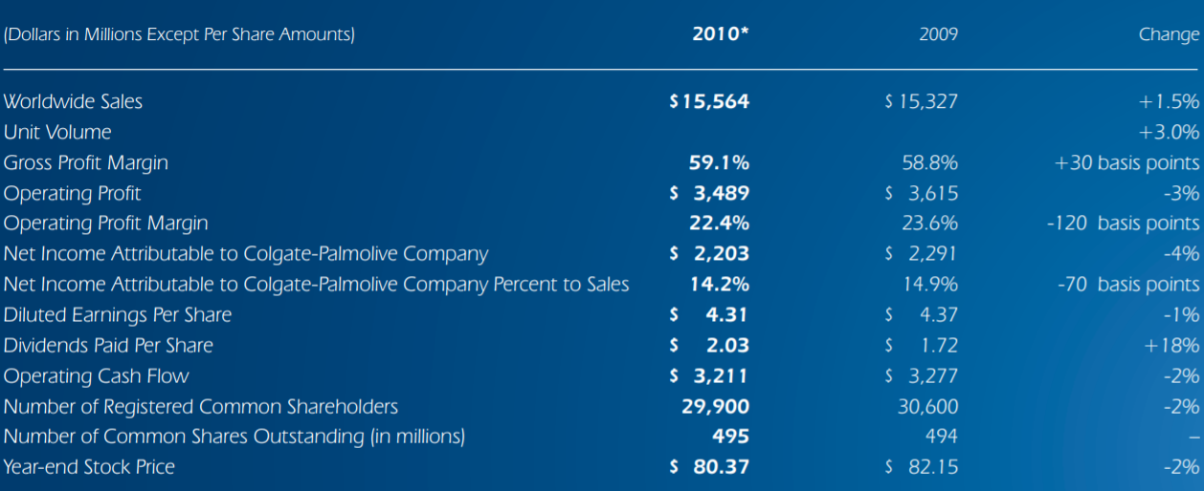

As in the above picture we can see that the worldwide sales increased by a meagre 1.5% and the gross profit by an even smaller 0.2%. But the operating profit, net income to the parent company, diluted earnings per share, operating cashflow, and stock price at the end of the year all fell within the 1% to 4% range.
But if worldwide sales increased what caused the subsequent fall in various fundamentals?
One can argue that the price hike forced the consumer to substitute the product within the Colgate family of toothpastes. However, the revenue from this sale did not contribute as hugely as the sale of the Colgate Strong Teeth would have possibly.
Even so, this is simply a theory. There could have been various other market and economic forces that could have caused this anomaly.

- Income level of consumers:
Colgate produces, markets and distributes consumer products. A rise in income in turn leads to a better standard of living. A better standard of living is brought upon by an increase in demand of consumer goods. Similarly, a fall in income will cause potential consumers to compromise on consumer products and demand lesser of it. Marginal utility determines the proportional change in demand levels.
Income level of most of the consumers is the middle-class range as we can infer from the questionnaire. Any reduction in the real income of the customer will cause the customer to sought to cheaper more adjustable toothpaste. Even though toothpaste is an essential commodity this is possible due to availability of substitutes in abundance.

- Consumers tastes and preferences:
Buyers taste and preferences plays a very important role in quantity demanded of a commodity. Advertisement plays a significant role in driving this demand. Goods which are thoroughly and properly advertised show a positive demand trend. Colgate is one of the toothpastes which are aggressively and strategically advertised. It does not try to claim the entire consumer population but choses a part of it and dominates it shrewdly. We will talk about this in further points.

- Buyer’s expectation of the price:
If the consumer expects the price of Colgate toothpaste to rise in the future, they will demand more of it today and vice versa. But does this really happen? With toothpaste? Does mum go the supermarket and come back with a basket case of Colgate toothpaste because the price over the weekend is probably going to reach a market high? Is the target audience for this brand even going to speculate a price change? No. What it will probably do if it even notices a price change is probably compromise or stay loyal to the brand. Which is why Colgate has always made an increase in price discreetly.

- Government policies:
Government policies often affect commodities prominently. They can either cause an adverse or positive affect. For example, a leeway in tax subsidies has a positive effect on the commodity.
When GST was introduced, it enabled Colgate-Palmolive (India) Ltd to lower its prices in the year 2017. "GST has enabled Colgate-Palmolive (India) to extend to its consumers the benefits of reduction in MRPs by 8 to 9 per cent, for the key categories of toothpastes and toothbrushes," the company said in a statement. FMCG firms including Colgate were extending the tax benefits under the new GST regime to customers either by reducing the prices or by increasing the weight of the product while keeping the price unchanged.

- Price of complementary and substitute goods:
Complimentary goods: Complementary goods are goods that go in combination. A rise in price of one causes a decrease in demand of the other. But an increase in the price of toothbrushes will not cause a person to use toothpaste stringently. Hence, we can conclude that toothpaste is not a complementary good to any commodity.

Substitute goods: Substitute goods are commodities that can be replaced with another commodity. In our case if we increase our price to the dislike of consumer’s they can choose to substitute Colgate toothpaste with other toothpaste brands such as Meswak, Close-up, Pepsodent etc.

INCOME ELASTICITY OF DEMAND:
What Is Income Elasticity of Demand?
Income elasticity of demand refers to the sensitivity of the quantity demanded for a certain good to a change in the real income of consumers who buy this good.
Ey = % change in quantity demanded ÷ % change in real income
Highly elastic goods will see their quantity demanded change rapidly with income changes, while inelastic goods will see the same quantity demanded even as income changes.
But Colgate has a lot of substitutes, this causes a rapid shift if there is any major change in real income of the customer as this will cause them to move to cheaper brands available in the market. There is substantial part of the pie whose income is in the middle-class range which is the current target audience of Colgate-Palmolive. The middle-class income as seen in the questionnaire lies between Rs. 50,000-1,00,000. When the pandemic hit, a lot of jobs were lost, however I understand that that was the result of the supply restraint imposed by the government and not what caused the reduction in sales in 2020.

CROSS ELASTICITY OF DEMAND:
Cross elasticity demand, also known as XED, is the measurement of the sensitivity of quantity demanded for one good to the change in the price of another good.
XED = % change in quantity demanded of good A ÷ % change in price of good B

COVID-19 IMPACT ON COLAGTE COMPANY:
The covid wave has not spared this industry. The supply chain everywhere has been disrupted causing numerous manufacturing plants to shut down. It has also caused a lot unemployment. Under government laws the manufacturing activities have been severely subdued. Since production at the start is adversely affected supply has been lower than the previous optimum. This has caused negative outcomes for many companies.
According to the Times of India data released in May 2020, Colgate-Palmolive (India) sales plunged by 7.4% to $150.87 million, with a volume reduction of 8%.
When the pandemic hit, a lot of jobs were lost, however I understand that that was the result of the supply restraint imposed by the government and not what caused the reduction in sales in 2020.
Quarter ended June 30, 2020
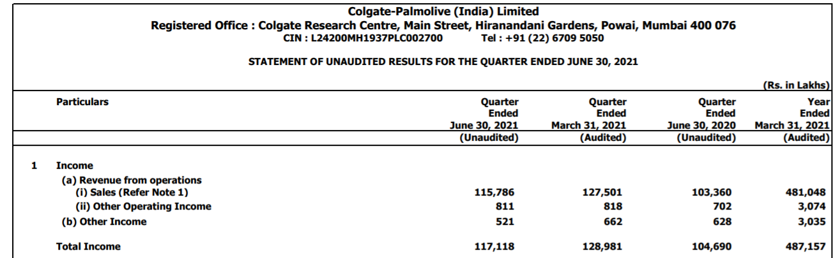

Quarter ended June 30, 2019
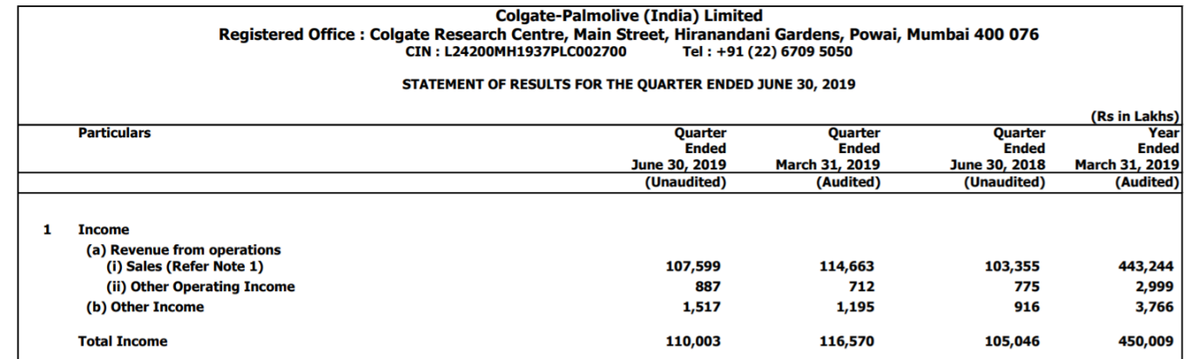

As we can see from the above data, the revenue from operations fell from Rs. 1,07,599 in June 30, 2019 to Rs. 1,03,360 on June 30, 2020.
"We had plants and distribution channels shut down for almost two weeks. They're obviously coming back online as we speak, but that had a significant impact at the back end of the quarter and has had a significant impact in April," said Noel Wallace, President & CEO, Colgate-Palmolive on a Q12020 earnings call.
Globally, the company announced that it had chosen to withdraw the annual guidance for 2020. "This was not an easy decision for us. However, given the combined uncertainty surrounding the future impact to COVID-19 and government actions to stem the spread of the virus, we believe this is the correct choice," said Wallace.
On the pandemic, CPIL said it has a "major impact on shopper and consumer behaviour" and the subsequent lockdowns and re-openings affected trade and retail operations.
Moreover, there has been an evident change in the relevance of channels in the Indian FMCG retail landscape and CPIL has responded in an agile and seamless manner, it added.
The e-commerce channel continued its exponential growth trajectory.
It had launched a DigiOrder App for these retailers to send their orders to CPIL’s partner distributors.
While the pandemic has had an impact on the supply part of Colgate as an enterprise, the demand side is expected to be unaffected, according to the company.
This is because the product, i.e., Colgate toothpaste is viewed as an essential product. People aren’t going to wake up and not brush their teeth because there is pandemic. The thought may have crossed their minds, but hopefully passed just as fast.
Although it is an essential product, the Company must keep in mind the strain this pandemic has brought upon people’s pocket. Raising prices during these times to meet increased cost is not optimal unless the competition too agrees on a price hike. More research needs to be put in to enhance the product and sales in these tough times.
Essential products usually do not see a decline in demand due to raised prices, but Colgate along with being an essential commodity is also substitutable with other cheaper brands. Hence, the demand for this brand of toothpaste, as stated earlier is relatively elastic.
Therefore, if any price hike needs to be done it would be ideal to harmonize it with that of the competition.

SOCIETAL CONTRIBUTIONS DURING THE PANDEMIC:
Colgate has launched a research program that includes clinical studies among infected people to assess the effectiveness of certain oral care products in temporarily reducing the amount of the virus in the mouth. Laboratory studies sponsored by the company show that toothpastes containing zinc or stannous and mouthwash formulas with cetylpyridinium chloride (CPC) neutralize the virus that causes COVID-19 by 99.9 percent.
It has mobilized five of their manufacturing plants on three continents to produce the new soap, which is specially packaged with instructions on proper handwashing to amplify the World Health Organization (WHO) #SafeHands message. They are working with partners including CARE, Save the Children and DHL to distribute the products around the globe.
To create greater awareness for proper handwashing, they are promoting the #SafeHands Challenge across various media platforms and also engaging global ambassadors and influencers. They have also mobilized our Bright Smiles, Bright Futures® dental vans in the U.S. to distribute the health & hygiene products to communities in need.

Donating $20 Million in Health and Hygiene Products to Community-Based Organizations:
They are providing $20 million in health and hygiene products to community-based organizations that are distributing the donated product to those most in need in local communities. Local Colgate teams are also supporting the most vulnerable populations including front line medical and emergency care workers through donations of health and hygiene products including 1 million bars of Protex soap in Thailand, skin care products from EltaMD and PCA Skin in the US, and products to the Red Cross in Southern Europe and other organizations including the Good+ Foundation, NHS, Good360, Habitat para la Humanidad, Salud Pública RD and United Way. PCA Skin also donated proceeds of its Daily Care Mask sales to assist in the production of Personal Protective Equipment. (PPE). In New York, Colgate has donated health and hygiene products to local hospitals including Memorial Sloan Kettering and Mount Sinai, medical professionals, and non-profit organizations serving the homeless. They are also supporting small businesses by offering protection kits/screens in Peru and the Dominican Republic.

Supporting Healthcare Professionals and Small Business:
To help aid healthcare professionals on the front lines, Tom's of Maine has donated $60,000 and nearly $500,000 worth of personal care products to Direct Relief, a humanitarian organization providing protective gear and supplies to communities hardest hit by COVID-19. The organization is also supporting 50 small businesses across the U.S. through its #NatureNurtures video experiences to help us all feel more connected, mindful and healthy.

SUPPORTING ANIMAL WELFARE PARTNERS
Their Hill's Pet Nutrition team has a strong commitment to animal welfare programs around the world. Hill's Disaster Relief Network in the U.S. has donated 36,000+ pounds of nutritional support to more than 55 organizations including shelters, pet food pantry partners, veterinary hospitals, and other non-profits that support animal welfare. Hill’s has also partnered with The Association for Animal Welfare Advancement to provide $400,000 in grants to animal shelters impacted by COVID-19. In Italy, Hill’s has donated 2325kg of nutritional support to facilities in the northern Lombardy region. In Brazil, we've donated six months of food to under-resourced pet shelters.

Launching Global Employee Matching Gifts Program to Support Relief:
Colgate launched an employee matching gift campaign for all 34,000 Colgate employees around the world. Colgate is matching $1 million in employee donations, which will go to non-profit partners supporting those in need, such as WHO, Save the Children and CARE, among others.

COLGATE PLAMOLIVE SUPPLY CHAIN MANAGEMENT:
A very important part of being a leader in an industry is following a pragmatically-designed strategy that harmonizes the corporate’s mission, vision, values, goals and objectives so that it can gain a long-term competitive position in the market. The supply chain strategy has to be properly aligned with the business strategy as it forms the vital element of any enterprise.
An enterprise which does not have a properly-integrated Supply Chain Management strategy is unable to successfully meet the demands of its target market.
What does SCM do?
It makes sure that logistics are planned out in advanced to ensure:
- Efficient supply of raw materials
- Minimal level of inventory is maintained
- Operating cost of supply chain is diminished
These measures ensure that an organization is able to generate an appropriate amount of profit and maintain its strong position in the industry.
Business strategy is the basis on which most of the companies want to compete in the market and gain competitive edge for a long period, therefore it is believed that SCM strategy is highly dependent on the business strategy.
Since the past year there has been a diminished supply of raw materials. This brunt is being faced by FMCG companies worldwide. It has become important for every organization to enter into contractual agreements with the suppliers so that it can minimize its risk of facing any raw material shortage in its business tenure.
With the help of variable cost agreement, both the buyer and seller will have a win-win situation; each party will get exposure to the advantages of changes in the price. The seller is protected from the increase in price that could have eroded the margins and the buyer can avail the low-priced product if the price of commodity declines during the period of a contract (Business for Social Responsibility, 2008).
Initially, Colgate-Palmolive had a decentralized structure which was causing many problems in its business operations especially in its SCM. In 1999, it refurbished its technological infrastructure to provide for coordination of each and every function throughout the organization across all of its operational activities on a global level.
The global SCM system of Colgate-Palmolive has been replaced with SAP R/3 solution so that it can capitalize on its resources along with enhancement of the global SCM management so that the retailers, customers and management are provided service of superior quality, inventory cost is controlled to a great extent and revenue stream started to increase at a good pace (Blanchard, 2010).

COLGATE-PALMOLIVE VISION AND CORE VALUES
The vision statement of Colgate-Palmolive is “To offer products on the basis of three core values, i.e., global teamwork, caring attitude and improvement on continuous basis”. The core values of the company are:
- To offer growth opportunities to the company’s employees both on professional and personal levels.
- To fulfil all Corporate Social Responsibilities as a key member of the community on global level.
- To enhance the value of shareholders.
- To develop processes and policies that will ensure that the company is able to strengthen its position in the market and respective industry.
- To explore all latest initiatives and opportunities that are existing in the market.

SUPPLY CHAIN STRUCTURE OF COLGATE-PALMOLIVE
To tackle the main problem Colgate-Palmolive, Colgate’s global supply chain system was developed.

There three key supply chain strategies that formed the basis of this system:
- The first one was the introduction of the Vendor Inventory Control (VMI) product so that there was a decline in the inventory channel and timing of the cycle as well.
- The second strategy was the implementation of a resource planning system at cross-border level so that regional models were developed for the international patterns; it ensured that the company had adequate pool of assets so that there was a balance with the company’s business strategy.
- The last and final strategy was implementation of a collaborative program that ensured there was a well-balanced downstream business system for effective management of the market demand of supply chain along with effective coordination of the system’s activities.
Advantages:
- Everyone in the organization is well-aware of the supply chain statistics.
- Technological upgradation boosted the SCM which aided in accessing supply chain information with proper accuracy, ensuring consumers were rendered easy access to the products.
- Shortage problems was reduced by 50% in the first three months of the SAP R/3 implementation.
A well-coordinated SCM system is vital as it what blends together the company’s supply chain strategy and the business strategy. They both need to complement each other, which is ensure by the SCM. With a practical SCM in place, a few of the many advantages are; effective product planning and inventory management, the company itself, consumers and the partners can have faster and punctual orders thereby increasing order fulfilment rate at a higher level. Moreover, the performance of Colgate can be efficiently monitored.
The COVID-19 pandemic highlighted the connection between production operations and the supply chain. In response, Colgate-Palmolive is connecting asset health and the supply chain to free up capital for strategic growth.

DETAILED SUPPLY CHAIN MANAGEMENT ANALYSIS
The growing need for transparency is particularly relevant for plant-level operators and systems integrators because it often requires more integration between supply chain software and manufacturing execution systems (MES) to extract granular data such as equipment health and material availability that can help to more accurately gauge a facility’s true capacity. If there is a proper way of acquiring this data and dispatching it to supply chain partners as and when events occur, it can aid the suppliers in efficiently procuring items and in turn build up the company’s inventory activities.
Colgate-Palmolive is a good example of connecting manufacturing operations to the supply chain. According to Warren Pruitt, vice president, global engineering services, the company has been strengthening its supply chain management through thorough technical upgradation.
The predictive maintenance model employed by the company “preserves machine health through 24/7 monitoring via wireless sensors combined with analytics powered by artificial intelligence (AI),” said Pruitt.
The wireless sensor data is fed into Augury’s machine health software platform by the corporate. Pruitt said that this enables Colgate-Palmolive’s machine data to be compared with machine data from more than 80,000 other machines connected to the Augury platform around the world.
“That massive analytical scale brings us insights on how to optimize the performance of equipment and make ever-smarter choices on how and where we deploy it,” Pruitt said. “What’s possible only gets more compelling as this AI solution harnesses more data to create better health outcomes for our machines and our business.”
The sensors used in the Augury Machine Health system were retrofitted onto Colgate-Palmolive’s existing equipment to capture vibration, temperature, and magnetic data and transmit it to the Augury platform.
Pruitt explained that Colgate-Palmolive uses Augury’s sensors on a variety of rotating equipment, such as homogenizers, mixers, pumps, case packers, fillers, cartoners, conveyors, and agitators.
Sensor data is transmitted via Wi-Fi to the Augury Machine Health platform in the cloud. With the data in the system, Augury’s AI algorithms can diagnose machine malfunctions to create what Augury calls the “baseline.”

IMPROVEMENTS THROUGH SCM:
An example of how Augury’s Machine Health system optimized production is when Pruitt noted that the system’s AI detected rising temperatures in the driver of a tube maker and alerted the plant team. A quick inspection revealed a problem with the water-cooling system. It was efficiently resolved thereby preventing the drive from failing due to overheating, which would result in a halt in the tube production line which would in turn lead to incurring replacement costs. This saved 192 hours of downtime, 2.8 million tubes of toothpaste in output, $12,000 for a new motor and $27,000 in variable conversion costs.
Another instance is when the Machine Health’s AI provided an early warning that a gearbox in a liquids machine was experiencing structural and operational issues, putting it at high risk of failure that could shut down the line. A replacement gearbox was ordered by the team. Maintenance was planned to swap it in and bring the machine to acceptable conditions with minimal interruption. Pruitt said, “The benefits of having real-time access to machine health analytics have been so powerful, we’re going to roll out this technology across our global supply chain.”

DETERMINANTS OF SUPPLY:
- Cost of production:
There is an inverse relationship between supply and cost of raw materials. As cost of raw materials increases the quantity of commodity that can be supplied reduces. And as the cost of raw material decreases the quantity of commodity that can be supplied rises. In the pandemic, not only did cost of raw materials increase but also supply chain itself was hit, therefore the quantity of Colgate toothpaste that could be supplied was relatively low.
- Productivity:
As the productivity in a corporate increases so does the supply of commodity. As it degrades the quantity of commodity supplied also diminishes. There is a direct relationship between productivity and supply. Colgate-Palmolive gives great importance to productivity and innovation. It owes it significant market share to constant innovation and entrepreneurial vision which it prides itself on.
- Technology:
As technology enhances, productivity increases which in turn increases quantity of commodity that can be supplied. When there is no technology upgradation processes of production along with machinery employed becomes redundant thus increasing the cost of production. Colgate-Palmolive realizes this and pays attention to practice technological upgradation and product improvement.
- Taxes and Subsidies:
What are taxes and what are subsidies?
Taxes: charges levied by government.
Subsidies: grants rendered by government.
Tax and supply ha e an inverse relationship whereas subsidies and supply have a direct relationship. When taxes levied by the government are increased it puts a strain on supply as it increases cost of production. However, when subsidies are offered it reduces the cost of production and thereby quantity of commodity that can be produced increases causing supply to rise.
- Transport:
Transportation conditions seriously affect supply of a commodity. Even if the price of a commodity increases, if good transportation conditions do not prevail the supply of commodity is adversely affected. Hence, even when price rises, supply cannot be escalated when such situations exist.
- Factor prices and their availability:
What are factors?
Inputs such as raw materials, equipment, and machinery required at the time of production are termed as factors.
When there is availability of factors of production and they are priced favourably to the supplier the cost of production lowers which thereby increases quantity of commodity that can be supplied. When these factors are scarce and expensive the cost of production increases which causes quantity of commodity that can be supplied to reduce.

IMPROVED PRODUCTIVITY:
Colgate-Palmolive has always been ahead with innovation. As it operates globally and faces competition on an international level it has to have progressive technological upgradation. Any company that functions on a worldwide platform has to upgrade its technology in order to lower costs and make product improvements to gain a competitive edge. For this it needs a strong research and development team and a visionary mind. Colgate-Palmolive knows this and has been incorporating this since birth. It always comes up with newer better products and cost-effective production strategies. It focuses on discounts and offers, box sets, aesthetic etc. which are a few of the main reasons customers buy Colgate toothpaste.

COLGATE-PALMOLIVE ADVERTISEMENT STRATEGY:
The major reasons for Colgate-Palmolive’s global success and incredible market share is good marketing strategies and intelligent branding. The company applies effective marketing strategies according to its market segmentation, demographic, psychographic, and consumer behavioural patterns.
Top 5 Marketing Strategies for Colgate-Palmolive:
- Collaborating with influencers
- Location based targeting
- Creative packaging with a strong message
- Build trust
- Reflecting the innovations

Currently, the advertisements for Colgate are centred towards the middle-class families, especially mothers, even though the product, i.e., the Colgate toothpaste can be used by almost everyone in the familial spectrum. There is a good reason behind this. For this lets first understand the difference between customer and consumer. As a kid we were the consumers of the snacks we ate bought from stores by our parents and/ or grandparents, the customers.
Therefore,
Consumer: user of the commodity
Customer: person who purchases afore mentioned commodity.
Coming back to our advertisement, they are focused towards mums because they are usually the ones protecting and caring for the family. Colgate-Palmolive designs their advertisements in such a way that it reaches to mothers everywhere in the country and relays the message that Colgate is the best toothpaste for your child and family and by choosing it you are safeguarding the oral health of your loved ones.
Colgate-Palmolive (India) Limited spent Rs 625.53 crore on advertising during the fiscal ended 31st March 2021 compared to Rs 626 crore in the previous fiscal. For the quarter ending March, the company's ad spends stood at Rs 148.89 crore as against Rs 155.5 crore.
The company reported Net Sales growth of 20% over the same quarter of the previous year aggregating to Rs. 1,275 crores for the quarter ended March 31, 2021. Domestic net sales for the quarter reported a strong momentum of 20.2% growth. Reported Net profit after tax for the quarter was Rs. 314.6 crore as against the Net Profit of Rs. 204.1 crore for the same quarter of the previous year, a growth of 54.1%.
Net Sales for the year ended March 31, 2021 was recorded at Rs. 4,810.5 crore, an increase of 7.2% over the same period of the previous year. Reported net profit after tax for the year was Rs. 1,035.4 crore, an increase of 26.8% over the previous year.
Net Sales at Rs 1,165.97 crore in June 2021 up 12.05% from Rs. 1,040.62 crore in June 2020.
Quarterly Net Profit at Rs. 233.23 crore in June 2021 up 17.69% from Rs. 198.18 crore in June 2020.
During the pandemic of 2020 which is still going on, due to the initial shock; the company suffered as mentioned earlier. But to turn this around it made many improvements such as the DigiOrder App, increasing advertisement etc. as described earlier in the analysis. These all contributed to the boosted net sales, gross profit margin and net profit in 2021’s successive quarters. This tells us that innovative strategies for advertisements and building pathways to reach consumers goes a long way in strengthening sales and keeping a sustainable growth rate (the profit in this fiscal year offsetting the loss of the previous financial year).

SWOT ANALYSIS:
STRENGTH:
- Indigenous marketing:
Unlike most of its competitors, Colgate-Palmolive owns its manufacturing facilities (60 facilities are owned by them) and manufactures all their products in the very facilities owned by them. These make their products indigenous. It also ensures higher operational efficiency.
- Its history:
Colgate was founded in 1806 which well more than 200 years ago and thus enjoys a long standing in respect to its competitors. Pioneering in research it is one of the oldest companies in the market globally in its industry. It has been voted as one of the best places to work in by Forbes and received a lot of awards.
- Brand significance:
Being the longest running and pioneer in its industry has accredited Colgate-Palmolive with outstanding goodwill. Moreover, due to its innovation, technological upgradation and product improvements, Colgate-Palmolive enjoys the trust of various members of society such as investors, customers, government, and the general public. Due to its product being good and affective as inferred from the questionnaire, Colgate-Palmolive enjoys superior brand loyalty as compared to its competitors.
- Clear positioning:
Colgate-Palmolive was the first to recognize the need to make different types of toothpastes to satisfy the various types of consumers. This gave it a clear-cut advantage in the market and also a competitive edge. The fact that it designed its toothpaste to suit the various needs of the consumers gave it a huge market influence.
- Testimonials:
As the questionnaire highlights Colgate enjoys huge customer satisfaction and brand loyalty. We also know Colgate uses significant advertisements, in these advertisements Colgate the testimonials of customers which tip the scales in their favour. This is because positive feedback goes a long way.

WEAKNESS:
- Brand dilution/ Substitution:
Nowadays, competitors are coming up with new toothpastes to satisfy various needs. This makes the brand more diluted as it can now easily be substituted with other toothpastes. Colgate now is losing its edge in this aspect to its competitors. The market is getting diluted with many toothpastes satisfying the same need.
- High operational cost:
The global competition is intense. Colgate has to figure out latest technology, increase productivity, increase research and development, and advertise according to changing times. This requires a lot of capital and personnel, moreover, these do not guarantee results. So, Colgate does not only have to bear these costs but also always be under the risk that these measures will not bear fruit.

OPPORTUNITIES:
- Unexploited rural opportunities:
In most industries rural areas represent a market to explore since these are the regions that are least distributed in. Once the product has settled it can be introduced to the rural area. The biggest rural markets are in China and India and these offer huge potential for companies who operate in the personal and oral care segment. The competition here is not yet intense and can be ventured into since the company has a good base to rely on.

THREATS:
- Competition:
The company faces intense competition from other brands in the industry such as Meswak, Pepsodent, Close-up, Dabur etc.
- Growing apprehension on chemicals:
Nowadays, consumers are weary of chemicals, especially in consumable goods. They prefer ayurvedic and organic products.

INFERRENCE FROM THE QUESTIONNAIRE AND STUDY:

All in all, Colgate toothpaste has been doing very well for itself despite the intense competition it has maintained its substantial market share, even when the pandemic hit it was able to bounce back quickly from its adversities, it rarely increases its prices and even when it does it is by miniscule measures.
From the questionnaire we can concur that most of the consumers, prefer Colgate than other toothpastes. The main reason for consumers purchasing a certain brand of toothpaste is its taste and aesthetic. Most of the consumers chose Colgate and everyone was either satisfied or more than satisfised.
I added a particular question in the questionnaire asking if consumers had multiple uses of toothpaste. Almost everyone used Colgate toothpaste for more than one purpose of oral hygiene. This was so I could understand its elasticity. Products with more than one use generally have elastic demand. So even though toothpaste is an essential commodity its has an elastic demand not only due to excess availability of substitutes but also because of its property of multiple uses.
Currently, Colgate toothpaste is doing alright but it needs to buck up. For the huge amounts of capital, it spends on budgeting it has been publishing on publishing on outdated platforms such as television, physical newspapers and radio. It needs to push its advertisements on more rising platforms such as apps, websites, dentist clinics etc. Most consumers prefer to buy box sets, so it should invest in making box sets more lucrative and pragmatic. It needs to come up with more ayurvedic, organic and vegan lines of toothpastes since that is what consumers prefer these days. For this very reason Patanjali is its top competitor. They provide ayurvedic toothpastes at low prices. Colgate always had the edge in making different toothpastes for a variety of consumers, if it does not rise up to this challenge it will most probably lose its competitive edge and superior market share.
The limitations of Colgate are that it has a very humungous cost of production and high advertisement cost. It runs the charge of owning all its manufacturing facilities and also making huge technical upgradation as stated earlier in SCM. It also pours a lot of capital into research and development which will put a strain on balance sheet lest the sales reflect the investment.

Bibliography

- Colgate-Palmolive – Global Household & Consumer Product
www.colgatepalmolive.co.in
- The History of Colgate Toothpaste Marketing Essay
www.ukessays.com
- Colgate (toothpaste) - Wikipedia
en.wikipedia.org
- SWOT analysis of Colgate Palmolive - Colgate Palmolive SWOT analysis
www.marketing91.com
- https://www.automationworld.com/process/plant-maintenance/article/21549899/colgatepalmolive-focuses-on-machine-health-to-improve-supply-chain-operations
- Supply Chain Strategy Of Colgate Palmolive Commerce Essay
www.ukessays.com

