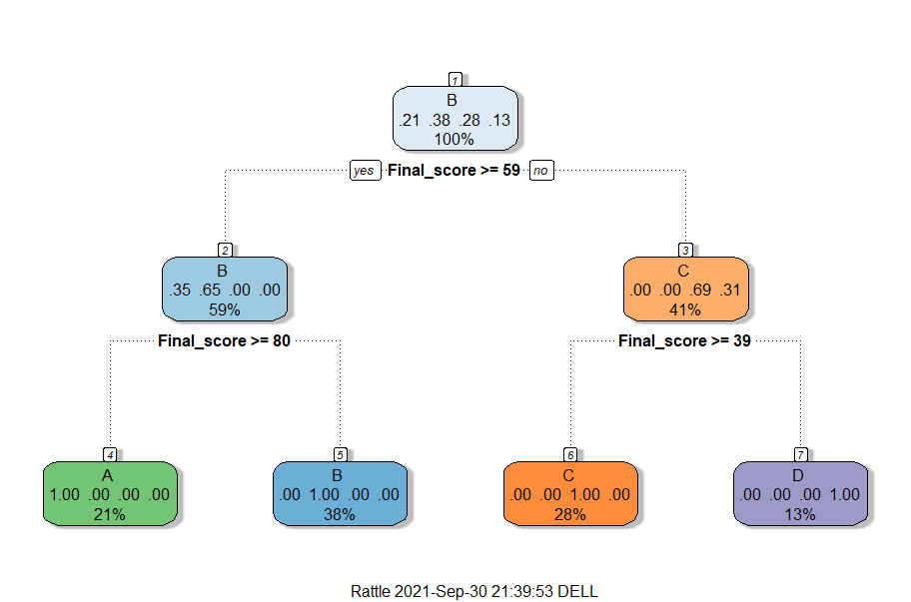
1. Determine the grade of the students.

Accuracy=0.9230769

2. The percentage of marks obtained.
Correlation = 0.8964672
percentage
4 13 14 15 16 18 19 22 23
0.7146103 0.7037098 0.6542524 0.6542524 0.6846721 0.2372183 0.8438882 0.7143663 0.8558366
25 28 32 45 49 56 63 72 77
0.4983715 0.4956642 0.8690280 0.7334175 0.2181197 0.5496789 0.2844418 0.7195118 0.4970717
79 80 81 86 95 99 101 103
0.5072693 0.7194266 0.2715764 0.6862884 0.4843497 0.2711403 0.7071876 0.6915728

