INSTITUTE OF ACTURIAL SCIENCE AND QUANTITATIVE FINANCE

INFLATION VS GROWTH: BALANCE

Jas rathi
Roll no : 439

INDEX

COVER PAGE……………………………………………………………………………………………………………….. 1

INDEX…………………….……………………………………………………………………………………………………. 2

ABSTRACT…………………………………………………………………………………………………………………… 3

INTRODUCTION………………………………………………………………………………………………………….. 4

INFLATION………………………………………………………………………………..………………………………… 5-7

ECONOMIC GROWTH…………………………………………………………………………………..……………… 8

RELATIONSHIP BETWEEN INFLATION AND GROWTH……..…………………………………………….9- 10

METHODOLOGY……………………………………………………………………………………………………….. 11-14

CONCLUSION…………………………………………………………………………………………….………………… 15

BLIOGRAPHY………………………………………………………………………………………………………………. 16

ABSTRACT

The relationship between inflation and growth has been investigated by several researchers around the world. However there has been various conflicting results. The specific objective of this investigation was to determine the influence that inflation has on growth. Using empirical evidences, I have tried to assess the relationship between growth and rate of inflation in our country.

INTRODUCTION

Economists known as monetarists believe that inflation is caused by overexpansion of the money supply. This means that the Federal Reserve, the country's central bank, creates more money than the economy needs for steady growth, and this excess leads to higher prices
Inflation began ratcheting upward in the mid-1960s and reached more than 14 percent in 1980. It eventually declined to average only 3.5 percent in the latter half of the 1980s.
Inflation can be good or bad, depending on how fast the price level rises. A moderate increase of 1%-to-2% a year generally does little harm to the economy. But when inflation really takes off, it hurts people and businesses by eroding the purchasing power of money. Consumers rush to buy things before prices climb higher, which makes them rise even faster. Inflation is especially hurtful to retired people on fixed incomes who can’t hope to keep up with the rising cost of living.

What Is Inflation?

Inflation is the decline of purchasing power of a given currency over time. A quantitative estimate of the rate at which the decline in purchasing power occurs can be reflected in the increase of an average price level of a basket of selected goods and services in an economy over some period of time. The rise in the general level of prices, often expressed as a percentage, means that a unit of currency effectively buys less than it did in prior periods.
Inflation aims to measure the overall impact of price changes for a diversified set of products and services, and allows for a single value representation of the increase in the price level of goods and services in an economy over a period of time.

As a currency loses value, prices rise and it buys fewer goods and services. This loss of purchasing power impacts the general cost of living for the common public which ultimately leads to a deceleration in economic growth. The consensus view among economists is that sustained inflation occurs when a nation's money supply growth outpaces economic growth.

What Causes Inflation?

There are three main causes of inflation: demand-pull inflation, cost-push inflation, and built-in inflation. Demand-pull inflation refers to situations where there are not enough products or services being produced to keep up with demand, causing their prices to increase.
Cost-push inflation, on the other hand, occurs when the cost of producing products and services rises, forcing businesses to raise their prices.
Lastly, built-in inflation—sometimes referred to as a “wage-price spiral”—occurs when workers demand higher wages to keep up with rising living costs. This in turn causes businesses to raise their prices in order to offset their rising wage costs, leading to a self-reinforcing loop of wage and price increases.

Is Inflation Good or Bad?

Too much inflation is generally considered bad for an economy, while too little inflation is also considered harmful. Many economists advocate for a middle-ground of low to moderate inflation, of around 2% per year.
Generally speaking, higher inflation harms savers because it erodes the purchasing power of the money they have saved. However, it can benefit borrowers because the inflation-adjusted value of their outstanding debts shrinks over time.

WHAT ARE THE EFFECTS OF INFLATION ON AN ECONOMY?
Inflation has both Negative and Positive points which are as follows.
- Negative
• Add inefficiencies in the market, and make it difficult for companies to budget or plan longterm
• Can impose hidden tax increases, as inflated earnings push taxpayers into higher income tax rates.
• Cost-push inflation - Rising inflation can prompt employees to demand higher wages, to keep up with consumer prices. Rising wages in turn can help fuel inflation.
• Hoarding - People buy consumer durables as stores of wealth in the absence of viable Alternatives as a means of getting rid of excess cash before it is devalued, creating shortages of the Hoarded objects.
Hyperinflation - If inflation gets totally out of control (in the upward direction), it can grossly interfere with the normal workings of the economy, hurting its ability to supply.
- Positive
• Labor-market adjustments - Inflation would lower the real wage if nominal wages are kept constant, Keynesians argue that some inflation is good for the economy, as it would allow labor markets to reach equilibrium faster.
• Debt relief - Debtors who have debts with a fixed nominal rate of interest will see a reduction in the "real" interest rate as the inflation rate rises

ECONOMIC GROWTH

Economic growth can be defined as the increase or improvement in the inflation-adjusted market values of the goods and services produced by an economy over time. Statisticians conventionally measure such growth as the percent rate of increase in the real gross domestic product, or real GDP.

Growth is usually calculated in real terms – i.e., inflation-adjusted terms – to eliminate the distorting effect of inflation on the prices of goods produced. Measurement of growth uses national income accounting. Since economic growth is measured as the annual percent change of gross domestic product (GDP), it has all the advantages and drawbacks of that measure. The economic growth-rates of countries are commonly compared using the ratio of the GDP to population (per capita income).

The "rate of economic growth" refers to the geometric annual rate of growth in GDP between the first and the last year over a period of time. This growth rate represents the trend in the average level of GDP over the period, and ignores any fluctuations in the GDP around this trend.

What is the relationship between inflation & economic growth?

- If economic growth is caused by aggregate demand (AD) increasing faster than productive capacity (LRAS) – if economic growth is above the long trend run rate trend then economic growth is likely to cause inflation.
- If economic growth is caused by increased productivity (LRAS), then the growth can be sustainable and not cause inflation.
- With cost-push inflation, it is possible to get both negative economic growth and inflation at the same time (stagflation).

Why can economic growth lead to inflation?

If demand rises faster than firms can increase supply, firms will respond to the excess demand and supply constraints by putting up prices.
- In a period of rapid growth, firms will employ more workers and unemployment will fall. As unemployment falls, firms may find it harder to fill job vacancies; this shortage of labour will cause wages to rise.
- If wages rise, a firms costs increase and therefore firms pass these cost increases on to consumers.
- Also, with rising wages, workers have more disposable income to spend – causing a further rise in aggregate demand (AD)
- With higher economic growth, people may start to expect inflation – and this expectation of rising prices can become self-fulfilling.
- Therefore, rapid economic growth tends to cause upward pressure on prices and wages – leading to a higher inflation rate.

Methodology
So basically we took a few scenerios from the past , which happened in UK in 19th centuary.
So we will be comparing scenerios, and will be checking upon the each outcome of every consequences and then would be arriving to conclusions.

LAWSON BOOM – late 1980’s
An example of high growth causing inflation was LAWSON BOOM OF LATE 1980’s. In this period, economic growth reached an annualised rate of up to 5%. This was much higher than the UK’s long-run trend rate of growth (of around 2.5%) and this rapid growth caused inflation to increase to 11% for some months.
High economic growth in the late 1980s – led to high inflation. The recession of 1991, brought inflation down.

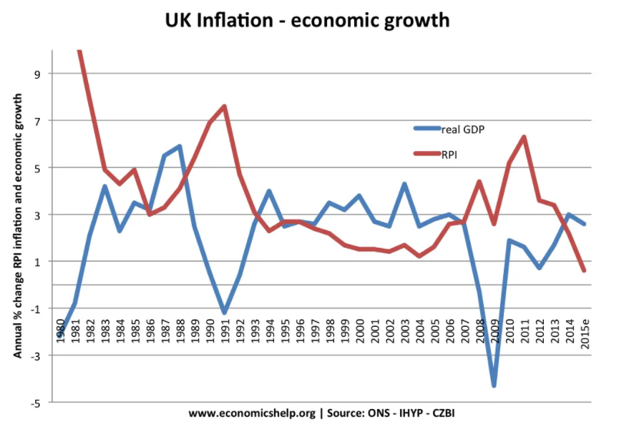

Low inflation causes long-term economic growth
It is also argued that low inflation can contribute to a higher rate of economic growth in the long term. This is because low inflation helps promote stability, confidence, security and therefore encourages investment. This investment helps promote long-term economic growth. If an economy has periods of high and volatile inflation rates, then rates of economic growth tend to be lower. The cost-push inflation of 1973 (rising oil prices) led to recession because the higher prices lead to declining disposable income.

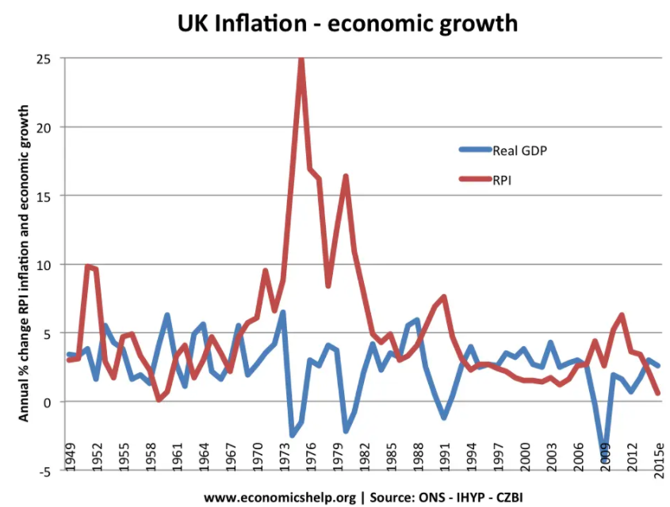

Economic growth and low inflation
It is possible that we can have economic growth without causing inflation. If growth is caused by increased productivity and investment, then the productive capacity of the economy can increase at the same rate as aggregate demand (AD). This enables economic growth without inflation. For example, between 1993 and 2007, the UK experienced low inflationary growth. This is partly due to economic growth being sustainable i.e. close to the 2.5% average; it was also due to productivity improvements such as privatisation and more flexible labour markets.

High Inflation and Low Growth
It is possible that an economy can experience low growth and high inflation (e.g. in 2009, 2011, 2017)
This can occur if there is cost-push inflation. Cost push inflation could be caused by rising oil prices. It increases costs for firms and reduces disposable income. Therefore, there is lower growth, whilst high inflation. This is sometimes known a stagflation
In 2011, the UK is experienced a fall in the rate of economic growth and relatively high inflation.
The inflation was caused by
- Rising food prices/oil prices
- Devaluation of the pound – causing rising import prices.
- Rising taxes
Therefore, despite low growth, inflation was high.

CONCLUSION
Over time, the growth in GDP causes inflation—inflation, if left unchecked, runs the risk of morphing into hyperinflation. Most economists today agree that a small amount of inflation, about 1% to 2% a year, is more beneficial than detrimental to the economy.

He found that economic growth is negatively associated with inflation and that inflation reduces economic growth by reducing the growth in productivity and investment. ... He estimated that a 10% percentage increase in the average inflation per year reduces the per capita GDP growth rate by 0.2-0.3 percent.

There can be a conflict between economic growth and inflation. In periods of rapid economic growth, inflation is likely to rise. However, it is possible to have both low inflation and positive economic growth

BIBLIGRAPHY

Websites used :

- https://globalyouth.wharton.upenn.edu/articles/your-money/inflation-what-it-is-where-it-comes-from-and-how-it-can-bite-you/
- https://www.economicshelp.org/blog/458/economics/conflict-between-economic-growth-and-inflation/
- https://www.investopedia.com/terms/i/inflation.asp
- https://www.nber.org/digest/dec97/does-inflation-harm-economic-growth

