PTSA
ASSIGNMENT – 1

UNIT-2

Q.1.A brokerage costs.

Q.2.C restructure companies to increase cash flow.

Q.3.D ALL of the above.

Q.4.C Car insurance company.

Q.5.A An endowment.

Q.6.C Minimum total return requirement of 8%.

Q.7.B high within each asset class and low among asset classes.

Q.8.B incorporate forecasts of future economic conditions.

Q.9.
- Many derivative instruments are leveraged, which means a small amount of capital is required to have an interest in a large amount of value in the underlying asset which makes it more complex and riskier in nature.
- Young investors should be convinced to be risk- seeking and not risk- averse as risky assets can provide a boost to total portfolio returns.
- Risk-seeking investors will often construct a portfolio of high risk investments that they believe have the potential to reap high gains. There are various strategies investors can employ to construct a high-risk portfolio.
- Some of the common strategies include:
- concentrated portfolio which focuses only on investing in a single sector or industry, such as technology.
- Momentum investing - this method relies upon working with volatility and seeking investments that are already trending up.
- Building a high-risk portfolio include investing in currencies, options, or futures.
- If the youngster is willing to take the risk and has the ability to face losses only then we should use derivatives & leveraged products in his portfolio.

Q.10.
- An investment policy statement (IPS) is a document drafted between a portfolio manager and a client that outlines general rules for the manager.
- The portfolio needs to be prepared on the basis of clients demands and the manager cannot invest where the client does not agree to invest in. Investments should be based on client's willingness and ability to take risks.
- Investment managers seek to make their clients’ money grow so that they can achieve their goals and aspirations, to help offer a more comfortable future. Investment managers are required to arrange for a custodian for assets they manage for their clients.
- Procedures to update IPS and to respond to various possible situations.
- The IPS should relate the purpose of the assets being invested to one or more broad investment objectives. Identify performance objectives for each asset class eligible for investment. The IPS should set forth all permissible asset classes in which the portfolio may be invested.
- Although some asset classes may not be used at all times, they should still be identified in the IPS. For each asset class, a brief description of the class should be provided and a benchmark for performance should be identified.
- Identify special factors to be used in including or excluding potential investments from the portfolio. Investors may choose to impose limits on certain investments because they believe extra-financial factors affect security prices, they desire to avoid concentrated risks in a particular industry. In particular, attention to ESG factors to screen investments is increasingly common.

Q.11.
- Liquidity is the degree to which a security can be quickly purchased or sold in the market at a price reflecting its current value. Liquidity in finance refers to the ease with which a security or an asset can be converted into cash at market price.
- An investment time horizon, or just time horizon, is the period of time one expects to hold an investment until they need the money back. The longer an investor's time horizon, the more risk and less liquidity the investor can accept in the portfolio. E.g. someone will not be ok with having a risky investment when he needs the money by end of this year to pay for tuition.
- Investors need to understand that the federal government taxes not only investment income such as dividends, interest, and rent on real estate but also realized capital gains. When calculating capital gains taxes, the holding period matters. Long-term investments are subject to lower tax rates.
- Securities and Exchange Board of India (SEBI), Reserve Bank of India (RBI), Insurance Regulatory and Development Authority of India (IRDAI), Pension Funds Regulatory and Development Authority (PFRDA), Association of Mutual Funds in India (AMFI), Ministry of Corporate Affairs (MCA) are few regulatory bodies that regulate all the investor’s funds in India.

Q.12.
- Environmental, social, and governance (ESG) criteria are a set of standards for a company’s operations that socially conscious investors use to screen potential investments.
- Environmental criteria consider how a company performs as a steward of nature. Social criteria examine how it manages relationships with employees, suppliers, customers, and the communities where it operates.
- Governance deals with a company’s leadership, executive pay, audits, internal controls, and shareholder rights.
- ESG, or environmental, social and governance investing, is a way to build a more ethical portfolio.
- Most investors acknowledge that the devastating effect of climate change or the political and social risks resulting from increased levels of inequality are major threats to society and, ultimately, to financial stability.
- They understand that supporting the low carbon transition or enabling more sustainable societies is a condition to continue delivering long-term returns for the benefit of all stakeholders.

Q.13.
Diversification is used to reduce a portfolio's overall volatility. Building a portfolio out of many unrelated (uncorrelated) investments minimizes total volatility (risk). The idea is that most assets will provide a return similar to their expected return and will offset those in the portfolio that perform poorly. The diversification ratio is the ratio of the standard deviation of an equally weighted portfolio to the standard deviation of a randomly selected security.

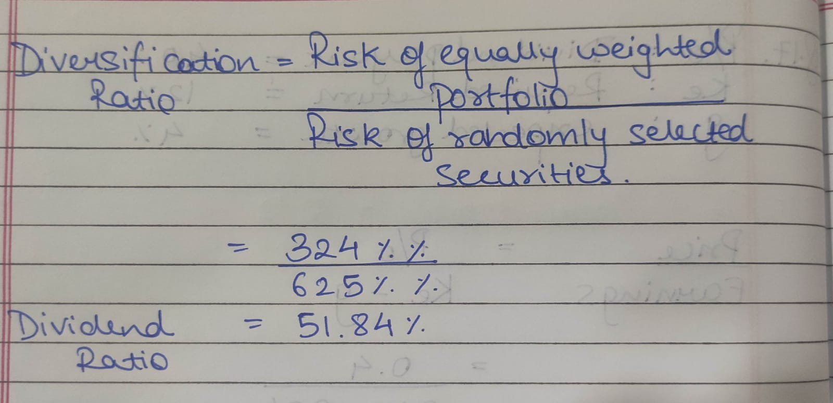

Q.14.

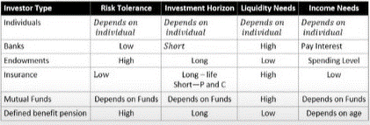

Q15. Defined contribution pension plan: firm contributes a sum each period to the employee's retirement account. (CPF)
Defined benefit pension plan: the firm promises to make periodic payments to employees after retirement.

UNIT 4

Q1. B. The sensitivity of their earnings to the business cycle.

Q2. C. Derive their revenue and earnings from similar business activities.

Q.3. A. Output

Q.4. A. Market correlations.

Q.5. D.ALL OF THE ABOVE

Q.6. B. market concentration.

Q.7. C. decreases pricing power and greater ease of exit increases pricing power.

Q.8. B. Shakeout.

Q.9. A. An energy exploration firm in financial distress that owns drilling rights for offshore areas.

Q.10. Price multiple models

Q.11. Porter recognized that organizations likely keep a close watch on their rivals, but he encouraged them to look beyond the actions of their competitors and examine what other factors could impact the business environment.

- Competitive Rivalry. This looks at the number and strength of your competitors. How many rivals do you have? Who are they, and how does the quality of their products and services compare with yours?
Where rivalry is intense, companies can attract customers with aggressive price cuts and high-impact marketing campaigns. Also, in markets with lots of rivals, your suppliers and buyers can go elsewhere if they feel that they're not getting a good deal from you.
On the other hand, where competitive rivalry is minimal, and no one else is doing what you do, then you'll likely have tremendous strength and healthy profits.

- Supplier Power. This is determined by how easy it is for your suppliers to increase their prices. How many potential suppliers do you have? How unique is the product or service that they provide, and how expensive would it be to switch from one supplier to another?
The more you have to choose from, the easier it will be to switch to a cheaper alternative. But the fewer suppliers there are, and the more you need their help, the stronger their position and their ability to charge you more. That can impact your profit.

- Buyer Power. Here, you ask yourself how easy it is for buyers to drive your prices down. How many buyers are there, and how big are their orders? How much would it cost them to switch from your products and services to those of a rival? Are your buyers strong enough to dictate terms to you?
When you deal with only a few savvy customers, they have more power, but your power increases if you have many customers.

- Threat of Substitution. This refers to the likelihood of your customers finding a different way of doing what you do. For example, if you supply a unique software product that automates an important process, people may substitute it by doing the process manually or by outsourcing it. A substitution that is easy and cheap to make can weaken your position and threaten your profitability.

- Threat of New Entry. Your position can be affected by people's ability to enter your market. So, think about how easily this could be done. How easy is it to get a foothold in your industry or market? How much would it cost, and how tightly is your sector regulated?
If it takes little money and effort to enter your market and compete effectively, or if you have little protection for your key technologies, then rivals can quickly enter your market and weaken your position. If you have strong and durable barriers to entry, then you can preserve a favorable position and take fair advantage of it.

Q12. Technological Influences
Established companies face the threat of technological obsolescence, while technological developments may also help established industries reinforce growth. Infant industries face the threat of a new product not being accepted by the marketplace.

Demographic Influences
Broad shifts in population distribution, age, and income can have very marked effects on different industries. For example, a greater role of sports in the lives of many Americans has increased demand for sports trauma orthopedics.
In most cases, demographic shifts are easy to identify, because they occur over a very long time period. However, it is much harder to quantify such trends and determine their influence on a particular industry.
Governmental Influences
Government regulations, laws, and tax policies can have a marked influence on many industries. They may potentially increase or decrease an industry's prospects.
In certain cases, government policies create new industries. For example, after the Firestone case, governments required the original auto manufacturers to submit all information about their cars, which created a new auto business intelligence software industry.
Trade barriers established by governments support demand for specific domestic industries by fending off foreign competition

Q13.

- A stock split is when a company divides the existing shares of its stock into multiple new shares to boost the stock's liquidity. Although the number of shares outstanding increases by a specific multiple, the total dollar value of the shares remains the same compared to pre-split amounts, because the split does not add any real value.

- A reverse stock split is a measure taken by companies to reduce their number of outstanding shares in the market. Existing shares are consolidated into fewer, proportionally more valuable, shares, resulting in a boost to the company’s stock price.

- A share repurchase is a transaction whereby a company buys back its own shares from the marketplace. A company might buy back its shares because management considers them undervalued. The company buys share directly from the market or offers its shareholders the option of tendering their shares directly to the company at a fixed price.

- Cash dividends provide investors income, but come with tax consequences; they also cause the company's share price to drop.

- Stock dividends are not usually taxed, increase the shareholder's stake in the company and give them the choice to keep or sell the shares; stock payouts are also optimal for companies that lack sufficient liquid cash.

- An extra dividend is a one-time dividend paid to a company's shareholders. An extra dividend is paid out by a company when they have surplus cash and are able to reward their shareholders. Extra dividends are usually a one-time occurrence and for a larger amount than the company's regular dividends.

Q14.
Free cash flow to equity (FCFE) is the amount of cash a business generates that is available to be potentially distributed to shareholders. It is calculated as Cash from Operations less capital expenditure plus net debt issued.

FCFE = Cash from Operating Activities – Capital Expenditures + Net Debt Issued (Repaid)

Free cash flow to equity is composed of net income, capital expenditures, working capital, and debt.
The FCFE metric is often used by analysts in an attempt to determine the value of a company.

FCFE, as a method of valuation, gained popularity as an alternative to the dividend discount model (DDM), especially for cases in which a company does not pay a dividend. Although FCFE may calculate the amount available to shareholders, it does not necessarily equate to the amount paid out to shareholders.

Analysts use FCFE to determine if dividend payments and stock repurchases are paid for with free cash flow to equity or some other form of financing. Investors want to see a dividend payment and share repurchase that is fully paid by FCFE.

If FCFE is less than the dividend payment and the cost to buy back shares, the company is funding with either debt or existing capital or issuing new securities. Existing capital includes retained earnings made in previous periods.

Q15.
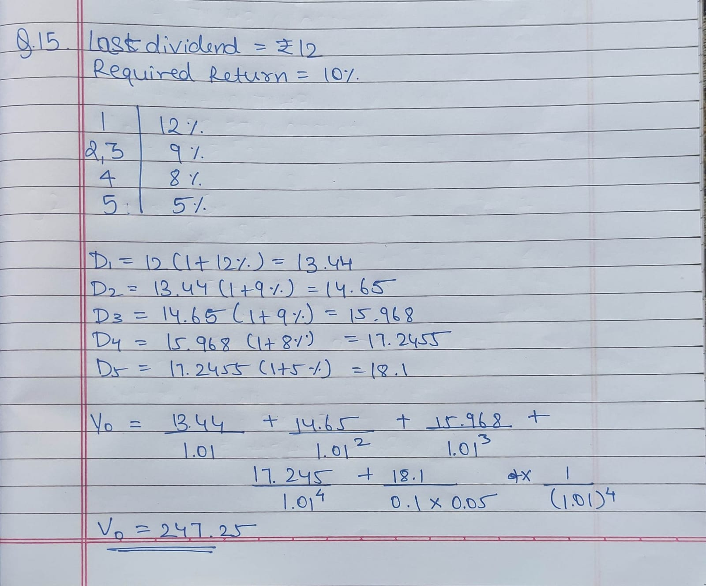

Q16.
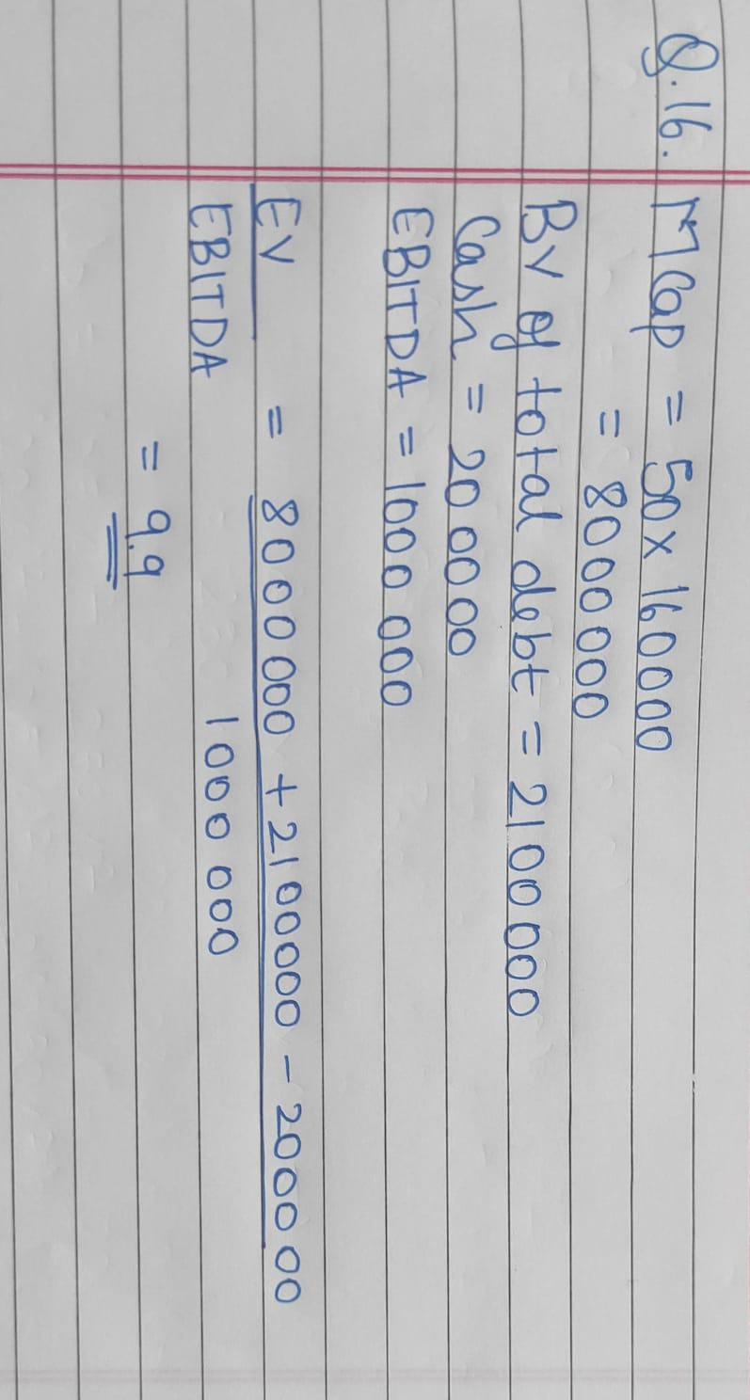

Q17.
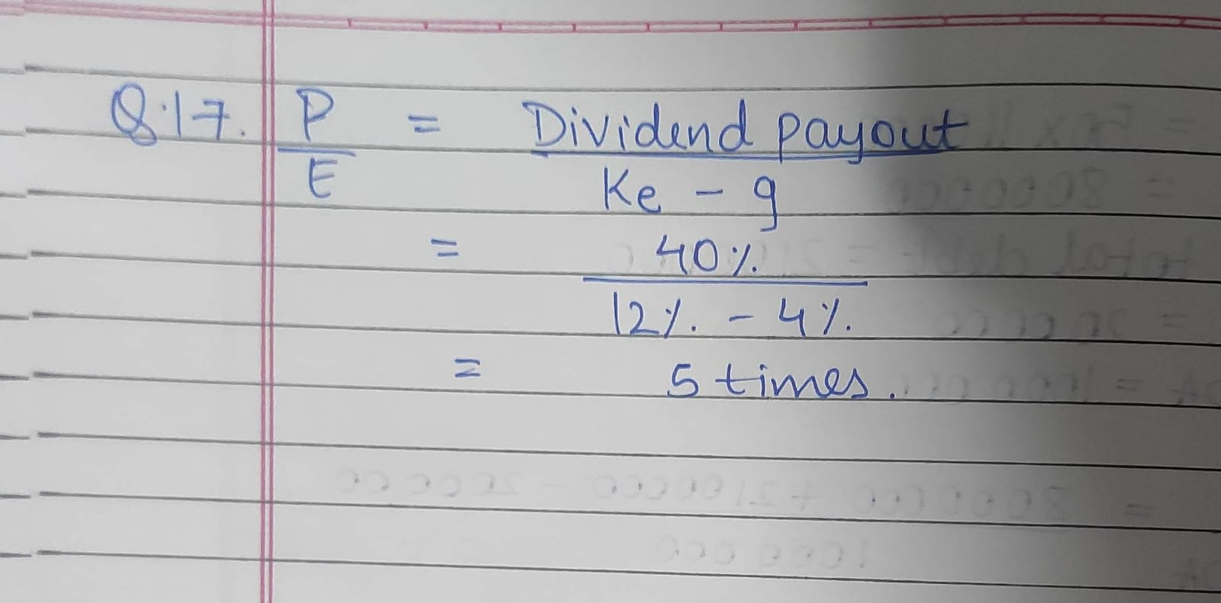

Unit 3
Q1.

Q2.

Q3.


