ABT project

Question 1
Money control news letter
Indian market index

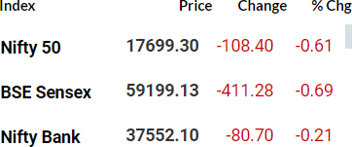

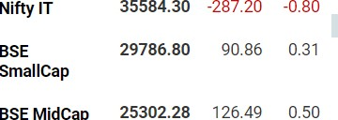

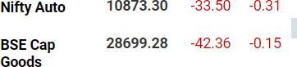

FII and DII activity
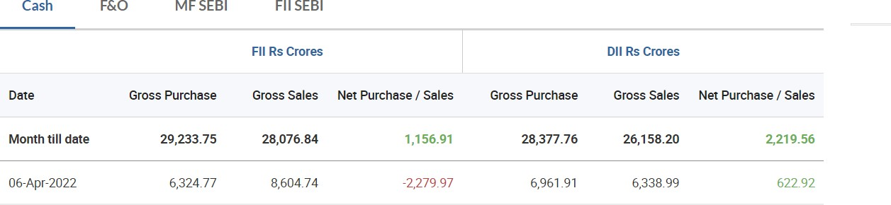

Top 5 nifty gainers

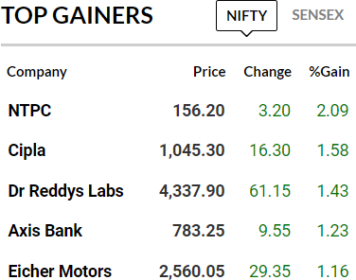

Top 5 nifty losers
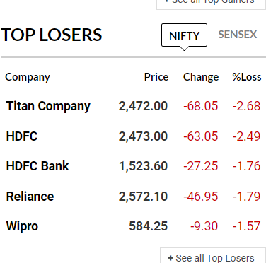
Advance to decline ratio nifty 50
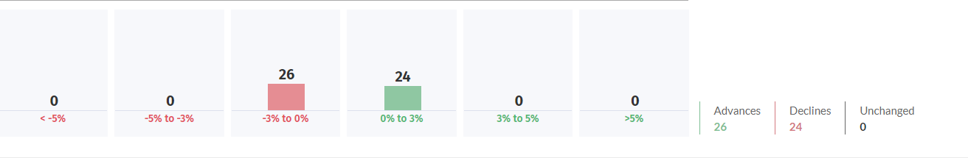

Indian vix

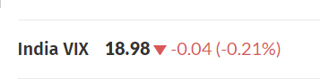

Only buyers
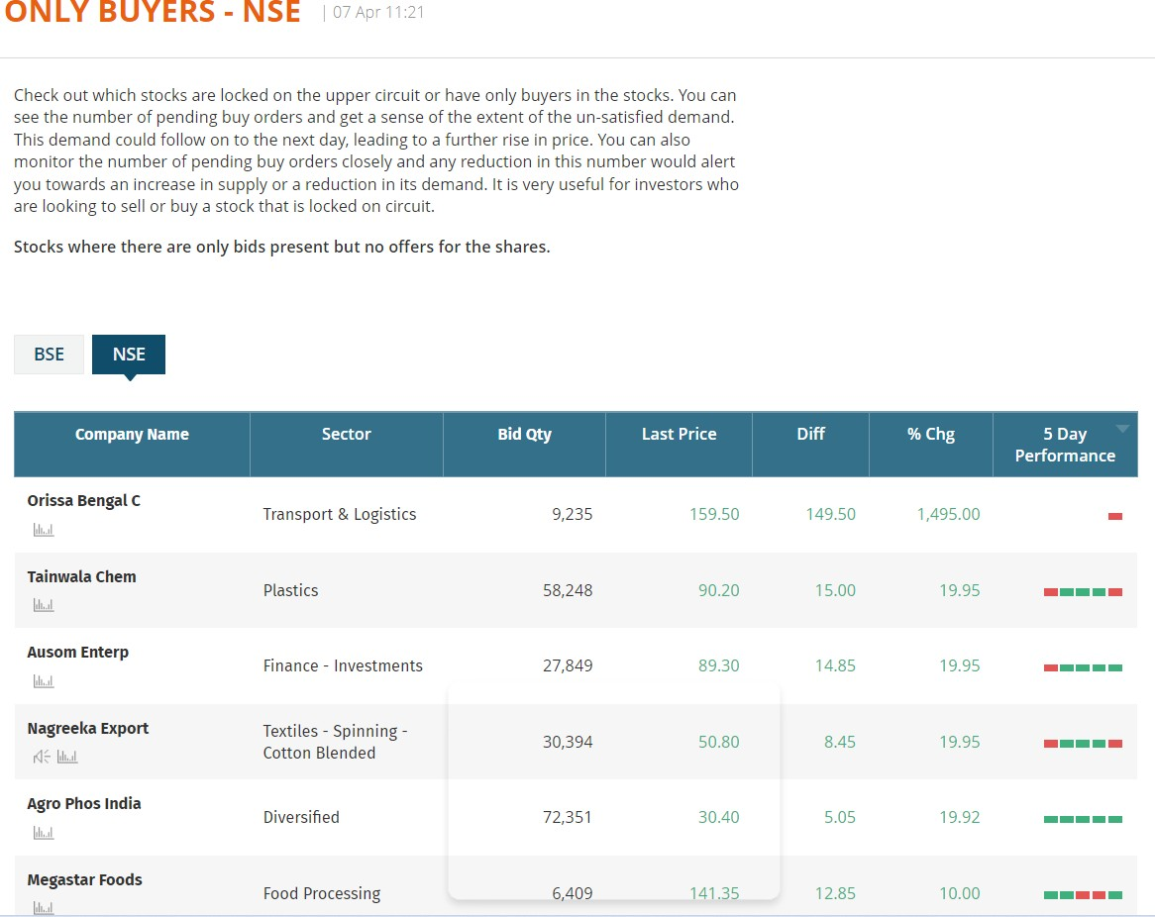
52 week high

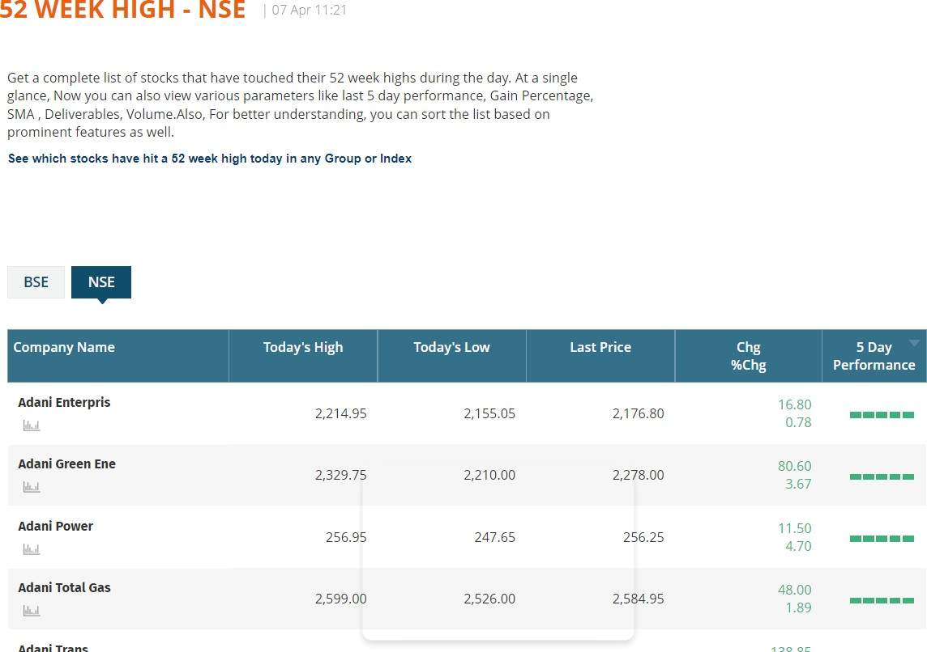

Only sellers
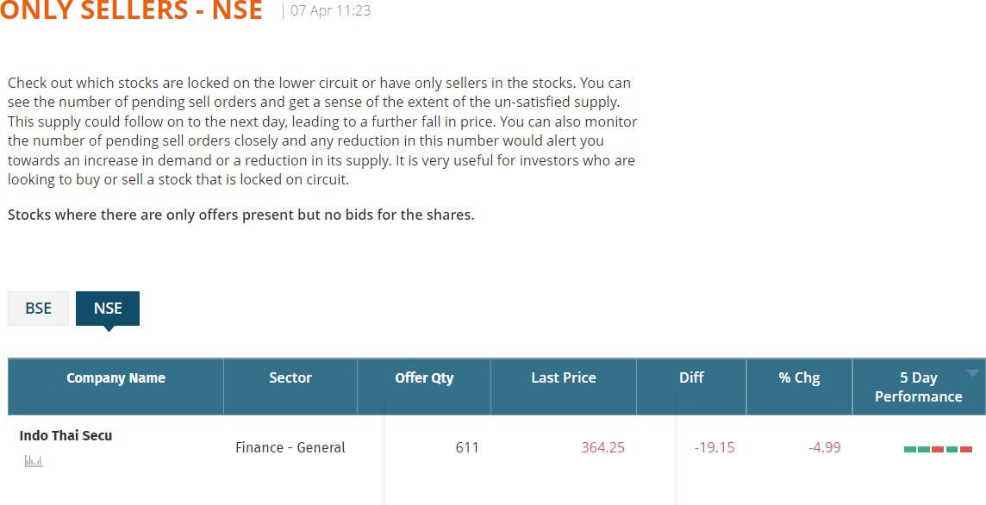
52 week low

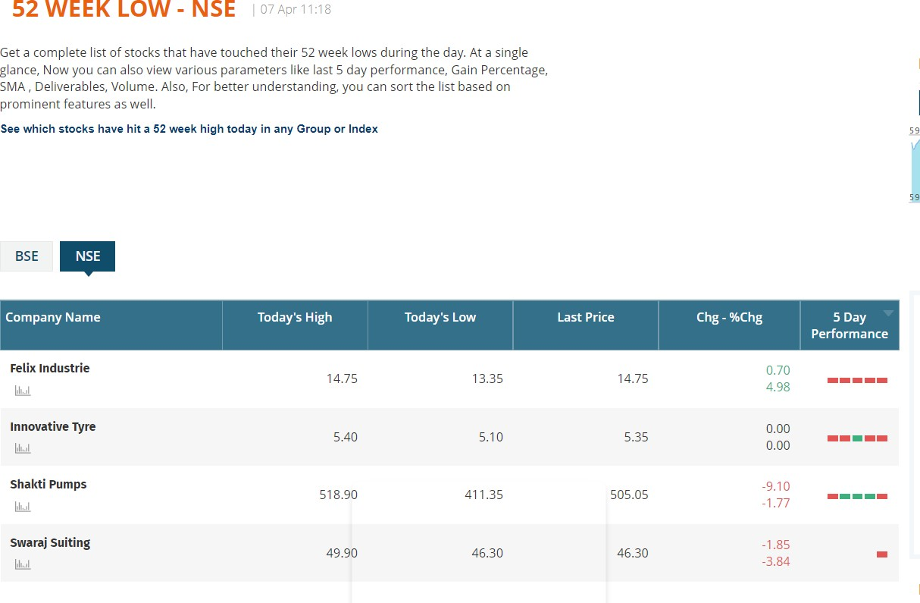

Global market indices

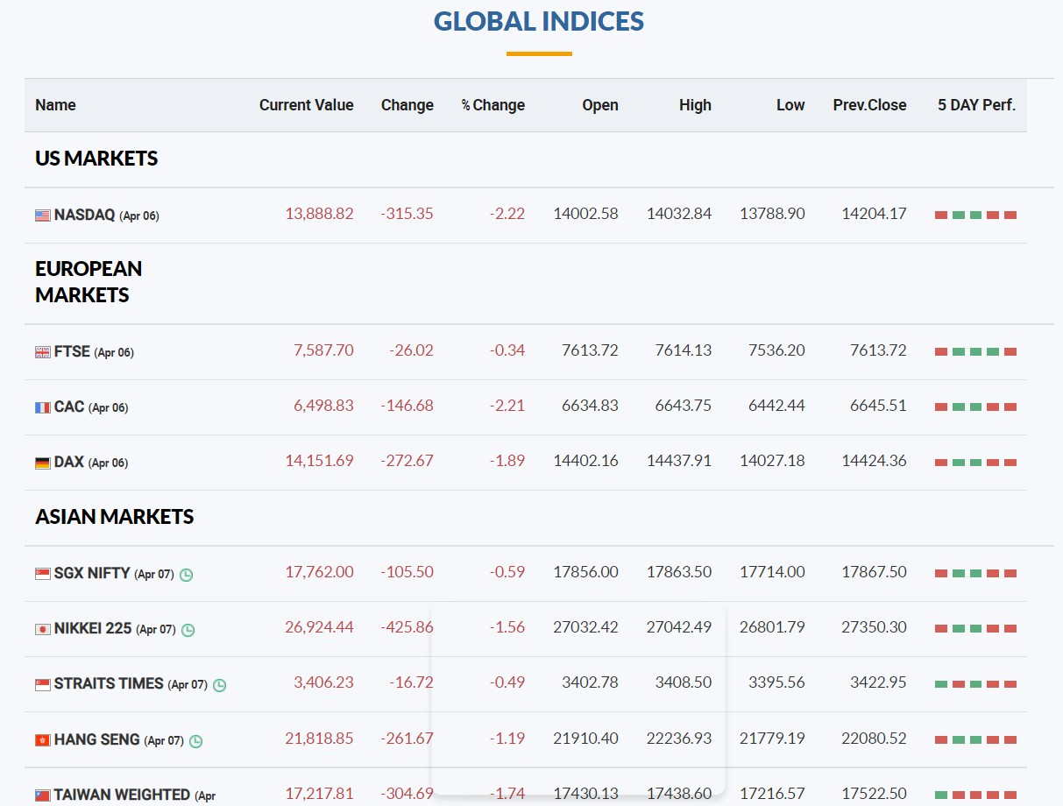

Question2 Subpart a
FII are net sellers and the market is moved by foreign institutional investors and they are net sellers of 1657.05 crores (this figure is FII activity – DII activity) this caused the market to move downwards on the 6th of April

Subpart b
The change in the fear index is not by a lot but by a small margin of -0.04(-0.21%) this means that the confidence in the market is increasing as the volatility of the market is reducing which shows that the market is getting stronger and healthier

Subpart c
the stocks that have caused movement in the markets towards the upward and downward trend are

Subpart d
the top performing sector is as follows

The best forming sector is NIFTY bank the reason BSE small cap or BSE midcap haven’t been taken under consideration is because they aren’t sectors
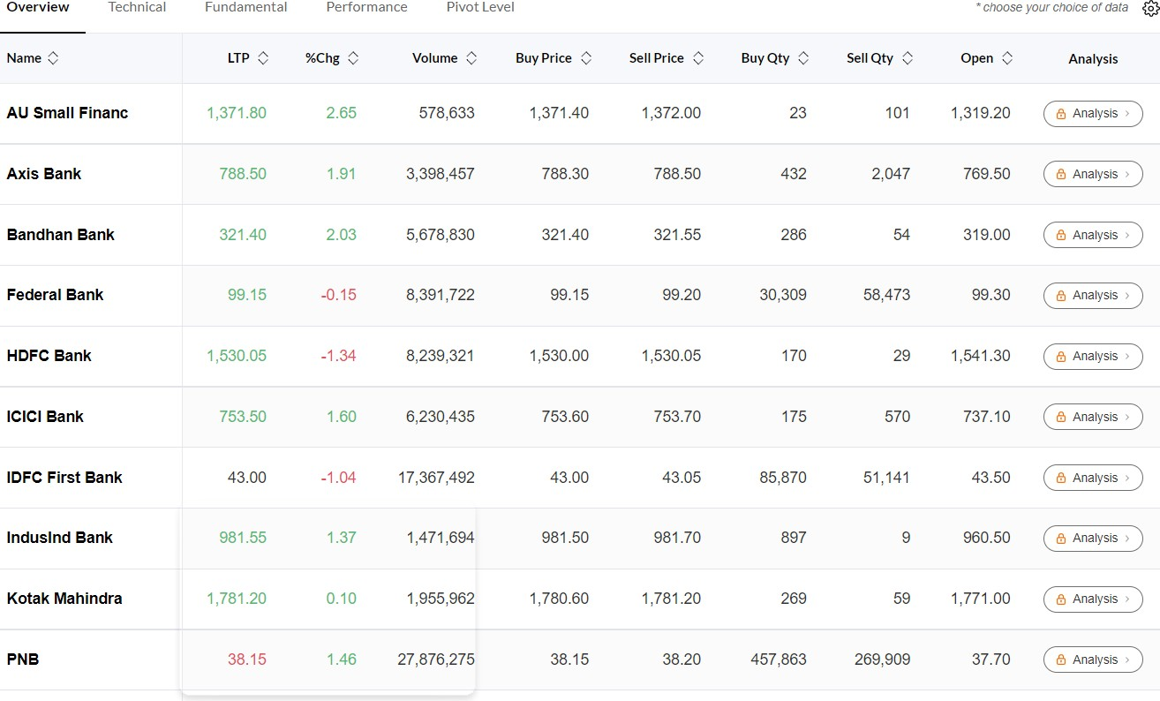

Subpart e

The sector that has caused the maximum downward movement today is

According to the data above the answer is NIFTY IT

The stocks that have induced this selling are as follows

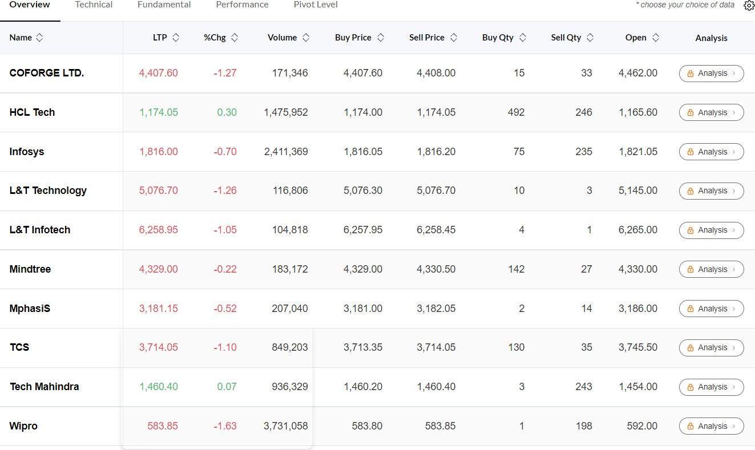

Question number 3
The 52-week high stock according to our criteria are as follows:
- Tata ELEXSI
- Solar industries
- Page industries
- Adani Enterprise
- Sun Pharma
- Triveni Engineering
The criteria that I have taken while considering the 52-week high stocks:
- Chart beginning from the bottom left of the screen and ending at the top roght of the screen
- Size of the candles are not to big
- No continuous circuits in the stock or blank space (gap up and gap down excluded openings)
- No big dips in the middle of the chart
- Smooth shape (upward trend/movement) on the chart
- The market cap of the company over 50.00 billion rupees
- % change from 52 week high -20.00 to 0

Screenshot of the screener:

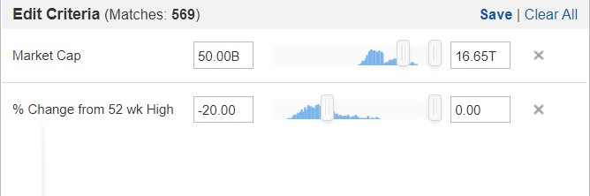

Question 4
