i) Arbitrage opportunity is a situation where we can make a certain profit with no risk. An arbitrage opportunity means that
(a) we can start at time 0 with a portfolio that has a net value of zero (implying that we are long in some assets and short in others). This is usually called a zero-cost portfolio.
(b)at future time T:
the probability of a loss is 0
the probability that we make a strictly positive profit is greater than 0

i) Law of one price
The Law of one price states that any two portfolios that behave in the same way must have the same price. If this were not true, arbitrage arises.

iii)
a) Using Put-Call parity, the value of put option should be:
p1=c1+ Kexp(-(T-1))-Stexp(-q(T-1))
-30+120exp(-05 25)-125exp(-15.25) - 28.11

b) Arbitrage profit
If the put options are only Rs. 23 then they are cheap. If things are cheap then we buy them. So looking at the put-call parity relationship, we "buy the cheap side and sell the expensive side", ie we buy put options and shares and sell call options and cash.
For example:
sell 1 call option Rs. 30
buy 1 put option (Rs. 23)
buy 1 share (Rs.125)
sell (borrow) cash Rs.118
This is a zero-cost portfolio and, because put-call parity does not hold, we know it will make an arbitrage profit. We can check as follows: TATIVE STUDIES
In 3 months, repaying the cash will cost u 118exp(0.05-3/12) Rs. 119.48
We also receive dividends d on the share. If the share price is above 120 in 3 months then the other party will exercise their call option and we will have to give them the share. They will pay 120 for it and our profit is:
120-119.48+d=0.52+d
2. If the share price is below 120 in 3 months then we will exercise our put option and sell it for 120. Our profit is: 120-119.48+d=0.52+d
(The call option is useless to the other party and will expire worthlessly)
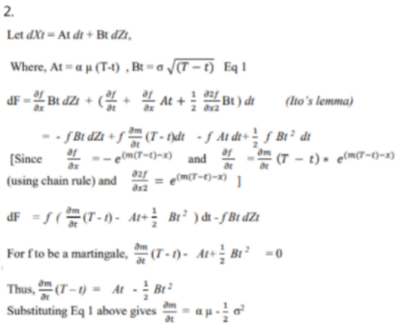

Q3 (on next page)
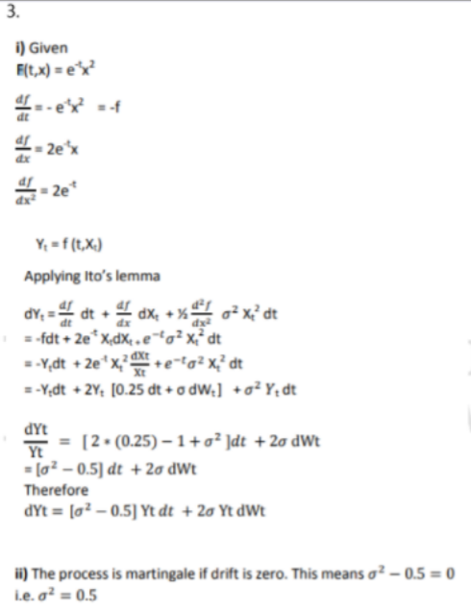
Q4 Let ex-dividend dates are anticipated for a stock and t1<t2<t3<….<tn the times before which the stock goes ex-dividend Dividends are denoted by d1….dn .
If the option is exercised before the ex-dividend date then the investor receives S(tn)-K
If the option is not exercised, the price drops to S(tn)-dn
The value of the American option is greater than S(tn)-&- Kexp(-tn(T-tn)
It is never optional to exercise the option if S(tn)-dn-Kesp(T-tn) >= S(tn)-K
Using this equation we have K*(1-exp(-r(T-tn))=350(1-exp(-0.95*(08333-0 251)) = 18.87 and 65*(1-exp(-0.95*(0.8333-0.25)) = 10.91 Hence it is never optimal to exercise the American option on the two ex-dividend rates

5. The required probability is the probability of the stock price being greater than Rs. 258 in 6 months.
The stock price follows Geometric Brownian motion Le. St=S0 exp(u-o^2/2)t + oWt
Therefore Ln (St) follows a normal distribution with mean Ln (50)+ (u-o^2/2)t and variance (o^2)t
Implies Ln (St) follows mean and variance
This means [Ln (St)-St))/ ot^(1/2) follows the standard normal distribution,
Hence the probability that the stock price will be higher than the strike price of Rs. 258 in 6 months time = 1-N(5.55-5.59)/0.247=1-N(-0.1364) = 0.5542
The put option is exercised if the stock price is less than Rs. 258 in 6 months.
The probability of this 1-0.5542 = 0.4457

6.

i) The given relationship can be written as:
Since St is a function of standard Brownian motion, Bt, applying Ito's Lemma, the SDE for the underlying stochastic process becomes:
dBt=0X dt+ 1 X dBt
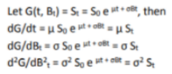
Hence, using Ito's Lemma from Page 46 in the Tables we have:
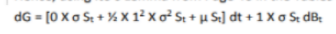
Thus,
ii) The expected value of St is:
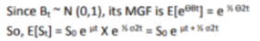
The variance of St is:
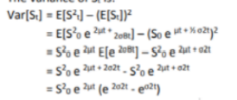
iii)
From above,
The expected value of the product is:
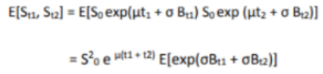
To evaluate this we need to split Bu into two independent components:
Hence,
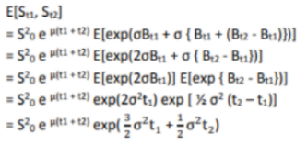
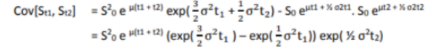
7.

i) Setting up the commodity tree using u for up move and d for down move, p is up-step probability:
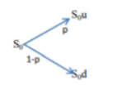
Where p is the up probability and (1-p) the down probability

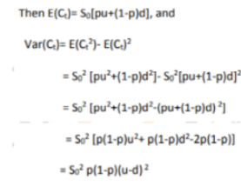
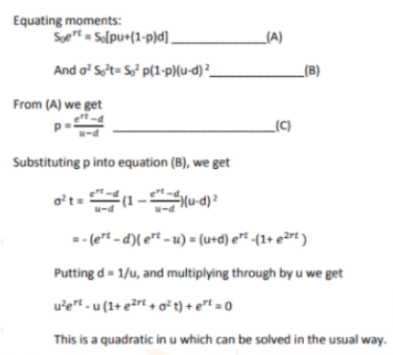
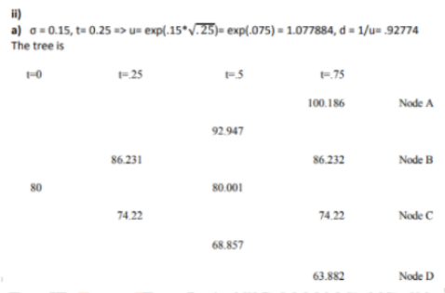
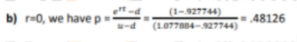
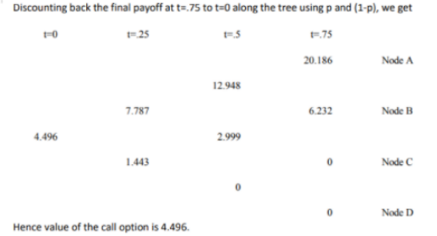
c) The lookback call pays the difference between the minimum value and the final value.
Notate paths by U for up and D for down, in order
We get the payoffs
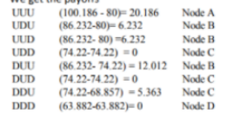
The lookback payoffs are, for each successful path (i.e. with a non-zero result)
Probabilities of arriving at each node are:
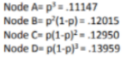
Hence the tree value of lookback option is:
(11147* 20.186)+ (0.12015 *(6.232+6.232+ 12.012)+(12950*5.363) = 5.8854

i) Consider a stock whose current price is S0 and an option whose current price is f. We suppose that the option lasts for time T and that during the life of the option the stock price can either move up from 50 to a new level S0u or move down to S0d where u> 1 and d < 1.
Let the payoff be fu if the stock price becomes S0u and fd if stock price becomes Sod Let us construct a portfolio which consists of a short position in the option and a long position in A shares. We calculate the value of & that makes the portfolio risk-free. Now if there is an upward movement in the stock the value of the portfolio becomes ASOU - fu and if there is a downward movement of stock, the value of the portfolio becomes ASOD The two portfolios are equal if AS-, ASud-t
Or 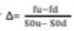so that the portfolio is risk-free and hence must earn the risk free rate of interest.
This means the present value of such a portfolio is
Where is the risk free rate of interest.
The cost of the portfolio is
Since the portfolio grows at a risk free rate, it follows that
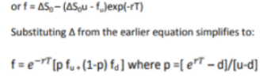
ii. The option pricing formula does not involve probabilities of stock going up or down although it is natural to assume that the probability of an upward movement in stock increases the value of call option and the value of put option decreases when the probability of stock price goes down.
This is because we are calculating the value of option not in absolute terms but in terms of the value of the underlying stock where the probabilities of future movements (up and down) in the stock already incorporates in the price of the stock. However, it is natural to interpret p as the probability of an up movement in the stock price.
The variable 1-p is then the probability of a down movement such that the above equation can be interpreted as that the value of option today is the expected future value discounted at the risk free rate
The expected stock price E(St) at time
or
Substituting p from above equation in
We get
i.e. stock price grows at a risk free rate or return on a stock is risk free rate

iv. In a risk neutral word individuals do not require compensation for risk or they are indifferent to risk. Hence expected return on all securities and options is the risk free interest rate. Hence value of an option is its expected payoff in a risk neutral discounted at risk free rate.

UNIT 2
9. The forward price is given by F=S*exp(rt) where S is the stock price, t is the delivery time and r is the continuously compounded risk-free rate of interest applicable up to time t.
Put-call parity states that c + K*exp(-rt) = p + S where c and p are the prices of a European call and put option respectively with strike K and time to expiry t and 5 is the current stock price.
To compute F, we need to find 5 and r.t is given to be 0.25 years.
Substituting the values from the first two rows of the table in the put-call parity, we get two equations in two unknowns (S and r):
13.334+70*exp(-0.25r) = 0.120 + S
8.869 + 75*exp(-0.25r) 0.568 + S
Solving the simultaneous equations for S and r, we get
5 = 82 and r = 7%
Therefore, we get the forward price

ii) Let the (continuously compounded, annualized) rate of interest over the next k months be n. Then the required forward rate re can be found from:
We know that r = 7%
To find r6, we substitute values from the last row in the put-call parity relationship and S = 82:
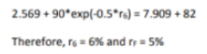
iii) Using the put-call parity for each row in the given table, we get:
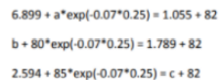
11.
i) A recombining binominal tree or binominal lattice is one in which the sizes of the up-steps and down-steps are assumed to be the same under all states and across all time intervals, ie, ut@-u and dt @)-d for all times t and states j, with d < exp(r) <u
-> It therefore follows that the risk neutral probability 'q' is also constant at all times
-> The main advantage of a 'n' period recombining binominal tree is that it has only [n+1] possible states of time as opposed to 2n possible states in a similar non-recombining binominal tree. This greatly reduces the amount of computation time required when using a binomial tree model.
-> The main disadvantage is that the recombining binomial tree implicitly assumes that the volatility and drift parameters of the underlying asset price are constant overtime, which assumption is contradicted by empirical evidence.

a) The risk-neutral probabilities at the first and second steps are as follows:
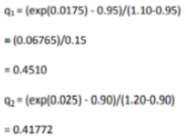
Put payoffs at the expiration date at each of the four possible states of expiry are 0,0,0 and 95.
Working backward, the value of the option V1 (1) following an up step over the first 3 months is

V1 (1) exp(0.025) - (0.41772* 0)+[0.58228*0] i.e. V1 (1) = 0

The value of the option V1 (2) following a down step over the first 3 months is: V1 (2)exp(0.025) [0.41772*0] + [0.58228*95) Le, V1 (2) 53.9508
The current value of the put option is:
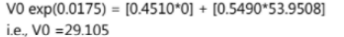
b) While the proposed modification would produce a more accurate valuation, there would be a lot more parameter values to specify. Appropriate values of u and d values of 'r for each month would be required for each branch of the tree and values of r for each month would be required.
The new tree would have 2 = 64 nodes in the expiry column. This would render the calculations prohibitive to do normally, and would require more programming and calculation time on the computer. An alternative model that might be more efficient numerically would be a 6-step recombining tree which would have only 7 nodes in the final column.
Q12]
Given Z(t) is standard Brownian
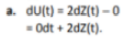
Thus, the stochastic process (U(t)) has zero drift.
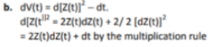
Thus, dv(t)- 2Z(t)dz(t). The stochastic process (Vit)) has zero drift.
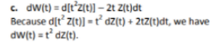
Thus The process (Wit)) has zero drift

13.
Let S/S, follows lognormal distribution with parameters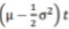, and (o^2)t such the
expected return on a stock is u and volatility is sigma
This means Expected value of stock price at the end of first time step = On the tree the expected price at that time =
To match the expected return on the stock with the tree's parameters we have
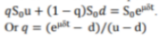

Volatility a of a stock price is defined so that is the standard deviation of the return on the stock price in a short time
The variance of stock price return is
Substituting the value of q in the expression above we have
When higher powers of ot other than öt are ignored. This implies 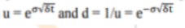
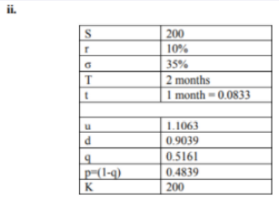
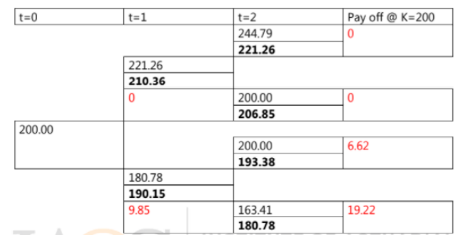
Note: Bold italies are GM of stock price,reds and the payoffs.
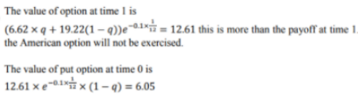
Q15}
