BUSINESS FINANCE 2 ASSIGNMENT-2
Jash Poonatar
Roll no. 25
Q.1 D) D. IRR is the most reliable means of choosing between mutually exclusive projects.

Q.2 A) Market price of share/ Earning per share

Q.3 D) All of the above

Q.4 D) 1000000

Q-5)
Sales- 2500
Cost- 1500
Tax rate- 40%
Discount rate- 20%
- Cash flow from the project at date 1 is:-
= Sales-Cost-Tax
= (2500-1500)- 40%
= 1000 – 40%
= ₹600
- NPV of the project is:-
= Net profit/ (1+discount rate)
= 600/1.2
= ₹500
- Since the suppliers are willing to get their payments one year later the present value of the expense decrease thereby the present value of the profit increase. This further causes the NPV to increase due to the increased time period.
Q.6
Efficiency ratios measure a company's ability to use its assets and manage its liabilities effectively in the current period or in the short-term. Although there are several efficiency ratios, they are similar in that they measure the time it takes to generate cash or income from a client or by liquidating inventory. Efficiency ratios include the inventory turnover ratio, asset turnover ratio, and receivables turnover ratio. These ratios measure how efficiently a company uses its assets to generate revenues and its ability to manage those assets.
- Inventory turnover ratio:- The inventory turnover ratio measures a company's ability to manage its inventory efficiently and provides insight into the sales of a company. The ratio also shows how well inventory is being managed including whether too much or not enough inventory is being bought. The ratio is calculated by dividing the cost of goods sold by the average inventory. An ideal inventory ratio is around 5 to 10 for most industries but may differ for certain cases.
- Asset turnover ratio:- The asset turnover ratio measures a company's ability to efficiently generate revenues from its assets. In other words, the asset turnover ratio calculates sales as a percentage of the company's assets. The ratio is effective in showing how many sales are generated from each rupee of asset a company owns. Higher the ratio the better since it indicates that the company is using their assets efficiently and vice versa.
- Receivables turnover ratio:- The receivables turnover ratio measures how efficiently a company can actively collect its debts and extend its credits. The ratio is calculated by dividing a company's net credit sales by its average accounts receivable. The higher the ratio better the company is at collecting debt but too high means that the company is not providing credit services to its customers.

Q.7
Limitations of Ratio Analysis:
- Ratio analysis information is historic – it is not current.
- Ratio analysis does not take into account external factors such as a worldwide recession.
- Ratio analysis does not measure the human element of a firm.
- Ratio analysis can only be used for comparison with other firms of the same size and type.
It may be difficult to compare with other businesses as they may not be willing to share the information
Q.8
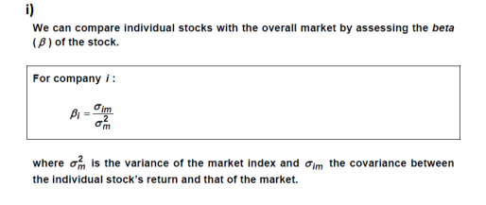
I. Beta is a measure of a stock's volatility in relation to the overall market. By definition, the market, such as the S&P 500 Index, has a beta of 1.0, and individual stocks are ranked according to how much they deviate from the market. A stock that swings more than the market over time has a beta above 1.0. If a stock moves less than the market, the stock's beta is less than 1.0. High-beta stocks are supposed to be riskier but provide higher return potential; low-beta stocks pose less risk but also lower returns.
Using the formulae to find beta we see that for each stock the beta we get will be different and unique due to its own returns and earnings, thus we can say that the beta will be different for all stocks.
II.
Geared Beta = Ungeared Beta/[1 + (1 – tax rate) (Debt Equity Ratio)]
Using this formulae we find the ungeared beta that is-
= Geared beta * (1+(1-Tax rate)*(Debt equity ratio))
= 1.1 * (1+(1-30%)*(1/2))
= 1.485
Now we find the geared beta at debt equity ratio of 2:2
= Ungeared beta/ (1+(1-Tax rate)*(Debt equity ratio))
= 1.485/ (1+(1-30%)*(2:2)
= 0.87353

Q.9
Initial investment- 100 Lakhs
Cost of capital- 10%
NPV- 10 Lakhs
IRR- 21%

Let X be positive cashflow
10 = X*(1+10%)^-1 – 100
110 = X*(1.1)^-1
X= 121
When cost of capital changes to 11%
The new NPV is:-
= 121*(1+11%)^-1
= 9.009 Lakhs
IRR doesn’t change and remain constant because the cashflows don’t change. Only the cost of capital is changing.

Q.10
I.
Market risk and specific risk are two different forms of risk that affect assets. All investment assets can be separated by two categories: systematic risk and specific risk. Market risk, or systematic risk, affects a large number of asset classes, whereas specific risk, or unsystematic risk, only affects an industry or particular company.
II.
Systematic risk is the risk of losing investments due to factors, such as political risk and macroeconomic risk, that affect the performance of the overall market. Market risk cannot be mitigated through portfolio diversification. However, an investor can hedge against systematic risk. Specific risk, or diversifiable risk on the other hand is the risk of losing an investment due to company or industry-specific hazard. Unlike systematic risk, an investor can only mitigate against unsystematic risk through diversification. An investor uses diversification to manage risk by investing in a variety of assets.
Systematic risk can be defined as a type of total risk that arises as a result of various external factors such as political factors, economic factors, and sociological factors. Systematic risk is non-diversifiable in nature. This means that this type of total risk cannot be controlled or minimized or avoided by the management of an organization. On the other hand, unsystematic risk can be defined as a type of total risk that arises as a result of various internal factors taking place within an organization. Unsystematic risks are diversifiable in nature. This means that these types of risks can be controlled, minimized and even avoided by the management of an organization

Q.11
1.
A beta coefficient can measure the volatility of an individual stock compared to the systematic risk of the entire market. In statistical terms, beta represents the slope of the line through a regression of data points. In finance, each of these data points represents an individual stock's returns against those of the market as a whole. Beta effectively describes the activity of a security's returns as it responds to swings in the market. A security's beta is calculated by dividing the product of the covariance of the security's returns and the market's returns by the variance of the market's returns over a specified period.
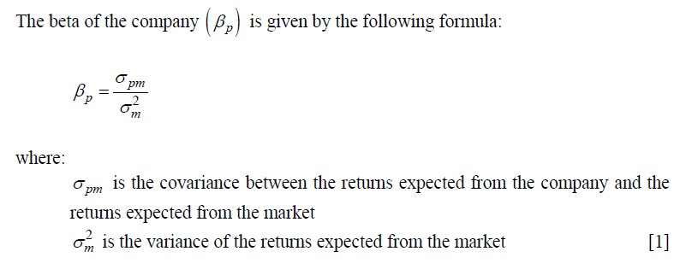
2.
The formulae to calculate beta is as follows:-
3.
As an active stock market investor I would likely invest in a stock with a beta of 1 rather than in a stock with beta -1 is because of the higher risk involved. A stock has a negative beta when usually market has a period of recession, the company is facing lawsuit or a acquisition battle which may lead to external correlation determining the beta rather than true market betas. A negative beta correlation would mean an investment that moves in the opposite direction from the stock market. When the market rises, then a negative-beta investment generally falls. When the market falls, then the negative-beta investment will tend to rise. Negative beta stocks usually act as a hedge against a well diversified portfolio of positive beta stocks. Thus it is bought with an assurance of risk covered in case of market turns and crash. Thus rather than risking the money against the most of my stocks hold it would be better if I bought a stock with beta 1.

4.
Cash is an financial instrument whose beta value is 0 as it has no changes in case of market ups/down. The value of cash remains same given there is no inflation .

Q.12
I.
Debt-equity ratio- 1:1
Risk free ROR- 7%
Equity risk premium- 5%
Cost of debt- 9%
Beta- 1.5
Tax- 25%

Cost of equity
= Risk-free rate + (Beta * Equity risk premium)
= 7% + 1.5 * 5%
= 14.5%
Cost of debt
= Cost of debt * (1-Tax Rate)
= 9% * (1 - 25%)
= 6.75%
Therefore WACC
= (0.5 * 14.5%) + (0.5 * 6.75%)
= 10.625%

II.
Ungeared beta is-
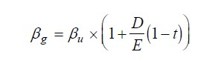
1.5 = Ungeared beta * (1 + 1/1 *(1-25%))
1.5 = Ungeared beta * 1.75
Ungeared beta = 1.5 / 1.75
= 0.857143
New cost of equity is therefore
= Risk-free rate + Ungeared beta * Equity risk premium
= 7% + 0.857143 * 5%
= 11.29%

Q.13
Annual cost saving- 40000 NPV= ?
Useful life- 4 years Cost of capital= ?
IRR- 15% Cost of project= ?
Profitability index- 1.064 Payback= ?
Salvage value- 0
- Cost of project is-
=40000*2.855
= 114200
Using the present values of inflow and IRR

- NPV for the project is-
= PV of inflow – PV of outflow
Now PV inflow is 114200*1.064 that is cost of project into the profitability index
= 121509
Therefore NPV is
= 121509- 114200
= 7309
- Cost of capital is-
= PV of inflows / annual cashflow
= 121509 / 40000
= 3.038
With reference to Cumulative PVAF table gives us Cost of capital 12%
- Payback period is
= Cost of project / Annual cashflow
= 114200/ 40000
= 2.855 years

Q.14
I.
A. Current ratio:- To assess whether the company will be able to pay its bills over the next few months. It provides a comparison of an estimate of the amount of money due to be received in the short term with an estimate of the amount of money to be paid over the same period.
Formulae is:- $\frac{CURRENT ASSETS}{CURRENT LIABILITIES}$
B. Debtors turnover ratio:- This is a measure of the average length of time taken for debtors (trade receivables) to settle their balance. It is desirable for this period to be as short as possible.
Formulae is:- $\frac{DEBTORS}{CREDIT SALES}*365$

II. The manager should keep an eye on the liquid ratio which indicates the company’s standing to pay off its current liabilities in a short period of time. It compares the liquid assets to the current liabilities and the company should aim to keep the ratio better than 1 at all times to ensure they can pay off their liabilities.
Its formulae is- $\frac{LIQUID ASSETS}{CURRENT LIABILITIES}$
Q.15
I.
Investors will invest in the shares of this company:
• To diversify the portfolio (minimize systemic risk)
• To maximize return as they would be believing in earning higher returns
• Other reasons specific to the investor e.g.- strategic holding, personal attachment with the company, own faith, and beliefs.
The suitable cost of capital is anything slightly higher than 6% (8%*0.5 + 4% * 0.5)
II.
Debt is cheaper than equity finance, so as gearing increases, the WACC should fall. However, increasing the proportion of debt finance increases the risk to shareholders so shareholders demand a greater return for this increased risk. Therefore beyond a certain level of gearing, the downward effect on the WACC of increasing the debt finance in the business will be more than offset by the increase in the return required by shareholders.
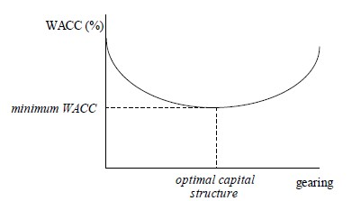

III.
First proposition of Modigliani and Miller is:- The market value of any firm is independent of its capital structure. The following are the assumptions:
• There are no taxes in the economy
• Unlimited personal and company borrowing is possible at the same rate of interest
• Debt is risk-free
• There are no agency costs
• There are no information asymmetries.
IV.
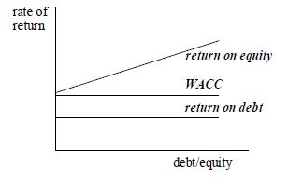

WACC remains constant as gearing increases. As gearing increases, the cost of equity increases by just enough to offset the increasing proportion of the cheaper debt.
V.
A.
Cost of equity is
= Risk-free return + Beta*(Equity risk premium)
= 6% + (1.4 *5%)
= 6% + 7%
= 13%
B.
Geared equity beta is
= Ungeared Beta*[1+(Debt : Equity ratio)*(1 - Tax)]
Here the Debt : Equity ratio is based on market capitalization,
Therefore
Geared equity beta is
= 1.4*[1+(0.5/0.5)*(1 – 0.3)]
= 1.4*(1+0.7)
= 1.4*1.7
= 2.38
C.
Cost of equity is
= Risk-free return + Beta*(Equity risk premium)
= 6% + (2.38*5%)
= 17.9%

