SRM PROJECT
414

QUESTION 3:
Code:
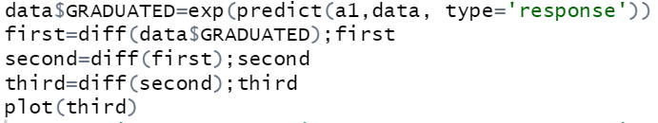

Output:

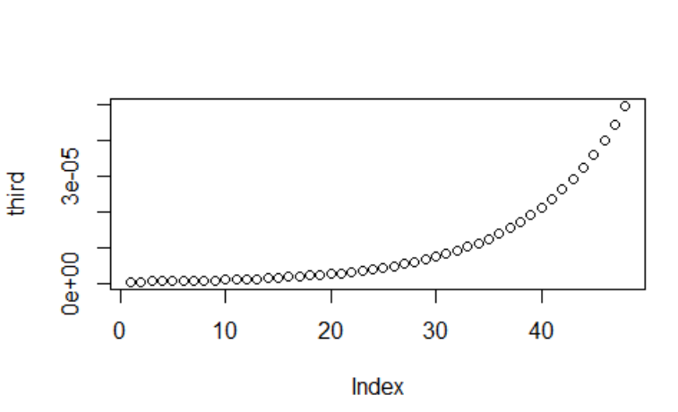
- the values are very low compared to the original values and they progress regularly.
- the data is smooth.
QUESTION 5:
- Most of the values are towards the positive side. Twenty are on the negative side while 31 are on the positive side.
- Absolute deviations value is high compared to expected value.
- Some outliers are present on the lower side but none on the upper side.
- The graph is positively skewed.
QUESTION 5b:
At 5% level of significance, we reject the null hypothesis that the data is
a true representation of the given mortality rates.
QUESTION 5c:
At 5% level of significance, we accept the null hypothesis that the data is a
true representation of the given mortality rates.
QUESTION 5d:
At 5% level of significance, we accept the null hypothesis that the data is a
true representation of the given mortality rates.

