Name – Jas Rathi
Roll no - 439

1)

- Arbitrage opportunity is a situation where we can make a certain profit with no risk. This is sometimes described as a free lunch.
An arbitrage opportunity means that:
- we can start at time 0 with a portfolio that has a net value of zero (implying that we are long in some assets and short in others). This is usually called a zero-cost portfolio.
- at some future time, T:
the probability of a loss is 0 and the probability that we make a strictly positive profit is greater than 0.
If such an opportunity existed then we could multiply up this portfolio as much as we wanted to make as large a profit as we desired.
- The Law of one price states that any two portfolios that behave in exactly the same way must have the same price. If this were not true, we could buy the ‘cheap’ one and sell the ‘expensive’ one to make an arbitrage (risk- free) profit.

- Using Put- Call parity, the value of put option should be:
pt=ct+ Kexp(-r(T-t))-Stexp(-q(T-t))
= 30+120exp (-.05*.25)-125exp (-.15*.25)
= 28.11
- If the put options are only Rs. 23 then they are cheap. If things are cheap then we buy them.
So, looking at the put-call parity relationship, we “buy the cheap side and sell the expensive side”, i.e., we buy put options and shares and sell call options and cash.
For example:
- sell 1 call option Rs. 30
- buy 1 put option (Rs. 23)
- buy 1 share (Rs.125)
- sell (borrow) cash Rs.118
This is a zero-cost portfolio and, because put-call parity does not hold, we know it will make an arbitrage profit. We can check as follows:
In 3 months’, time, repaying the cash will cost us:
118exp (0.05*3 /12) = Rs. 119.48
We also receive dividends d on the share.
If the share price is above 120 in 3 months’ time, then the other party will exercise their call option and we will have to give them the share. They will pay 120 for it and our profit is:
120 −119.48 + d = 0.52 + d
(The put option is useless to us)
If the share price is below 120 in 3 months’ time, then we will exercise our put option and sell it for 120. Our profit is:
120 −119.48 + d = 0.52 + d
(The call option is useless to the other party and will expire worthless)
- $Let dXt=At dt+Bt dZt,$
$$Where, At=αμ\left(T-t\right), Bt=σ\sqrt{\left(T-t\right)} Eq 1$$
$$dF=\frac{∂f}{∂x}Bt dZt+\left(\frac{∂f}{∂x}+\frac{∂f}{∂x}At+\frac{1}{2}\frac{∂2f}{∂x2}Bt\right)dt \left(Ito^{'}s Lemma\right)$$
$$dF=-f Bt dZt+f\frac{∂m}{∂t}\left(T-t\right)dt-f At dt+\frac{1}{2}f Bt^{2} dt$$
$$\left[Since \frac{∂f}{∂x}=-e^{m\left(T-t\right)-x} and \frac{∂f}{∂x}=\frac{∂m}{∂t}\left(T-t\right)*e^{m\left(T-t\right)-x} \left(using chain rule\right) and \frac{∂2f}{∂x2}= e^{m\left(T-t\right)-x}\right]$$
$$dF=f\left(\frac{∂m}{∂t}\left(T-t\right)-At+\frac{1}{2}Bt^{2}\right)dt-f Bt dZt$$
$$For f to be a martingale, \frac{∂m}{∂t}\left(T-t\right)-At+\frac{1}{2}Bt^{2}=0$$
$$Thus, \frac{∂m}{∂t}\left(T-t\right)=At-\frac{1}{2}Bt^{2}$$
$$Substituting Eq 1 above gives \frac{∂m}{∂t}=αμ-\frac{1}{2}σ^{2}$$

- Given
$$F\left(t,x\right)=e^{-t}x^{2}$$
$$\frac{df}{dt}=-e^{-t}x^{2}=-f$$
$$\frac{df}{dx}=2e^{-t}x$$
$$\frac{df}{dx^{2}}=2e^{-t}$$
$$Y_{t}=f\left(t,X_{t}\right)$$
$$Applying Ito^{'}s Lemma$$
$$dY_{t}=\frac{df}{dt}dt+\frac{df}{dx}dX_{t}+\frac{\frac{1}{2}d^{2}f}{dx^{2}}σ^{2}X_{t}^{2} dt$$
$$dY_{t}=-fdt + 2e^{-t} X_{t} {dX}_{t} +e^{-t}σ^{2} X_{t}^{2} dt$$
$$dY_{t}=-Y_{t}dt+2e^{-t} X_{t}^{2}\frac{dXt}{Xt}+e^{-t}σ^{2}X_{t}^{2} dt$$
$$-Y_{t} dt+2Y_{t}[0.24 dt+σ^{2}Y_{t} dt$$
$$\frac{dYt}{Yt}=\left[2*\left(0.25\right)-1+σ^{2}\right]dt+2σ dWt$$
$$\frac{dYt}{Yt}=\left[σ^{2}-0.5\right]Yt dt+2σ Yt dWt$$
- The process is martingale if drift is zero. This means $σ^{2}-0.5=0$
i.e. $σ^{2}=0.5$
- Let n ex-dividend dates are anticipated for a stock and t1<t2<....tn are the times before which the stock goes ex-dividend. Dividends are denoted by d1.... dn.
If the option is exercised prior to the ex-dividend date then the investor receives S(tn) – K. If the option is not exercised, the price drops to S(tn) – dn.
The value of the American option is greater than S(tn) – dn- Kexp(-r(T-tn).
It is never optional to exercise the option if S(tn) – dn- Kexp(-r(T-tn) >= S(tn) – K i.e., dn<=K*(1-exp(-r(T-tn)).
Using this equation: we have K*(1-exp(-r(T-tn)) = 350*(1-exp(-0.95*(0.8333-0.25))=18.87 and 65*(1-exp(-0.95*(0.8333-0.25)) =10.91.Hence it is never optimal to exercise the American option on the two ex-dividend rates.
- The required probability is the probability of the stock price being greater than Rs. 258 in 6 months’ time.
The stock price follows Geometric Brownian motion i.e. $S_{t}=S_{0}\exp\left(μ-\frac{σ^{2}}{2}\right)t+σ W_{t}$
Therefore Ln (St) follows normal distribution with mean Ln (S0) + ($μ$ – σ ^2/2) t and variance σ^2*t
Implies Ln (St) follows $φ\left(Ln 254+\left(0.16-\frac{{0.35}^{2}}{2}\right)*0.5, 035*{0.5}^{\frac{1}{2}}\right)=φ\left(0.59,0.247\right)$
This means [Ln (St) – St)]/ σt^ (1/2) follows standard normal distribution. Hence the probability that stock price will be higher than the strike price of Rs. 258 in 6 months’ time = 1- N (5.55-5.59)/0.247 = 1- N (-0.1364) =0.5542.
The put option is exercised if the stock price is less than Rs. 258 in 6 months’ time. The probability of this = 1- 0.5542= 0.4457

- The given relationship can be written as:
$$S_{t}= S_{0} e^{µt+σBt}$$
Since St is a function of standard Brownian motion, Bt, applying Ito’s Lemma, the SDE for the underlying stochastic process becomes:
$${dB}_{t}=0 X dt+1 X {dB}_{t}$$
$$Let G\left(t, B_{t}\right)=S_{t}=S_{0} e^{µt+σBt}, then$$
$$\frac{dG}{dt}=µ S_{0} e^{µt+σBt}=µ S_{t}$$
$$\frac{dG}{{dB}_{t}}=σ S_{0} e^{µt+σBt}=σ S_{t}$$
$$\frac{d^{2}G}{{dB}_{t}^{2}}=σ^{2} S_{0} e^{µt+σBt} = σ^{2} S_{t}$$
Hence, using Ito’s Lemma from Page 46 in the Tables we have:
$$dG=\left[0 X σ S_{t} + ½ X 1^{2} X σ^{2} S_{t} + µ S_{t}\right]dt + 1 X σ S_{t} {dB}_{t}$$
$$i.e. {dS}_{t}=\left(µ + ½ σ^{2}\right)S_{t} dt+σ S_{t} {dB}_{t}$$
Thus,
$$\frac{{dS}_{t}}{S_{t}}=σ {dB}_{t}+\left(µ + ½ σ^{2}\right)dt$$
$$So, c_{1}=σ and c_{2}=µ + ½ σ^{2}$$
- The expected value of St is:
$$E\left[S_{t}\right]=E \left[S_{0} e^{µt+σBt}\right]=S_{0} e^{µt} E\left[e^{σBt}\right]$$
$$Since B_{t} \sim N \left(0,1\right), its MGF is E\left[e^{ϴBt}\right]= e^{½ϴ2t}$$
$$So, E\left[S_{t}\right]=S_{0} e^{µt} X e^{½σ2t}=S_{0} e^{µt+½σ2t}$$
The variance of St is:
$$Var\left[S_{t}\right]=E\left[S_{t}^{2}\right]– {\left(E\left[S_{t}\right]\right)}^{2}=E\left[S_{0}^{2} e^{2µt+2σBt}\right]–{\left(S_{0} e^{µt+½ σ2t}\right)}^{2}=S_{0}^{2} e^{2}µt E\left[e^{2σBt}\right]–S_{0}^{2} e^{2µt}+σ^{2t}=S_{0}^{2} e^{2µt+2σ2t}-S_{0}^{2} e^{2µt+σ2t}=S_{0}^{2} e^{2µt}\left(e^{2σ2t}-e^{σ2t}\right)$$
- $Cov\left[S_{t1}, S_{t2}\right]=E\left[S_{t1}, S_{t2}\right]-E\left[S_{t1}\right]E\left[S_{t2}\right]$
From above,
$$E\left[S_{t1}\right]=S_{0} e^{µt1+½ σ2t1} and E\left[S_{t2}\right]=S_{0} e^{µt2+½ σ2t2}$$
$$The expected value of the product is:$$
$$E\left[S_{t1}, S_{t2}\right]=E\left[S_{0} exp\left(µt_{1}+σ {Bt}_{1}\right)S_{0}\exp\left(µt_{2}+σ {Bt}_{2}\right)\right]=S_{0}^{2} e^{µ\left(t1 + t2\right)} E\left[\exp\left(σB_{t1}+σB_{t2}\right)\right]$$
$$To evaluate this we need to split Bt2 into two independent components:$$
$$B_{t2}=B_{t1}+\left(B_{t2}-B_{t1}\right)where B_{t2}-B_{t1} \sim N\left(0, t_{2}–t_{1}\right)$$
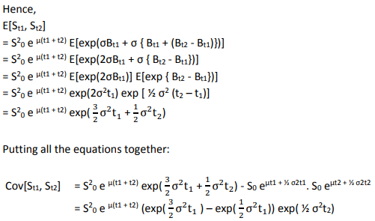

- Setting up the commodity tree using u for up move and d for down move, p is up-step probability:
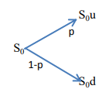
Where p is the up probability and (1-p) the down probability.
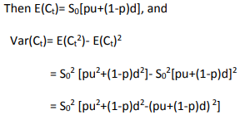
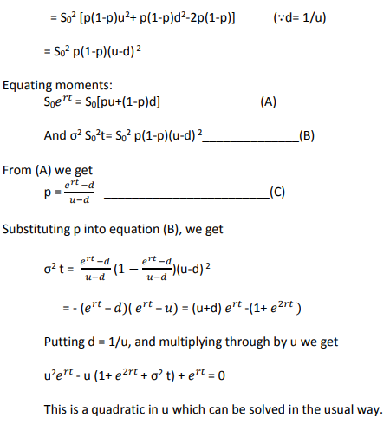

- σ = 0.15, t= 0.25 => u= exp(.15*√. 25)= exp(.075) = 1.077884, d = 1/u= .92774
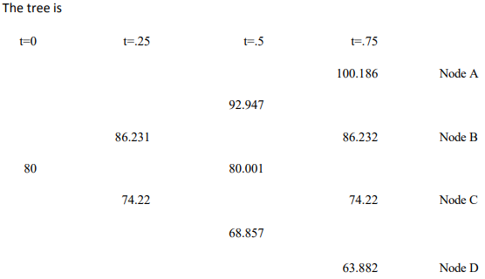
- $r=0, we have p=\frac{e^{rt}-d}{u-d}=\frac{\left(1-.927744\right)}{1.077884-.927744}=.48126$
Discounting back the final payoff at t=.75 to t=0 along the tree using p and (1-p), we get
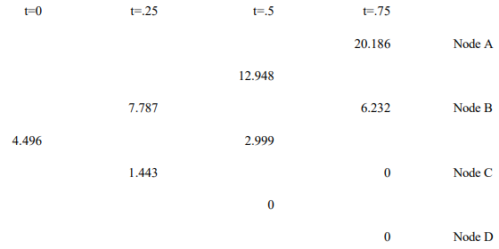
Hence value of the call option is 4.496.
- The lookback call pays the difference between the minimum value and the final value.
Notate paths by U for up and D for down, in order
We get the payoffs
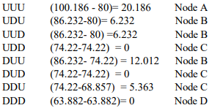
The lookback payoffs are, for each successful path (i.e., with a non- zero result)
Probabilities of arriving at each node are:
Node A= p3 = .11147
Node B= p2(1-p) = .12015
Node C= p(1-p)2 = .12950
Node D= p(1-p)3 = .13959
Hence the tree value of lookback option is:
(.11147*20.186) + (.12015*[6.232+ 6.232+ 12.012]) + (.12950*5.363) = 5.8854

- Consider a stock whose current price is S0 and an option whose current price is f. We suppose that the option lasts for time T and that during the life of the option the stock price can either move up from S0 to a new level S0u or move down to S0d where u > 1 and d < 1.
Let the payoff be fu if the stock price becomes S0u and fd if stock price becomes S0d.
Let us construct a portfolio which consists of a short position in the option and a long position in Δ shares. We calculate the value of Δ that makes the portfolio risk-free.
Now if there is an upward movement in the stock, the value of the portfolio becomes ΔS0u - fu and if there is a downward movement of stock, the value of the portfolio becomes ΔS0d – fd
The two portfolios are equal if ΔS0u - fu = ΔS0d – fd
Or Δ=fu-fd/S0u-S0d so that the portfolio is risk-free and hence must earn the risk-free rate of interest.
This means the present value of such a portfolio is (ΔS0u - fu) exp(-rT)
Where r is the risk-free rate of interest.
The cost of the portfolio is ΔS0 – f
Since the portfolio grows at a risk-free rate, it follows that
(ΔS0u - fu) exp(-rT) = ΔS0 – f
or f = ΔS0 – (ΔS0u - fu) exp(-rT)
Substituting Δ from the earlier equation simplifies to:
$$f =e^{-rT} \left[p f_{u}+\left(1-p\right)f_{d} \right]where p=\frac{\left[e^{rT}–d\right]}{u-d}$$
- The option pricing formula does not involve probabilities of stock going up or down although it is natural to assume that the probability of an upward movement in stock increases the value of call option and the value of put option decreases when the probability of stock price goes down
This is because we are calculating the value of option not in absolute terms but in terms of the value of the underlying stock where the probabilities of future movements (up and down) in the stock already incorporates in the price of the stock. However, it is natural to interpret p as the probability of an up movement in the stock price. The variable 1-p is then the probability of a down movement such that the above equation can be interpreted as that the value of option today is the expected future value discounted at the risk-free rate
- The expected stock price E(ST) at time T = pS0u + (1-p) S0d 0.5
or E(ST) = p S0(u-d) + S0d ---0.5
Substituting p from above equation in (i) i.e., p = [$e^{rT}$– d]/[u-d] ---1
We get E(ST) =$e^{rT}$S0 ---0.5 -----1
i.e., stock price grows at a risk-free rate or return on a stock is risk free rate
iv) In a risk neutral word individuals do not require compensation for risk or they are indifferent to risk. Hence expected return on all securities and options is the risk free interest rate. Hence value of an option is its expected payoff in a risk neutral discounted at risk free rate.

- The forward price is given by 𝐹 = . exp(𝑟t) where S is the stock price, t is the delivery time and r is the continuously compounded risk-free rate of interest applicable up to time t.
Put-call parity states that: 𝑐 + 𝐾 ∙ 𝑒xp(−𝑟t) = 𝑝 + 𝑆 where c and p are the prices of a European call and put option respectively with strike K and time to expiry t and S is the current stock price.
To compute F, we need to find S and r. t is given to be 0.25 years.
Substituting the values from the first two rows of the table in the put-call parity, we get two equations in two unknowns (S and r):
13.334 + 70 ∙ 𝑒xp(−0.25𝑟) = 0.120 + S
8.869 + 75 ∙ 𝑒xp(−0.25𝑟) = 0.568 + S
Solving the simultaneous equations for S and r, we get:
S = 82 and r = 7%
Therefore, we get the forward price 𝐹 = 82 ∙ 𝑒xp (0.07 ∗ 0.25) = 83.45
- Let the (continuously compounded, annualized) rate of interest over the next k months be rk. Then the required forward rate rF can be found from:
exp(r6*0.5) = exp(r3*0.25) *exp(rF*0.25) or 2*r6 = r3 + rF
We know that r3 = 7%.
To find r6, we substitute values from the last row in the put-call parity relationship and S = 82:
2.569 + 90*exp(-0.5*r6) = 7.909 + 82
Therefore, r6 = 6% and rF = 5%
- Using the put-call parity for each row in the given table, we get:
6.899 + a*exp (-0.07*0.25) = 1.055 + 82
b + 80*exp (-0.07*0.25) = 1.789 + 82
2.594 + 85*exp (-0.07*0.25) = c + 82
Solving individually, we get:
a = 77.5 b = 5.177 c = 4.119

- Since interest rates are assumed zero, the risk-neutral up-step probability is given as:
𝑞𝑞 = (1 − 𝑑) / (𝑢 − 𝑑)
where u and d are the sizes of up-step and down-step respectively
For a recombining tree, d = 1/u.
Substituting d = 1/u in the expression for q and simplifying, we get:
q = (1-1/u) / (u – 1/u) = 1 / (u+1)
For no-arbitrage to hold, we must have u > 1 > d.
Then, u > 1 => u + 1 > 2 => q = 1 / (u+1) < ½. Hence proved.
- Since each step is one month and the expiry of the derivative is one year from now.
Therefore, a 12-step recombining binomial tree needs to be created, i.e. n = 12.
Further, at time T = 12 months, the stock price will be S0uk
dn-k with risk-neutral probability
nCk qk (1-q) n-k where q, the up-step probability is 1/3, u, the up-step size is 2, and d = 1/u = ½.
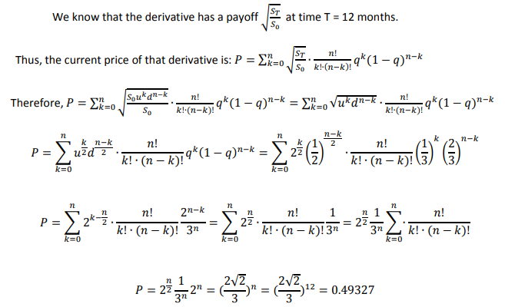

- A recombining binominal tree or binominal lattice is one in which the sizes of the up-steps and down-steps are assumed to be the same under all states and across all time intervals. i.e., u t (j)=u and d t (j)=d for all times t and states j, with d < exp(r) < u
It therefore follows that the risk neutral probability ‘q’ is also constant at all times and in all states eg. q t (j)=q
The main advantage of a ‘n’ period recombining binominal tree is that it has only [n+1] possible states of time as opposed to 2n possible states in a similar non-recombining binominal tree. This greatly reduces the amount of computation time required when using a binominal tree model.
The main dis-advantage is that the recombining binominal tree implicitly assumes that the volatility and drift parameters of the underlying asset price are constant over time, which assumption is contradicted by empirical evidence
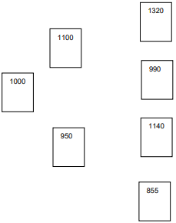

- The risk-neutral probabilities at the first and second steps are as follows:
q1 = (exp (0.0175) - 0.95)/ (1.10-0.95) = (0.06765)/0.15 = 0.4510
q2 = (exp (0.025) - 0.90)/ (1.20-0.90) = 0.41772
Put payoffs at the expiration date at each of the four possible states of expiry are 0,0,0 and 95.
Working backwards, the value of the option V1 (1) following an up step over the first 3 months is
V1 (1) exp (0.025) = [0.41772* 0] + [0.58228*0] i.e., V1 (1) = 0
The value of the option V1 (2) following a down step over the first 3 months is: V1 (2) exp (0.025) = [0.41772* 0] + [0.58228*95] i.e., V1 (2) = 53.9508
The current value of the put option is: V0 exp (0.0175) = [0.4510*0] + [0.5490*53.9508] i.e., V0 =29.105
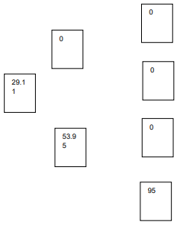
- While the proposed modification would produce a more accurate valuation, there would be a lot more parameter values to specify. Appropriate values of u and d would be required for each branch of the tree and values of ‘r’ for each month would be required.
The new tree would have 2^6 = 64 nodes in the expiry column. This would render the calculations prohibitive to do normally, and would require more programming and calculation time on the computer.
An alternative model that might be more efficient numerically would be a 6-step recombining tree which would have only 7 nodes in the final column.
- Given Z(t) is standard Brownian
- dU(t) = 2dZ(t) − 0 = 0dt + 2dZ(t).
Thus, the stochastic process {U(t)} has zero drift.
- dV(t) = d[Z(t)]2 − dt. d[Z(t)]2 = 2Z(t)dZ(t) + 2/ 2 [dZ(t)]2 = 2Z(t)dZ(t) + dt by the multiplication rule
Thus, dV(t) = 2Z(t)dZ(t). The stochastic process {V(t)} has zero drift.
- dW(t) = d [t2 Z(t)] − 2t Z(t)dt Because d [t2 Z(t)] = t2 dZ(t) + 2tZ(t)dt, we have dW(t) = t2 dZ(t).
Thus, the process {W(t)} has zero drift.

