A PROJECT REPORT ON

DEMAND & SUPPLY OF
CEAT TYRES

NAME: PRANAVI SHAH
ROLL NO.: 32

INDEX

PARTICULARS | PAGE NO.
INTRODUCTION | 3
PRODUCT ANALYSIS | 4 – 6
DEMAND FOR THE PRODUCT | 7 – 11
MARKET/INDUSTRY ANALYSIS | 12 – 18
SUPPLY OF THE PRODUCT | 19
PRICE ELASTICITY | 20 – 22
CONCLUSION | 23
REFERANCES | 24

INTRODUCTION

CEAT Limited (formerly, Cavi Elettrici e Affini Torino) is an Indian multinational tyre manufacturing company owned by the RPG Group. It was established in 1924 in Turin, Italy. As of date, CEAT is one of India's leading tyre manufacturers and has a presence in global markets. CEAT produces over 165 million tyres a year and manufactures tyres for passenger cars, two-wheelers, trucks and buses, light commercial vehicles, earth-movers, forklifts, tractors, trailers, and auto-rickshaws. The current capacity of CEAT tyres' plants is over 800 tonnes per day.
For a successful business it is important that marketing plays a pivotal role. Marketing department is one of the most important components of a business’s survival in the market. The main aim of the marketing department revolves around understanding the customers and their needs. Marketing activities involve designing, promoting, pricing a product according to the needs of the market and customers.
Today the competition is gradually increasing with the increase in customers’ expectations and needs. The main aim of the project is to ensure that changing the requirements of the customers are well understood and product or service is developed or altered to meet these requirements. Customers’ buying decision is influenced by various factors just as product features, price, quality packaging, and prompt delivery and after sales support. The project aims to work towards finding out the present and future needs of the customers. In order to anticipate future needs, proper analysis of customer trends should be undertaken. In order to gain a competitive advantage it is necessary that the firm has the capability to develop new products quickly.
Therefore, the main objective of this project is to find out the customer trends and the demand & supply of the CEAT tyres.

PRODUCT ANALYSIS

The Group's principal activities are to manufacture
The groups principal activities are to manufacture and distribute automotive tyres, tubes and flaps. The products include nylon fabric, nylon tyre yarn, glass fibre, automotive flaps, filament mats and other rubber products. The Group also provides investment financial services. The Group supplies to over 50 countries with the major business links in the United States of America, Singapore, the United Arab Emirates, Bangladesh, Philippines, Afghanistan, and Nigeria and other Asian, Middle East and African countries.

CEAT CAR TYRE:
The fuel efficient CEAT car tyres feature new generation tread compound equipped with optimised depth and rigid blocks at the shoulder. Alongside it has also got wide circumferential groove pattern for better grip levels. In addition to uniform tread wear, the tyre offers noise-free ride together with stability and enhanced grip while cornering. The long life of tyres with improved handling under dry and wet conditions provides peaceful and safer drive.

CEAT SUV TYRE:
Tyres for SUVs and MPVs/MUVs require thorough robustness and rigidity. With the innovative tread compound coupled with optimised shoulder depth, the 4-rib tread groove design offers maximum surface contact leading to uniform tread wear. The tyre’s broad circumferential pattern with stiff shoulder blocks provide better load carrying capabilities and high tear strength. The two SUV/MUV specific Milaze tyres namely Milaze TL and Milaze for SUV are endowed with longer tread life for better productivity in load bearing. Milaze presents stability while cornering and superior traction levels in wet and dry weather conditions. With Milaze SUV tyres CEAT claims improved life and greater mileage by up to 100,000 kilometres.

CEAT SCOOTER TYRE:
The mileage-friendly range of CEAT scooter tyres is available in all the key markets nationwide. Particularly designed keeping in mind the requirements of the business community for daily to-and-fro, the tyres are manufactured with high bead strength and flatter tread profile. In addition to load carrying ability, the sturdy blocks with innumerable sipes allow the tyre supply better grip and uniform wear alongside good water pumping on drenched roads.

CEAT BIKE TYRE:
Safety, especially at high speeds, has been the prime concern for CEAT motorcycle tyres, and CEAT motorcycle tyres just offer that. Moreover, they are equipped with brilliant water dispersal mechanics under wet conditions. The tyre has got high NSD and strong nylon casing which ensures long tyre life, while the unique groove pattern makes it go anywhere. The range of bike tyres includes hot sellers CEAT Milaze, CEAT Milaze Super and CEAT Milaze Tubeless.

CEAT TYRES PRICE:
CEAT tyres are quite affordable and carry value for money price tag. The Milaze series of scooter tyres starts with INR 1000 for tube type and goes up to INR 1700 for the tubeless tyre. The motorcycle tyre range falls in the price bracket of INR 1400-INR 1800. Coming to the Milaze four-wheeler tyre range, the car and SUV tyres opens at as low as INR 1500 and stretches up to INR 5000.

SWOT ANALYSIS

STRENGTHS:
- Right products, quality and reliability.
- Superior product performances vs. competitors.
- Brand image.
- Products have required accreditations.
- High degree of customer satisfaction.

WEAKNESS:
- Not very popular in the international market.
- Delivery-staff need training.
- Customer service staff need training.
- Processes and systems.
- Management cover insufficient.

OPPURTUNITIES:
- Profit margins will be good
- Could extend to overseas
- Could seek better supplier details
- An applied research centre to create opportunities for developing techniques to provide added-value services.

THREATS:
- Vulnerable to reactive attack by major competitors.
- Lack of infra structure in rural areas could constrain investments.
- High volume/low cost market is intensely competitive.
DEMAND FOR CEAT TYRES

The major factors affecting the demand for tyres include the level of industrial activity, availability and cost of credit, transportation volumes and network of roads, execution of vehicle loading rules, radialization, retreading and exports.

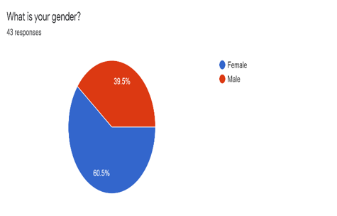

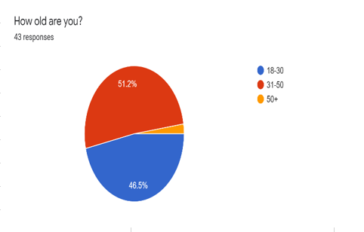

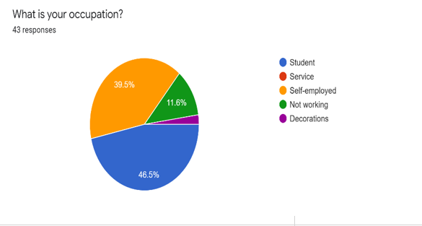

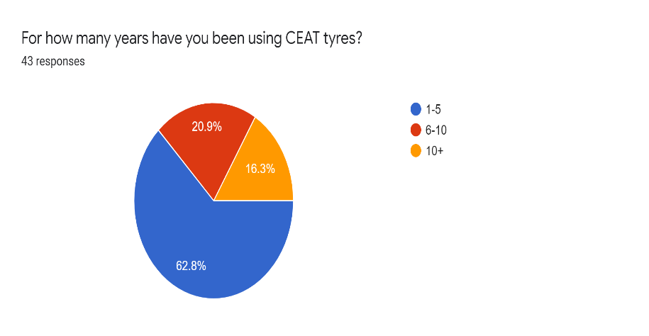

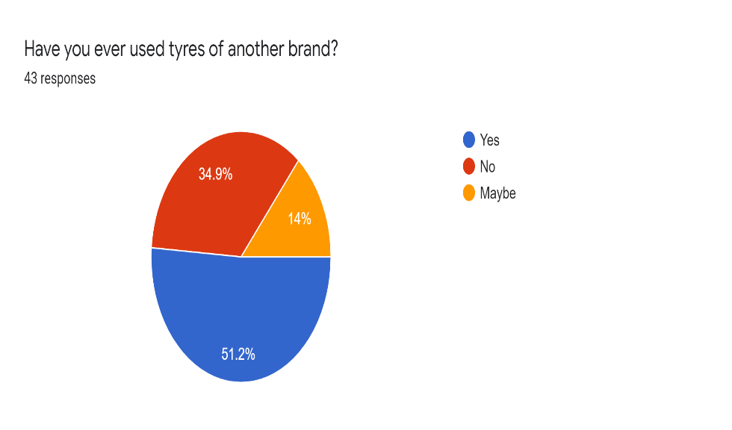

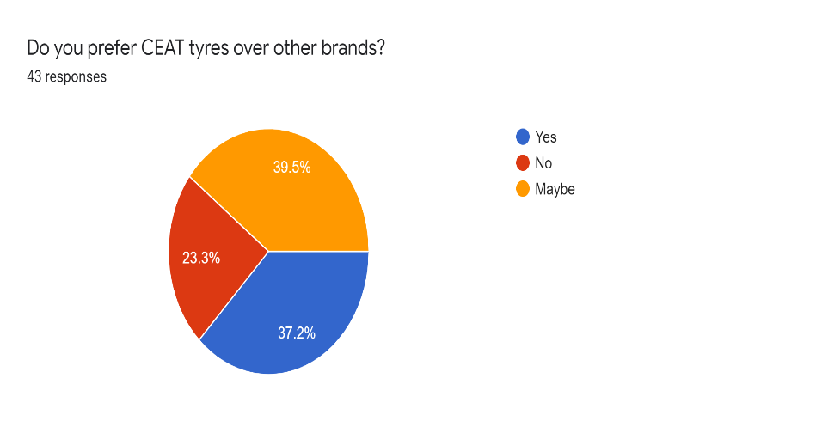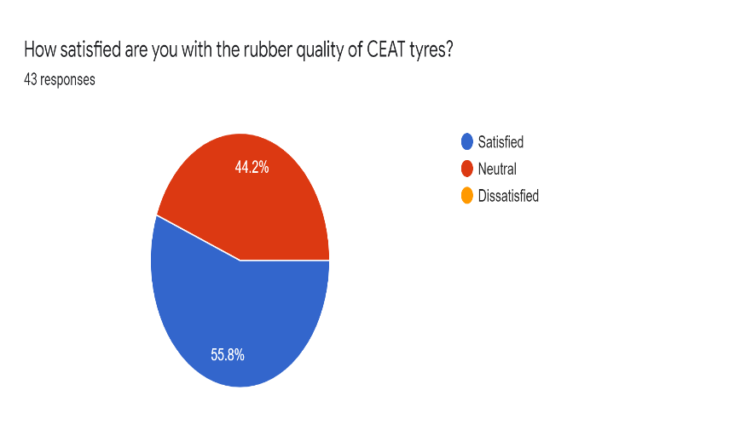
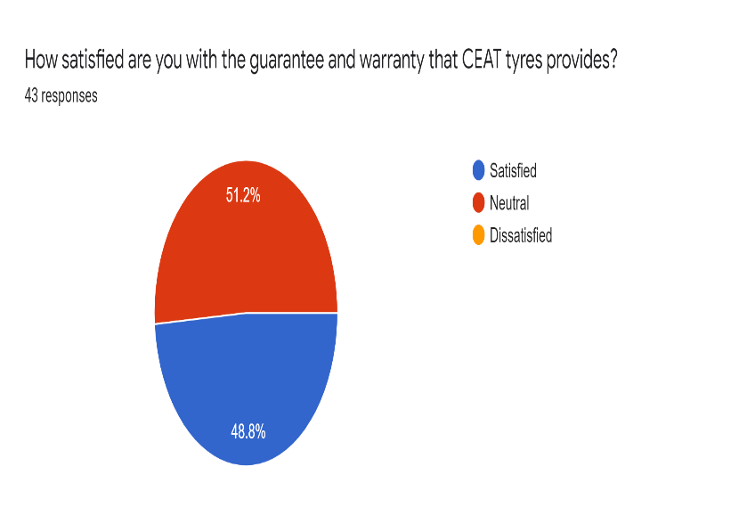

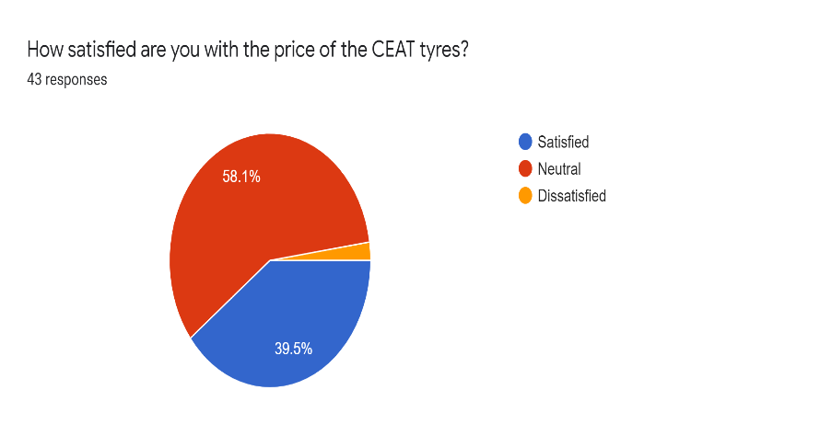
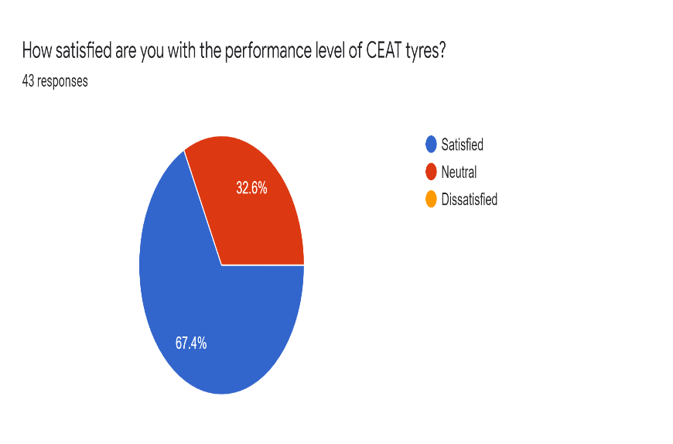

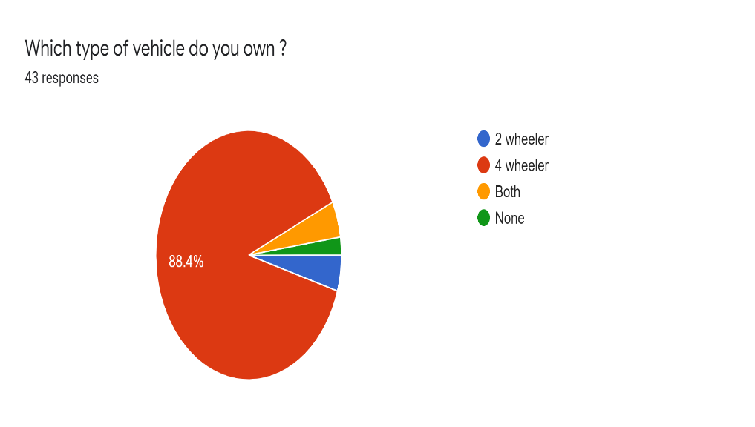

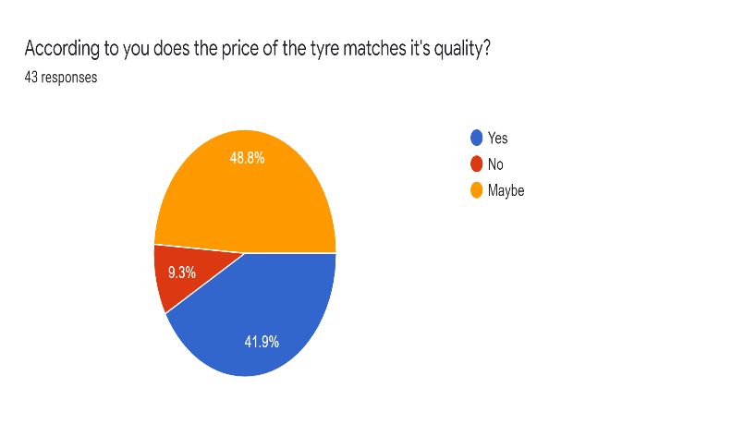

The survey that was conducted in Mumbai for the demand of CEAT tyres got around 43 responses. According to the survey we got to know that the majority were between the age-group of 31-50 while the least was 50 + and it had a good response from people who were in the age-group of 18-30. The majority were female users. Most of the people owned a 4-wheeler and were satisfied with the performance level of CEAT tyres. 46.5% were students and 39.5% of the people were working. 62.8% of the people have used CEAT tyres for 1-5 years while 20% have used it for 6-10 years. There are 51.2% people who have used tyres of other brands and few of them have replaced CEAT with other brands. 37.2% people prefer other brands over CEAT an most of them cannot choose between CEAT and other brands. 55.8% are satisfied with the rubber quality while the other people aren’t very sure if the quality is up to the mark.

More than half of the customers are satisfied with the guarantee and warranty that the company provides after sale. 39.5% of the people are satisfied with the price of the tyres while 58.1% aren’t very sure if they are satisfied or dissatisfied with the price set by the company. 67.4% are satisfied with the performance level of the tyres. 88.8% of the respondents own a 4-wheeler while the others own two- wheelers or none of the vehicles. 41.9% of the customers are satisfied with the quality of the tyre as it matches the price well.

Hence, we come to know that the demand for CEAT tyres is more if the price matches the quality of the tyre and is affordable for students as well as people who are working currently. The demand for four-wheeler’s tyres is more than the tyres used for other vehicles. They should also provide with a good after sale service of the tyres for more demand. As most people aren’t really satisfied or dissatisfied with the price, they could adjust it according to the market price and customer and suppliers needs.

MARKET ANALYSIS

TYRE INDUSTRY

The Indian Tyre Industry is an integral part of the Auto Sector – It contributes to ~3% of the manufacturing GDP of India and ~0.5% of the total GDP directly. So, let’s understand the dynamics of the Tyre Industry in India.

Indian tyre industry has almost doubled from ~Rs 30,000 crores in 2010-11 to ~Rs 59,500 crores in 2017-18 of which 90-95% came from the domestic markets. The top three companies – MRF, Apollo Tyres and JK Tyres have ~60% of the market share in terms of revenue. In terms of segmentation tyres can be divided in two ways – based on end market and based on product

Indian tyre market is clearly skewed towards the replacement segment which contributes ~70% of total revenues. Whereas in volume (tonnage) terms the replacement segment contributes ~60% indicating realizations in the after-market are clearly higher than OEMs (Original Equipment Manufacturer) market.

T&B tyres in India generates the major revenue i.e. 55% of total revenue whereas globally it’s the PCR (Passenger Car Radials) contribute the largest portion of the revenue. This is mainly because of very low penetration of passenger vehicles in India – below 20 per 1,000 people whereas in China the number is ~69 per 1,000 people and 786 per 1,000 people in US. In terms of volume (tonnage) T&B contributes around ~50% of the total volume.

The demand from OEM’s is widely spread across the segment where T&B contributed ~35% and PVs & 2/3 Wheeler’s contributed ~25% & ~22% respectively. In term of the replacement segment the demand was more skewed towards the T&B tyres which contributed ~61% and PVs & 2/3 Wheeler’s contributed ~14% & ~9% respectively.

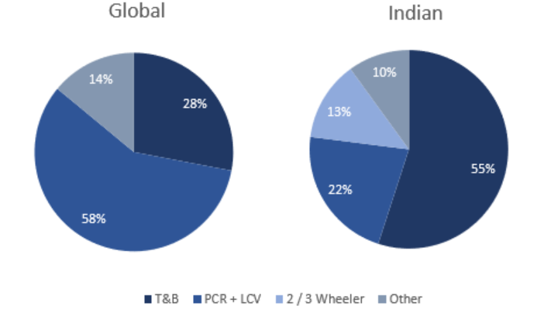

COST STRUCTURE

Tyre Industry is known for its capital-intensive structure where 60% to 65% of the revenues is raw material cost. The other important cost involved are SG&A (selling general & administrative) which roughly contribute from 6% to 12% of the revenues and employee cost contributing from 7% to 14% of revenues.

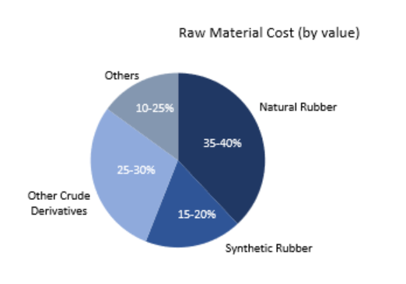
Around 250 different raw material are put together to manufacture a tyre but the major cost generating raw materials are natural rubber, synthetic rubber and crude derivatives like carbon black which contribute to ~80% to 85% of the total raw material cost. Hence, rubber and crude price are key variable to tyre company’s profitability.

The Indian tyre industry has been under raw material pressure for last two year due to increase in rubber and crude prices. As per the managements the pressure on the raw materials is expected to continue in the shorter term due to increasing crude prices.

COMPARISON
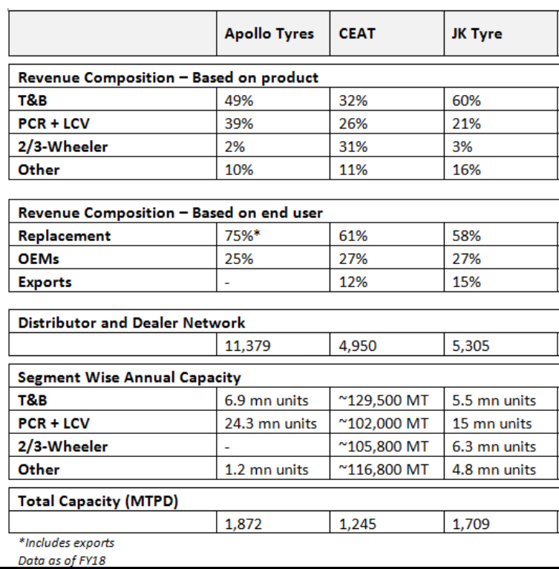

ECONOMIC INDICATORS

Inability to pass price rise to OEMs:

The ability to pass on sharp rises in raw material prices to OEMs remains a challenge for industry players. Generally, many tyre manufactures are unable to pass on higher raw material prices to OEMs, due to bulk demand fearing loss of market share.

Rising interest rates:

As many players in the tyre industry have plans to further expand their capacities which will be partly funded by debt. As RBI has been recently increasing interest rates due to macro issues. The expected increase in rates could lead to increase in finance cost of the companies.

Vehicle production fell by 13%-15% in the past two years (ending FY21) on account of weak consumer sentiments and subdued economic activities while domestic tyre demand contracted by 8%. In line with the overall auto industry, tyre demand contracted sharply in Q1 FY21 due to the nationwide lockdown, but recovery in tyre demand was stronger and faster as tyre volumes reached the pre-Covid levels in Q2 FY21 and witnessed a healthy growth in the subsequent two quarters

GOVERNMENT POLICIES

The Central Government recently announced import restrictions on pneumatic tyres used in bicycles, two-wheelers, passenger vehicles, commercial vehicles, and buses, with the aim of boosting sales for domestic tyre manufacturers.
Adding these products under the 'restricted' category means that importers will now require a licence and permission from the Directorate General of Foreign Trade.
Until recently global tyre manufacturers could import their range of tyres to India from anywhere across the globe, without restrictions. However there has been a massive growth in imports of tyres from China and other Southeast Asian countries. Rupees 33.10 crore worth of imports were registered over the financial year 2019-20 as compared to the Rs 26.10 crore registered over the preceding financial year. The government has taken these measures to promote local manufacturing, and to help reduce import bills of non-essential goods. The country's imports stood at Rs 46,700 crore for the last financial year - a reduction of roughly 10 percent via the Make-in-India initiative.
The government's recently bid for an "Aatmanirbhar Bharat" and has coined the 'Vocal for Local' slogan in an attempt to make India self-sufficient once the Covid-19 crisis has passed. While the restrictions are limited to imports of tyres at the moment, the scope for it expands across the entire equipment industry. Most automotive companies in India import ancillaries, electronic components, and sometimes batteries from China. This equipment that is imported are crucial parts of every vehicle. With demand currently at an all time low, companies are looking at ways to boost sales, and in turn, manufacturing - all of which will help the economy. In addition, the Government has been aggressively pushing for electric and sustained mobility that currently relies heavily on imports of basic components.

TAX AND SUBSIDIES
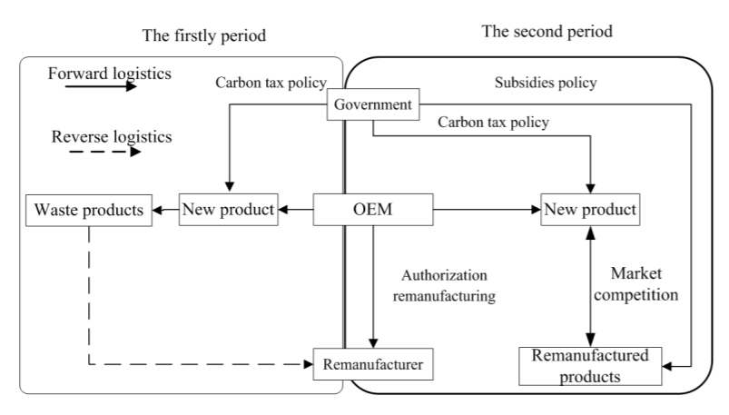

India may impose an anti-subsidy duty on imports of a particular kind of rubber from South Korea as the commerce ministry has recommended for the same after concluding an investigation.
The commerce ministry's investigation arm Directorate General of Trade Remedies (DGTR) has conducted the probe to see whether the subsidy programmes of South Korea for exports of "Styrene Butadiene Rubber" to India is impacting the domestic industry.

SUPPLY OF PRODUCT

CEAT has more than 4000 authorised tyre dealers across 2882 cities in India with wide range of car tyres, bike tyres, scooter tyres and heavy vehicles tyres.

As of date, CEAT is one of India's leading tyre manufacturers and has a presence in global markets. CEAT produces over 165 million tyres a year and manufactures tyres for passenger cars, two-wheelers, trucks and buses, light commercial vehicles, earth-movers, forklifts, tractors, trailers, and auto-rickshaws.

Even in these less than ideal times that we’re facing, it’s interesting to see how big the Indian tyre industry is. Take April – December 2019, and the number of tyres manufactured was staggering 13.65 crores. Considering that a year ago during the same period, the industry churned out 14.63 crore tyres shall give you a stronger idea. The major chunk of the tyres that are produced and sold in India are for motorcycles, followed by scooters, passenger vehicles, three-wheelers, LCVs, and trucks and buses. Some of the few company’s that can be a substitute to CEAT tyres are MRF Tyres, JK Tyres, Apollo Tyres, Bridgestone and TVS Tyres.

Every tyre, tube and flap manufactured and/or marketed by “CEAT Ltd” is warranted to be free from defects in terms of quality of material or workmanship, in its first tread life and warranty period. In case, as per our examination, a product fails during the warranty period mentioned in the warranty policy, we will replace the product on pro-rata wear basis subject to the T & C of this warranty policy. The compensation amount of the tyre will be calculated basis the percentage of tread wear. In this case, the “remaining tread depth measurement system” will be applied.

PRICE ELASTICITY

PRICE ELASTICITY OF DEMAND

The price elasticity of demand is calculated as the percentage change in quantity demanded divided by the percentage change in price.

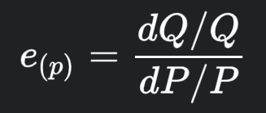

e_{(p)} = price elasticity
Q = quantity of the demanded good
P = price of the demanded good

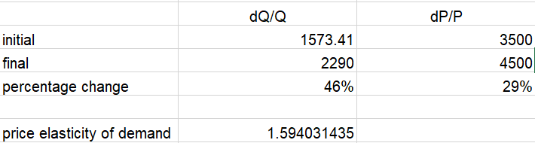

As, the price elasticity of demand is greater than 1, it is demand elastic.
Hence, demand for CEAT tyres is sensitive to an increase in price.

PRICE ELASTICITY OF SUPPLY

The price elasticity of supply is calculated as the percentage change in quantity supplied divided by the percentage change in price.

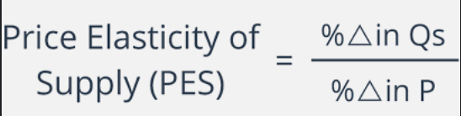

Q = quantity of supplied good
P = price of the supplied good

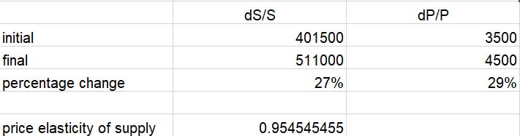

As, the price elasticity of supply is less than 1, the supply is inelastic.
Hence, the supply of CEAT tyres is not that sensitive to the price.

CONCLUSION

From the survey taken place in Mumbai we come to know that the demand for CEAT tyres is more if the price matches the quality of the tyre and is affordable for students as well as people who are working currently. The demand for four-wheeler’s tyres is more than the tyres used for other vehicles. They should also provide with a good after sale service of the tyres for more demand. As most people aren’t really satisfied or dissatisfied with the price, they could adjust it according to the market price and customer and suppliers needs.

From the product analysis we came to know that there is a varied range of the products that CEAT provides its customers. They have their own strengths and weakness as mentioned in the swot analysis. They can improve their weaknesses by understanding the main problem behind them and making rules and regulations that must be implemented to the people in charge.

From the market analysis we came to know that there are many companies in the market that act as the competitors of CEAT such as JK Tyres, MRF Tyres, Apollo Tyres and a few more. These companies also have a similar price range and quality to CEAT. Hence, they can become a replacement or substitute products of CEAT, if the customers are not satisfied with the CEAT tyres quality, price or the warranty and guarantee of the product that they use in their day to day life. But as of today CEAT is one of the leading companies in customer satisfaction and in the market for their products.

The price elasticity of demand of CEAT tyres is elastic while the price elasticity of supply of CEAT tyres is inelastic. Hence, demand for CEAT tyres is sensitive to an increase in price and the supply of CEAT tyres is not that sensitive to the price.

REFERANCES

- https://auto.economictimes.indiatimes.com/
- https://www.expertmarketresearch.com/
- https://www.ceat.com/
- https://www.tyremarket.com/
- https://www.wallstreetmojo.com/
- https://en.wikipedia.org/
Right products, quality and

