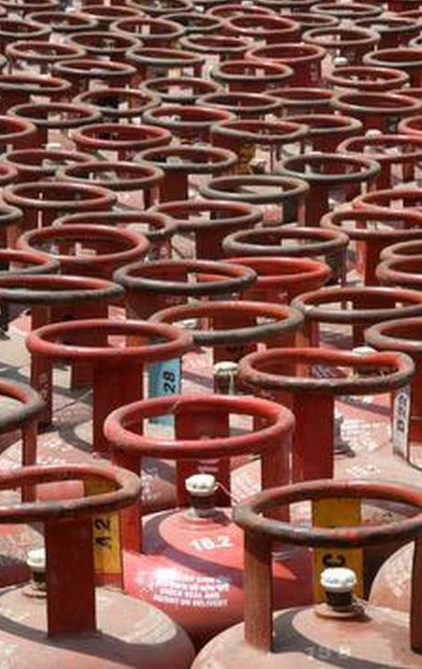

LPG Cylinder
  - Price – Demand analysis
Devansh Jain | BEM | 25/09/2021

Index
- Abstract
- Preface
  - Industry Background
    - Industry Growth
    - Competitive landscape
  - Alternatives
    - Types of cooktops available
    - Efficiency and cost of various cooktops
    - Other factors
- Hypothesis
- Methodology
- Results
- Reference

Abstract
Liquified petrol gas comes from natural gas processing and petroleum refining and is used for fuel in heating, cooking, hot water and vehicles, as well as for refrigerants, aerosol propellants and petrochemical feedstock. Since LPG is an essential commodity, it is subsidized by the government (up to 12 cylinders per year per household. There are 28 Crore customers of LPG in India. This survey analyses all the factors affecting the demand of LPG cylinders to understand the nature of demand of LPG. The survey was done using an online questionnaire. It was surprising to find out that even though consumer income and price of cylinder was changed, the demand of LPG cylinder did not change much even when the price rose above its substitutes which means that demand for LPG cylinders is highly inelastic.

Preface

Industry background
  - Industry Growth
India is the second largest consumer of LPG after China. Indian LPG consumption in 2020 was at 27.41 million tons, 4.3% higher than a year earlier, according to government data. Due to the government initiatives, the demand for clean cooking fuel in the rural residential areas is expected to grow further in the coming years, which is further anticipated to contribute to the growth of the Liquefied Petroleum Gas market in the country. Additionally, rapid expansion of Liquefied Petroleum Gas production capacity, newly assigned refinery expansion projects and new pipelines laid all across the cities in both North and South regions coupled with the considerable demand for LPG, is emerging as a major go that will help supplement the India Liquefied Petroleum Gas market through the next decade. The government has planned to expand a few of its petrochemical plants and lay new pipelines across few states. Being one of the prime producers and traders of LPG, India’s market share is anticipated to increase further by 2030. Additionally, privately owned companies such as SHV, Aegis Logistics, and Total India are leading LPG distributors in India, who are acting as a parallel marketer. These factors are projected to boost the growth of the Liquefied Petroleum Gas market in the country.
However, Market penetration of LPG is 97.5% in India which means the industry is nearly saturated. Just like the automobile industry, many people are quickly making the switch to electric alternatives which are safer and less polluting. Also, the recent price hike of LPG has put the cost of LPG just 3% lower than the cost of operating Electric Induction.
Hence, I think that the growth rate of LPG will decrease significantly over the next decade
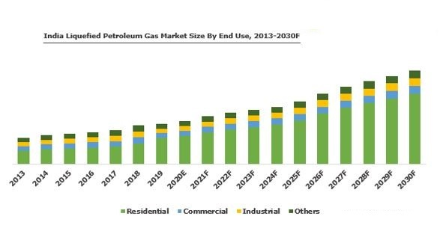

  - Competitive Landscape
There are three major manufacturers of LPG gas in India
- Indane Gas (Run by Bharat Petroleum Corporation Ltd.)
- HP gas (Run by Hindustan Petroleum Corporation Ltd.)
- Bharat Gas (Run by Bharat Petroleum Corporation Ltd.)

In addition to these, there are some smaller private companies that also provide LPG, such as Total Gas, Super Gas among others.
The government sets the price for subsidized cylinders and since LPG is a commodity, even unsubsidized cylinders have nearly the same price across companies, so there isn’t any price difference among the companies.

Alternatives
  - Types of cooktops available
There are 3 types of cook-tops available in market: Gas, Electric and Induction. This is how they are different:
- Gas: This type of cooktop has a burner on top and uses gas (LPG or PNG) to burn a flame that is used to cook food.
- Electric: This type of cook-top has a coil that heats up due to resistance when current passes through it. As its name, it uses electricity to generate heat and cook food.
- Induction: Although this type of cook-top uses electricity but it uses magnetic property of steel to directly heat the cooking vessel. Unlike other cooking methods it does not use flames or red-hot element to cook. Thus, it is considered more energy efficient. Also, it only heats the vessel in contact thus reduces possibility of injury

  - Efficiency and Cost of various cooktops.
US Department of energy did some boiling water tests to come up with efficiency of various cook-tops (Source: US DOE) and below were the results of the same:
 | Gas | Electric | Induction
Efficiency | 40% | 74% | 84%

Looking at the numbers above one cannot decide which is better economically as one has to also factor in the costs of various sources. So, we decided to compare apples to apples. There are 3 types of sources that we commonly get: LPG Cylinders, Piped Natural Gas and Electricity. Now how do these 3 compare:
Let’s take an example that we want to boil 10 liters of water (at 25 degrees).
Now this is how various sources compare:
 |  | PNG Stove | Induction Cooktop | Electric Coil Cooktop
 | LPG Stove | PNG Stove | Induction Cooktop | Electric Coil Cooktop
Cost per Unit (in Rs) | Rs 423 (Subsidized), | Rs 23 | Rs 5 | Rs 5
Cost per Unit (in Rs) | Rs 900 (Un-Subsidized) | Rs 23 | Rs 5 | Rs 5
Cost of heating 10 lts water (in Rs) | Rs 5.09 (Subsidized), | Rs 4.33 | Rs 5.21 | Rs 5.91
Cost of heating 10 lts water (in Rs) | Rs 10.8 (Un-Subsidized) | Rs 4.33 | Rs 5.21 | Rs 5.91

  - Other Factors
Cost isn’t the only factor that people consider while buying a cooktop. So, let’s look at the pros and cons of each type of cooktop
For Gas Stoves:
Pros:
- Gas stoves provide better cooking control. One does not have to worry too much about position and size of the utensil kept on it. Though it can impact efficiency.
- One does not have to depend on power cuts for cooking.
- Good for cooking most Indian food like chapatti, etc.
- No specific requirement for utensil type.
Cons:
- Inflammable and thus dangerous. Can cause burns.
- Heats up the surroundings as well. Can increase the cooling bills if the environment is air conditioned.
- Ceiling Fans cannot be used along with it.
- Flames do produce CO2.
For Electric Coil Cook-tops:
Pros:
- Not inflammable thus creates a little safer environment.
- More energy efficient than gas stoves and can be economical than gas stoves if gas is not available at subsidized rates.
- Releases less heat to the surrounding and ceiling fans can be used along with it.
Cons:
- Can cause burns when touched.
- Takes time to heat up.
- Can only be used with flat surface utensils.
- Inadequate power supply can stop cooking.
For Induction Cook-tops:
Pros:
- Induction cook-tops heat faster and distribute heat more evenly.
- They are completely safe as they heat only when a steel or iron element comes in contact.
- They are easier to clean.
- Efficient in terms of energy use.
- Come with programmable temperature controls.
- No heat wasted as it cools quickly as one shuts it down.
Cons:
- Can only be used with steel or iron utensils. Thus, the kitchen has to be adjusted accordingly.
- They are generally expensive than regular cook-tops.
- Can be used only with flat surface utensils.
- Inadequate power supply can stop cooking.
- Will not work at all for some Indian food like chapatti.
- Some people observe that the heating is localized and mostly happens at the center of the utensil. This makes it important to put the right sized utensil on a induction cook-top and oversized ones should not be used.

Hypothesis
Before looking at the results, I have several hypotheses that I want to test using the results:
- Since LPG is an essential commodity, it should be inelastic over small changes of price
- Since LPG’s price is so close to Electric Induction’s price, it should be elastic over bigger changes in price
- Safety is people’s highest priority while choosing a cooktop
- There has to be a correlation between number of people in a house and number of cylinders used per year

Methodology
The survey was done using Google forms. These are the questions:
What’s your age?
- 0-13
- 13-18
- 18-24
- 24+
Where do you live?
- Mumbai
- Other…
Employment Status
- Employed
- Unemployed
- Self-employed
- Student
Family income(annual)
- Less than 10 lacs
- 10-30 lacs
- 30-70 lacs
- 70 lacs-1.3 Cr
- More than 1.3 Cr
How many people live in your house?

What do you use for cooking at your home?
- LPG
- PNG
- Electric coil
- Electric induction

If you use LPG, how many Cylinders do you buy per year?

Which company would/do you take LPG cylinders from?
- Indane Gas
- Bharat Gas
- HP Gas
- Other…
Price Elasticity
The current price of 1 cylinder is Rs 885, and cooking with electric induction is 5% more expensive (not including the cost of buying an induction cooker).
How many cylinders would you buy in a year at the following prices? (Enter 0 if you would completely switch to other forms)
- 900
- 925
- 950
- 975
- 1000

Rate the factors in terms of importance (1-lowest, 5-highest)
1 2 3 4 5
Price
Pollution caused
Safety
Convenience

Results
The results can be summarized as follows:

Price | 880 | 900 | 925 | 950 | 975 | 1000
Demand | 129 | 124 | 116 | 113 | 98 | 93 | Avg:
Price Elasticity |  | 1.71 | 1.97 | 1.56 | 2.23 | 2.05 | 1.90

Hypothesis one and two are true because the price elasticity increases and the price change gets bigger. However, the demand was not “inelastic” over small price changes.

Hypothesis 3 is also true as can be shown by the following chart:
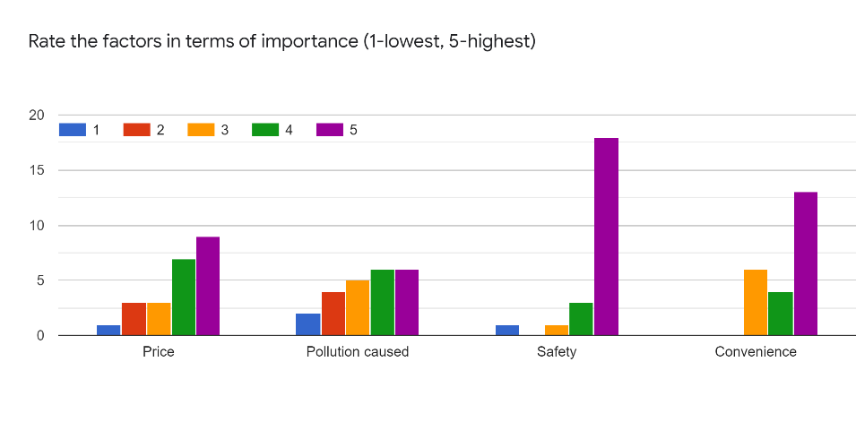
There is not enough data to support hypothesis 4, as can be showed by the following chart:

One observation after this survey was that the respondents can be categorized as three categories:
- Unaffected by price (7 respondents)
- Reduce usage (6 respondents)
- Completely switch to alternative (4 respondents)
If the survey had been on a non-essential, there would have been significantly less respondents in the first category and significantly more in the second and third.

References
https://www.bankbazaar.com/gas-connection.html
https://www.bijlibachao.com/appliances/cooktop-comparison-gas-electric-and-induction.html
All other information was taken from Survey results and general google searches

End of Report

