- C
- A Nominal wages are equal to expected wages
- C There is excess demand and the exchange rate should rise.
- D Interest rate must fall to restore equilibrium in the goods market.
- D Quantitative easing
- C Real wages are highly flexible
- C Negative relationship between inflation and unemployment
- B Weaken
- C Information on job availability
- B The velocity of circulation must have fallen
- D Imposition of Indirect Tax
- A Negative
- B
- C
- C
- D
- A
- C
- C
- A
- C
- D
- C
- B
- A
- B
- Increases
- 2016
- C
- D Better education and training.
- C Rise while import value may rise or fall.
- B The purchase of shares in an Indian company by foreign investors.
- A Fluctuate more than consumer expenditure.
- C Increase and the domestic money supply rise.
- D Import volumes will increase.
- B High rates of interest are discouraging borrowing.
- D Provision of infrastructure
- A Interventionist supply-side Policy
- To achieve an inflation target, central banks use monetary policy. If predicted inflation is higher than the target, they use contractionary policy to increase interest rates and lower aggregate demand, thus lowering the rate of inflation. If predicted inflation is lower than the target, they use expansionary policy to lower interest rates and increase aggregate demand.
Advantages of inflation targeting-
A lower rate of inflation. Particularly in countries that have experienced persistent high rates of inflation, inflation targeting can be a method to reduce it.
A more stable rate of inflation. This refers to reduced fluctuations in the rate of inflation, likely to be achieved when a target rate is pursued.
Improved ability of economic decision-makers (firms, consumers) to anticipate the future rate of inflation. Public knowledge about the central bank’s objectives on inflation reduces uncertainty and facilitate economic decision making about the future (such as investment decisions).
Greater co-ordination between monetary and fiscal policy. Knowledge about inflation targets allows the government to plan its fiscal policy to complement the central bank’s monetary policy.
Greater central bank transparency and accountability. The central bank becomes more open about its activities and more accountable to the government and the public. If it fails to bring inflation close to the target, it must provide an explanation.
Disadvantages of inflation targeting-
Reduced ability of the central bank to pursue other macroeconomic objectives. If the central bank focuses only or mainly on inflation at a particular target rate, it is unable to use monetary policy to pursue other goals, such as for example, the full employment level of real GDP or exchange rate stability.
Reduced ability of the central bank to respond to supply-side shocks. In the event of a supply-side shock, such as a sudden increase in oil prices, leading to cost-push inflation and stagflation, the central bank may need flexibility to pursue an expansionary policy to bring the economy out of recession, and this may mean a higher rate of inflation than the target.
Reduced ability of the central bank to deal with unexpected events, such as financial crises. A financial crisis may also require an expansionary monetary policy, which might also lead to inflation higher than the target.
Finding an appropriate inflation target. An inflation target that is too high or too low can lead to problems. If it is too low, it may lead to higher unemployment; if it is too high, it could lead to the problems resulting from high inflation.
Difficulties of implementation. Inflation targeting is based heavily on forecasts of future inflation and economic activity, and forecasts are often highly unreliable.
- The five main factors affecting the demand for money are-
Money national income - An increase in money national income (either arising from an increase in real national income or an increase in prices) will lead to an increase in expenditure on goods and services and hence an increase in the demand for money with which to buy them.
The frequency with which people are paid - The less frequently people get paid, the greater the demand for money.
Financial innovations, e.g., the use of credit cards reduces the demand for money; the use of cash machines and debit cards and the payment of interest on current accounts increase the desirability of holding money.
Speculation regarding the expected returns on financial assets - if returns are expected to fall, there will be an increase in the demand for money; if the domestic currency is expected to appreciate, there will be an increase in the demand for money.
The rate of interest – The opportunity cost of holding money as an asset is the interest foregone by not holding other higher-earning assets such as shares and bonds, so the higher the interest rate on assets such as bonds, the greater the opportunity cost of holding money and so the lower the demand for money.

- An exchange rate index or the effective exchange rate is a weighted average of the exchange rate of a particular currency against all other currencies, where the weights are based on the proportion of transactions between each country.
- This is because a less developed country depends on developed countries for the import of plant and machinery (and related technology) for its development programs. This causes a situation of adverse or negative balance of payments for the less developed countries. Accordingly, their forex reserves are low while the need for such reserves (to cope with rising imports) continues to be high. High exchange rate (or paying more and more for a dollar in the international market) is the obvious consequence.

- Money supply will be unaffected because the public’s cash is withdrawn from banks and government spends it, so it is redeposited in the banking system. Hence, no overall change in the amount of cash held in the banking system.
- Increase because there will be more cash deposited in banks, rather than being held outside of the banking system, which they can use to create credit.

- A fall in the national income leads to a decrease in the transactions demand for money. The demand for money curve will shift to the left.
- A decrease in the expected value of domestic currency will cause a decrease in the demand for the currency, i.e., the demand for money curve will shift to the left.

- Points on the IS curve show combinations of interest rates and national income at which injections equal withdrawals and consequently the total output (national income) equals total expenditure, giving equilibrium in the markets for goods and services.
Points on the LM curve show combinations of interest rates and national income at which the demand for money (liquidity) equals the supply of money, giving equilibrium in the money markets.
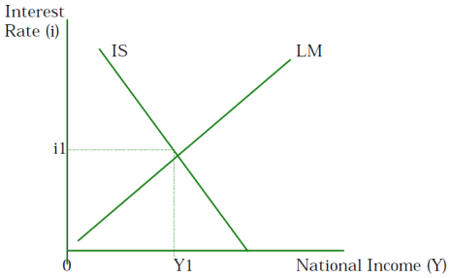
The IS-LM curves are drawn on a graph with interest rates on the vertical axis and national income on the horizontal axis. The IS curve slopes downward from left to right showing that lower rates of interest lead to higher levels of national income. The LM curve slopes upward from left to right showing that in order to obtain equilibrium in the money market, given the supply of money, higher levels of national income are associated with higher rates of interest.
At the rate of interest and level of national income where the IS-LM curves intersect in the graph both the money market and the market for goods and services are in equilibrium.
- An increase in the average price level will result in a reduction in the real value of the money supply. A reduction in the money supply will shift the LM curve to the left giving an increase in the equilibrium rate of interest and a fall in the equilibrium level of national income.
The reduction in the money supply gives an excess demand for money causing rates of interest to rise. The rise in interest rates discourages investment and consumer expenditure, reducing injections and causing the equilibrium level of national income to fall.
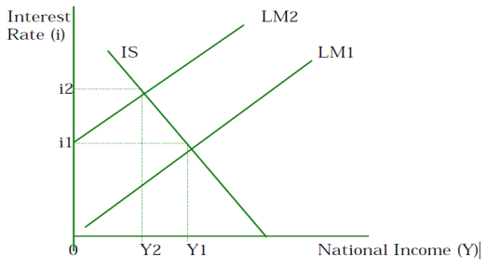
- With an expansionary fiscal policy financed by the sale of bonds, the government sells bonds and uses the proceeds raised to finance increased government expenditure. The effect on the money supply should be zero as the money raised from the bond sales is spent by the government.
However, the increase in the supply of bonds for sale pushes down bond prices and raises the interest rate. There is a multiplier effect associated with the increase in government expenditure which is only partially offset by the effect of rising interest rates on consumption and investment so there is a net increase in the level of national income.
This is depicted in the diagram below with the increase in government expenditure shifting the IS curve to the right from IS1 to IS2 and the interest rate rising from r1 to r2 and the level of national income rising from Y1 to Y2.
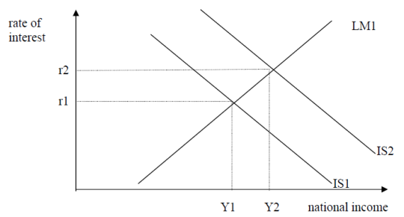

- Line 1 – Exports
The balance of trade in goods is the net figure of exports and imports. We therefore have:
Exports =425 -40
Exports are therefore equal to $385m
Line 6 - Balance of trade in services
The balance of trade in services is the net of exports and imports of services. We therefore have:
165 - 185 = balance of trade in services
The balance of trade in services is therefore -$20m.
Line 8 - Income payments
The net income receipts (line 9) are the net of income receipts and income payments. We therefore have:
190 - income payments = 15
Income payments are therefore -$175m.
Line 11 - Net income flows
Net income flows are the net of net income receipts and net current transfers. We therefore have:
15 - 50 = net income flows
Net income flows are therefore -$35m.
Line 12 - Current account balance
The current account balance is the sum of the balance of trade in goods (line 3), the balance of trade in services (line 6) and net income flows (line 11). We therefore have:
-40 -20 - 35 = current account balance
The current account balance is therefore -$95m.
Line 18 - Capital and financial account balance
The balance of payments has to balance. In other words the net of the current account balance and the capital and financial account balance must be 0.
Since the current account is -$95, the capital and financial account balance must be +$95m.

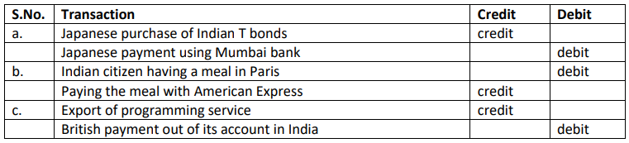

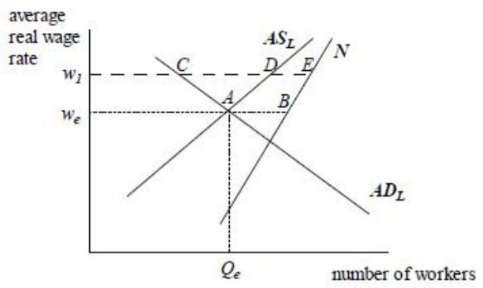
The aggregate demand for labour curve (ADL) shows the total demand for labour at different average real wage rates. It assumes that at higher wages, employers take on fewer workers. The curve labelled N shows the registered labour force. It assumes that more people are willing to enter the labour force at higher wage rates.
The aggregate supply of labour curve (ASL) shows the number of people willing and able to accept jobs at each wage rate. It assumes that at higher wage rates more people become willing to accept jobs. The difference between the N and ASL schedules represents the number of people who are in the labour force, but who are not immediately willing or able to accept a job at the current wage rate.
- The labour market is in equilibrium with a real wage of we and an equilibrium level of employment Qe (i.e., when ADL= ASL). At the real wage we, there is unemployment of AB. This is called the equilibrium level of unemployment.
If wages are held above the equilibrium at a wage of w1, then total unemployment is CE. Of this, DE consists of those workers who are not willing or able to accept a job at w1, but CD is a result of excess supply of labour and is called disequilibrium unemployment.
Reasons for equilibrium unemployment are 1. Frictional unemployment 2. Structural unemployment 3. Technological unemployment 4. Regional unemployment 5. Seasonal unemployment
Reasons for disequilibrium unemployment are 1. Demand deficient unemployment 2. Real-wage unemployment 3. Growth in labour supply

- Frequent changes in currency value could adversely affect trade and investment by creating uncertainty and losing business confidence. Government, therefore, wish to prevent fluctuations in currency value.
- The measures available to the central bank in this regard would depend on whether the aim is to curtail day to day or longer-term changes in exchange rate.
- Government can use fiscal and monetary policies to maintain the monetary value of the currency for longer periods such as months and years.
- The government may also improve supply side policies like improving the long-term competitiveness of the domestic industry by improving quality of goods produced and lowering the production cost. This can be achieved for quality of training and research / development.
- Contractionary fiscal and monetary policy can be used to reduce aggregate demand. A contractionary fiscal policy would involve raising taxes / reducing government spending. A contractionary monetary policy would involve raising interest rate to reduce borrowing and hence aggregate demand.

- 30m surplus
- 10m deficit
- -40m
- No, the country does not have a fully flexible exchange rate. We can deduce this from the entry decrease in official reserves” which indicates that the central bank has been purchasing the domestic currency.

