IAQS: SEMESTER - 3
SUBJECT: PORTFOLIO THEORY AND SECURITY ANALYSIS
ASSIGNMENT 1

UNIT 2

Q1) B
Q2) B
Q3) B
Q4) C
Q5) A
Q6) A
Q7) B
Q8) B

Q9) An investor’s overall risk tolerance is a function of his ability to bear risk and his or her risk attitude or willingness to take risk. An above average ability to bear risk and an above average willingness to take risk imply an above average risk tolerance and vice versa. The ability to bear risk is measured in terms of objective factors such as income, time horizon and the level of wealth relative to liabilities. An investor with a 25-year time horizon has a greater ability to bear risk than an investor with a 5-year time horizon as there is sufficient time for the former to recover any losses. Similarly, an investor whose assets and wealth are in excess of the liabilities has a greater ability to bear risk than one who does not. The willingness to take risk is a more subject factor based on the investor’s psychology and circumstances. The psychological factors influencing the risk attitude include personality type, self esteem etc. Some investors may find investing distressing while others may be comfortable with the associated risk. The risk attitude may also depend on non-psychological factors such as the investor’s financial knowledge and decision-making style. The adviser needs to examine and make sure that the investor’s ability to take risk is consistent with his willingness to take risk. When the ability to take risk is below average and the willingness to take risk is above average, the investor’s risk tolerance should be regarded as below average overall. When the ability to take risk is above average and the willingness to take risk is below average, the adviser may explain the conflict and its implications to the investor.

Q10) The major components of an IPS include:
- Introduction: describes the client
- Statement of Purpose: states the purpose of the IPS
- Statement of Duties and Responsibilities: details the duties and responsibilities of the client and investment manager
- Procedures: includes the steps to keep the IPS up to date and the procedure to follow in case of contingencies
- Investment Objective: explains the client’s objectives in investing
-Investment Constraints: explain the client’s constraints in seeking to achieve the objectives
- Investment Guidelines: tells us how the policy should be executed
- Evaluation and Review: provides steps to obtain feedback on the result from investing
- Appendices: consists of Strategic Asset Allocation and Rebalancing Policy

Q11) The five major constraints on portfolio selection are:
- Liquidity Requirements: the IPS should clearly state what the client’s likely requirements are to withdraw funds from the portfolio which could be to meet endowment funds for institution, covering health care for individuals or to meet claims for insurance companies. The manager should allocate a part of the portfolio to cover liabilities by investing in assets that are liquid and have low risk tolerance when the liquidity need is actually present
- Time Horizon: the IPS should state the time horizon over which the client is investing as it affects the nature of investments used in the portfolio. Risky investments may be unsuitable for an investor with a short-time horizon but suitable for an investor with a long-time horizon especially if the investments are to have higher returns
- Tax Concerns: some investors will be subject to taxation on returns while some may face a different tax rate on income than they do on capital gains. Usually, income is taxed more highly than gain and is taxed as it is earned whereas gains may be taxed when they are realised. The portfolio should reflect the tax status of the client.
- Legal and Regulatory Factors: the IPS should state any legal and regulatory restrictions that constrain how the portfolio is invested as well as any self-investment limits
- Unique Circumstances: the IPS should also cover the client’s circumstances like his beliefs and values that may impact the composition of the portfolio. A client may have personal objections to certain practices and products such as environmental impact, labour standards, weapons, tobacco etc

Q12) Environmental, Social and Governance consideration are referred to as ESG, and investing in accordance with such considerations is referred to as Socially Responsible Investing. There are several implementation approaches in which ESG considerations can be expressed in an investment portfolio:
- Negative Screening: it is the oldest form of implementation which refers to the practice of excluding certain sectors or excluding companies that deviate from accepted standards or norms
- Best-in-class: investors seek to identify companies within an industry that rank most favourably based on ESG considerations. Under this approach, investor portfolios would include only securities of those companies that exceed a certain threshold when evaluating ESG considerations
- Shareholder engagement: it is the practice of entering into a dialogue with companies including with respect to ESG issues
While exclusionary screening and best-in-class eliminate investment options, thematic investing and impact investing focus on investment in objectives, themes, and trends that relate positively to ESG issues. An example of a thematic investment (i.e., related to a business theme or societal trend) that considers ESG would be investments in alternative energy providers. In impact investing, an investment is selected primarily on its expected social or environmental benefits with measurable investment returns.

Q13) Diversification ratio = Standard deviation of equally weighted portfolio / Standard deviation of randomly selected security
= sqrt (324%%) / sqrt (625%%)
= 18/25 = 0.72

Q14)
Investor | Risk Tolerance | Investment Horizon | Liquidity Needs | Income Needs
Individuals | varies | varies | varies | varies
Banks | low | short term | high | to pay interest on deposits and operational expenses
Endowments | high | very long term | low | to meet spending commitments
Insurance | low | short term or long term | high | low
Mutual Funds | varies | varies | varies | varies
Defined Benefit Pensions | high | long term | varies | high or low

Q15)
Defined Contribution Pension Plans: they are retirement plans in the employee’s name usually funded by both the employer and the employee. Individuals invest a part of their salaries while working, expecting the draw on the accumulated funds to provide income during retirement. In this plan, the employee accepts the investment and inflation risk and is responsible for ensuring that there are enough assets in the plan to meet the requirements. Some individuals will be investing for growth and will hence seek assets that have the potential for capital gains.
Defined Benefit Pension Plans: they are company-sponsored plans that offer the employees a predefined benefit upon retirement. The plan requires the plan sponsor to specify the obligation stated in terms on the retirement income owed to the employee. Employers are usually responsible for the contributions made to the plan and bear the risk associated with adequately funding the benefits offered to the employee.

UNIT 4

Q1) B
Q2) C
Q3) A
Q4) A
Q5) B
Q6) B
Q7) A
Q8) B
Q9) B
Q10) A

Q11) Porter’s five forces include:
- the threat of entry: industries that are easier to enter into will generally be more competitive than industries with high barriers to entry
- the power of buyers: this affects the competition among industries by exerting influence on suppliers regarding prices
- the power of suppliers: this may lead to an increase in prices or restriction in the supply of inputs to a firm
- the threat of substitutes: if consumers find another way to satisfy their needs, the demand of the product declines
- the rivalry among existing competitors: fragmented industries with high barriers to exit have greater competition than those without

Q12)
1. Macroeconomic Influences: trends in the industry can be cyclical or structural depending on the overall economic activity. The macroeconomic variables that influencer an industry’s profits are:
- Gross Domestic Product or GDP
- interest rates
- Inflation
- The availability of credit
2. Technological Influences: new technologies create better and new products that can change an industry and how others using the products conduct their activities. Some industry examples are:
- Print
- Telecommunications
- Computer / Hardware

3. Demographic Influences: changes in the size of the population, in the immigration and emigration rates, in the distribution of age and gender, affect the economy significantly as well as the types of good and services consumed. For example:
- a result of an aging population might be seen as negative in terms of declining workforce but will be a benefit for the healthcare industry
4. Governmental Influences: the government affects the economy in the following ways:
- governments are a major purchaser of goods and services from different industries
- they play an important role in setting tax rates which affects income
- they have a significant influence on an industry’s profits as they set up rules for corporations and individuals
- they also overlook other regulatory bodies and organisations like the stock exchange
- government contracts directly affect the military, defence and public works and departments
5. Social Influences: changes in the society as a result of a change in work habits, how people choose to spend their money and enjoy their leisure time and a change in tastes and interest affect sales of various industries

Q13)
1. Stock Split: it involves an increase in the number of shares outstanding with a subsequent decrease in share price
2. Reverse Stock Split: it involves a decrease in the number of shares outstanding with a subsequent increase in share price
3. Share Repurchases: it involves a company using cash to buy back its own shares, usually if the shares are undervalued, for tax efficiency in markets or to increase flexibility in the amount of dividend distribution to the shareholders
4. Cash Dividends: a cash distribution made by the company to shareholders at regular intervals
5. Extra Cash Dividends: a cash distribution made by a company that does not pay dividends regularly or is being paid in addition to the regular cash dividends to the shareholders as an extra payment
6. Stock Dividends: it is a distribution of additional shares of a common stock by a company to its shareholders instead of cash

Q14)
Free Cash Flow to Equity is a measure of dividend paying capacity. In order to use a dividend discount model, the timing and amount of the first dividend as well as the dividend growth thereafter must be known. Predicting the values for non-dividend paying stocks is difficult and hence we often use FCFE models instead as the dividend paying capacity should be reflected in the cash flow estimates rather than the expected dividends. It is a measure of how cash flow generated in a period that is available for distribution to the common shareholders. The FCFE can be calculated from the cash flow from operations while subtracting the cash flow needed for fixed capital investment and adding the net amounts borrowed.
CFCE = CFO + Net Borrowing - Fixed Capital Investment

Q15) D0 = Rs.12, r=10%
D1 = 12 (1.12) = 13.44
D2 = 13.44 (1.09) = 14.65
D3 = 14.65 (1.09) = 15.97
D4 = 15.97 (1.08) = 17.25
V0 = (13.44/1.1) + (14.65/(1.1)^2) + (15.97/(1.1)^3) + (17.25/(1.1)^4) + (((17.25*(1.05))/0.05)/(1.1)^4)
= 295.59

Q16) EV = Market Capitalisation + Market Value of long-term Debt – Cash and Investments
= (50 * 160000) + 700000 – 200000 = 8500000
EBITDA = 1000000
EV/EBITDA = 8500000/1000000 = 8.5

Q17) P = (D0(1 + g)) / (Ke – g)
P/E = (D0(1 + g)) / (E(Ke – g))
P/E1 = (D1) / (E(Ke – g)) = 40% / (12% - 4%) = 5

UNIT 3

Q1)


Q2)
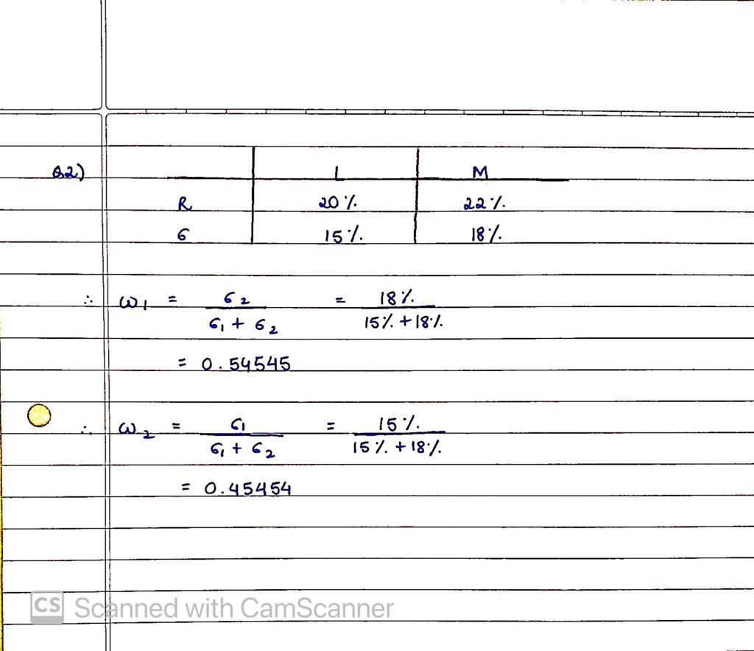

Q3)


