Statistical risk modelling in R
Assignment 2
Roll no. 29
Animish Sathe

> dataset1 <- read.csv(file.choose())
> dataset1
ï..Exam1 Exam2 Exam3 Exam4 Final_score Grade Pass.fail
1 60 10 16 7.0 40.79 C P
2 90 0 0 0.0 69.23 B P
3 130 20 24 1.0 76.75 B P
4 130 10 24 8.5 75.66 B P
5 90 5 22 9.5 55.48 C P
6 100 30 20 3.0 67.11 B P
7 105 20 22 8.0 67.98 B P
8 120 40 18 16.0 85.09 A P
9 120 20 30 18.0 82.46 A P
10 130 45 22 10.5 91.01 A P
11 90 40 20 7.0 68.86 B P
12 130 30 28 10.5 87.06 A P
13 100 30 22 6.5 69.52 B P
14 0 30 18 0.0 60.00 B P
15 0 30 18 0.0 60.00 B P
16 80 0 24 3.0 60.11 B P
17 105 40 22 6.5 76.10 B P
18 10 0 0 8.0 12.16 D F
19 130 35 24 0.0 90.00 A P
20 0 15 20 7.0 42.86 C P
21 40 10 14 6.0 30.70 D F
22 90 15 28 8.5 62.06 B P
23 110 0 24 9.5 80.62 A P
24 65 5 24 1.0 41.67 C P
25 55 15 18 0.0 41.90 C P
26 100 50 30 11.5 83.99 A P
27 95 40 24 8.0 73.25 B P
28 0 10 24 0.0 42.50 C P
29 0 0 18 0.0 60.00 B P
30 65 20 20 0.0 50.00 C P
31 110 25 18 6.0 69.74 B P
32 130 45 24 8.0 90.79 A P
33 120 40 30 9.0 87.28 A P
34 70 20 24 1.0 50.44 C P
35 130 45 10 16.5 88.38 A P
36 0 0 18 10.0 58.33 C P
37 0 25 24 0.0 61.25 B P
38 50 30 12 4.0 42.11 C P
39 0 25 16 0.0 51.25 C P
40 95 20 20 6.0 61.84 B P
41 40 15 10 2.5 29.61 D F
42 70 0 18 0.0 55.00 C P
43 0 0 26 0.0 86.67 A P
44 100 25 14 9.5 65.13 B P
45 95 30 30 12.0 73.25 B P
46 0 25 18 0.0 53.75 C P
47 100 40 24 0.0 78.10 B P
48 0 0 16 2.0 37.50 D F
49 0 0 0 2.0 11.11 D F
50 130 40 28 16.5 94.08 A P
51 0 0 0 15.5 86.11 A P
52 0 0 0 8.0 44.44 C P
53 105 40 28 9.5 80.04 A P
54 0 0 16 0.0 53.33 C P
55 110 25 20 3.0 69.30 B P
56 60 20 28 10.5 51.97 C P
57 120 40 30 9.5 87.50 A P
58 110 35 26 10.0 79.39 B P
59 110 35 24 8.0 77.63 B P
60 125 25 24 0.0 82.86 A P
61 100 0 28 0.0 60.95 B P
62 0 0 0 2.0 11.11 D F
63 60 0 24 4.0 38.60 D F
64 125 30 30 11.5 86.18 A P
65 0 0 24 0.0 80.00 A P
66 75 15 16 0.0 50.48 C P
67 0 0 0 5.0 27.78 D F
68 0 0 0 10.0 55.56 C P
69 0 30 16 8.0 55.10 C P
70 65 15 14 10.5 45.83 C P
71 0 0 0 2.0 11.11 D F
72 100 15 28 9.5 66.89 B P
73 90 35 12 1.0 60.53 B P
74 60 15 12 5.0 40.35 C P
75 40 20 16 10.5 37.94 D F
76 100 35 24 0.0 75.71 B P
77 0 15 24 0.0 48.75 C P
78 100 15 20 0.0 64.29 B P
79 120 0 14 2.0 59.65 C P
80 110 35 26 8.0 78.51 B P
81 50 20 20 1.0 39.91 D F
82 0 25 0 0.0 50.00 C P
83 120 20 28 10.0 78.07 B P
84 100 35 24 10.5 74.34 B P
85 0 0 0 1.0 5.56 D F
86 115 20 22 0.0 74.76 B P
87 110 25 18 0.0 72.86 B P
88 0 20 18 0.0 47.50 C P
89 0 0 0 2.0 11.11 D F
90 0 30 24 0.0 67.50 B P
91 110 25 24 4.0 71.49 B P
92 0 0 0 6.5 36.11 D F
93 85 30 20 2.5 60.31 B P
94 0 30 20 12.5 63.78 B P
95 0 25 16 0.0 51.25 C P
96 100 35 20 0.0 73.81 B P
97 0 0 26 0.0 86.67 A P
98 100 0 0 4.0 58.43 C P
99 0 15 28 0.0 18.86 D F
100 65 25 30 14.5 58.99 C P
101 105 30 16 11.5 71.27 B P
102 95 20 20 9.5 63.38 B P
103 110 10 16 7.5 62.94 B P
104 90 35 20 5.5 66.01 B P
> str(dataset1)
'data.frame': 104 obs. of 7 variables:
$ ï..Exam1 : int 60 90 130 130 90 100 105 120 120 130 ...
$ Exam2 : int 10 0 20 10 5 30 20 40 20 45 ...
$ Exam3 : int 16 0 24 24 22 20 22 18 30 22 ...
$ Exam4 : num 7 0 1 8.5 9.5 3 8 16 18 10.5 ...
$ Final_score: num 40.8 69.2 76.8 75.7 55.5 ...
$ Grade : chr "C " "B " "B " "B " ...
$ Pass.fail : chr "P" "P" "P" "P" ...
> dim(dataset1)
[1] 104 7
> library(dplyr)
> dataset1 =dataset1 %>%
+ rename(Exam1 = ï..Exam1)
> dataset1$Grade <- as.factor(dataset1$Grade)
> dataset1$Pass.fail <- as.factor(dataset1$Pass.fail)
> dataset1$Pass.fail<-ifelse(dataset1$Pass.fail=="P",1,0)
> s <- sample(nrow(dataset1), 0.75*nrow(dataset1))
> dataset1_tr <- dataset1[s,]
> dataset1_ts <- dataset1[-s,]
> library(rpart)
> grade <- rpart(Grade~., data = dataset1_tr, method = "class")
> library(rattle)
> fancyRpartPlot(grade)

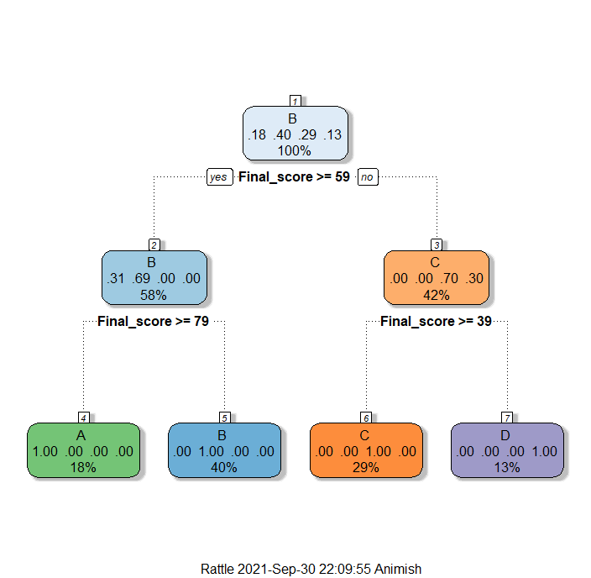

>printcp(grade)

Classification tree:
rpart(formula = Grade ~ ., data = dataset1_tr, method = "class")

Variables actually used in tree construction:
[1] Final_score

Root node error: 47/78 = 0.60256

n= 78

CP nsplit rel error xerror xstd
1 0.48936 0 1.00000 1.00000 0.091957
2 0.29787 1 0.51064 0.51064 0.086728
3 0.21277 2 0.21277 0.21277 0.062822
4 0.01000 3 0.00000 0.00000 0.000000
> plotcp(grade)
>
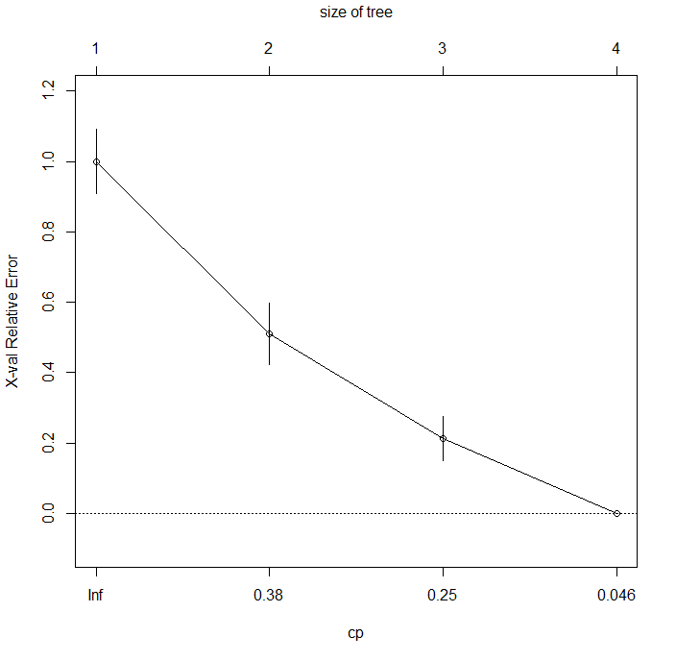
>grade_new<- rpart(Grade~., data = dataset1_tr, method = "class", control = rpart.control(cp=0.05))
> fancyRpartPlot(grade_new)
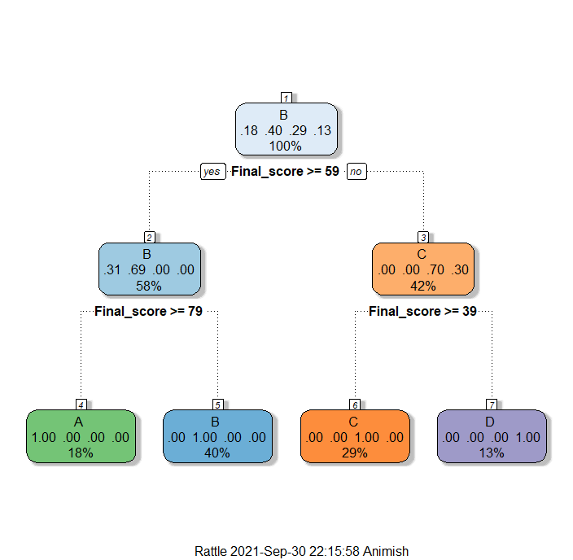

>printcp(grade_new)

Classification tree:
rpart(formula = Grade ~ ., data = dataset1_tr, method = "class",
control = rpart.control(cp = 0.05))

Variables actually used in tree construction:
[1] Final_score

Root node error: 47/78 = 0.60256

n= 78

CP nsplit rel error xerror xstd
1 0.48936 0 1.00000 1.00000 0.091957
2 0.29787 1 0.51064 0.51064 0.086728
3 0.21277 2 0.21277 0.21277 0.062822
4 0.05000 3 0.00000 0.00000 0.000000
> plotcp(grade_new)
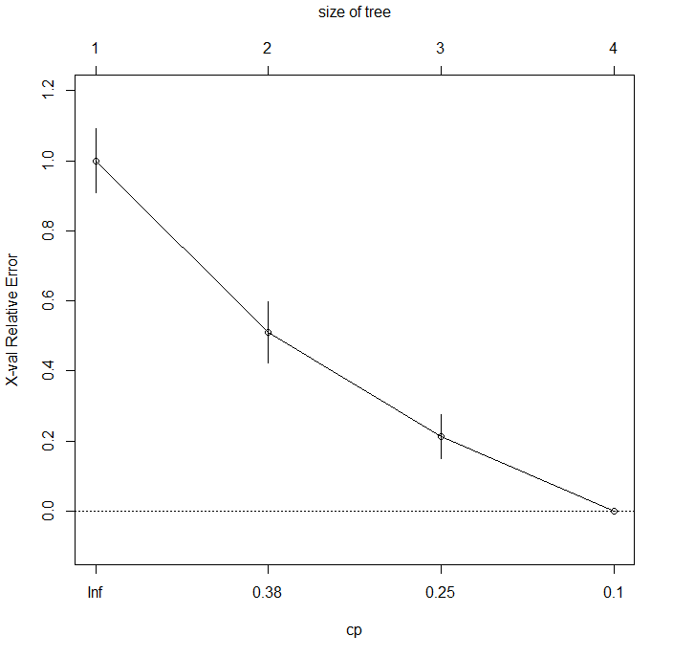

>grade_p <- predict(grade, dataset1_ts, type = "class")
> grade_p1 <- predict(grade_new, dataset1_ts, type = "class")
> t=table(dataset1_ts$Grade, grade_p)
> accuracy = sum(diag(t))/sum(t)
> accuracy
[1] 0.8846154
> t1=table(dataset1_ts$Grade, grade_p1)
> accuracy1 = sum(diag(t1))/sum(t1)
> accuracy1
[1] 0.8846154
> marks <- lm(Final_score~.-Pass.fail, data = dataset1_tr)
> summary(marks)

Call:
lm(formula = Final_score ~ . - Pass.fail, data = dataset1_tr)

Residuals:
Min 1Q Median 3Q Max
-12.7577 -4.7307 -0.7914 5.2820 16.1476

Coefficients:
Estimate Std. Error t value Pr(>|t|)
(Intercept) 75.55466 3.47222 21.760 < 2e-16 ***
Exam1 0.04604 0.02199 2.093 0.0399 *
Exam2 0.03274 0.06408 0.511 0.6110
Exam3 0.14798 0.10266 1.441 0.1539
Exam4 0.29905 0.17368 1.722 0.0895 .
GradeB -16.07999 2.29629 -7.003 1.24e-09 ***
GradeC -31.31927 2.66800 -11.739 < 2e-16 ***
GradeD -57.53603 3.47318 -16.566 < 2e-16 ***
---
Signif. codes: 0 ‘***’ 0.001 ‘**’ 0.01 ‘*’ 0.05 ‘.’ 0.1 ‘ ’ 1

Residual standard error: 6.625 on 70 degrees of freedom
Multiple R-squared: 0.909, Adjusted R-squared: 0.8999
F-statistic: 99.87 on 7 and 70 DF, p-value: < 2.2e-16

> marks_predict <- predict(marks, dataset1_ts)
> marks_predict
1 7 9 26 27 37 40 41 45 48 57
51.78620 70.61164 91.55653 89.67423 71.10207 63.84473 69.25719 22.57879 72.85869 20.98437 89.66949
58 60 65 66 67 77 79 81 88 89 90
72.52300 85.67972 79.10613 50.54718 19.51388 48.27801 52.42997 24.23411 47.55386 18.61673 64.00844
91 96 102 103
70.10532 68.18425 70.30386 69.47701
> cor(marks_predict, dataset1_ts$Final_score)^2
[1] 0.9087098
> marks_predict
1 7 9 26 27 37 40 41 45 48 57
51.78620 70.61164 91.55653 89.67423 71.10207 63.84473 69.25719 22.57879 72.85869 20.98437 89.66949
58 60 65 66 67 77 79 81 88 89 90
72.52300 85.67972 79.10613 50.54718 19.51388 48.27801 52.42997 24.23411 47.55386 18.61673 64.00844
91 96 102 103
70.10532 68.18425 70.30386 69.47701
> percentage <- marks_predict/100
> percentage
1 7 9 26 27 37 40 41 45 48
0.5178620 0.7061164 0.9155653 0.8967423 0.7110207 0.6384473 0.6925719 0.2257879 0.7285869 0.2098437
57 58 60 65 66 67 77 79 81 88
0.8966949 0.7252300 0.8567972 0.7910613 0.5054718 0.1951388 0.4827801 0.5242997 0.2423411 0.4755386
89 90 91 96 102 103
0.1861673 0.6400844 0.7010532 0.6818425 0.7030386 0.6947701

##Comment: Accuracy is 92.05282%

