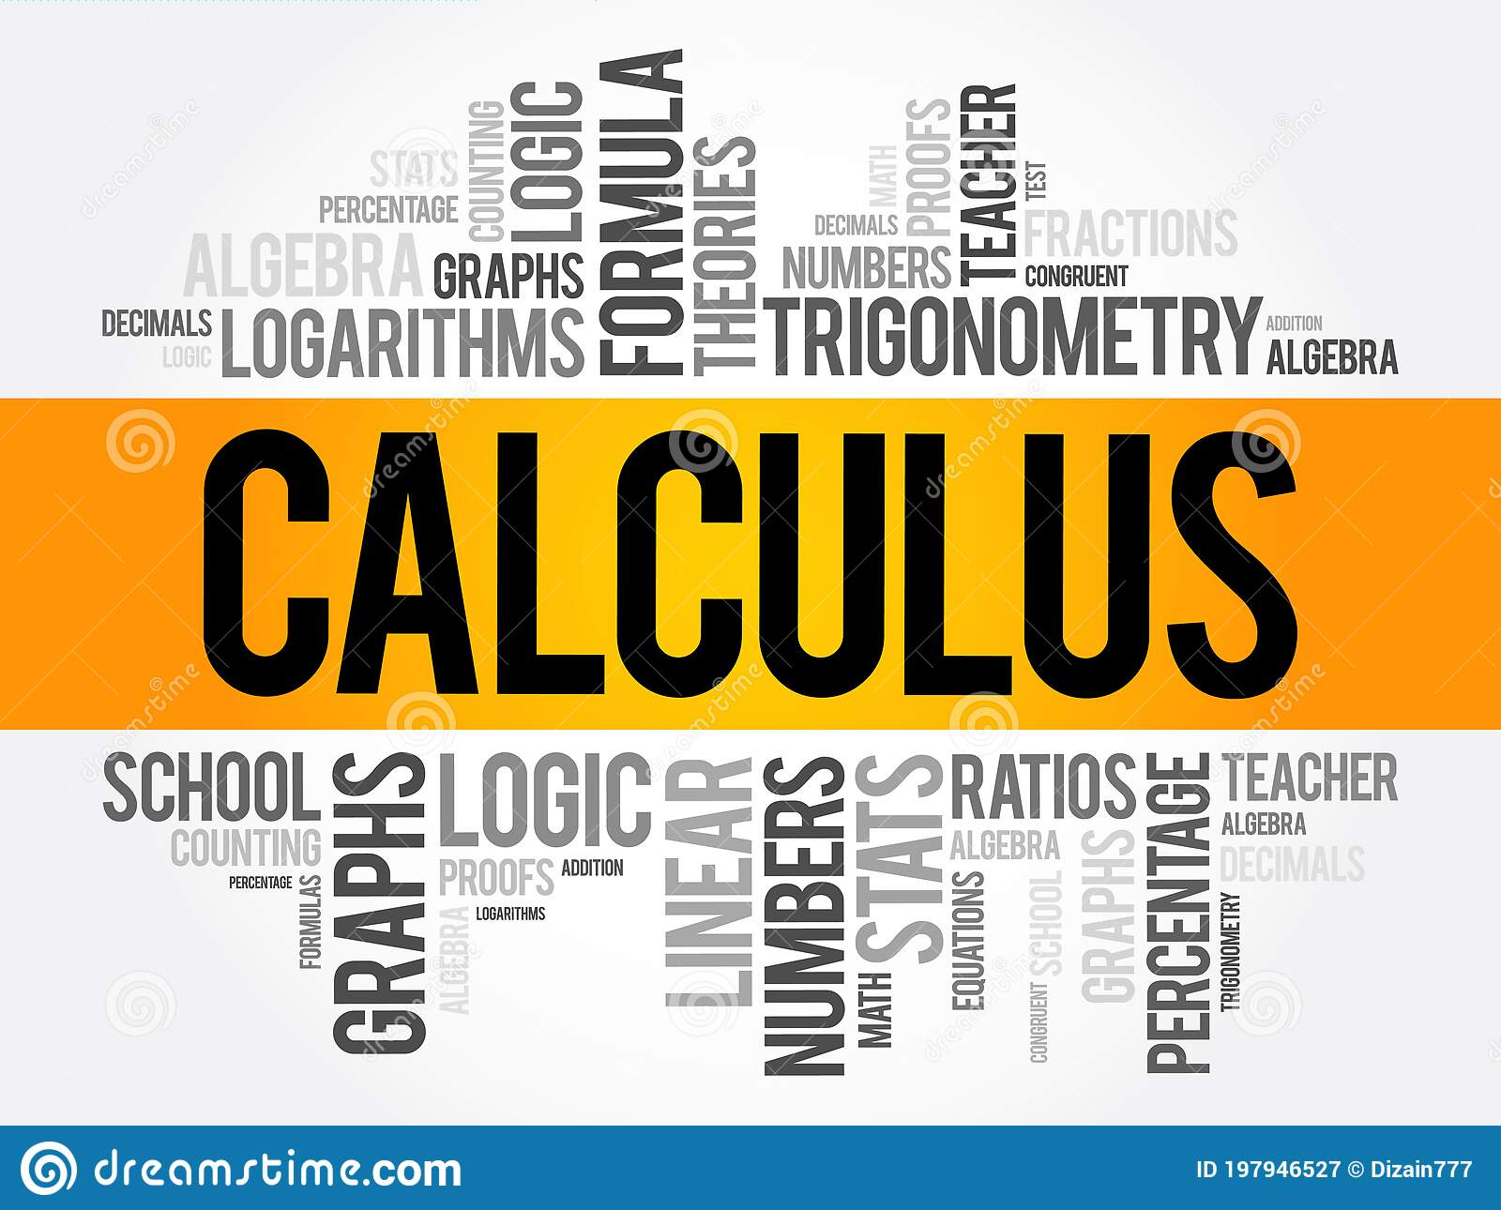

CALCULUS- PROJECT
  - NAME-LITTLE JAIN |ROLL NO.-32
  - 23.12.2021

Q1. Time of death; use of calculus in calculating the time of death of a dead body during post mortem?
→ The time of death is calculated using Newton’s Law of Cooling.
Newton's Law of Cooling states that the rate of cooling of an object is proportional to the temperature difference between the object and its surroundings, provided that this difference is not too large.1 When estimating the time of death, one needs to know the temperature of the surroundings and the temperature of the body at two different times in order to make an accurate estimate.
It is assumed that the temperature of the body T(t) is governed by Newton's Law of Cooling,
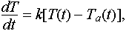
Limitations of Newton’s Law of Cooling
- The difference in temperature between the body and surroundings must be small
- The loss of heat from the body should be by radiation only.
- The major limitation of Newton’s law of cooling is that the temperature of surroundings must remain constant during the cooling of the body.

Q2. Movie making in cinema; Use of calculus?
→ We'll begin with a brief discussion of the role calculus plays in the making of the equipment that filmmakers use to work their magic. Hopefully, you'll see pretty quickly that much of this magic relies on the discipline of calculus.In a very important sense, almost every aspect of filmmaking is heavily dependent on calculus. This is because the process of filming a movie involves the use of equipment that is based on different forms of science and technology, which in their turn are founded on the strict application of calculusematical principles. In other words, one of the many ways that calculus is involved in filmmaking is through its equipment.For instance, can you imagine making even the simplest video camera without a deep understanding of optics, geometry, and trigonometry? How about light meters, sound equipment, and the incredible amounts of electricity required to make a single movie? This is just scratching the surface, but even a little reflection will tell you that none of this equipment would be possible without calculus.The producer. Many of the producer's everyday duties require the use of calculus. Though most of these duties involve creating and adjusting the movie's budget, the constant recalculations require more than a cursory knowledge of accounting practices and calculus.Animators. Not surprisingly, animators use calculus more than anyone else in the industry. While much of this work is sometimes done by a computer, animators are still required to have practical knowledge of many advanced calculusematical concepts. Depending on the film's complexity, this can include anything from basic algebra and trigonometry to integral calculus, geometry, and harmonics.Cinematographers and cameramen. A great deal of calculus goes into the work of the cinematographer and their cameramen. Much of this work has to do with the video camera itself, which requires the use of calculus to choose the appropriate aperture speeds, the location of focal points, and to decide on the best camera angles for a given shot.

Q3. Application of calculus in sports?
→ We have numerous applications of calculus in different types of sports. It plays an important role in the field of sports. Baseball is one type of sport in which we use the application of calculus. Athletes, trainers, and coaches often use calculus to gain benefits over their counterparts. Calculus can also be used to calculate the projectile motion of baseball's trajectory, speed of baseball when hit, and predict if runners can make it to the next base on time, given their running Speed.
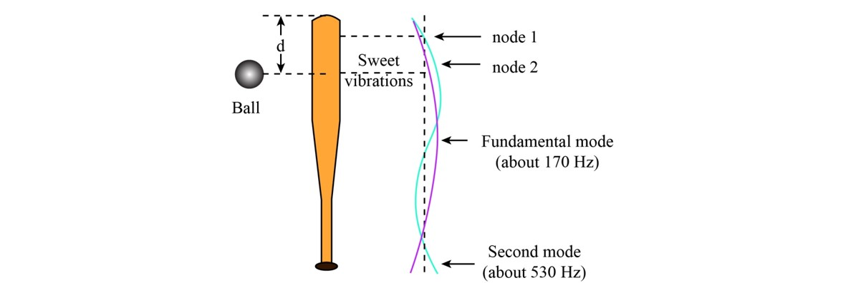
BASEBALL BAT

Q4. Application of calculus in car design?
→ Whether you realize it or not, calculus is a fundamental function of life and we use it on a daily basis. We use calculus for everything from balancing our check book, to computing fuel mileage, to purchasing aftermarket goodies, to counting the number of cars ahead of you at the stoplight. Even more impressive is that it's the only universal language in the world.
The point is, calculus is a precise, consistent, and invaluable tool for all gearheads when applied properly. We can use some simple calculus formulas to calculate relationships between tires and rpm for ideal gear ratios, compression ratios, the exact engine displacement with various bore and stroke combinations, and even to project quarter-mile and top-end speeds.
One of the most versatile use of calculus is in automobile industry to design the car because it is used to find the rate of wind that works against the car to reduce the speed and so therefore try different models and calculate in which the wind tension is maximum and then choosing the one which suits perfect and have least air tension.

Q5. Application of calculus in skyscraper design?
→Calculus is widely used for calculating the building’s heat loss, areas and masses of difficult geometric form structures, for minimizing or maximizing areas of designed structures (f.e. to find the heat loss of heat during the day all you have to do is create a graph (heat loss vs. time) and calculate the area under the curve using integral).
The structures as in the picture on the left (Sydney Opera House) are made with a number of shells that are interconnected and supported by concrete. So, the density of each shell may differ. Therefore, it is more difficult to find the total density of the structure. And this is where calculus can be applied — we use vector calculus to calculate the total mass.
Architects also use integral calculus to calculate the number of materials needed for construction and the type of support systems required to prevent constructions from collapsing.
Even the Eiffel tower was constructed with calculus in mind, focusing exclusively on wind resistance. And Gustav Eifel was very proud of his work which resulted from mathematical calculations, as he said:
“Now to what phenomenon did I have to give primary concern in designing the Tower? It was wind resistance. Well then! I hold that the curvature of the monument’s four outer edges, which is as mathematical calculation dictated it should be (…) will give a great impression of strength and beauty, for it will reveal to the eyes of the observer the boldness.” 

Q6. Application of calculus in credit card companies?
→When minimum payments on a credit card needs to be computed, calculus is the method used. Credit card companies use the differential type of calculus to calculate this amount. There are several variables that go into the calculation because it is calculated by the amount of money that is due by a certain time (usually the due date that is listed on the bill). Add on to that the interest rate given and it becomes a complicated task. With all the changing parts, interest rates and available balances, the calculation has to be done simultaneously in order to provide the customer with an accurate minimum balance. The calculation that is used to determine the minimum payment starts with determining the interest that has accrued since the last payment, or over the month. To calculate the amount of interest, the following calculation is done: Accrued interest = Beginning balance * (interest rate/12) The 12 in the calculation represents the number of months in a year. So, if you have a beginning balance of 5,400 and an interest rate of 9.75%, the accrued interest for the month would be Rs.43.88. Once that amount is calculated, then we can find out what the minimum payment is. After establishing the credit and signing up with the credit card company, a minimum monthly payment was set for what absolutely have to be paid on the card each month even if you used it that month or not. Most of the time, this amount is pretty small; Rs.20 is what is usually set. The minimum payment that is on the credit card statement is calculated as such:
=MAX (Minimum month payment, interest + minimum monthly payment) This means that if the interested accrued added to the minimum monthly payment is less that the set minimum monthly payment, then the largest amount must be paid. For instance, take the problem above. The minimum payment is Rs.20 and the interest is Rs.43.88; those two added together would be Rs.63.88. Based on this problem, the minimum payment would be Rs.63.88 because it is the larger amount.

Q7. Application of calculus by Central Bank?
→Calculus affects the financial decisions that we make every day. From paying our bills to using coupons at the grocery store, calculus is a part of our everyday lives. Number sense and a facility with calculus concepts is especially useful in banking.
We use calculus for budgeting, spending, saving, and investing. In each case, a good understanding of calculus concepts will be beneficial for your personal finances.
Since banking refers to managing money, we are all essentially “bankers” in our own lives. It is vital that we devise a responsible budget to ensure that our needs are met without overspending. Likewise, we must be aware of our spending habits so that we can take care of our financial responsibilities. We are using calculusematical concepts every day when we utilize online banking to help us pay bills, transfer money, and manage our personal accounts. Furthermore, it is important that bankers have a strong knowledge of fundamental quantitative concepts in order to make the most out of their investments. For starters, understanding the basic principles of interest will help you to get the most out of your money. Whether you are looking at interest as a means to make money, or considering the effects of paying interest on a loan, this is a concept that we run into constantly in our daily lives. Knowing the advantages and disadvantages of interest will help you to be a smarter “banker.” Even more complex is understanding simple and compound interest and how it works for you. These calculus principles play a very important role in our daily lives and can have a big impact on your financial future. In addition, bankers use calculus to help them understand and evaluate risk assessment. If you are dealing with stocks, bonds, or other investments, you will need to have an understanding of these fundamental concepts in order to make wise investment decisions.
From the most basic concepts of budgeting and spending to the more complex concepts of investments and interest, calculus is used in our everyday lives with regards to banking. While we live in a world that does so much of the calculus work for us, it is still extremely important that you have a strong sense of calculusematical principles in order to manage your personal finances. Not only will a strong foundation in calculus help you to manage your money, but it can help to shape your financial future. Calculus concepts are no doubt a key role in the planning and success of our financial lives.

Q8. Application of calculus in weaponry?
→ From the viewpoint of calculus (dynamics, to be exact), a firearm, as for most weapons, is a system for delivering maximum destructive energy to the target with minimum delivery of energy on the shooter. [citation needed] The momentum delivered to the target, however, cannot be any more than that (due to recoil) on the shooter. This is due to conservation of momentum, which dictates that the momentum imparted to the bullet is equal and opposite to that imparted to the gun-shooter system.
From a thermodynamic point of view, a firearm is a special type of piston engine, or in general heat engine where the bullet has a function of a piston. The energy conversion efficiency of a firearm strongly depends on its construction, especially on its caliber and barrel length. However, for illustration, here is the energy balance of a typical small firearm for .300 Hawk ammunition:[1]which is comparable with a typical piston engine.
Higher efficiency can be achieved in longer barrel firearms because they have better volume ratio. However, the efficiency gain is less than corresponding to the volume ratio, because the expansion is not truly adiabatic and burnt gas becomes cold faster because of exchange of heat with the barrel. Large firearms (such as cannons) achieve smaller barrel-heating loss because they have better volume-to-surface ratio. High barrel diameter is also helpful because lower barrel friction is induced by sealing compared to the accelerating force. The force is proportional to the square of the barrel diameter while sealing needs are proportional to the perimeter by the same pressure.
According to Newtonian mechanics, if the gun and shooter are at rest initially, the force on the bullet will be equal to that on the gun-shooter. This is due to Newton's third law of motion (For every action, there is an equal and opposite reaction). Consider a system where the gun and shooter have a combined mass mg and the bullet has a mass mb. When the gun is fired, the two masses move away from one another with velocities vg and vb respectively. But the law of conservation of momentum states that the magnitudes of their momenta must be equal, and as momentum is a vector quantity and their directions are opposite:
In technical mathematical terms, the derivative of momentum with respect to time is force, which implies the force on the bullet will equal the force on the gun, and the momentum of the bullet/shooter can be derived via integrating the force-time function of the bullet or shooter. This is mathematically written as follows:
Gunshot victims frequently fall or collapse when shot; this is less a result of the momentum of the bullet pushing them over, but is primarily caused by physical damage or psychological effects, perhaps combined with being off balance. This is not the case if the victim is hit by heavier projectiles such as 20 mm cannon shell, where the momentum effects can be enormous; this is why very few such weapons can be fired without being mounted on a weapons platform.

