SUBMITTED By : akshay jodha (711)
IAQS
PAML PROJECT report: MACHINE LEARNING

Introduction:

The name machine learning was instituted in 1959 by Arthur Samuel. Tom M. Mitchell gave a generally cited, more conventional meaning of the calculations contemplated in the AI field: “A computer program is said to learn from experience E with respect to some class of tasks T and performance measure P if its performance at tasks in T, as measured by P, improves with experience E.”

Defining Machine Learning :
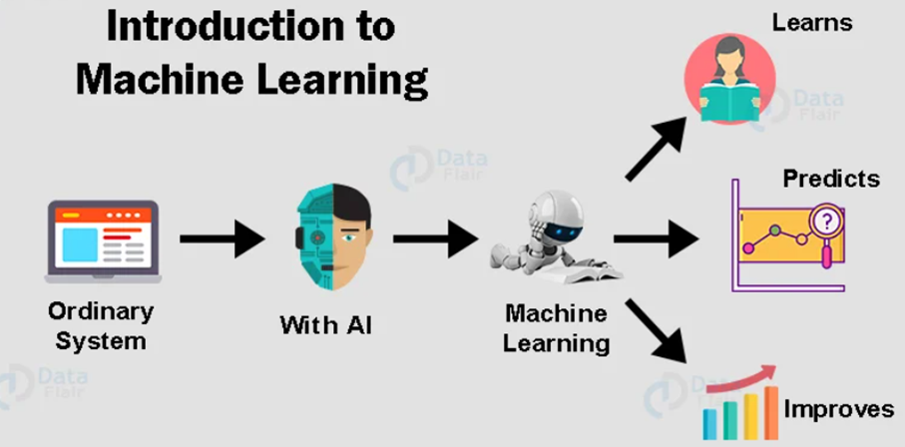

Machine learning is an application of AI that enables systems to learn and improve from experience without being explicitly programmed. Machine learning focuses on developing computer programs that can access data and use it to learn for themselves. Similar to how the human brain gains knowledge and understanding, machine learning relies on input, such as training data or knowledge graphs, to understand entities, domains and the connections between them. With entities defined, deep learning can begin
Machine Learning can be thought of as the study of a list of sub-problems, viz: decision making, clustering, classification, forecasting, deep-learning, inductive logic programming, support vector machines, reinforcement learning, similarity and metric learning, genetic algorithms, sparse dictionary learning, etc..

Uses:
ML has proven valuable because it can solve problems at a speed and scale that cannot be duplicated by the human mind alone. With massive amounts of computational ability behind a single task or multiple specific tasks, machines can be trained to identify patterns in and relationships between input data and automate routine processes and can do much more .
It is already widely used by businesses across all sectors to advance innovation and increase process efficiency. In 2021, 41% of companies accelerated their rollout of AI as a result of the pandemic. These newcomers are joining the 31% of companies that already have AI in production or are actively piloting AI technologies.

- Data security: Machine learning models can identify data security vulnerabilities before they can turn into breaches. By looking at past experiences, machine learning models can predict future high-risk activities so risk can be proactively mitigated.

- Finance: Banks, trading brokerages and fintech firms use machine learning algorithms to automate trading and to provide financial advisory services to investors. Bank of America is using a chatbot, Erica, to automate customer support.

- Healthcare: ML is used to analyze massive healthcare data sets to accelerate discovery of treatments and cures, improve patient outcomes, and automate routine processes to prevent human error. For example, IBM’s Watson uses data mining to provide physicians data they can use to personalize patient treatment.

- Fraud detection: AI is being used in the financial and banking sector to autonomously analyze large numbers of transactions to uncover fraudulent activity in real time. Technology services firm Capgemini claims that fraud detection systems using machine learning and analytics minimize fraud investigation time by 70% and improve detection accuracy by 90%.

- Retail: AI researchers and developers are using ML algorithms to develop AI recommendation engines that offer relevant product suggestions based on buyers’ past choices, as well as historical, geographic and demographic data.

Types:
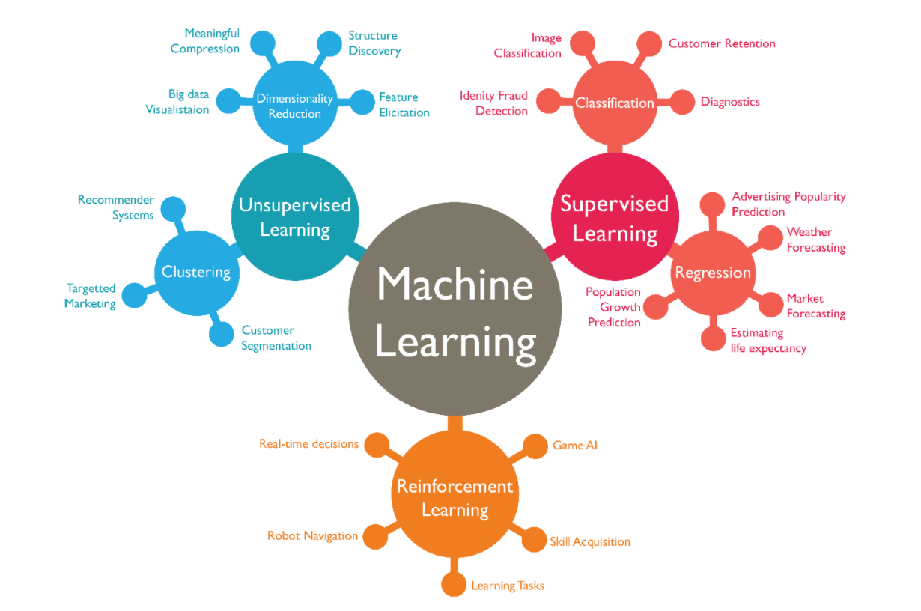
1) Supervised Learning
It is used in prediction models where the output result is specified and the machine is supposed to follow a specific aim. With those specific details and parameters, the best prediction is achieved.
These algorithms work by describing the input data, hypothesized function and the expected results. By repeating the function’s execution on the training data along with introduction of control parameters the model improves. It is considered a success if the predictions and the mapping are correct.
We have prediction of real estate prices, image classification, weather for casting, etc can be used as examples for Supervised Learning

2) Unsupervised Learning
It is a type of Machine Learning in which models are trained using unlabeled dataset and are allowed to act on that data without any supervision
This type of learning cannot be directly be put into a regression problem as there no specific output variable given.
Its aim is to basically find the underlying dataset structure that are difficult for humans to process without visualizing in higher dimensions. It works explicitly on unlabelled data with very less user involvement.
This Learning is divided into two categories of algorithm: clustering and association
Few real life examples can be said as finding customer sectors or different target group or reducing the difficult or features of a problem.

3) Reinforcement Learning
In this, machine Learning is basically attempting to find the best way to complete a goal or improve performance on a particular task. The algorithms work by choosing an action and observing the consequences of that action, with this it learns how optimal the result is. This is re-repeated over time and the right strategy is chosen.
Trial error search and delayed reward are important characteristics of reinforcement learning.
Video games, self driving cars, youtube ads are full of reinforcement learning.

4) Semi-supervised Learning
In this type of Machine Learning algorithm, it represents the midway ground between Supervised and Unsupervised Learning Algorithms. It includes both labeled and unlabeled datasets, but it consists more of unlabeled data.
It means the model can be trained to label data without to use as much labeled trained data.
Speech Analysis, text document or web content classification etc are examples for semi supervised learning.

Difference B/W Supervised and Unsupervised

Parameters | Supervised machine learning technique | Unsupervised machine learning technique
Process | In a supervised learning model, input and output variables will be given. | In unsupervised learning model, only input data will be given
Input Data | Algorithms are trained using labeled data. | Algorithms are used against data which is not labeled
Algorithms Used | Support vector machine, Neural network, Linear and logistics regression, random forest, and Classification trees. | Unsupervised algorithms can be divided into different categories: like Cluster algorithms, K-means, Hierarchical clustering, etc.
Computational Complexity | Supervised learning is a simpler method. | Unsupervised learning is computationally complex
Use of Data | Supervised learning model uses training data to learn a link between the input and the outputs. | Unsupervised learning does not use output data.
Accuracy of Results | Highly accurate and trustworthy method. | Less accurate and trustworthy method.
Real Time Learning | Learning method takes place offline. | Learning method takes place in real time.
Number of Classes | Number of classes is known. | Number of classes is not known.
Main Drawback | Classifying big data can be a real challenge in Supervised Learning. | You cannot get precise information regarding data sorting, and the output as data used in unsupervised learning is labeled and not known.

Models:

for Supervised Learning
Linear Regression
This is a type of supervised Machine Learning algorithm that helps to get the best approx. linear fit to the points. Linear regression is, at its heart, a linear strategy to detecting the connection between two variables, one of which is dependent and the other independent. The goal is to comprehend how a change in one variable affects the other, resulting in a positive or negative connection.

The regression line is represented by a:
linear equation: 𝑌i = 𝑎 + 𝑏𝑋i , Where a is the intercept and b is the Slope.

This approach is used when the projected output is continuous and has a constant slope, such as when estimating sales based on pricing. Risk assessment for specific assets, for example:
Linear Regression may be extended by including more and more input data to predict the output, but as the number of input variables increases, so does the model's complexity. To fit a multiple linear regression model, a computer programmer is often utilized.
Linear Regression has certain drawbacks. It fails when the dataset has a significant degree of multicollinearity (correlation between predictor variables) and when the data is insufficient. As a result, in such cases, ridge regression is utilized to generate a precise model.

Model for Unsupervised Learning
K-Means algorithm
The K-means algorithm searches for a predetermined number of clusters in an unlabeled multidimensional dataset and concludes by using a simple interpretation of how an optimum cluster may be stated.
The concept would mostly be divided into two phases.
1) To begin, the cluster center is the arithmetic mean (AM) of all data points connected with the cluster.
2) In compared to other cluster centers, each point is next to its cluster center. The k-means clustering model is built on these two views.

You may think of the center as a data point that defines the cluster's means; however, it may or may not be a member of the dataset. In basic terms, k-means clustering allows us to cluster data into numerous groups by finding unique types of groups in unlabeled datasets without the need for data training. This is a centroid-based technique in which each cluster is connected to a centroid with the goal of minimizing the sum of distances between data points and their respective clusters.
As an input, the method consumes an unlabeled dataset, divides it into k clusters, and iterates the process until the proper clusters are found; the value of k should be preset.

What’s the difference between a supervised and unsupervised image classification?
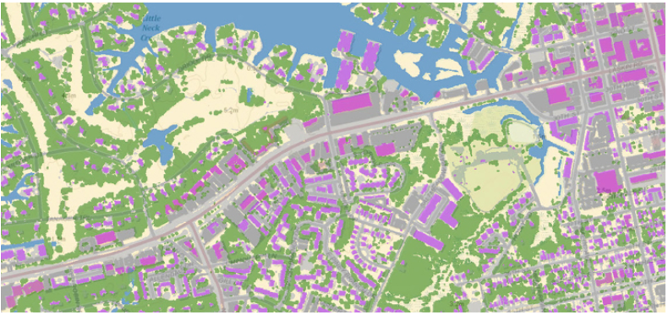

2_major categories of image classification techniques include unsupervised (calculated by software) and supervised (human-guided) classification.
Unsupervised classification is where the outcomes (groupings of pixels with common characteristics) are based on the software analysis of an image without the user providing sample classes. The computer uses techniques to determine which pixels are related and groups them into classes. The user can specify which algorism the software will use and the desired number of output classes but otherwise does not aid in the classification process. However, the user must have knowledge of the area being classified when the groupings of pixels with common characteristics produced by the computer have to be related to actual features on the ground (such as wetlands, developed areas, coniferous forests, etc.).
Supervised classification is based on the idea that a user can select sample pixels in an image that are representative of specific classes and then direct the image processing software to use these training sites as references for the classification of all other pixels in the image. Training sites (also known as testing sets or input classes) are selected based on the knowledge of the user. The user also sets the bounds for how similar other pixels must be to group them together. These bounds are often set based on the spectral characteristics of the training area, plus or minus a certain increment (often based on “brightness” or strength of reflection in specific spectral bands). The user also designates the number of classes that the image is classified into. Many analysts use a combination of supervised and unsupervised classification processes to develop final output analysis and classified maps.

T h a n k Y o u

