- C
- C
- C
- C
- C
- C
- C
- C
- D
- D
- C
- C
- C
- C
- D
- C
- D
- B
- B
- B
- B
- C
- D
- C
- D
- B
- B
- D
- NDY = 60300
GDY = 62000
NNY = 60000
- 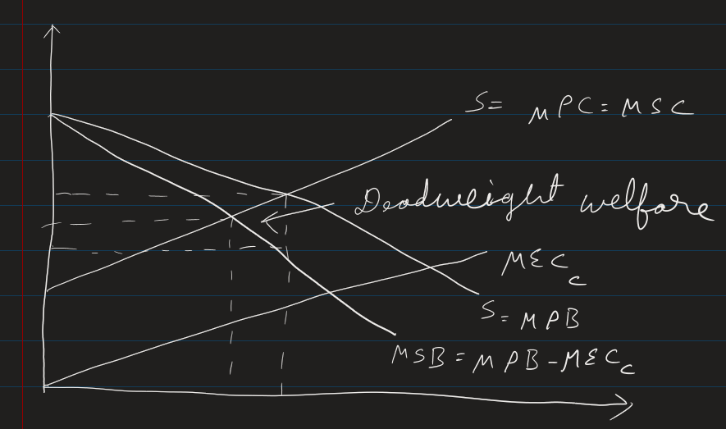
1. MSC- Marginal Social cost
2. MPC- Marginal Private Cost
3. MPB- Marginal Private Benefit
4. MSB- Marginal Social Benefit
5. MECc- Marginal External Cost of consumption
6. Q*- Socially optimum level of output at price P*
7. QPc- Market level of output at price Ppc.
8. Deadweight loss of social welfare happens when MSC> MPC
9. Social welfare loss occurs as QPc > Q*
As plastic is causing environmental pollution, it has social cost. Individuals are using plastic as it is convenient for them. Therefore, Marginal Social Cost (MSC) differs from Marginal Personal Cost (MPC). 2. Plastic usage cause environmental pollution and animals may die due to consumption of plastic bags. Therefore, there is Marginal external Cost which may be incurred to keep water bodies clean and to protect animals from consumption of plastic. 3. Therefore, MSB is lower than MPB. MSB= MPB - MECc. This is represented by MSB curve below MPB curve in the diagram. Market will have equilibrium position at QPc with Price Ppc. At socially optimal equilibrium at output Q* of price P* , MSB = MSC. 4. The external cost of consumption result in level of output above socially optimum level, QPc > Q* From society’s point of view, too many plastic bags are being produced and consumed. This results in a dead weight welfare loss caused by overconsumption and represented by a triangle in diagram A.
- Negative Externality Definition - Negative externalities occur when production and/or consumption impose external costs on third parties outside of the market for which no appropriate compensation is paid. This causes social costs to exceed private costs. An example of a negative externality: i. People may smoke in public places and ignore harmful impact of toxic passive smoking on non-smokers. ii. The passive smoking may harm health of non-smoker and may cause various respiratory diseases. iii. In young ladies passive smoking may cause pre-mature child birth and asthma. iv. Passive smoking increases the risk of respiratory illnesses in children, including asthma, bronchitis and pneumonia. v. Healthcare expenditure involved in treatment of smoking related illnesses
ii) Price Related Intervention: a) The Government imposes a tax on the producer that reflects the marginal cost of the externality. b) Fines are imposed if smoking is done in public places Non- Price Related Intervention: a) Smoking is banned in public places like gardens, restaurants, libraries, work places, etc. b) A law prohibiting any manufacturer, retailer, or distributor of tobacco from selling or distributing products to persons under age eighteen. c) Use of media / advertisements, public education to emphasize ill effects of smoking and motivate smokers to leave smoking d) Specially designed medical care and or programs for smokers to quit smoking. iii) Diagram- marginal social benefit curve and marginal private benefit curve when a negative externality in consumption exists
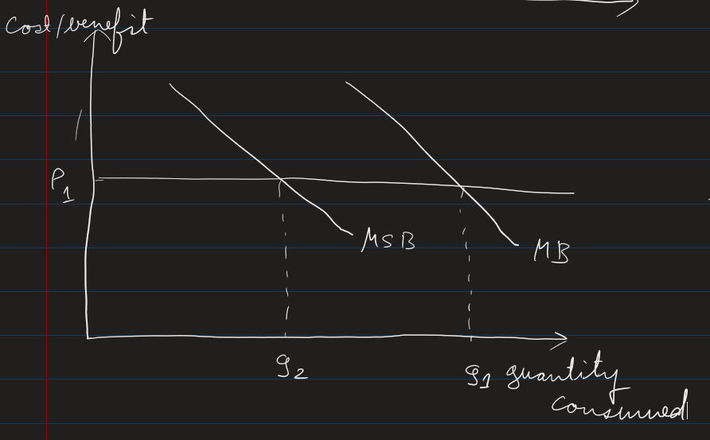
Q1- Consumption by private sector
Q2- Socially optimal level of consumption
MSB- Marginal Social Benefit
MB- Marginal Private Benefit
P1- Market price
- Actual economic growth can also be known as demand side economic growth because it is affected by changes in the demand in an economy. It is an increase in output as measured by real GDP/ national income. It can be achieved by shifting AD (Aggregate demand) to the right by increasing AD, by influencing any of the factors of aggregate demand. (As shown below) •Consumption •Government Spending •Net Exports * Investment (However this is also a component of LRAS) On the other hand potential deals with the supply side of the economy. It is an increase in the productive capacity (potential). An increase in the short term/long term aggregate supply will cause potential economic growth. The short term deals with costs of production and the long term is affected by changes in the quality and quantity of the factors of production.
- Income measure : This measures the total of factor earnings. These are factor payments to land, labour and capital. Transfer payments are not included (to avoid double counting).
Output measure: This measure the value of goods and services produced. To avoid double counting we only include the “value added” component of firms’ output.
Expenditure method: This includes all expenditure (including exports minus imports) in the economy and also what would have to be spent to purchase increases in inventories (or stocks). To avoid double counting, we include only expenditure on final goods.
The three concepts are identically equal. However, in practice difficulties of measurement and collection of data (eg the black economy) mean that the three measures will not be equal.

