Assignment -1 (unit 1,2)-Business Economics- MACRO
Kareena Tated- 415
- C
- C
- C
- D
- A
- C
- B
- C
- D
- D
- C
- C
- C
- C
- D
- C
- D
- (a.) Net domestic income=Mixed income of the self-employed + Operating surplus + Compensation of employees = 28,000 + 10,000 + 24,000 = Rs. 62,000 crores

(b) Gross Domestic income= Net domestic income+ depreciation
=62000+1700=Rs.63,700 crores

(c) Net National Income = Net domestic income + net factor income from abroad
= 62,000 – 300 = Rs. 61,700 crores
19. 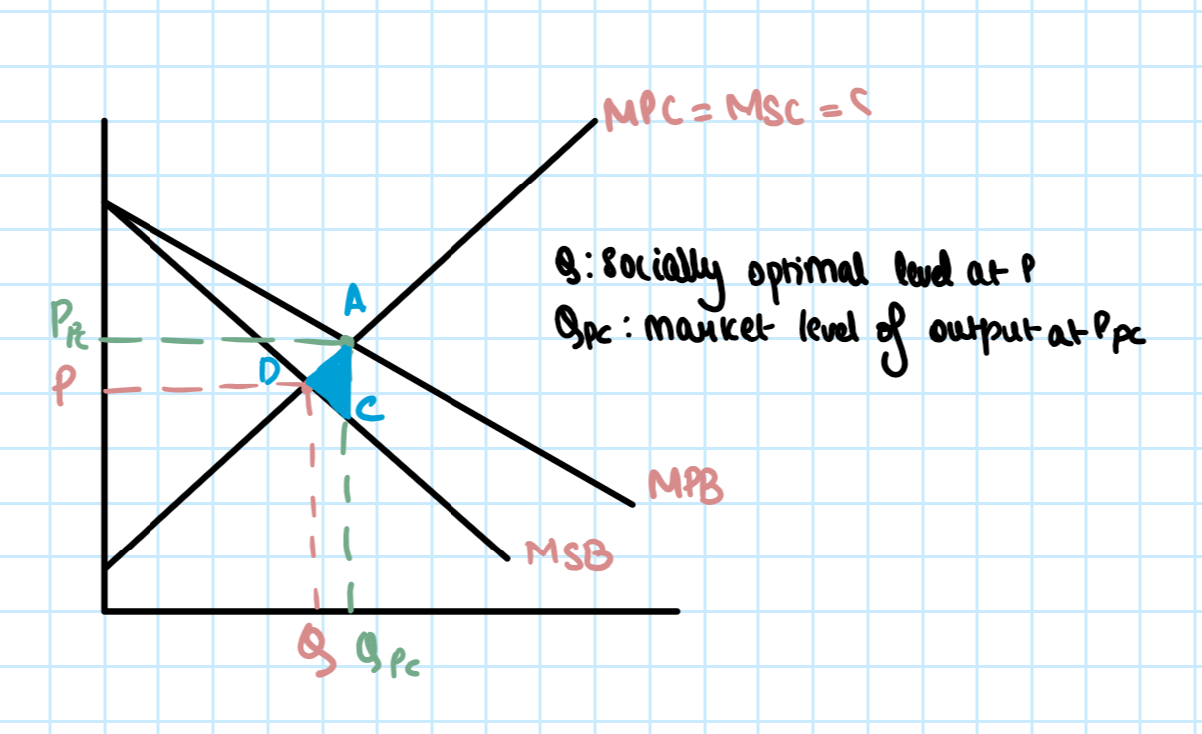

Since plastic is non-biodegradable, excessive use of plastic is harmful for our environment. When the plastic waste generated by the society finds its way into water bodies it can be harmful for the marine ecosystem. Thus, plastic usage is a negative externality. So the marginal social cost is higher than marginal private cost.

But the benefit derived by a single consumer from consuming plastic is greater than the society as a whole. So, the marginal private benefit (MPB) is greater than the marginal social benefit (MSB).
If externalities are ignored, market will be in equilibrium at the point where Ppc is equal to Qpc, i.e. point A. However, if we consider the socially optimum level of output, the market equilibrium will be at the point where P equal Q. Since MPB > MSB and MSC > MPC, there is over production and over consumption of plastic. There in deadweight welfare loss caused by overconsumption and represented by the shaded triangle.

20. The short-run aggregate supply curve is an upward-sloping curve that shows the quantity of total output that will be produced at each price level in the short run.
In the short run, the equilibrium price level and the equilibrium level of total output are determined by the intersection of the aggregate demand and the short-run aggregate supply curves. In the short run, output can be either below or above potential output.
The short-run aggregate supply curve is upward sloping because the quantity supplied increases when the price rises. there is a positive correlation between the price level and output, which is shown on the short-run aggregate supply curve.

21. i. Negative externality is the cost that spills over by a third party not involved in the transaction directly. Consumption of cigarettes may cause respiratory problems and this will add pressure to the health care system. It will also make people ill and that will cause productivity to decrease. Decreased productiivity of workers increases the cost of productivity for firms and decreases profits which might lead to a fall in wages. A fall in wages will cause the standard of living of the workers to decrease.
ii. The government may impose higher indirect taxes on tobacco consumption to stop people from smoking. They can spread information about the harmful effects of smoking on health through ad campaigns.
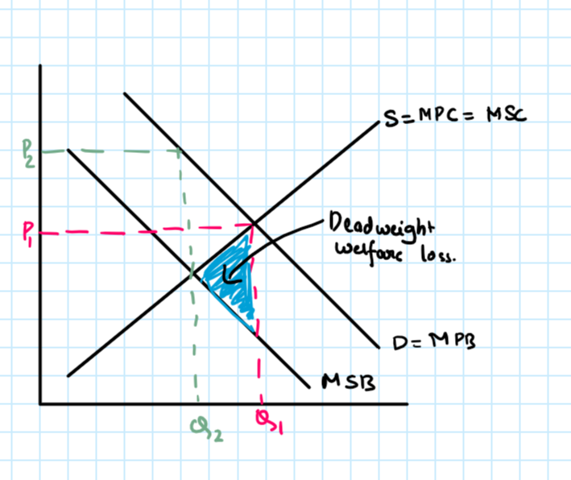
iii.

22. Actual economic growth is measured by the annual percentage change in a country’s real national output (GDP).
Potential economic growth is also known as trend growth and is measured by the estimated annual change in a country’s potential level of national output. Potential growth is driven by improvements in long run aggregate supply (LRAS).

23.
he three methods of measuring national income are as follows:

- (a.) Product (Output) method =The value of all goods and services produced during the year is added up in this method. This is the most direct method of calculating the national income of a country. It is sometimes also referred as value-added method to GDP. Basically, it is the sum of gross value added.
When one uses this method to calculate the national income, the problem of double counting arises. This is because the output of one industry is the input of another. Thus, when we calculate the national income using product method, we might be summing the same output multiple times.
To avoid this issue, one must use the concept of ‘value added’, which is the difference between output value and input at each stage of production.

- (b.) Income method = National income calculated using this approach is the summation of all factor incomes, i.e., wages, salaries, rent, interest, and profit that one earns during production of goods and services in the nation.

Double counting in this method arises when we use the same factor income twice in the calculation process. For example – a labourer earns wages by working. He in turn uses his income to purchase goods and services which give rise to profit for a firm. Thus, during the calculation process, in essence, we have used the same income twice.

- (c.) Expenditure method = Calculating the national income using this approach would be to add up the flows of expenditure needed to purchase the nation’s output. If we had to formulate it, it would look like this: GDP = C + I + G + (X – M), where;

C – consumer expenditure
I – investment expenditure
G – government expenditure
X – income from exports
M – import expenditure

The answer produced by each of these three methods will differ because all three methods consider different aspects. Output method considers value of produced goods, income method considers the factor payments, whereas expenditure method uses amount spent on expenditure. Thus, the answers we will arrive at will be different.

