PHB ASSIGNMENT -1

Q1.) Explain Fedrick herzbergs 2 factor model and its application ?

Herzberg’s Motivation Theory model, or Two Factor Theory, argues that there are two factors that an organization can adjust to influence motivation in the workplace.
The two factors identified by Herzberg are motivators and hygiene factors.
1. Motivating Factors:
The presence of motivators causes employees to work harder. They are found within the actual job itself.
2. Hygiene Factors:
The absence of hygiene factors will cause employees to work less hard. Hygiene factors are not present in the actual job itself but surround the job.

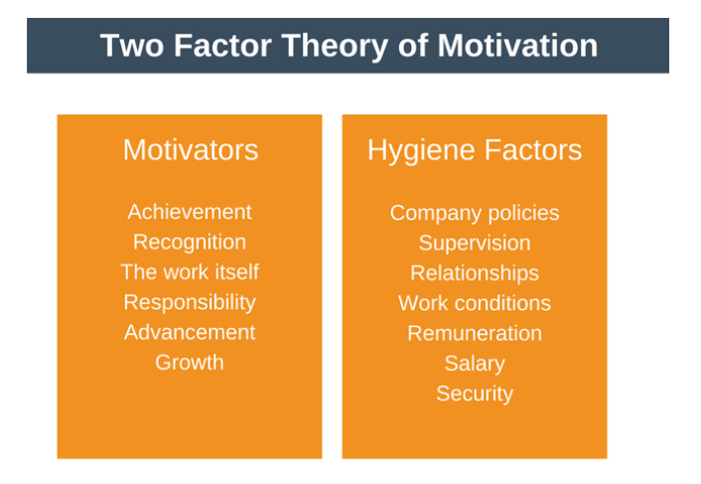
Application of Two Factor Theory in Workplace:
There is a two-step process to use the Two Factor Theory model to increase the motivation in workplace :
1> Eliminate job hygiene stressors.
2> Boost job satisfaction.

1. Eliminate Job Hygiene Stressors
The first step to enhancing the motivation is to ensure that the hygiene factors are not causing dissatisfaction.
Each person will examine hygiene factors through their own unique frame of reference. Because of this, it’s important to work with each member of your team to understand their specific perspective.

Some common steps to remove hygiene stressors are:
»Rectify petty and bureaucratic company policies.
»Ensure each team member feels supported without feeling micromanaged. You can do this by using servant leadership or a democratic leadership style.
»Ensure the day to day working culture is supportive. No bullying. No cliques. Everyone treated with equal respect.
»Ensure that salaries are competitive within the industry. Ensure there are no major salary disparities between employees doing similar jobs.
»To increase job satisfaction and status, aim to construct jobs in such a way that each team member finds their job meaningful.

2. Boost Job Satisfaction
Once you have removed hygiene stressors, the next step is to boost the job satisfaction in the workplace. We can do this by improving the actual content of the job itself. Again, a unique approach for each employee will be required.
Three techniques which can be used to achieve this are:

a. Job Enrichment:
Job enrichment means enriching employee’s job by giving them more challenging or complex tasks to perform. These more complex tasks should make the job more interesting.

b. Job Enlargement:
Job enlargement means giving employee a greater variety of tasks to perform. This variety can also make a job more interesting.

c. Employee Empowerment:
Employee empowerment means deligating increasing responsibility to each team member. This can be done by slowly increasing the amount of responsibility you delegate to an employee.

Q2.) Explain in detail management and managerial skills according to Robert Katz?

Managerial skills are the knowledge and ability of the individuals in a managerial position to fulfill some specific management activities or tasks. This knowledge and ability can be learned and practiced. However, they also can be acquired through the practical implementation of required activities and tasks. Therefore, you can develop each skill through learning and practical experience as a manager.
When we talk about these skills, we talk about the skills of a manager to maintain high efficiency in how their employees complete their everyday working tasks. Because of that, managers will need skills that will help them manage people and technology to ensure an effective and efficient realization of their working duties.

Robert Katz identifies three types of skills that are essential for a successful management process:
- Technical skills,
- Conceptual skills and
- Human or interpersonal management skills.

Technical Skills:
Technical management skills are closely related to the technical or engineering dimension of management. These skills are essential to start your company, build your products or services, and design the systems inside the company. Here we talk about management skills related to the mechanics of doing things. What will you need to do? How will you do that?
Technical skills are not related only to machines, production tools, or other equipment. They are also skills required to increase sales, design different products, and services, market the products and services, etc. They give managers the knowledge and ability to use different techniques to achieve what they want to achieve.
Technical skills are most important for first-level managers. When it comes to the top managers, these skills are not something with a high significance level. As we go through a hierarchy from the bottom to higher levels, technical skills lose their importance.

Conceptual Skills:
Conceptual skills present the knowledge or ability of a manager for more abstract thinking. That means he can easily see the whole through analysis and diagnosis of different states. In such a way, they can predict the future of the business or department as a whole.
Different business elements have different goals, even completely opposed goals. Think about marketing and production as a business function and their specific goals. You’ll see the essential difference. The conceptual skills will help managers to look outside their department’s goals. So, they will make decisions that will satisfy overall business goals.
Conceptual skills are vital for top managers, less critical for mid-level managers, and not required for first-level managers. As we go from the bottom of the managerial hierarchy to the top, the importance of these skills will rise.

Human or Interpersonal Managerial Skills:
Human management skills are related to managing critical social processes inside the company. These interpersonal management skills present a manager’s knowledge and ability to work with people. One of the most critical management tasks is to work with people. Without people, there will not be a need for the existence of management and managers.
These skills will enable managers to become leaders and motivate employees for better accomplishments. Also, they will help them to make more effective use of human potential in the company. They are essential skills for managers on all hierarchical levels in the company.

------------------------------------------------------------------------------------------------------------------

