NON-LIFE INSURANCE
ASSIGNMENT 2
- The term earned premium refers to the amount that an insurance company has received for the portion of an expiring policy. (c)
- Third party liability insurance covers damage caused to another vehicle when hit by the insured’s vehicle. (b)
- Types of motor insurance covers are third party car insurance, own damage and comprehensive policies.
- The few add on coverages in motor insurance are no claim bonus, nil depreciation, total cover, engine protection cover, consumables cover, return to invoice, roadside assistance and tyre protect cover.
- Health insurance covers ambulatory patient services, emergency services, hospitalization, pregnancy, maternity, mental health, prescription drugs and much more.
- The factors that are considered under underwriting of motor insurance are as follows:
- Age of prosper
- Sex
- Marital status
- Driving history of prosper
- Address of prosper
- Prospers history involving insurance in general
- Ownership of or financial interest in motor vehicle
- Description of use and distance to be covered by the motor vehicle
- Particulars of the motor vehicle
The factors that are considered under underwriting of fire insurance are as follows:
- Maintenance and repair standards
- High risk notifications
- Adjacent exposure data and related general liability exposure
- Loss estimates
- Estimated replacement costs
- Risk improvement recommendations
- Construction
- Occupancy
- Fire protection
- Common and special hazards
- Claims history
- Credit rating of the owner
The factors that are considered under underwriting of marine insurance are as follows:
- Past claim experience
- Conditions of insurance
- Trade routes and limits
- Cargo carried
- Management quality and ownership
The factors that are considered under underwriting of travel insurance are as follows:
- Age
- Trip cost
- Trip length
- Destination
- Departure window
- Departure month
- Number of destinations

- In motor insurance policy the following things are not covered:
- Third party liabilities
- Insured driving drunk
- Driving without a license
- Add on not bought
- Consequential damages
- Contributory negligence
In travel insurance policy the following things are not covered:
- Warfare
- Pre-existing ailments
- Sporting injury during travel
- Pregnancy
- When the tour operator cancels trips

In marine insurance policy the following things are not covered:
- Willful, planned or intentional misconduct
- Strike, rioting, war
- Poor packaging quality of the cargo
- Delays
- General leakage or wear and tear of the cargo
- Financial distress or insolvency of the shipping line
- Removal of wreck

In fire insurance policy the following things are not covered:
- Loss due to fire caused by earthquake, invasion, act of foreign enemy, hostiles or war
- Loss caused by subterranean (underground) fire
- Loss caused by burning of property by order of any public authority
- Loss by theft during or after the occurrence of the fire
- Loss or damage to the property caused by its own fermentation or spontaneous combustion
- Loss or damage by lightning or explosion is not covered unless these actual ignition which spread into fire

In health insurance policy the following things are not covered:
- Elective or cosmetic procedures
- Beauty treatments
- Fertility treatments
- Off-label prescriptions
- New technology in product or services

- Insurance fraud is any act committed to defraud an insurance process. It occurs when a claimant attempts to obtain some benefits or advantage they are not entitled to, or when an insurer knowingly denies some benefit that is due.
HEALTH INSURANCE FRAUD:
Fraud in India:
Insurer: ICICI Lombard General Insurance Company
Insured: Darbari Lal Dhawan
Claim lodged on 11.08.2016
As per the claimant the Insured died on 25.07. 2016.
Period of Insurance policy: from 2016-2021.
Detailed Description of the Death: Car accident.
After social media forensic analysis, it was found that the insured had died before July 2016.
The family’s facebook accounts were checked and they found posts indicating the loss of Darbari Lal on various dates before July 2016. One post also indicated his death in 2012.
ICICI detected the false claim and refused the payout.
UNDERWRITING OF HEALTH INSURANCE:
Objective: Measure and quantify health risk of applicant in line with organizations risk appetite
Information sources: Demographic: Gender, location, marital status, family size, Health Status, Lifestyle/ Habits, Claim History, Income.
Approach: Proposal Form, Agents Report, Attending physician report, Full medical underwriting, Medical questionnaire, Medical tests.
Risk Factors:
Factors which effect the Claim frequency or Severity
• Age
• Sum Insured
• Demography
• Medical Condition
• Gender
• Policy Type
Factors which are used in Rating are called Rating Factors.
- The coverages in personal accident insurance are as follows:
- Accidental death cover
- Permanent disability cover
- Permanent partial disability cover
- Temporary total disability
The coverages in travel insurance are as follows:
- Trip cancellation
- Trip interruption
- Travel delay
- Baggage damage or loss
- Baggage delay
- Emergency medical or dental
- Emergency evacuation
- Repatriation or remains
- Rental car or collision damage
The coverages in marine insurance are as follows:
- Hull
- Cargo
- Contingency insurance policy
- Damages due to inappropriate packing
- Infestation
- Customs rejection
- Employee’s dishonesty
- Voyage
- Freight
- Liability

- Another characteristic of travel insurance is the potential overlap with other insurance products. For example, automobile insurance may provide rental car collision damage insurance,
Home owner insurance may cover lost or damaged baggage, and health insurance may cover
emergency costs while traveling. Even in cases where a traditional policy may provide a benefit,
travel insurance remains distinctive because it only covers exposures related to travel, and is
usually tied to a specific trip.

- HISTORY OF MARINE INSURANCE:
The earliest forms of insurance were a primitive form of commercial insurance, especially in regards to shipping goods, since cargo was often lost or damaged or stolen by thieves and pirates. Please earliest methods of reducing risk involved either the pooling of risk or transferring the risk to moneylenders or investors of expeditions. For millennia, the primary and economical means of transport was to use waterways, but boats carrying cargo were often destroyed in rapids along the rivers. Enough cargo made it through to still make it more economical than land transport, but shippers realized that bad luck could ruin them financially. A primary means of reducing risk to individual shippers was to pool the risk amongst all of them. As early as 3000 BC, Chinese merchants pooled their risk of loss when moving cargo down the rapid Chinese rivers. In 3000 BC, merchants and traders in Sumer and Babylonia pooled their risk to prevent major losses of cargo to thieves and pirates. The market of marine insurance began in Lloyd’s coffeehouse opened by Edward Lloyd around 1688 on Tower Street in London. The establishment was a popular place for sailors, merchants, ship owners and Lloyd catered to them with reliable shipping news. As a centre of commerce and global trade, Great Britain was a natural place for marine insurance to develop, and one of the major insurers of voyages was Lloyd's of London. Insurance was written by individuals rather than companies where a ship-owner or merchant would publish a sheet of information describing the cargo ship, and its destination and any other pertinent information. The people who accepted part of that risk
wrote their names under the description of the risk and the terms in the agreement. This writing under the agreement gave rise to the term underwriter, one who selects and rejects risks.
Lloyd’s coffeehouse, opened by Edward Lloyd, became the main meeting place because the proprietor manufactured paper, pens, and information regarding shipping available and provided information regarding available shipping, thus becoming Lloyd's of London.

TYPES OF MARINE INSURANCE POLICY:
- Voyage policy
This policy gives more importance to the voyage. A voyage policy is that kind of marine insurance that is valid for a particular voyage. It covers the risk from the port of departure up to the port of destination. This type of policy is considered more useful for cargo. The insurance company give indemnity for loss/damage of any property of the insured during the voyage. The liability of the insurer continues during the landing and re-shipping of the goods. The policy ends when the ship reaches the port of arrival.
- Time Policy
The policy which is issued for a fixed period of time is known as time policy. A marine insurance policy is valid for a specified time period generally valid for a year. All the marine perils during that period are insured. This type of policy is suitable for full insurance. The policy is more commonly used for hull insurance than for cargo insurance. The ship is insured for a fixed period irrespective of voyages.
- Mixed Policy:
A marine insurance policy which offers a client the benefit of both time and voyage policy is recognized as a mixed policy.
- Open (or) Unvalued Policy:
In this type of marine insurance policy, the value of the cargo and consignment is not put down in the policy beforehand. Therefore, reimbursement is done only after the loss of the cargo and consignment is inspected and valued.

- Valued Policy:
A valued marine insurance policy is the opposite of an open marine insurance policy. In
this type of policy, the value of the cargo and consignment is ascertained and is mentioned in the policy document beforehand thus making clear about the value of the reimbursements in case of any loss to the cargo and consignment.
- Port Risk Policy:
This kind of marine insurance policy is taken out in order to ensure the safety of the
ship while it is stationed in a port.
- Wager Policy:
A wager policy is one where there are no fixed terms for reimbursements mentioned. If
the insurance company finds the damages worth the claim then the reimbursements are provided, else there is no compensation offered. Also, it has to be noted that a wager policy is not a written insurance policy and as such is not valid in a court of law.
- Floating Policy:
A marine insurance policy where only the amount of claim is specified and all other
details are omitted till the time the ship embarks on its journey, is known as a floating policy. For
clients who undertake frequent trips of cargo transportation through waters, this is the most ideal and feasible marine insurance policy.
- Single Vessel Policy:
This policy is suitable for small shipowner having only one ship or having one
ship in different fleets. It covers the risk of one vessel of the insured.
- Fleet Policy:
In this policy, several ships belonging to one owner are insured under the same policy.
- Block Policy:
This policy also comes under maritime insurance to protects the cargo owner against
damage or loss of cargo in all modes of transport through which his/her cargo is carried i.e. covering all the risks of rail, road, and sea transport.

- .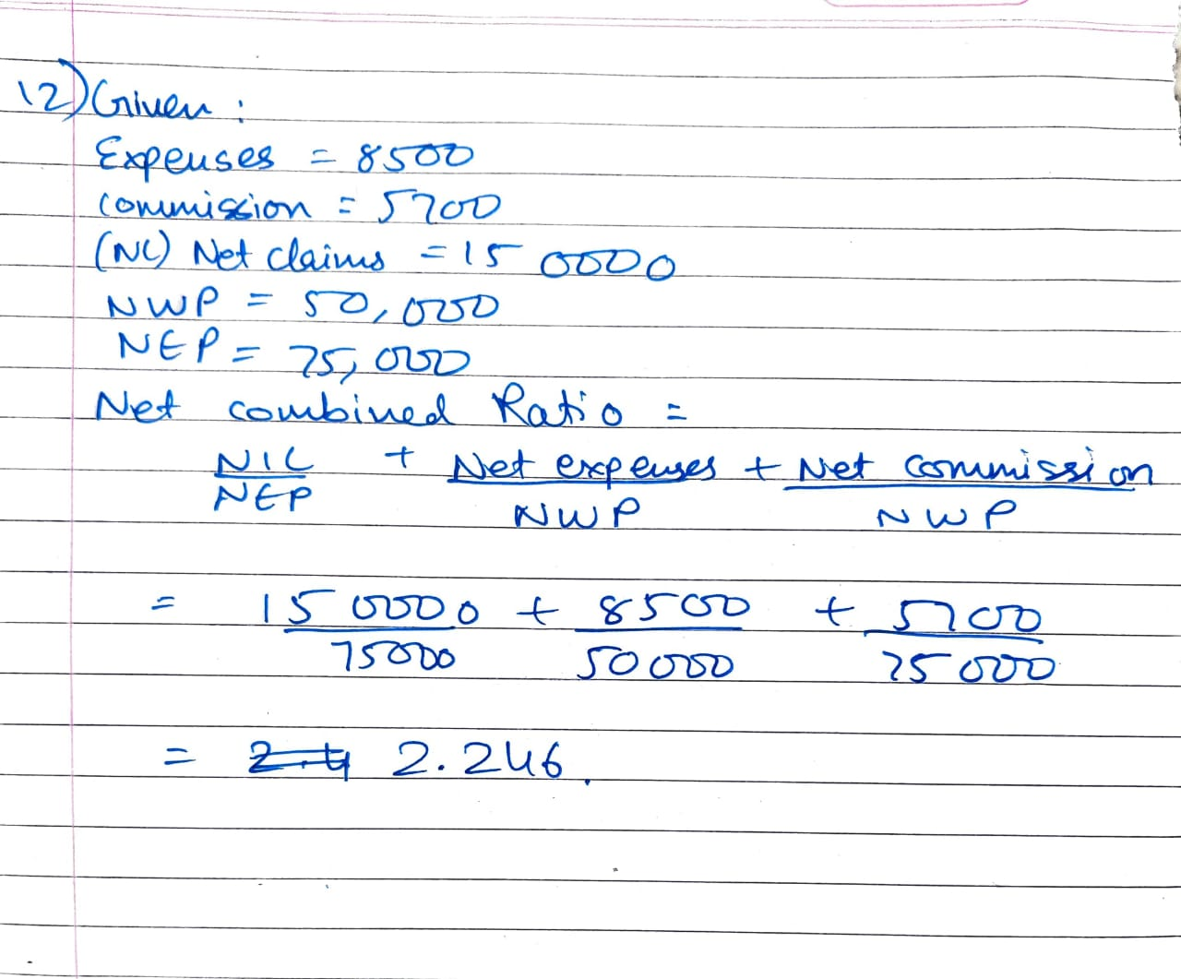
- Crop Insurance is a comprehensive yield-based policy meant to compensate farmers’ losses arising due to production problems. It covers pre-sowing and post-harvest losses due to cyclonic rains and rainfall deficit. These losses lead to reduction in crop yield, thus, affecting the income of farmers. In India, crop insurance is offered in the form of Pradhan Mantri Fasal Bima Yojna.
It covers localized calamities, sowing/planting/germination risk, standing crop loss, post-harvest losses.
It does not cover:
- losses arising out of war, nuclear risks
- malicious damage or other preventable risk arising out of negligence by the farmer or the manpower employed by the farmer
- burning of the crop by order of public authority
- damage caused by birds or animals
- lonizing radiations or contamination by nuclear waste
- harvested crops bundled and heaped before threshing

- the underwriting factors for credit insurance are as follows:
- geographical location
- character, reputation and lifestyle of applicant
- claims history
- implementation of safety precautions by the applicant
- previous criminal convictions
- nature and particulars of liability exposures
- Engineering insurance refers to the insurance that provides economic safeguard to the risks faced by the ongoing construction project, installation project, and machines and equipment in project operation. Product categories: Depending on the project, it can be divided into construction project all risks insurance and installation project all risks insurance; depending on the attribute of the object, it can be divided into project all risks insurance, and machinery breakdown insurance.
Insurance Period: the same as the construction period of the project.

