BRITANNIA MARIE GOLD BISCUIT

Sr.No. | Contents | Pg. No.
1. | Company Overview | 1-2
2. | Product Analysis | 3-6
3. | Industry Analysis | 7-8
4. | Supply Chain of the Product | 8-10
5. | Conclusion | 11-12
6. | References | 12

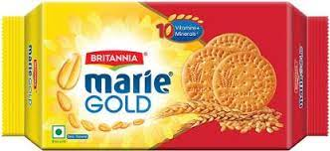
ALVA TRIKSHIT DAMODAR
ROLL NO.3
ABOUT THE COMPANY
One of the India’s most favourite Brands -Its story begins in 1892 to be precise, a biscuit company was started in a nondescript house in Calcutta (now Kolkata) with an initial investment of Rs. 295. The company we all know as Britannia today. The beginnings might have been humble-the dreams were anything but. By 1910, with the advent of electricity, Britannia mechanised its operations, and in 1921, it became the first company east of the Suez Canal to use imported gas ovens. Britannia's business was flourishing. But, more importantly, Britannia was acquiring a reputation for quality and value. As a result, during the tragic World War II, the Government reposed its trust in Britannia by contracting it to supply large quantities of "service biscuits" to the armed forces. As time moved on, the biscuit market continued to grow and Britannia grew along with it. In 1975, the Britannia Biscuit Company took over the distribution of biscuits from Parry's who till now distributed Britannia biscuits in India. In the subsequent public issue of 1978, Indian shareholding crossed 60%, firmly establishing the Indianness of the firm. The following year, Britannia Biscuit Company was rechristened Britannia Industries Limited (BIL). Four years later in 1983, it crossed the Rs. 100 crores revenue mark. On the operations front, the company was making equally dynamic strides. In 1992, it celebrated its Platinum Jubilee. In 1997, the company unveiled its new corporate identity - "Eat Healthy, Think Better" - and made its first foray into the dairy products market. In 1999, the "Britannia Khao, World Cup Jao" promotion further fortified the affinity consumers had with 'Brand Britannia'. Britannia strode into the 21st Century as one of India's biggest brands and the pre-eminent food brand of the country. It was equally recognised for its innovative approach to products and marketing: the Lagaan Match was voted India's most successful promotional activity of the year 2001 while the delicious Britannia 50-50 Maska-Chaska became India's most successful product launch. In 2002, Britannia's New Business Division formed a joint venture with Fonterra, the world's second largest Dairy Company, and Britannia New Zealand Foods Pvt. Ltd. was born. In recognition of its vision and accelerating graph, Forbes Global rated Britannia 'One amongst the Top 200 Small Companies of the World', and The Economic Times pegged Britannia India's 2nd Most Trusted Brand.

A Marie biscuit is a type of biscuit similar to a rich tea biscuit. The name Marie is a variation of the biscuit’s original name Maria, derived from Russia’s Grand Duchess Maria, who married the Duke of Edinburg. The wedding was the inspiration behind the biscuit’s birth when an English bakery made a sweet small round cookie stamped with the Duchess name, Maria. It is also known as María, Mariebon and Marietta, amongst other names.
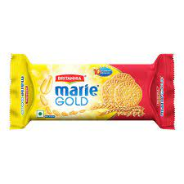
The biscuit is round and usually has the name embossed upon its top surface, the edges of which are also embossed with an intricate design. It is made with wheat flour, sugar, palm oil or sunflower seed oil and, unlike the rich tea biscuit, is typically vanilla-flavoured.

The Marie biscuit was created by the London bakery Peek Freans in 1874 to commemorate the marriage of the Grand Duchess Maria Alexandrovna of Russia to the Duke of Edinburgh. It became popular throughout Europe, particularly in Portugal and Spain where, following the Civil War, the biscuit became a symbol of the country's economic recovery after bakeries produced mass quantities to consume a surplus of wheat.

In India, Treff Marie Biscuits by Disha Foods is one of the most popular brands. Other popular brands of Marie Biscuits in India include Mariebon (Bonn Food Industries); Vita Marie (Britannia Industries); and Marie Light (ITC Limited).

PRODUCT ANALYSIS:
- Type of Good:
Goods that are purchased for consumption by individuals are called Private goods. But precisely you can tell Marie Biscuits as Consumable Goods. Marie biscuits are dunkable cookies and they are best served with tea.
- Features:
Marie Biscuit is crisp, light, healthy and delicious. It is a type of biscuit made with wheat flour, sugar, vegetable oil and vanilla flavouring. It is usually round in shape, with the name of the brand engraved on the top surface. The edges of the top surface are also engraved with an intricate design. Marie biscuit is used abundantly in India as a snack, base for desserts.
- Health Benefits:
- Marie is one variety of biscuit that is highly recommended by dieticians.
- Marie biscuits, a favourite among diabetics, contain both sugar and refined wheat flour so they must be had in moderation only.
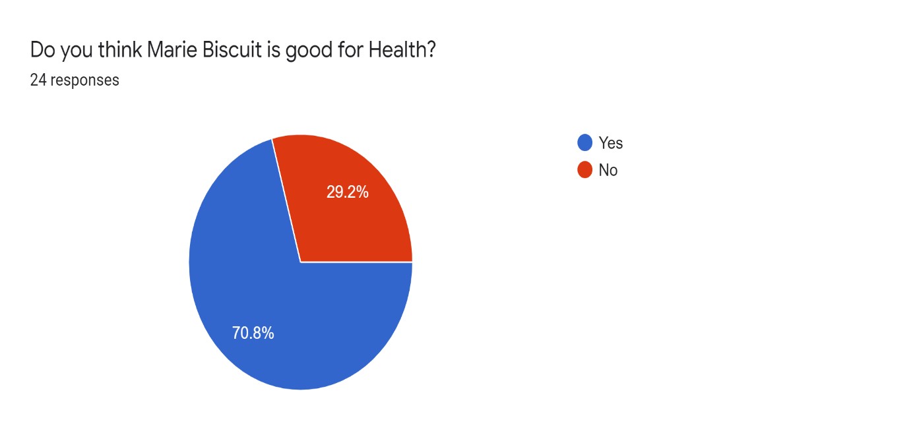
The above shown poll tells you that more than 70% i.e. (17 out of 24) say that Marie biscuit is healthy.

- PRICING AND AVAILABILTY:

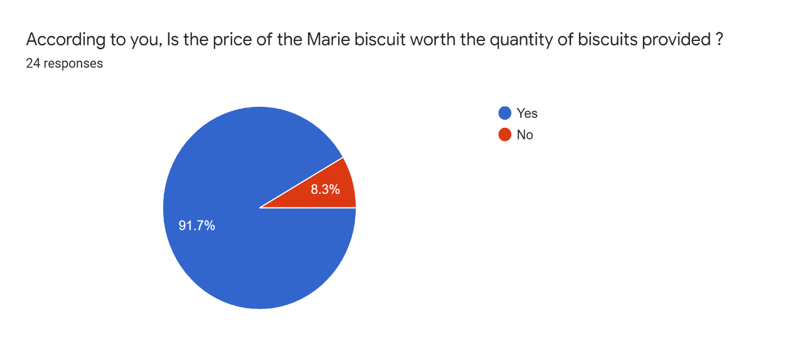
- In the data collected from the survey more than 90% of the people are satisfied with the price and the quantity available.
- The Marie is arguably the most recognisable biscuit—being distinctive, affordable and present almost everywhere.
- In India there are different brands of Marie biscuit, in which the most popular and available everywhere is -Britannia Marie Biscuit.
- Britannia Marie biscuit is available for every class of people at a very minimal cost and good quantity which helps it to gather a large consumer support.

- SWOT ANALYSIS:
- Strengths:
- Britannia has a strong brand name.
- Good market penetration and Extensive distribution networks.
- Good Quality and Affordable price.
- Known throughout India as a product which is ‘Good for Health’.
- Widely accepted in all generations.

- Weakness:
- Not an Extensive overseas market.
- Biscuits with not a range of flavours.
- Lesser demand in Rural Areas.

- Opportunities:
- Providing the product with different flavours.
- Targeting interior area of India.
- Increasing the demand for diet and sugar free biscuits.

- Threats:
- Competitors with lower price offering.
- Increase in cost of raw materials.
- Entry of new Domestic players in the Rural areas
DEMAND FOR THE PRODUCT:
- Britannia Marie gold biscuits are one of the all-time favourite biscuits. First of all, these biscuits are very light and they do not contain any kind of heavy fat content. It gives very good taste. These biscuits are very crispy and give very good company to have it along with the tea or coffee.
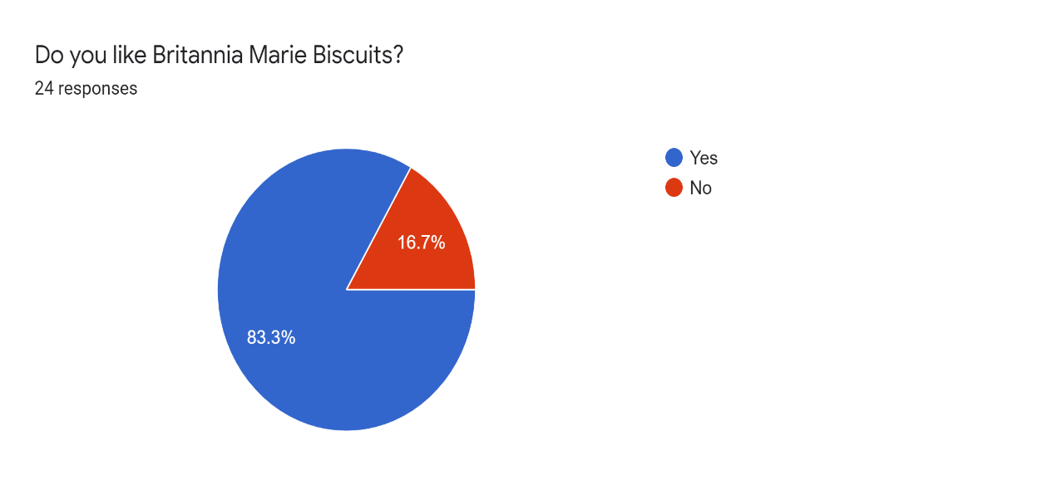
- In the conducted survey we found that 80% of the people like Britannia Marie Gold Biscuits which indeed tells us that it has a great demand.
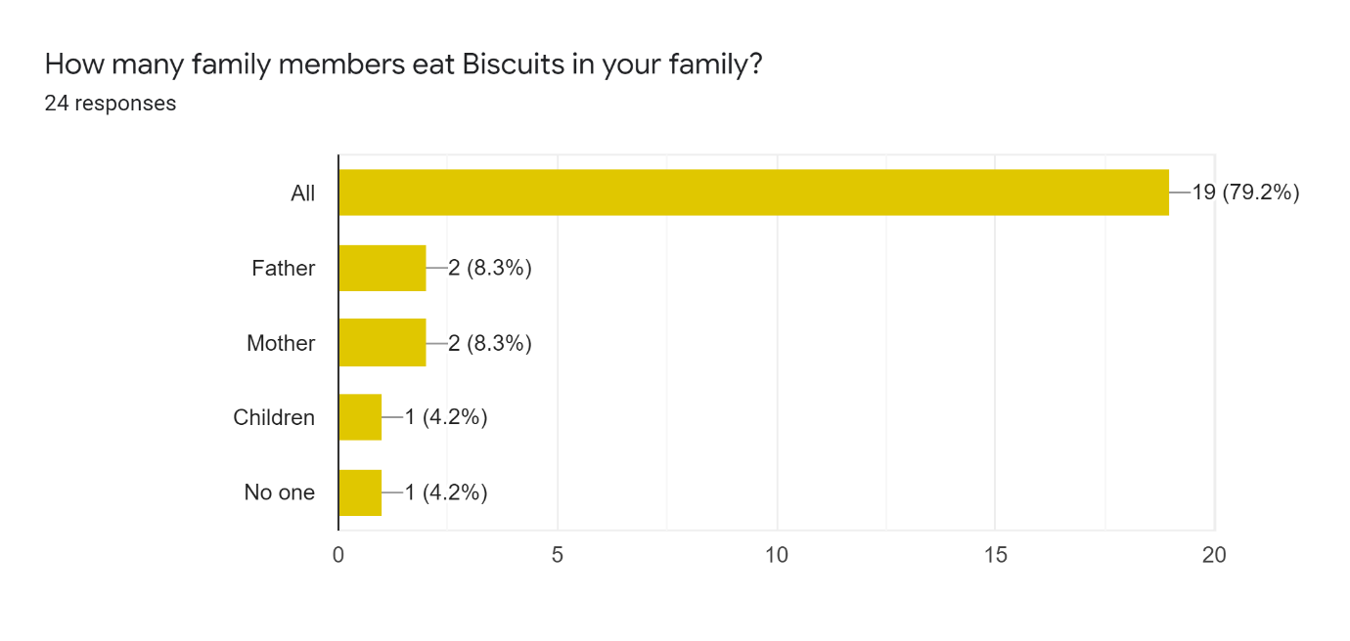
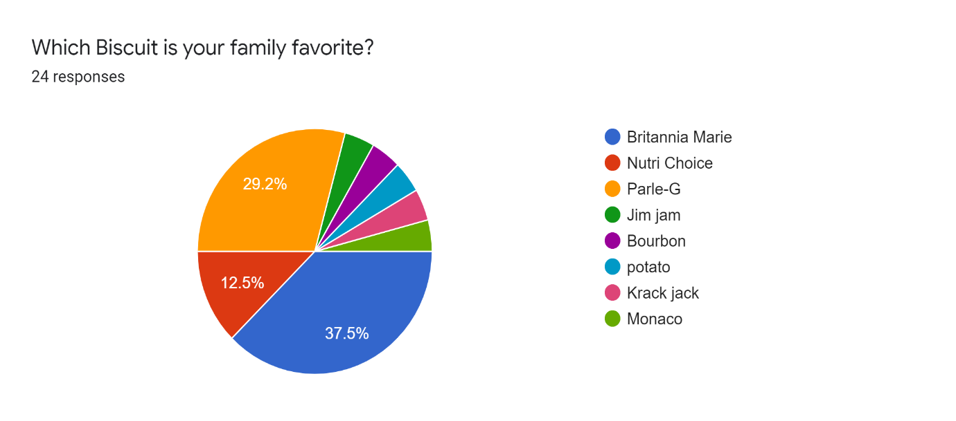
- Above conducted surveys tells us that Britannia Marie biscuits are considered favourite family biscuits in most of the responses but it has some competitors like Nutri-Choice & Parle-G. But Marie biscuit is liked by all the Generation which gives it an upper hand.

INDUSTRY ANALYSIS:
- Market Condition
India is the second largest producer of biscuits in the world after the US. Biscuit industry is one of the largest food industries in India instead of volatility in Raw material prices & shift in tax slab due to GST. India is a transitional market as far as biscuit consumption is concerned. The shift in consumption towards bakery products owing to better appeal, taste, and convenience is a significant driver of the market growth. The fast-paced lifestyle and impact of urbanization have increased the demand for crackers and other baked goods. The consumers are more conscious than ever before and the availability of biscuits with functional ingredients such as wheat, oats, and multi-grains, honey, etc. appeal to health-conscious consumers who choose such biscuits as a healthy snacking option. Furthermore, Rise in the innovation of biscuits product offerings, increasing per capita household income, the surge in consumer spending on food products will lead the market over the forecast period. Maharashtra and West Bengal, the most industrially -developed states, hold the maximum amount of consumption of biscuits.
The Indian biscuit market has seen demand rise during the pandemic due to an increase in at-home consumption. Milk biscuits and Marie in particular, drove up demand, bringing the growth rate to about 12% in 2020.
Panic buying in response to the covid- 19 pandemic prompted biscuit companies to concentrate on launching new variants and expanding their presence, especially in rural India. Companies with a smaller biscuit market share are now ramping up their plans by consolidating distribution and introducing new products.
Biscuits have long been common in India, with Maharashtra and West Bengal having the highest consumption rates. After 2005, India became the world's third-largest biscuit maker. Exports in 2020 were 17 metric tonnes, up from 16.6 metric tonnes in 2019. It’s worth noting that, India's biscuit market has come a long way, accounting for roughly 72 percent of the bakery industry's revenue.
The biscuit industry is currently divided into two sectors: organized and unorganized, with well-known brands controlling the organized sector's market share. Small bakery units, cottage and household style manufacturing and packaging units, on the other hand, make up the unorganized market, which helps them distribute their products in the surrounding areas. The growth of the unorganized sector is aided by self-managed and concentrated product lines, as well as lower marketing expenditures.
According to estimates, India's overall biscuit market is worth $5-5.5 billion, with cookies accounting for 35-40% of that amount. Plain biscuits, such as marie and milk biscuits, account for 25% of the market, while cream biscuits and crackers each account for 15%.
- Government Policies and Taxes
The higher tax has been a matter of concern for biscuit-makers since 2017, when the GST regime came into effect. For instance, biscuits priced below Rs 100 a kg were taxed at 12 per cent before GST implementation. This category largely includes affordable biscuits that account for 25 per cent of all biscuit sales in India, and are typically priced under Rs 10.
When the GST was being implemented, companies had expected the tax to be fixed at 12 per cent for premium biscuits and 5 per cent for the lower-priced ones. However, under the GST regime, all biscuits were brought under the 18 per cent tax structure, forcing companies to increase prices, affecting sales.

SUPPLY CHAIN OF THE PRODUCT:
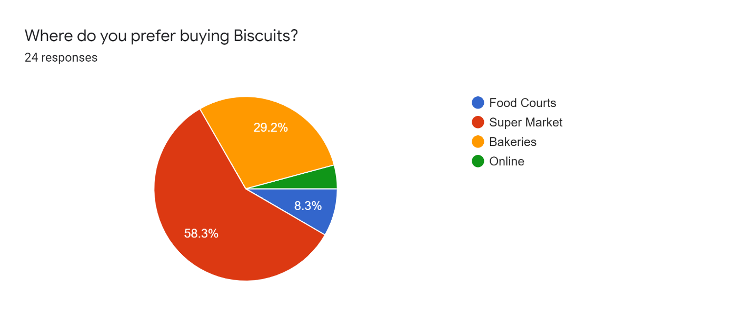
Currently, biscuits are distributed in eight million outlets across India, and having a wide supply chain network is crucial for companies looking to capture a significant share of the market. Moreover, the market for biscuits is likely to continue as the Covid-19 pandemic has made more people to work from home, a trend that is likely to continue throughout 2021.

Britannia has decided to attach 2 lakh stores in their direct network every year. According to company’s research, there are nearly 11 million retail outlets in the country out of which 8 million sell biscuits.

With the direct distribution model, Britannia wants to control the complete supply chain itself. Right now, the company has more than 20,000 employees who visit retail stores to analyse the need of sellers and suggest them products. These workers then take orders and send to the distributors by using mobile apps. In this new model, the distributors will have to send the products within one day to ensure the increase in sales.
Before distributors, Britannia sends products to wholesale dealers after manufacturing. The whole process takes around 7-10 days and this time will be saved from now on. Of course, it will take more manpower and advanced technology, but to improve the business it was much needed as rivals are already following these policies and customer these days just cares about service.

The distance between the retail stores and distribution centres will be reduced and will customers who want quick service. Gunjan Shah, the vice president (sales), Britannia revealed that company wants to focus on non-metro cities as they contribute a big portion in Britannia’s sales. Direct Distribution model will definitely help them in expanding the reach of their products in the retail market. Time is a major factor in the modern world and by saving this Britannia is showing its future plans.
Other big players in the market have made Britannia do this. As of now, the Indian brand only serves around 6.5 lakh retail stores directly which is very less as compared to Pepsico brand Fritolay’s direct reach of 1.1 million stores despite being 1/4 of Britannia’s size.

Parle-G is the largest distributor in the country because of its quick delivery service. With more than 70 factories across the country, Britannia wants to increase its share in the biscuit market.
Although this model has been running in some cities but, it is not enough. With direct distribution model retailers will know the location of their orders products at any instant before delivery.
Britannia has probably recognized the need of advanced technology in the business world. Change is the rule of this world and if any company wants to achieve and maintain success, they cannot ignore the technology factor.
Substitute for Britannia Marie Biscuit:
You can substitute it with any digestive biscuits or graham crackers. The other great biscuit options are Gluco biscuits or Parle-G biscuits. Parle-G is one of the best-selling biscuit brand in the world.
Achievement:
SOUTH ASIA PR CAMPAIGN OF THE YEAR
GOLD: Britannia Marie Gold: My Startup-2. O: Home-makers Turn Job-Creators
A PRWeek Award is a unique symbol of excellence, leadership and immediately sets victors apart from all others. It celebrates the best of the best corporate, agency, non-profit and education teams, and the work they produce.


CONCLUSION:
Britannia Marie gold gained acceptance from the customers. They have huge potential to expand its market share and become leaders in few of the business category. Britannia Marie Gold is most popular among its users mainly because of its taste and preferences, low price and much more availability. Customers came to ask for specific biscuit of Britannia in retail shop because of their advertisement. If the particular brand is not available, they would not recommend any other brand. Customer purchase Britannia Marie biscuits as a single purchase. Retailer’s level of satisfaction is very high towards the Britannia Marie biscuits the sell. While comparing to other biscuits the price of Britannia Marie biscuits is very low. They offer many display schemes to the retailers. They offer many replacement policies to the retailers. The distributors are giving good services to retailers. The sales of Britannia Marie biscuits can be increased keeping price at affordable levels. The retailers keep much more stock of Britannia Marie with them. I came to conclusion that the visibility effects of sales of Britannia Marie biscuits in a very special way and in terms of biscuit variety Britannia Marie is very much selling biscuits among the customers and retailers gain profit.

Suggestions:
Retailers should know the needs and wants of their customers. Company should offer more replacement policy to the retailers. More offers should be provided to the customers. Company should know the awareness of primary customers. Company should provide more and more distributor. Company has to give maximum support to the customers. Retailers should keep more stock of Britannia Marie biscuits because customers ask for it specifically.

Learnings:
- Britannia launches My Start-up Season 3.0 with Rs 10 lakh to 10 homemakers
Britannia Marie Gold’s My Start-up campaign version 3 is now broadened to help homemakers leverage the Internet to grow their businesses. This follows after a survey by Britannia and Momspresso which indicated that 77% of homemakers who desire to set up their own ventures, consider technology as an enabler. The last day for online submissions is November 05.
Quoting the highlights of the Indian Homemakers’ Entrepreneurship Report 2021, Britannia too stated that 62% of homemakers have dreams & aspirations to start a business of their own. The primary drivers for these homemakers who aspire to set up their own business desire to be financially independent which is 60% and the ability to contribute financially to the family.
To support these aspirations, participants will be able to access a set of digital skilling resources from Google. These digital resources are available in six languages – Hindi, Telugu, Tamil, Kannada, Bengali and English, according to Britannia.

REFERENCES:
http://britannia.co.in/
https://www.prweek.com/
https://www.einnews.com/
https://en.wikipedia.org/
https://www.indianmirror.com/

