Statistical And Risk Modelling-1
Project Work- Graduation Tests

Jash Poonatar
Roll No-18
Question 1
We have already been given the dataset required for the project work which includes data of the age of the person, central exposed to risk for the age “x” last birthday and number of deaths recorded at age “x” last birthday. Using the data given we have to find the values of subsequent columns of crude mortality rate, graduated mortality rates, etc.
So, we start by loading the data in our R environment and attaching the data frame to make our code simpler to understand.
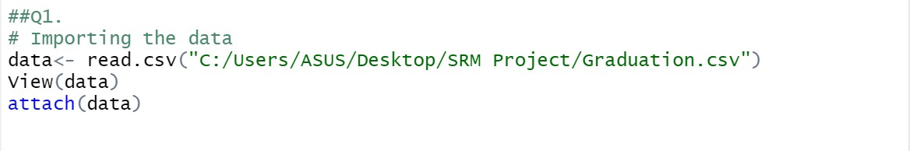
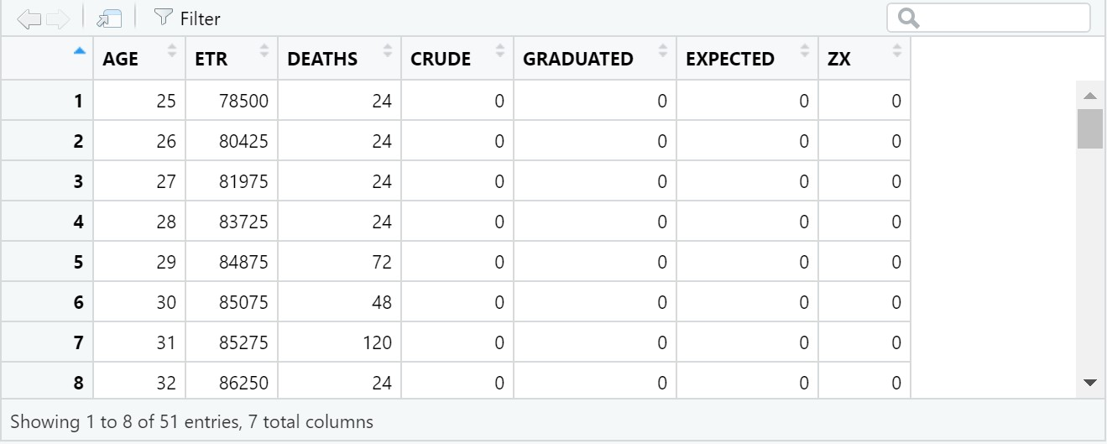
We get the output as follows:-

Then we use the column of deaths and central exposed to risk to find the crude mortality rate for age “x” last birthday by dividing the deaths by central exposed to risk.
We get the crude rates as follows for all the rows as follows:-
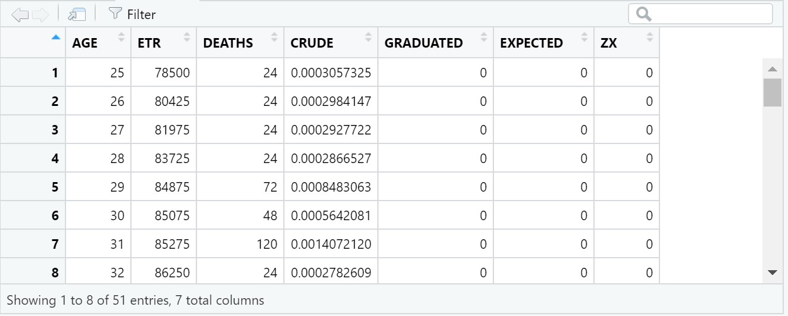

Question 2
Now we need to find the values of graduated mortality rates for age “x” last birthday using Gompertz law.
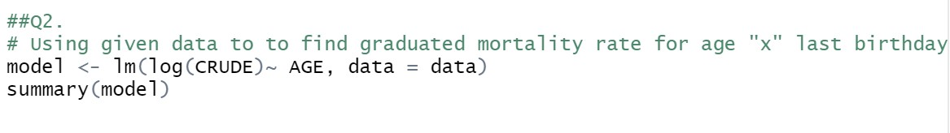
We get the output of the summary of model as follows:-
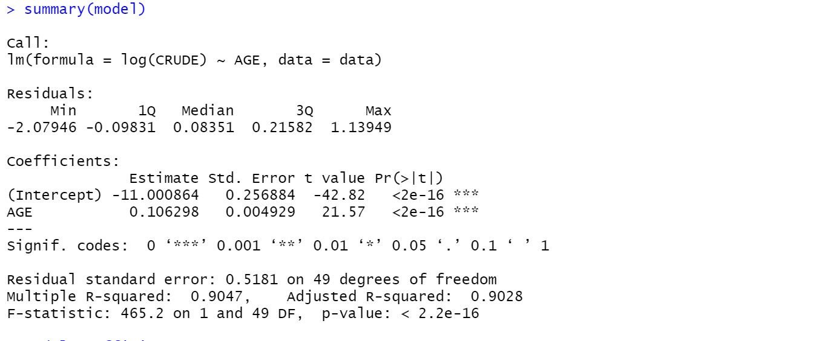 Then we find the values of B and C using Gompertz law where B represents the intercept and C is the coefficient for age of the person and then using the formulae given below we find the values of graduated mortality rates.
$$u_{x}=A+Bc^{x}$$
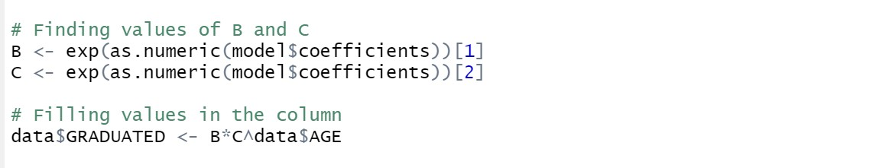
We get the values as:-
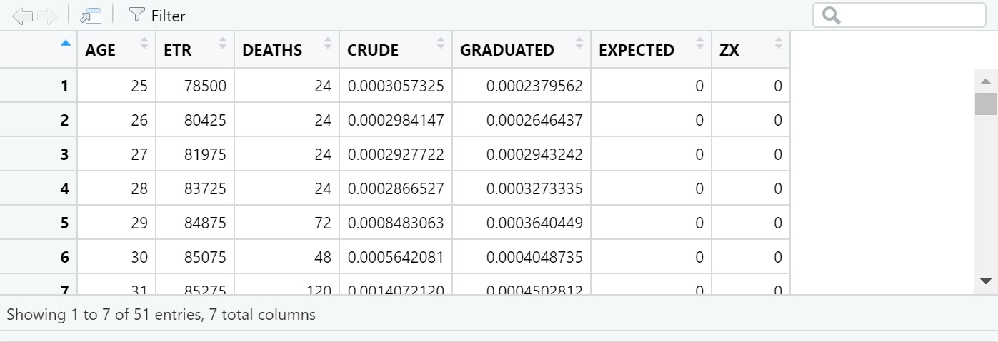

Question 3
Now we have to check for smoothness by applying third differences to the crude and graduated rates.
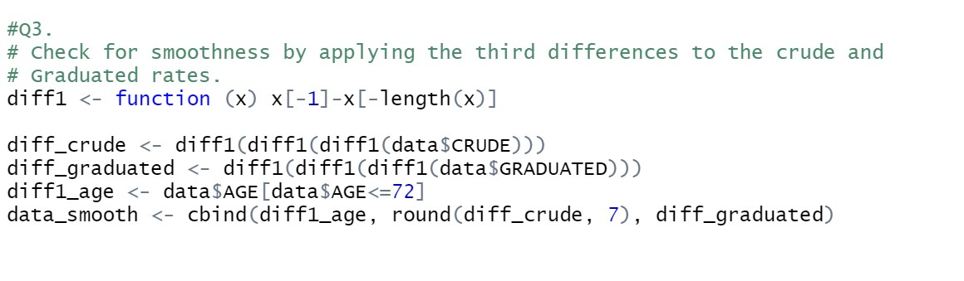
So we use function (x) x[x-1]-x[-length(x)] which is given to us to make a function. We reuse the same function 3 times to find the third differences and since with every difference we remove age by -1 so by doing it 3 times we need to remove the last 3 ages from 73 to 75.
Then we bind the values in a new data set and round off the values to 7 decimal places to get-
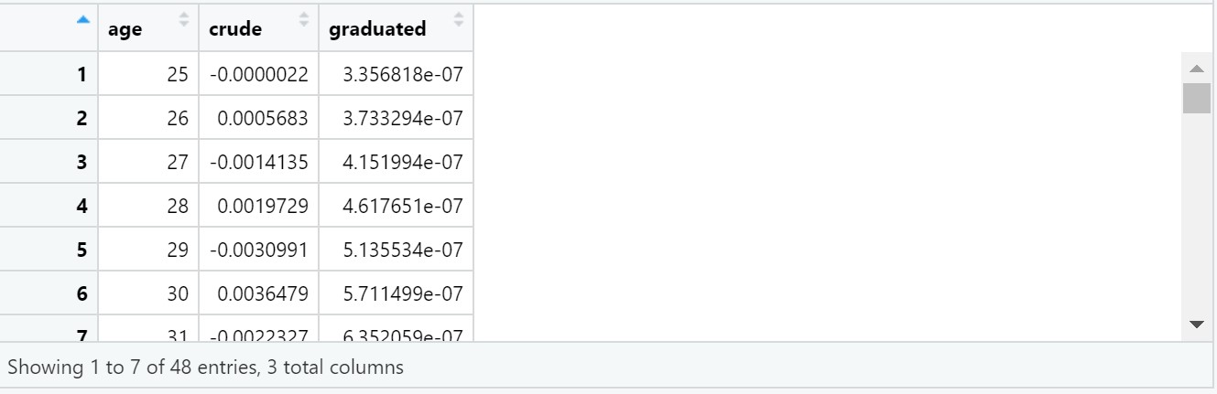

The third difference of the graduated rates is very small and they progress in regular manner. Hence, we can say that the graduated rates are very smooth.

Question 4
We need to find the values of expected and ZX in the table and perform chi-squared tests to check goodness of fit test. We do it by-
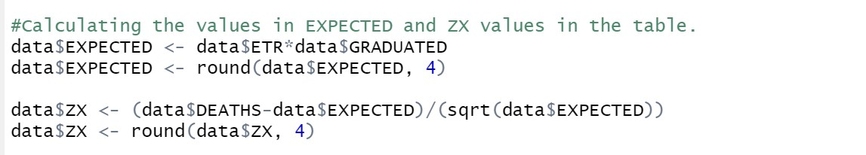
We find the values of expected and ZX using the above code and get the following results-
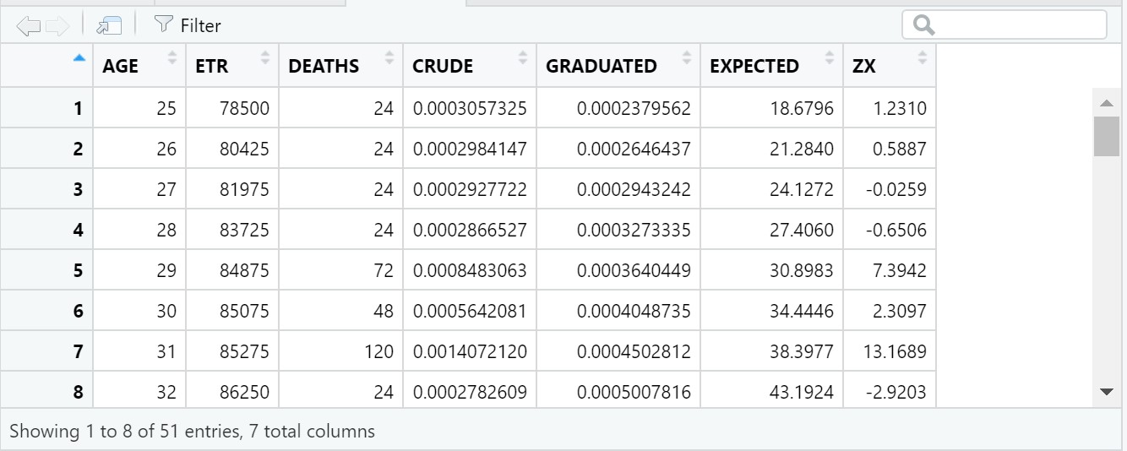
We then conduct chi-square test using the formulae and get the summary as:-
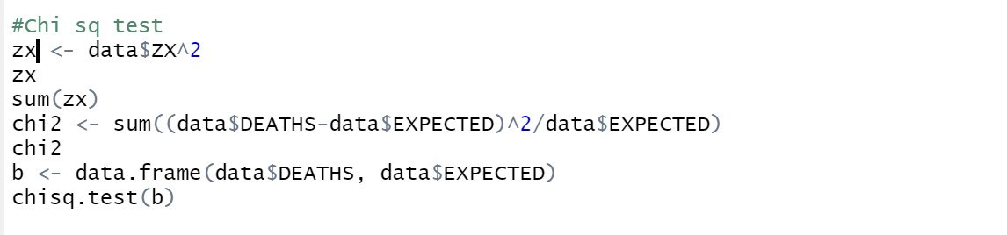
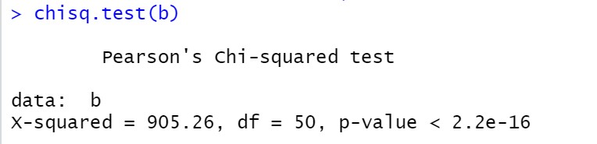
We can clearly see that the p-value is less than 0.05 so we accept the null hypothesis that there is a relationship between the variables.

Question 5
A)
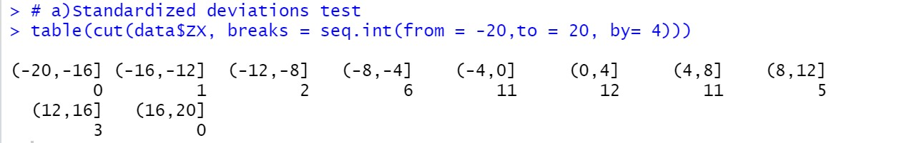
We find the overall shape of the standard deviation for each age by grouping it according to its value
- Thus, we can see that most of the values lie above 0 around 31 while 20 observations are less than 0 thus the data is slightly skewed
- The values of absolute deviations are comparatively higher than expected values
- There exists extreme outliers on both side in values (12,16) and (-20, -16).
- We can also see that data is positively skewed since there exists a higher number of observations in greater than 0 side.
- Thus we can conclude that the rates we found are not true representation of the mortality rates.

B)
Sign test
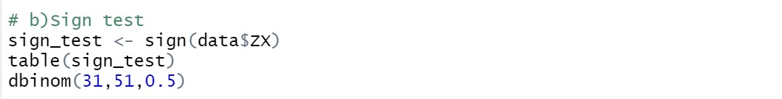
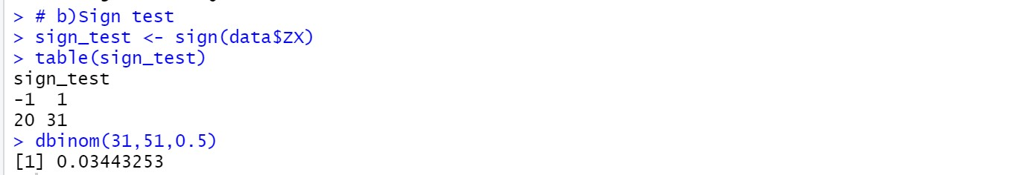
At 5% level of significance, we accept the null hypothesis that the data is a true representation of the given mortality rates.

C)
Cumulative deviation tests for entire age
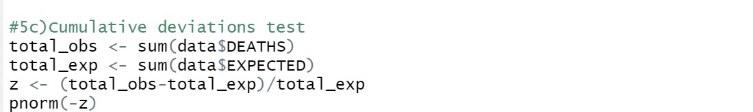
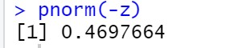
Thus at 5% level of significance, we accept the null hypothesis that the data is a true representation of the given mortality rates.

D)
At last we need to perform serial correlation tests
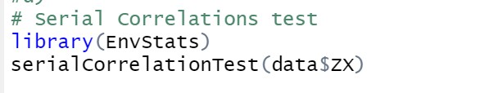
We get the following result:-
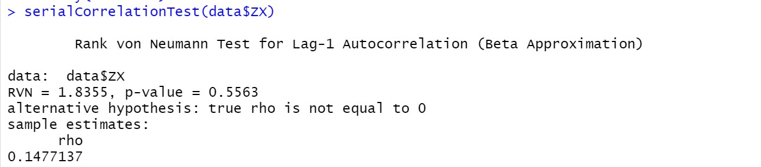
Thus at 5% level of significance, we accept the null hypothesis that the data is a true representation of the given mortality rates.

