##Importing the dataset
> df_marks = read.csv(file.choose())
> ##Performing exploratory data analysis:
> head(df_marks)
ï..Exam1 Exam2 Exam3 Exam4 Final_score Grade Pass.fail
1 60 10 16 7.0 40.79 C P
2 90 0 0 0.0 69.23 B P
3 130 20 24 1.0 76.75 B P
4 130 10 24 8.5 75.66 B P
5 90 5 22 9.5 55.48 C P
6 100 30 20 3.0 67.11 B P
> dim(df_marks)
[1] 104 7
> str(df_marks)
'data.frame': 104 obs. of 7 variables:
$ ï..Exam1 : int 60 90 130 130 90 100 105 120 120 130 ...
$ Exam2 : int 10 0 20 10 5 30 20 40 20 45 ...
$ Exam3 : int 16 0 24 24 22 20 22 18 30 22 ...
$ Exam4 : num 7 0 1 8.5 9.5 3 8 16 18 10.5 ...
$ Final_score: num 40.8 69.2 76.8 75.7 55.5 ...
$ Grade : chr "C " "B " "B " "B " ...
$ Pass.fail : chr "P" "P" "P" "P" ...
> ##Checking for missing values:
> sum(is.na(df_marks))
[1] 0
> sapply(df_marks, function(x) sum(is.na(df_marks)))
ï..Exam1 Exam2 Exam3 Exam4 Final_score Grade Pass.fail
0 0 0 0 0 0 0
> ##Checking for outliers:
> marks_outliers = sapply(df_marks[,-c(6,7)], function(x) (length(boxplot(x)$out)))
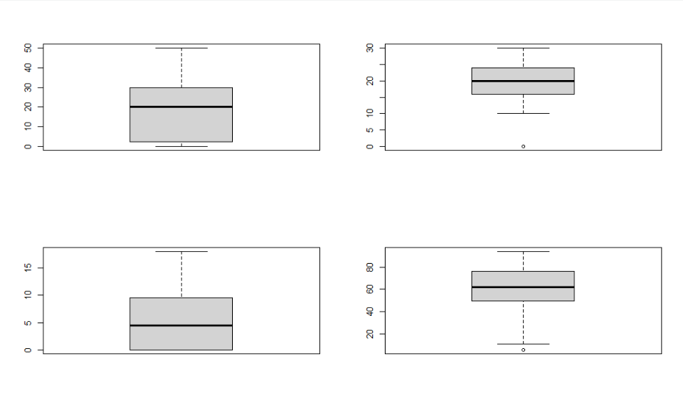
> marks_outliers
ï..Exam1 Exam2 Exam3 Exam4 Final_score
0 0 14 0 1
> ##Replacing Outliers:
> boxplot(df_marks$Exam3)$out
[1] 0 0 0 0 0 0 0 0 0 0 0 0 0 0
> df_marks$Exam3[(df_marks$Exam3 %in% (boxplot(df_marks$Exam3)$out))]=mean(df_marks$Exam3,na.rm=TRUE)
> boxplot(df_marks$Exam3)
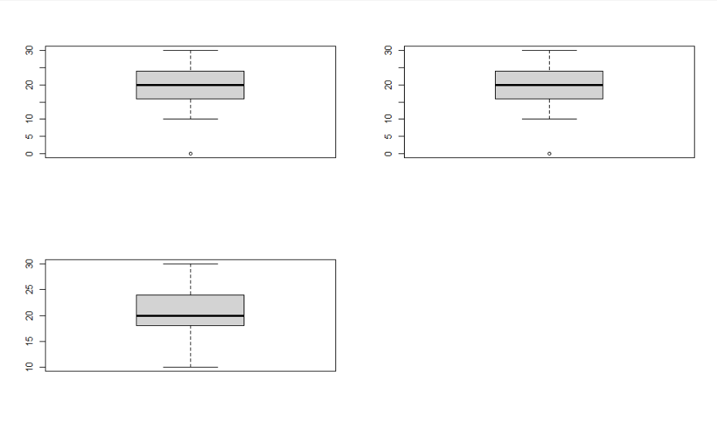
> ##Performing the Train-Test Split:
> set.seed(100)
> s = sample(nrow(df_marks),.80*nrow(df_marks))
> s
[1] 74 102 89 78 23 86 70 4 55 98 7 94 96 43 82 61 12 51 72 18 25 2 87 68 81 52 48 32 39 16
[31] 66 95 45 30 71 29 31 54 41 104 67 24 91 93 1 9 38 20 14 62 99 56 63 3 46 36 27 50 47 5
[61] 97 88 75 22 85 90 64 21 28 84 15 92 58 26 10 103 79 33 59 11 100 35 76
> df_training = df_marks[s,]
> df_training
ï..Exam1 Exam2 Exam3 Exam4 Final_score Grade Pass.fail
74 60 15 12.00000 5.0 40.35 C P
102 95 20 20.00000 9.5 63.38 B P
89 0 0 18.57692 2.0 11.11 D F
78 100 15 20.00000 0.0 64.29 B P
23 110 0 24.00000 9.5 80.62 A P
86 115 20 22.00000 0.0 74.76 B P
70 65 15 14.00000 10.5 45.83 C P
4 130 10 24.00000 8.5 75.66 B P
55 110 25 20.00000 3.0 69.30 B P
98 100 0 18.57692 4.0 58.43 C P
7 105 20 22.00000 8.0 67.98 B P
94 0 30 20.00000 12.5 63.78 B P
96 100 35 20.00000 0.0 73.81 B P
43 0 0 26.00000 0.0 86.67 A P
82 0 25 18.57692 0.0 50.00 C P
61 100 0 28.00000 0.0 60.95 B P
12 130 30 28.00000 10.5 87.06 A P
51 0 0 18.57692 15.5 86.11 A P
72 100 15 28.00000 9.5 66.89 B P
18 10 0 18.57692 8.0 12.16 D F
25 55 15 18.00000 0.0 41.90 C P
2 90 0 18.57692 0.0 69.23 B P
87 110 25 18.00000 0.0 72.86 B P
68 0 0 18.57692 10.0 55.56 C P
81 50 20 20.00000 1.0 39.91 D F
52 0 0 18.57692 8.0 44.44 C P
48 0 0 16.00000 2.0 37.50 D F
32 130 45 24.00000 8.0 90.79 A P
39 0 25 16.00000 0.0 51.25 C P
16 80 0 24.00000 3.0 60.11 B P
66 75 15 16.00000 0.0 50.48 C P
95 0 25 16.00000 0.0 51.25 C P
45 95 30 30.00000 12.0 73.25 B P
30 65 20 20.00000 0.0 50.00 C P
71 0 0 18.57692 2.0 11.11 D F
29 0 0 18.00000 0.0 60.00 B P
31 110 25 18.00000 6.0 69.74 B P
54 0 0 16.00000 0.0 53.33 C P
41 40 15 10.00000 2.5 29.61 D F
104 90 35 20.00000 5.5 66.01 B P
67 0 0 18.57692 5.0 27.78 D F
24 65 5 24.00000 1.0 41.67 C P
91 110 25 24.00000 4.0 71.49 B P
93 85 30 20.00000 2.5 60.31 B P
1 60 10 16.00000 7.0 40.79 C P
9 120 20 30.00000 18.0 82.46 A P
38 50 30 12.00000 4.0 42.11 C P
20 0 15 20.00000 7.0 42.86 C P
14 0 30 18.00000 0.0 60.00 B P
62 0 0 18.57692 2.0 11.11 D F
99 0 15 28.00000 0.0 18.86 D F
56 60 20 28.00000 10.5 51.97 C P
63 60 0 24.00000 4.0 38.60 D F
3 130 20 24.00000 1.0 76.75 B P
46 0 25 18.00000 0.0 53.75 C P
36 0 0 18.00000 10.0 58.33 C P
27 95 40 24.00000 8.0 73.25 B P
50 130 40 28.00000 16.5 94.08 A P
47 100 40 24.00000 0.0 78.10 B P
5 90 5 22.00000 9.5 55.48 C P
97 0 0 26.00000 0.0 86.67 A P
88 0 20 18.00000 0.0 47.50 C P
75 40 20 16.00000 10.5 37.94 D F
22 90 15 28.00000 8.5 62.06 B P
85 0 0 18.57692 1.0 5.56 D F
90 0 30 24.00000 0.0 67.50 B P
64 125 30 30.00000 11.5 86.18 A P
21 40 10 14.00000 6.0 30.70 D F
28 0 10 24.00000 0.0 42.50 C P
84 100 35 24.00000 10.5 74.34 B P
15 0 30 18.00000 0.0 60.00 B P
92 0 0 18.57692 6.5 36.11 D F
58 110 35 26.00000 10.0 79.39 B P
26 100 50 30.00000 11.5 83.99 A P
10 130 45 22.00000 10.5 91.01 A P
103 110 10 16.00000 7.5 62.94 B P
79 120 0 14.00000 2.0 59.65 C P
33 120 40 30.00000 9.0 87.28 A P
59 110 35 24.00000 8.0 77.63 B P
11 90 40 20.00000 7.0 68.86 B P
100 65 25 30.00000 14.5 58.99 C P
35 130 45 10.00000 16.5 88.38 A P
76 100 35 24.00000 0.0 75.71 B P
> df_testing = df_marks[-s,]
> df_testing
ï..Exam1 Exam2 Exam3 Exam4 Final_score Grade Pass.fail
6 100 30 20.00000 3.0 67.11 B P
8 120 40 18.00000 16.0 85.09 A P
13 100 30 22.00000 6.5 69.52 B P
17 105 40 22.00000 6.5 76.10 B P
19 130 35 24.00000 0.0 90.00 A P
34 70 20 24.00000 1.0 50.44 C P
37 0 25 24.00000 0.0 61.25 B P
40 95 20 20.00000 6.0 61.84 B P
42 70 0 18.00000 0.0 55.00 C P
44 100 25 14.00000 9.5 65.13 B P
49 0 0 18.57692 2.0 11.11 D F
53 105 40 28.00000 9.5 80.04 A P
57 120 40 30.00000 9.5 87.50 A P
60 125 25 24.00000 0.0 82.86 A P
65 0 0 24.00000 0.0 80.00 A P
69 0 30 16.00000 8.0 55.10 C P
73 90 35 12.00000 1.0 60.53 B P
77 0 15 24.00000 0.0 48.75 C P
80 110 35 26.00000 8.0 78.51 B P
83 120 20 28.00000 10.0 78.07 B P
101 105 30 16.00000 11.5 71.27 B P
> nrow(df_training)
[1] 83
> nrow(df_testing)
[1] 21
> ##1)For the prediction of Final Score:
> ##a)Linear Regression:
> model1 = lm(Final_score~., data = df_training)
> summary(model1)

Call:
lm(formula = Final_score ~ ., data = df_training)

Residuals:
Min 1Q Median 3Q Max
-17.5906 -4.9019 -0.2097 5.1356 14.4779

Coefficients: (1 not defined because of singularities)
Estimate Std. Error t value Pr(>|t|)
(Intercept) 76.30574 5.40857 14.108 < 2e-16 ***
ï..Exam1 0.05347 0.02119 2.523 0.0137 *
Exam2 0.09760 0.06432 1.518 0.1333
Exam3 0.08499 0.18545 0.458 0.6481
Exam4 0.09050 0.18483 0.490 0.6258
GradeB -16.75044 2.58027 -6.492 8.19e-09 ***
GradeC -32.13034 3.00177 -10.704 < 2e-16 ***
GradeD -54.82444 3.47681 -15.769 < 2e-16 ***
Pass.failP NA NA NA NA
---
Signif. codes: 0 ‘***’ 0.001 ‘**’ 0.01 ‘*’ 0.05 ‘.’ 0.1 ‘ ’ 1

Residual standard error: 7.02 on 75 degrees of freedom
Multiple R-squared: 0.8976, Adjusted R-squared: 0.888
F-statistic: 93.9 on 7 and 75 DF, p-value: < 2.2e-16

> model2 = lm(Final_score~ï..Exam1+Exam2+Exam3+Exam4, data = df_training)
> summary(model2)

Call:
lm(formula = Final_score ~ ï..Exam1 + Exam2 + Exam3 + Exam4,
data = df_training)

Residuals:
Min 1Q Median 3Q Max
-33.024 -7.163 0.018 6.178 43.898

Coefficients:
Estimate Std. Error t value Pr(>|t|)
(Intercept) 18.7466 7.1363 2.627 0.01037 *
ï..Exam1 0.1682 0.0398 4.225 6.42e-05 ***
Exam2 0.4064 0.1269 3.204 0.00197 **
Exam3 0.9657 0.3597 2.685 0.00886 **
Exam4 0.3564 0.3533 1.009 0.31618
---
Signif. codes: 0 ‘***’ 0.001 ‘**’ 0.01 ‘*’ 0.05 ‘.’ 0.1 ‘ ’ 1

Residual standard error: 14.6 on 78 degrees of freedom
Multiple R-squared: 0.5395, Adjusted R-squared: 0.5159
F-statistic: 22.84 on 4 and 78 DF, p-value: 1.622e-12

> ##We see that the R-squared is now just 53% which is poor
> ##The p-values of Exam1, 2 and 3 are less than 0.05 making them significant parameters
> ##The F-statistic however is just 22.84
> AIC(model2)
[1] 687.4067
> model3 = lm(Final_score~ï..Exam1+Exam2+Exam3, data = df_training)
> summary(model3)

Call:
lm(formula = Final_score ~ ï..Exam1 + Exam2 + Exam3, data = df_training)

Residuals:
Min 1Q Median 3Q Max
-34.748 -6.917 0.148 5.767 48.455

Coefficients:
Estimate Std. Error t value Pr(>|t|)
(Intercept) 18.56182 7.13473 2.602 0.01107 *
ï..Exam1 0.17707 0.03881 4.563 1.83e-05 ***
Exam2 0.41787 0.12637 3.307 0.00142 **
Exam3 1.02781 0.35446 2.900 0.00484 **
---
Signif. codes: 0 ‘***’ 0.001 ‘**’ 0.01 ‘*’ 0.05 ‘.’ 0.1 ‘ ’ 1

Residual standard error: 14.6 on 79 degrees of freedom
Multiple R-squared: 0.5335, Adjusted R-squared: 0.5158
F-statistic: 30.11 on 3 and 79 DF, p-value: 4.404e-13

> ##We see that the R-squared is now just 53% which is poor
> ##The p-values of Exam1, 2 and 3 are all less than 0.05 making them significant parameters
> ##The F-statistic however has increased to 30.11 making it a better model than model2 due to greater variance
> AIC(model3)
[1] 686.4826
> ##Checking for the assumption of linearity:
> plot(df_marks)
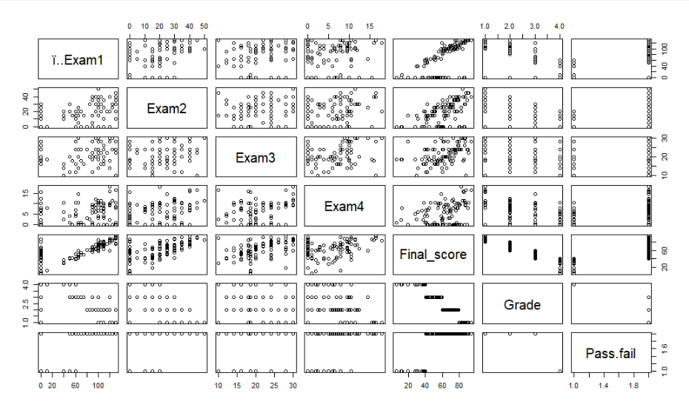
> ##We see that the Final Score has a linear relationship with Exam1, Exam2, Exam 3 and very slightly with Exam 4 which is in line with our linear model
> ##Checking for the assumption of multicollinearity:
> library(faraway)
> vif(model3)
ï..Exam1 Exam2 Exam3
1.406674 1.299321 1.156734
> ##Checking for the assumption of multivariate normality:
> shapiro.test(model3$residuals)

Shapiro-Wilk normality test

data: model3$residuals
W = 0.93866, p-value = 0.0006349

> plot(density(model3$residuals))
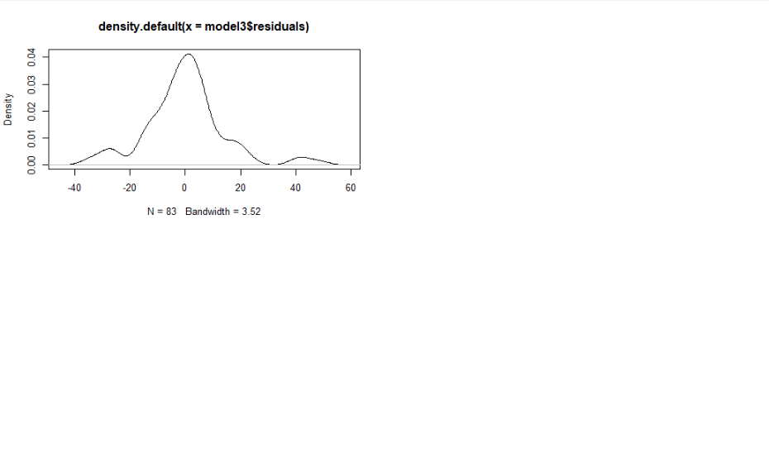
> ##Checking for the assumption of homoscedasticity:
> library(lmtest)
> bptest(model3)

studentized Breusch-Pagan test

data: model3
BP = 25.296, df = 3, p-value = 1.339e-05

> ##Printing Diagnostic Plots:
> dev.off()
null device
1
> par(mfrow=c(2,2))
> plot(model3)
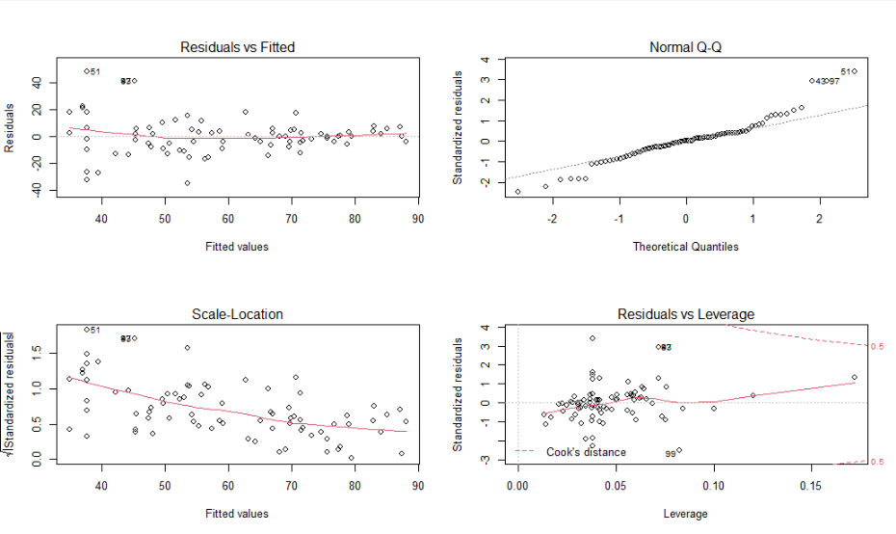
> ##Performing predictions on the basis of the Model3 and the testing dataset:
> p = predict(model3, df_testing)
> p
6 8 13 17 19 34 37 40 42 44 49 53 57 60
69.36122 75.02575 71.41684 76.48091 80.87395 63.98159 53.67595 64.29715 49.45733 61.10503 37.65530 82.64774 87.35943 75.80988
65 69 73 77 80 83 101
43.22917 47.54286 61.45742 49.49724 79.38813 76.94639 66.13536
> (cor(df_testing$Final_score, p))^2
[1] 0.5904017
> ##b)Creating a decision (regression) tree:
> library(rattle)
> library(rpart)
> library(rpart.plot)
> dtree = rpart(Final_score~ï..Exam1+Exam2+Exam3, data = df_training, method = "anova")
> ##Since the dataset is large enough, we do not need to tune the hyperparameters of the decision tree
> fancyRpartPlot(dtree)
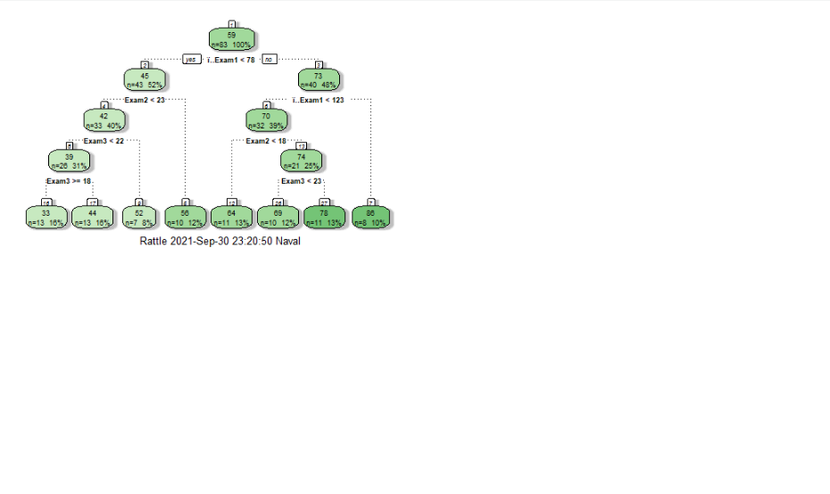
> ##Performing predictions based on dtree:
> p = predict(dtree, df_testing)
> p
6 8 13 17 19 34 37 40 42 44 49 53 57 60
68.70100 68.70100 68.70100 68.70100 86.23875 52.42000 55.86300 68.70100 44.17385 68.70100 33.37077 77.89909 77.89909 86.23875
65 69 73 77 80 83 101
52.42000 55.86300 68.70100 52.42000 77.89909 77.89909 68.70100
> ##Finding the R-Squared for accuracy:
> r_squared = cor(df_testing$Final_score, p)**2
> r_squared
[1] 0.6982822
> df_predict = data.frame("actual values" = df_testing$Final_score, "predicted values" = p)
> df_predict
actual.values predicted.values
6 67.11 68.70100
8 85.09 68.70100
13 69.52 68.70100
17 76.10 68.70100
19 90.00 86.23875
34 50.44 52.42000
37 61.25 55.86300
40 61.84 68.70100
42 55.00 44.17385
44 65.13 68.70100
49 11.11 33.37077
53 80.04 77.89909
57 87.50 77.89909
60 82.86 86.23875
65 80.00 52.42000
69 55.10 55.86300
73 60.53 68.70100
77 48.75 52.42000
80 78.51 77.89909
83 78.07 77.89909
101 71.27 68.70100
> ##Finding the min-max accuracy:
> min_max_accuracy = mean(apply(df_predict,1,min)/apply(df_predict,1,max))
> min_max_accuracy
[1] 0.891568
> ##We get an accuracy of 89% which is a good value
> ##2)For the prediction of Grade:
> ##a)Creating a decision (classification) tree:
> dtree1 = rpart(Grade~., data = df_training, method = "class")
> fancyRpartPlot(dtree1)
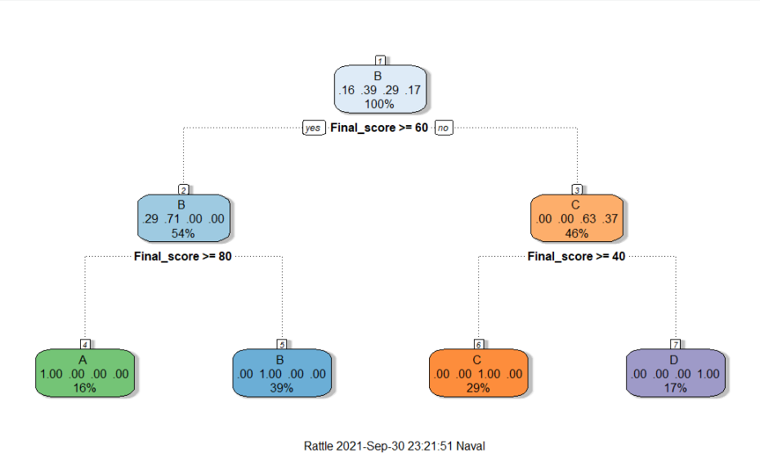
> ##Getting the complexity parameter:
> printcp(dtree1)

Classification tree:
rpart(formula = Grade ~ ., data = df_training, method = "class")

Variables actually used in tree construction:
[1] Final_score

Root node error: 51/83 = 0.61446

n= 83

CP nsplit rel error xerror xstd
1 0.47059 0 1.00000 1.000000 0.086946
2 0.27451 1 0.52941 0.549020 0.084460
3 0.25490 2 0.25490 0.450980 0.079952
4 0.01000 3 0.00000 0.078431 0.038259
> plotcp(dtree1)
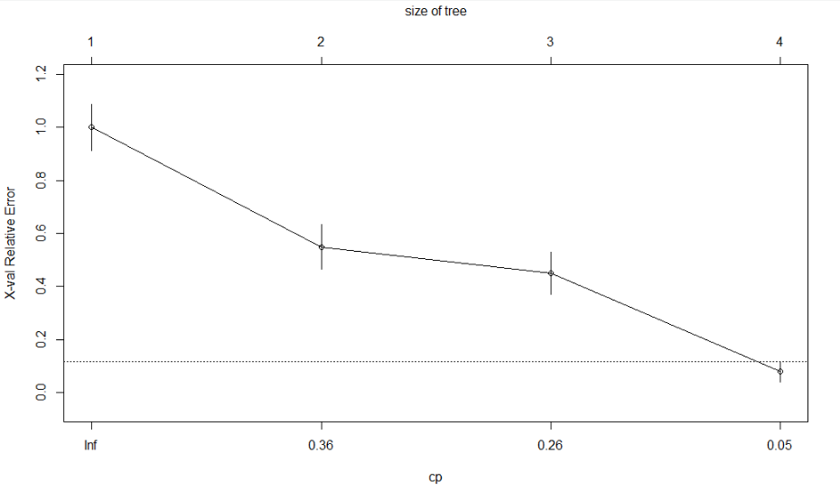
> ##Performing predictions based on dtree1:
> p1 = predict(dtree1, df_testing, type = "class")
> p1
6 8 13 17 19 34 37 40 42 44 49 53 57 60 65 69 73 77 80 83 101
B A B B A C B B C B D A A A B C B C B B B
Levels: A B C D
> ##Confusion Matrix:
> t = table(df_testing$Grade,p1)
> t
p1
A B C D
A 5 1 0 0
B 0 10 0 0
C 0 0 4 0
D 0 0 0 1
> accuracy = sum(diag(t))/sum(t)
> accuracy
[1] 0.952381

