BEM ASSIGNMENT-1

1. C
2. C
3. C
4. C
5. C
6. C
7. C
8. C
9. D
10. D
11. C
12. C
13. C
14. C
15. D
16. C
17. D
18. B
19. B
20. B
21. B
22. C
23. D
24. C
25. D
26. B
27. B
28. D
29. NDY = 60300
GDY = 62000
NNY = 60000
30.
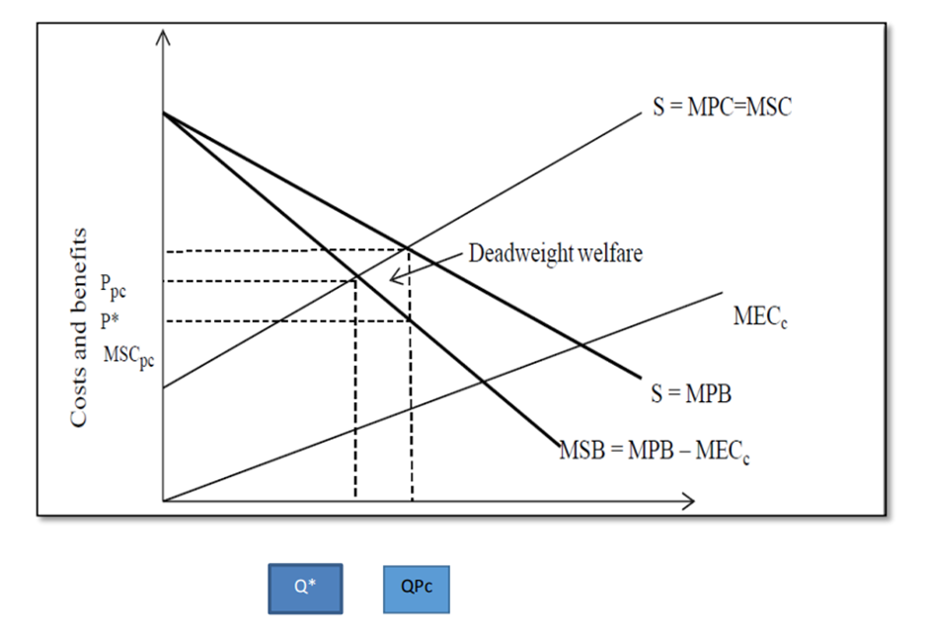1. MSC- Marginal Social Cost
2. MPC- Marginal Private Cost
3. MPB- Marginal Private Benefit
4. MSB- Marginal Social Benefit
5. MECc- Marginal External Cost of Consumption
6. Q*- Socially Optimum Level Of Output At Price P*
7. QPc- Market Level Of Output At Price Ppc.
8. Deadweight Loss of Social Welfare Happens When MSC> MPC
9. Social Welfare Loss Occurs As QPc > Q*
Plastic has a societal cost since it pollutes the environment. People use plastic because it is convenient for them. As a result, the Marginal Social Cost (MSC) is distinct from the Marginal Personal Cost (MPC) (MPC). 2. The use of plastic bags pollutes the ecosystem, and animals may die as a result of their eating. As a result, there may be a minor external cost associated with keeping water bodies clean and protecting animals from plastic eating. 3. As a result, MSB is less than MPB. MPB - MECc = MSB The MSB curve is shown below the MPB curve in the diagram. The market will be in an equilibrium situation with Price Ppc at QPc. MSB = MSC in a socially optimal equilibrium at output Q* of price P*. 4. The level of output is determined by the external cost of consumption. The external cost of consumption leads to output levels that are higher than the socially optimal level, QPc > Q*. Plastic bags are being created and consumed in excess, according to society. Overconsumption causes a dead weight welfare loss, which is depicted by a triangle in diagram A.
31. A
32.Negative Externality Definition - Negative externalities occur when production and/or consumption impose external costs on third parties outside of the market for which no appropriate compensation is paid. This causes social costs to exceed private costs. An example of a negative externality: i. People may smoke in public places and ignore harmful impact of toxic passive smoking on non-smokers. ii. The passive smoking may harm health of non-smoker and may cause various respiratory diseases. iii. In young ladies passive smoking may cause pre-mature child birth and asthma. iv. Passive smoking increases the risk of respiratory illnesses in children, including asthma, bronchitis and pneumonia. v. Healthcare expenditure involved in treatment of smoking related illnesses
ii) Price Related Intervention: a) The Government imposes a tax on the producer that reflects the marginal cost of the externality. b) Fines are imposed if smoking is done in public places Non- Price Related Intervention: a) Smoking is banned in public places like gardens, restaurants, libraries, work places, etc. b) A law prohibiting any manufacturer, retailer, or distributor of tobacco from selling or distributing products to persons under age eighteen. c) Use of media / advertisements, public education to emphasize ill effects of smoking and motivate smokers to leave smoking d) Specially designed medical care and or programs for smokers to quit smoking. iii) Diagram- marginal social benefit curve and marginal private benefit curve when a negative externality in consumption exists
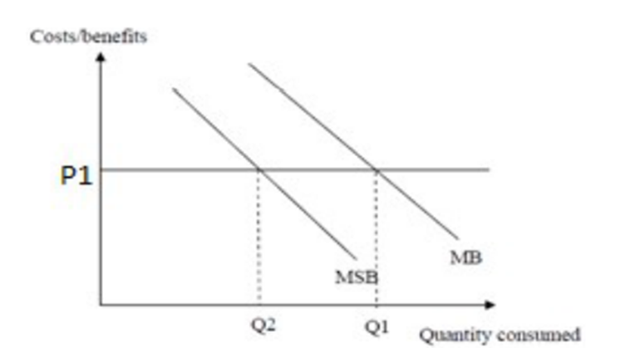
Q1- Consumption By Private Sector
Q2- Socially Optimal Level Of Consumption
MSB- Marginal Social Benefit
MB- Marginal Private Benefit
P1- Market Price
33.Actual economic growth can also be known as demand side economic growth because it is affected by changes in the demand in an economy. It is an increase in output as measured by real GDP/ national income. It can be achieved by shifting AD (Aggregate demand) to the right by increasing AD, by influencing any of the factors of aggregate demand. (As shown below) •Consumption •Government Spending •Net Exports * Investment (However this is also a component of LRAS) On the other hand potential deals with the supply side of the economy. It is an increase in the productive capacity (potential). An increase in the short term/long term aggregate supply will cause potential economic growth. The short term deals with costs of production and the long term is affected by changes in the quality and quantity of the factors of production.
34.Income measure : This is the sum of all factor earnings. These are payments made to land, labour, and capital as a result of factor payments. Payments for transfers are not included (to avoid double counting).

Output measure: This is a metric for determining the value of products and services produced. We only count the "value added" component of a firm's output to avoid double counting.

Expenditure method: This comprises all expenditure in the economy (including exports minus imports) as well as what would have to be spent to purchase inventory increases (or stocks). Only expenditure on final items is included to minimise double counting.

The three concepts are all the same. In practise, however, measurement and data gathering challenges (such as the black economy) mean that the three measures will not be equal.

