Professional Ethics Project

Unethical practices of Indian companies affecting the environment and sustainability.

IOC DEPOT FIRE-JAIPUR, 2009

C A S E R E P O R T
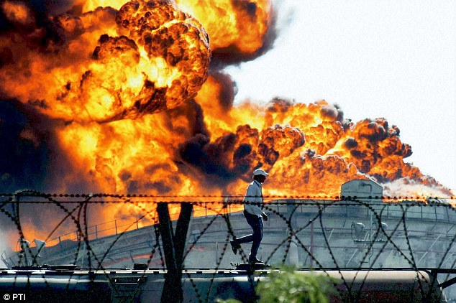

Name-KAREENA TATED
Roll No.-709
Email-ktated18@gmail.com
C O N T E N T S

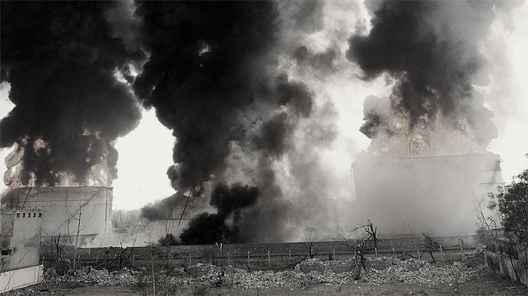

Page Number | Topic
03 | Introduction-Industrial Disasters
04 | Facts of the case
07 | Verdict of the case
08 | Measures/Reforms undertaken by the Government
09 | Analysis
10 | Recommendations
12 | Conclusion and Sources

Introduction-Industrial Disasters
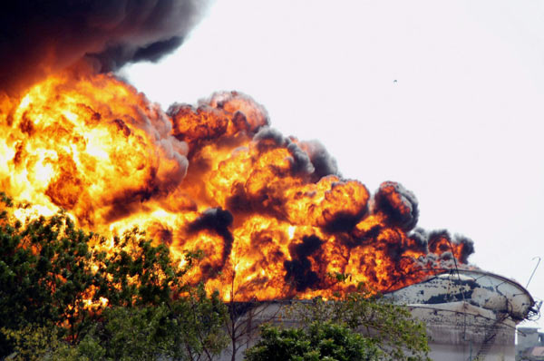
The negligence of large corporation has a drastic impact on the environment. It is ultimately the future generations who will bear the brunt of innumerable accidents caused by such corporations. One striking example of the same is the case of Indian Oil Corporation Depot in Jaipur.
In the recent decades there has been a budding awareness of the ever-increasing risks and consequences of industrial disasters. This fact is mirrored in official stats, mass media reports, and the emergence of new public institutions that address the problem. In an era that is witnessing deep and far-reaching societal and environmental change, the knowledge and impact of these disasters will be invaluable to humanity.
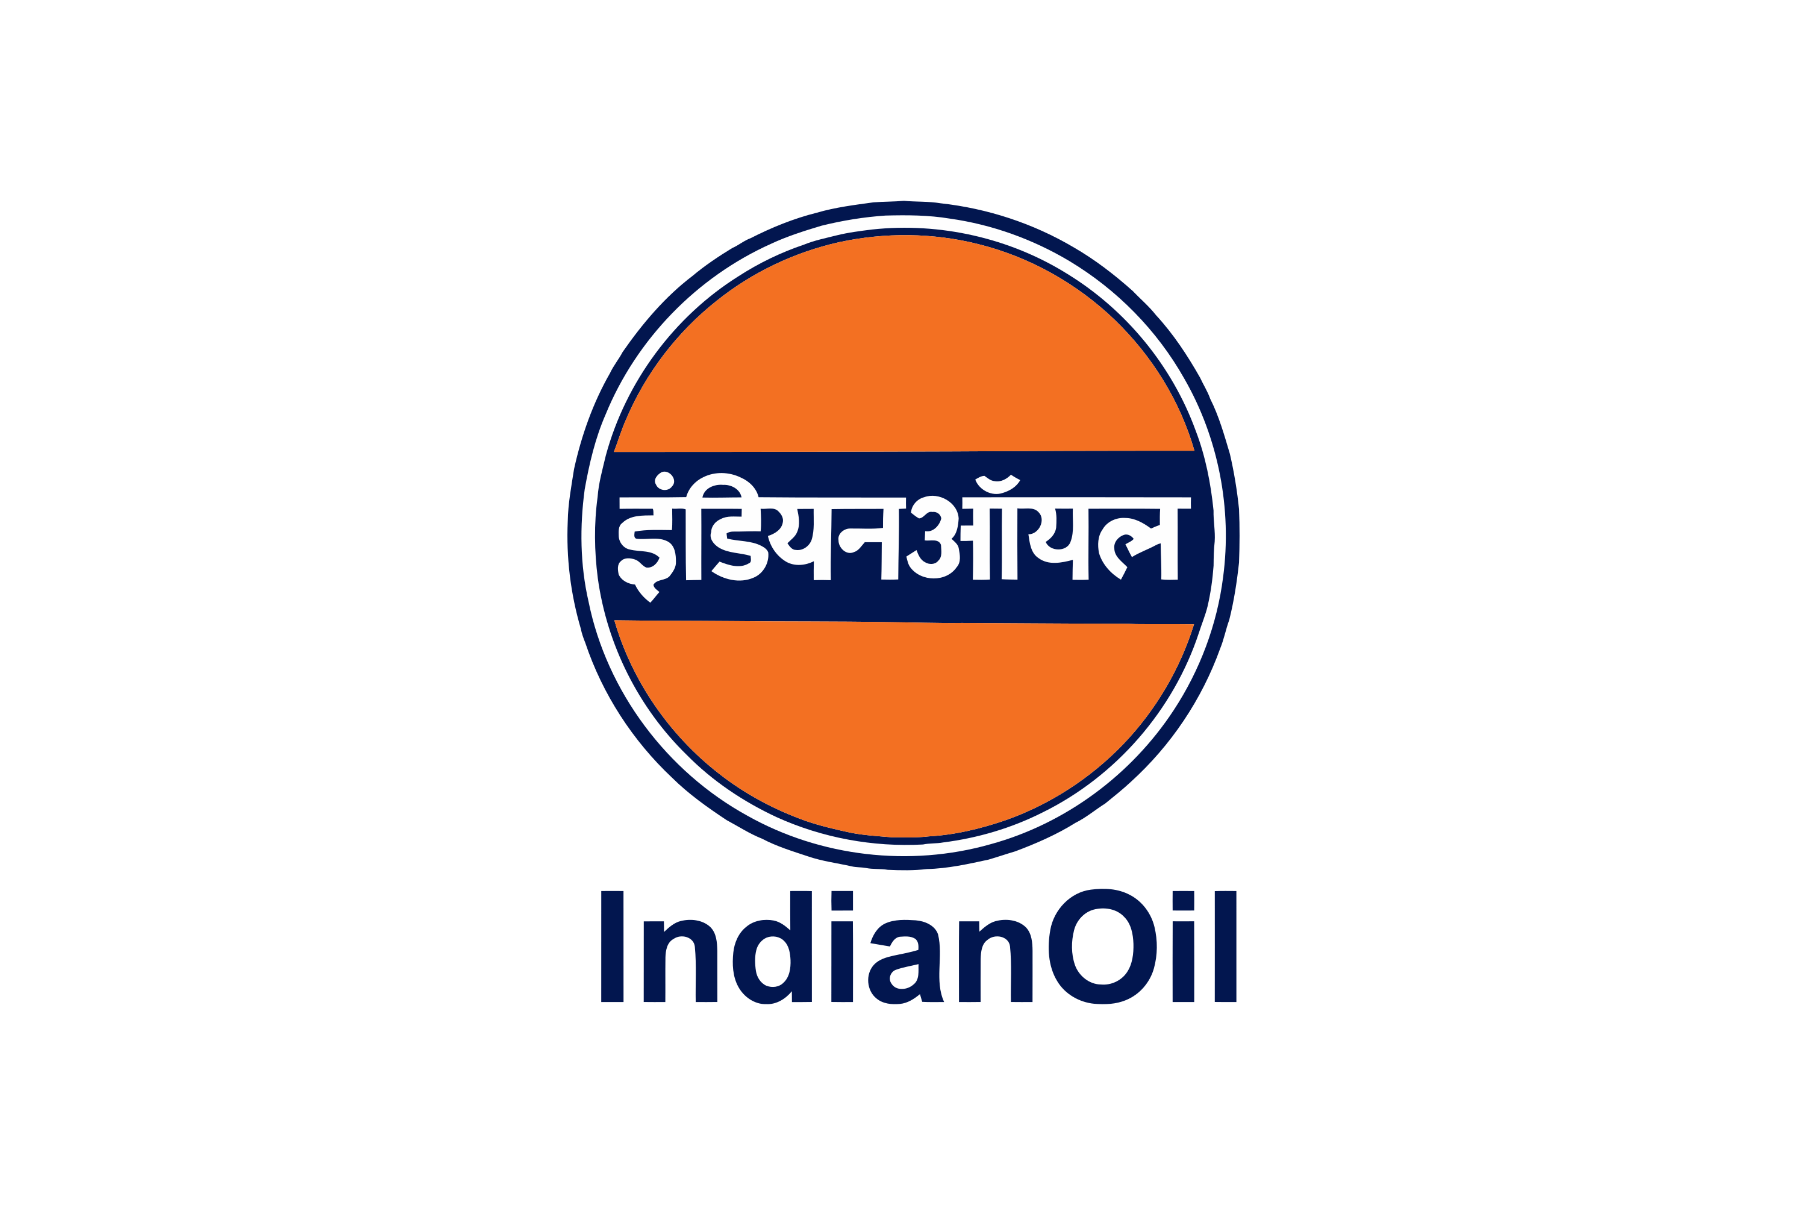
While we talk about an era of change it is worth mentioning that large corporations and industries are catalysts of such change. Their actions have a lasting impact on the overall ecosystem and it is therefore extremely essential for them to keep an eye on their actions. It is crucial to make sure that there is no negligence on their part such that it will lead to hazards and accidental disasters. It is important for them to act ethically and ensure the well-being of the very environment in which they thrive. It is their duty, as industries, to make sure that their practices are sustainable and this includes but is not limited to avoiding industrial disasters.
Industrial disasters as we see them, are not merely safety problems to be resolved. They have a wider significance because they offer vital opportunities to learn about the co-existence of society, technology, and environment. The very foundation of this existence, the environment, suffers shocks that are strengthened or weakened by unexpected events such as disasters.
Industrial hazards can be referred to as threats to people and life-support systems that arise from the mass production of goods and services. When these threats exceed human coping capacities or the absorptive capacities of environmental systems they give rise to industrial disasters. Industrial hazards can occur at any stage in the production process, including extraction, processing, manufacture, transportation, storage, use, and disposal.

Facts of the Case
Fire and explosion hazards in industrial storage units have gained a considerable attention in the past few years. Indian Oil Corporation (IOC) storage terminal accident in Jaipur, India, on 29th October 2009, is a recent example.
On the fateful evening of 29th October 2009, a massive fire broke out at the Indian Oil Corporation Oil depot’s giant tank which held 8000 kiloliters of oil in Sitapura districts on the outskirts of Jaipur, Rajasthan. This incident killed 12 people including IOC’s employees and left over 200 people injured. The fire was a major disaster with respect to the lives lost, persons injured, loss of business and more importantly the environmental impact it had on Jaipur.
In order to understand the facts of the case we must define Vapor Cloud Explosions. A vapor cloud explosion occurs when a sufficient amount of flammable or combustible material is released, mixes with air, and is ignited. Not all accidental releases of flammable gases and vapors create explosions, however the ones that find an ignition source can cause severe harm to the surroundings.
The incident
The IOC Jaipur incident was one of the major petroleum storage terminal accidents in India. The terminal was preparing to carry out a routine transfer operations of Motor Spirit (MS) to the neighboring terminal that was operated by Bharat Petroleum Corporation Limited (BPCL). 4 IOC employees were supposed to be on the shift and the operating crew started to prepare the MS tank (tank 401-A) for pumping oil to the BPCL terminal.
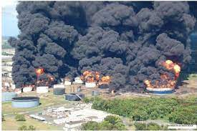
At about 6.10 pm, , a massive leak occurred from a ‘Hammer Blind Valve’ at the bottom of the tank while preparing for the transfer operations. As a result of the leak, a spurt of MS directed upwards from the valve under the hydrostatic pressure head of Motor Spirit in the tank. The operator lost consciousness because as the liquid MS rapidly spawned harmful vapors.
The accident caused 2,000 metric ton of gasoline to be released in the atmosphere, which caused the formation of 81 metric ton of vapor cloud covering an area of 180,000 m². As a result, the ignition of a combustible mixture caused massive explosions and violent fires. A series of powerful explosions could be heard even up to 32 kilometers away from the terminal.
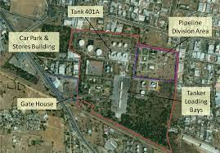
According to Seismological measurements, one of the VCE was equivalent to an earthquake with the intensity of around 2.3 on the Richter scale. Such massive explosions destroyed the entire facility and the buildings in the immediate vicinity suffered severe damage. The associated pressure wave caused the windows to break, which were found at a distance of about 2-3 km from the terminal. Soon after one of the major explosions, a fire broke out that engulfed 11 large storage tanks. The fire raged on for 11 days and it resulted in the destruction of most of the site.
The vegetation around the storage facility was completely consumed by the fire. The surroundings were evacuated and power was cut off. Approximately 5,00,000 people were shifted to safe locations. The factories and institutions operating in Sitapura were asked to shit their operations else-where. Army personnel assisted in the rescue operations as it was feared that people were trapped in the depot.

Casualties
Eleven people lost their lives in the accident (six from IOCL and five outsiders) and more than 150 peoples were injured. In addition to this, about 5,000 people in the nearby surrounding area had to be evacuated from their homes. Apart from the loss of life, property and money, this incident had a major impact on the environment, human health and even the agricultural environment. This makes it one of the most fatal accidents that have occurred during the last decade in the petroleum industry

Impact-Environmental and Others
Such fires cause loss of biodiversity and site degradation at landscape level leading to desertification. The depletion of terrestrial carbon by fires burning under extreme conditions in some vegetation types, including organic terrain in peat land biomes, is a major contributor to global climate change.
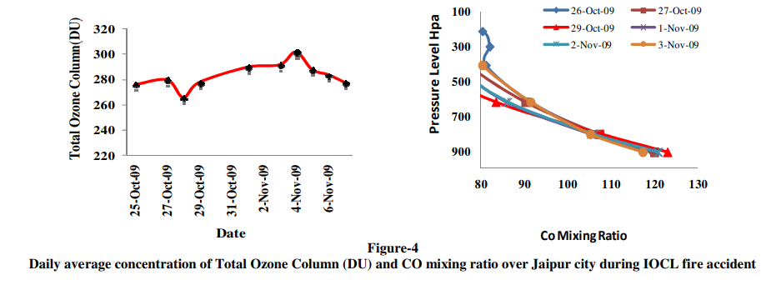
The immediate impact of the accident was reduced visibility in the surrounding areas. Hundreds of peoples visited health care centers and hospital complaining of sore throat, difficulty breathing, irritation in the eye, etc. Due to the fire, there was a massive release of carbon monoxide and carbon dioxide in the environment which would lead to long term effects on the already deteriorating climate. It was also noted that the concentration of Ozone suddenly increased and maximum concentration of 300 DU was observed. Ozone plays a major role in the configuration of smog and also contributes to different types of acidification and climate change. In figure 1, we can see the increasing value of Ozone. The presence of Ozone at troposphere can creates many types of human health related problems like penetration of the respiratory tract, irritation of the eyes etc.
Figure 1. Daily Average Concentration of Ozone Column
Figure 2. SPM and RSPM Concentration
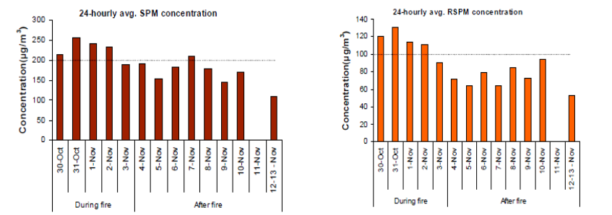
The PM and RSPM levels also increased as noted in figure 2. The maximum concentration of Suspended Particulate Matter was noticed which was approximately 250 microgram/m3 which is higher than standard limit of 200 µg/m3 of the residential area. Respiratory Suspended Particulate Matter (RSPM),which is mainly responsible for the respiratory disease was noticed at higher concentration.
The State Pollution Control Board deployed devices to measure pollution at 6 places in Sitapura reported a reduction in oxygen level apart from an increase in carbon compounds. It was also said that due to this incident, children would suffer the brunt of the pollution. An increase in the number of allergic and respiratory diseases was witnessed as expected.
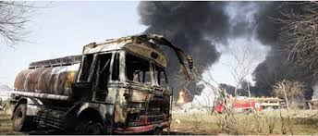
Massive stretches of agricultural fields that were located 10 to 15 km away from the IOC depot site have reported the presence of black flakes which are a threat to soil fertility. It is assessed that these thin black sheets of soot and pollutants will mix with soil and leave a permanent acidic effect which would directly impact the consumers. Apart from this, farmers noticed acidic content in the early morning dew.
The fast-spreading pollutants affected people even in villages far away from fire site such as Dahlas, Khoosar, Chatrawala, Vidhani, Ramchandrapura and Tiba.
As noted above this sort of an anthropogenic accident is a major threat for the environment and full proof precautions should be taken to avoid such type of incidents.

Verdict of the Case
It is worth noting that the Disaster Management Act, 2005 envisions that every district should have in place a Disaster Management Plan. 31 revenue districts of Rajasthan had the Disaster Management Plan in place on Rajasthan Government website however, the Jaipur District did not have one. A Disaster Management Plan for Jaipur District was only put on the website 20 days after the accident took place, that is on 17 November 2009. This clearly indicates negligence on the part of concerned authorities.
The Rajasthan State Control Board issued a legal notice to Indian Oil corporation for violating the Water (Prevention and Control of Pollution) Act 1974, the Air (Prevention and Control of Pollution) Act, 1981, and the Environment (Protection) Act, 1986 this is because the accident caused the pollution levels to increase way above acceptable level and it even impacted the air quality of Delhi and Agra. Various committees were formed to investigate the case.
As a result of the investigation, several FIRs were charged against various officials of the Indian Oil Corporation. Following the orders passed on 4 December 2009 by the Chief Judicial Magistrate, Jaipur Mr. Mahaveer Swami, the Police Station Adarsh Nagar, Jaipur has registered FIR 337/09 under various sections against 20 accused which included the Chairman, Directors of various departments and various other officials of the Indian Oil Corporations. Moreover, two more FIRs were registered against Indian Oil officials.
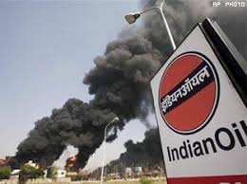
Eight months after roaming free, 9 senior company officials including the General manager of IOC were arrested on charges of criminal negligence. Those arrested included-IOC General Manager for Rajasthan Gautam Bose and 8 other officers. They were arrested under various sections of the Indian Penal Code (IPC) including section 304-II (culpable homicide not amounting to murder. Note that Section 304-II of IPC carries a maximum prison term of 10 years.
The others arrested include- Shashank Shekhar, Manager of Operation, K S Kanojia, senior terminal manager, Arun Poddar, Manager Terminal, Kapil Goyal, Deputy Manager Terminal, Ashok Gupta, officer of operations, Kailash Nath Agarwal, Chargeman, and S.S Gupta, DGM Pipeline. These officials were accused of not following "normal safety procedure."
It is unfortunate to note that 8 out of these 9 officials were granted bail in less than a week of being arrested. Ashok Kumar Gupta, officer of operations was the shift in-charge when fire broke out, was the only one who was declined bail. While the senior officials didn’t even stay in prison for a week, the widows of the late employees of IOC suffered because of false government promises.
Two widows Ms. Savita Saroha and Ms. Alka Kumar whose husbands Mr. S. K. Saroha and Mr. Ravindra Kumar passed away in the Fire on 29 October 2009 have moved to Rajasthan High Court in order to demand just and fair compensation. The duo alleged that they were not given the compensation of Rs. 1,000,000 (One million rupees) that was promised to them by Mr. Murli Deora, the Minister for Petroleum and Natural Gas, Government of India.

Measures/Reforms undertaken by the Government
After the incident, A division bench of Rajasthan HC asked the state government to explain within one week what steps it took after the fire blazed in the IOC depot, what relief was provided and what actions were taken to prevent air pollution.
The Minister of Petroleum and Natural Gas laid a statement regarding the IOC fire incident in which he mentioned the compensation that was provided to the injured and the families of the deceased. In this statement, the findings of the cases were reported and immediate actions were explained. Moreover, he also reported that IOC announced an ex-gratia payment of Rs. 1 lakh to those who died and Rs. 2 lakhs to those who were very injured, and Rs. 1 lakh to those who suffered minor injuries in addition to the compensation offered by the State Government.
In order to avoid the recurrence of such incidents, a 7-member committee was formed under the chairmanship of Shri M.B. Lal, Ex- C&MD of HPCL. Their responsibility was to seek inquiry into the causes of the incident and to suggest remedial measures to prevent it from happening again.
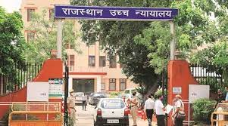
Apart from this, the government of Rajasthan requested Indian Oil Corporation to provide an ad hoc relief package that amounted to Rs. 50 crores to nearby industries. This was released to Rajasthan State Industrial Investment Corporation (RIICO) as a provisional relief for the small and medium industries unfavorably affected by the fire incident.
It is worth mentioning that during the course of the fire, the CM of Rajasthan personally monitored the situation and regular reviews were done by a Crisis Management group formed by the State Government. This Crisis Management group included Principal Secretary, Home, Govt, of Rajasthan; Chief Fire Officer, Jaipur, State Fire Brigade, Collector of Jaipur, State Police and Executive Director of Oil Industry Safety Directorate. The army, fire safety teams even from Essar, ONGC, GAIL and other national oil companies were available to take care of any contingency.
In order to assess the safety and security at the oil and gas installations in the country, the Ministry assembled a meeting on 3rd November 2009. This meeting was attended by CEOs of public as well as private oil companies operating throughout the country. Each company shared its individual experience in dealing with such incidents. They decided to exchange information on such cases with each other. Moreover, they agreed to share resources and infrastructure in future of such unfortunate events.
No mention of curbing the environmental damage or controlling pollution was made in this statement. Apart from the compensation announcements and assessment assemblies no major reform was introduced specifically because of the Jaipur IOC fire.
A Disaster Management plan released by the Disaster Management Authority lead by the CM of the state was laid out on 17/11/2009 that included guidelines for the public to protect themselves against such hazards. The plan lays out in great detail the steps that must be taken in case an accident occurred in any industry that could be a potential harm to human life. The plan includes aspects of mitigation, preparedness and response. It also educated the masses about the impact of injuries and environmental exposure after any event. Potential diagnosis posts any incident- of malnutrition and mental health consequences are also covered.
However, it is unfortunate that neither the masses nor the employees and officials of IOC were in a position to mitigate, respond or prepare for such an event because such a disaster management plan was only put in place after the accident actually occurred
Analysis
The October fire at IOC’s Jaipur terminal was undoubtedly caused by non-observance of normal safety procedures, as reported by a committee set up by the government.
The fire that raged on for 11 days, took 12 lives and resulted in losses up to Rs 280 Crore. was caused by an absence of written operating procedures that were specific to the Sitapura site, absence of leak-stopping devices from a remote location and inadequate understanding of hazards risks and consequences.
The state and local civil personnel were alerted by the IOC officials but due to the non-availability of appropriate self-contained breathing apparatus and fire suits, the authorities were rendered helpless.
At the time of the fire, IOC personnel present on site couldn’t even switch off the tank valve as the petrol vapors suffocated them. Moreover, the remote-control room switch was non-functional since 2003. The executive director of Oil Industry Safety Directorate (OISD) said, in its audit during 2003, that he had found the remote switch was non-functional and had asked the company to get it rectified. It should definitely not take 6 years for such a large company to fix a switch.
Poor safety norms and negligence on part of the company was surely the cause of this havoc. Had the company been more careful while carrying out its duties, the massive losses to life, property and environment could’ve been avoided even after the leak had taken place.
An astonishing factor is that the impact on the environment has been given little to no attention in any of the reports or statements by officials at IOC. Such ignorant practices of bigger corporations lead to lasting impacts on the environment which are hard to mitigate.
Apart from that, the harm to the environment will most definitely lead to deteriorating quality of human life over time. It is very important that companies like IOC comply with the standards and don’t take matters lightly.
It is delightful to hear that IOC carried out safety audits at its various operating depots to avoid the recurrence of such an accident but it is shameful that this step that should be routine in nature was only taken when such a large loss of life and property was incurred.
This incident could easily have been avoided had the company paid proper attention to its impact on the larger ecosystem. The officials who visited the site post the accident discovered that only 2 people were manning the huge depot that was spread over 100 acres of land.
In order to cut costs amidst rise in global oil prices IOC seems to have slacked in appointing enough employees.
The government is also at fault because it was warned that the oil and gas installations were vulnerable of fire. The state-owned oil refiners- IOC, BPCL and HPCL were well aware of the threats to the population and environment.
Even after all the parties involved were no stranger to the fact that such an accident could break out they must not compromise on safety and security in the name of cost cutting.
The lack of strictness while practicing the law is another factor which could potentially lead to another disaster. The top officials responsible for the matter were arrested too late and they received bail too early. The widows on the other hand suffered the loss of their husbands were not even compensated as much as promised.
Even though the company was accused of violating the environment acts, they were not penalized for the same. This highlights the absence of stricter framework with regards to environmental laws.
It is these big corporations that, not only with these industrial hazards but even with their daily activities cause immeasurable harm to the environment. It is taken extremely lightly and that needs to be changed.
Another point worth noting is the impact on the agricultural ecosystem. No official report acknowledged the impact of the accident on the quality of soil and groundwater. It was blatantly ignored. Bigger corporations like IOC can sustain even such huge losses and recover rapidly. However, the pitiable conditions of the farmers in the country is not a mystery. The losses that they might have suffered due to the deteriorating soil conditions could be massive and the farmers would take long enough to recover from it. Moreover, the lasting impact that poor soil conditions can cause to human health are also serious.
The negligent behavior could be attributed to the lack of fear of punishment. Such large companies do get out of trouble by colluding with the government officials and can live the same life, completely oblivious, or rather, ignorant of the consequences of their actions on the environment. Stricter laws need to be practices to ensure that companies strive towards sustainability and so that they act ethically.

Recommendation
The role of policy makers is crucial when it comes to avoiding the recurrence of incidents akin to the IOC Jaipur depot fire. The need to press adequate charges against largest of the corporations for their negligence is ever increasing. Unethical practices of these companies cause the environment to suffer for which they must be penalized adequately.
I would like to suggest both internal and external recommendations that should potentially make India a safer country in terms of Industrial disasters. Internal recommendations include steps that the company must take in order to be more ethical and act within the law. External recommendations include steps that the external authorities like the state and central government, population control boards, judiciary authorities, etc. must take in order to keep the activities of businesses in check.
Internal recommendations:
- The companies should take adequate measures to conduct routine safety checks -(quarterly or annually) to assess the impact of the operations at all their sites, that they will carry out in the next quarter/year on the environment. They need to keep in mind the climatic conditions pertaining to that time period and area and make sure they aren’t aggravating the problems of climate change.
- The companies need to be aware of their carbon footprint and make sure that their routine activities aren’t increasing carbon emissions in the atmosphere. In terms of accidental hazards that can increase emissions they must act voluntarily so as to curb the impact of global warming and/or climate change. One such suggestion could be to shift to cleaner technologies for internal affairs, for example solar panels that generate electricity for the corporate offices.
- Adequate employee training and knowledge. The employees should be well trained to act in case of an emergency and should be prepared in times of need. They should be trained in evacuation practices and should know the routes throughout the industrial sites. They should also be trained to protect themselves in times of industrial and/or fire hazards. Mock drills should be conducted routinely and companies should focus on employee safety measures too.
- The code of conduct in the company should be strictly followed by everyone including the top management persons. The senior managers of the company should act within the law and should not take actions for their personal gains. Moreover, they should not indulge in unfair practices that might lead to monetary gains but lead to loss of biodiversity or cause harm to the environment otherwise.
- The top management and the senior officials of the company should make sure that the operations carried out by them are within the framework of the law. They should not take advantages of the weak framework of pollution control laws in India. Companies must understand their role in the overall ecosystem and take accountability of their actions. They should rather promote sustainable culture through their actions so that smaller businesses will follow suit. A sustainable business will gain customer support and will eventually grow to their full potential.

External recommendations:
- The government should focus on strengthening the pollution control laws and environmental laws in India. There should be constant monitoring on the formulation, implementation and execution of the new policies with respect to environmental laws. The punishment to corporations for non-compliance should be severe in the form of heavy fines, bans or license withdrawals. These strict rules will make sure that huge companies don’t take advantage of their sheer size and influence.
- The committees that are in place to conduct safety audits should carry out the audit in a just manner. The members should be changed annually or otherwise so that the company officials don’t have the option of bribing the committee members which can lead to negligence from both parties.
- The local or state government must always have a disaster management plan ready for any such disaster that might cause large scale damage. This applies to every industry. The people of the state or locality must be prepared to evacuate in times of emergency. The disaster management department must carry out it’s duties religiously and not delay the release of reports.
- The government must urge companies to act in a manner that’s sustainable. This could be done through incentives to those companies who are more sustainable (higher ESG score). These incentives could include tax rebates, subsidies, etc.
- The pollution control board should be given more power and their authority must be respected. The fines and complaints filed by them should be considered and the corporations must be punished for the same.
- The judicial bodies must take stricter actions against those entities that don’t act sustainably. They should not allow bails to be granted as easily as it was done in the case of IOC. An example should be set for the future so that it will deter the companies when they try to take advantage of the law or act negligent.

Conclusion
The case of IOC Sitapur Jaipur is a great lesson for generations of entities to come. This incident highlights the importance of following appropriate safety measures.
It teaches us the drastic impact that a small negligence can have on human lives, property and most importantly, the environment. Industrial disasters aren’t new to our country and we have witnessed incidents worse than what happened in Jaipur in 2009.
This implies that it is high time we have adequate measures in place to mitigate such accidents and if not, be prepared to face them so as to reduce as many casualties as possible. The environmental impact of every major decision should be considered by companies and they should strive to attain the highest level of sustainability.
The environment has suffered long enough at the hands of the big corporations and its now their turn to try and protect the eco system for the sake of the future generations.
Big companies like IOC can bring about a positive change through their actions. If they act sustainably, consumers will prefer them over their competitors. Government will support companies that are good for the environment. This would lead other companies to follow suit and in turn make the entire industry sustainable.
Clearly, this is an extremely idealistic scenario and it won’t be easy to implement in a big country like India but we still need to take a step in the right direction. A collective effort of the entities and government will surely lead to a sustainable future with strict pollution control laws and a professional environment where every entity acts within the frame of ethics and law.

Let’s take the unfortunate incident of Indian Oil Corporation as an example to never repeat again. Let’s instill a sense of responsibilities in the new generation of professionals towards both the country and environment so that they can someday lead us into a brighter future that isn’t shrouded by dark vapor clouds of unsustainability and unlawful practices.

Sources
Following are the sources that helped me gather relevant data for the case report of Jaipur IOC disaster:
- https://economictimes.indiatimes.com/policy/jaipur-mishap-was-it-preventable/articleshow/5245276.cms?from=mdr
- https://taxguru.in/finance/after-jaipur-tragedy-ioc-started-safety-audit-of-all-its-operating-depots-terminals-and-plants-in-the-country.html
- https://timesofindia.indiatimes.com/india/HC-notice-to-state-on-IOC-fire/articleshow/5194155.cms
- https://indiankanoon.org/doc/353131/
- https://www.esri.in/~/media/esri-india/files/pdfs/events/uc2011/papers/DM_UCP0014.pdf
- https://en.wikipedia.org/wiki/2009_Jaipur_fire#Disaster_Management_Plan
- http://sihfwrajasthan.com/Ppts/Full/Disaster%20management.pdf
- https://www.thehindu.com/news/national/Poor-safety-norms-caused-fire-in-Jaipur-IOC-depot-panel/article16812027.ece
- https://www.outlookindia.com/newswire/story/human-error-led-to-fire-at-iocs-jaipur-depot/673938
- https://timesofindia.indiatimes.com/city/jaipur/jaipur-oil-depot-fire-looks-like-no-lessons-learnt-from-2009-tragedy/articleshow/13326559.cms
- http://niohenvis.nic.in/newsletters/vol9_no4_Indian%20Industrial%20Disasters.pdf

