1) C
2) C
3) D
4) C
5) C
6) C
7) B
8) C
9) C
10) D
11) C
12) D
13) C
14) B
15) D
16) A
17) B

18)
a) Net domestic income = GDP – Capital Depreciation
= (9000+1800+28000+10000+24000)-1700
=71200

b) Gross Domestic Income = (9000+1800+28000+10000+24000)
=72800

c) Net National Income = gross national income- depreciation of fixed capital assets
= (72800-300)-1700
= 70800

19)

20) In the short-run, firms have one fixed factor of production. When the curve shifts outward the real GDP and output increases at a particular price.
Because of that a positive correlation is present between the price level and output, which is shown on the short-run aggregate supply curve.
The upward slope of the supply curve is due to the fact that nominal wages are slow to adjust to changes in the overall price level. the curve slopes upward because the prices of some goods and services are slow to adjust to changes in the price level.

21)
1) A negative externality is a cost that is suffered by a third party as a consequence of an economic transaction. In a transaction, the producer and consumer are the first and second parties, and third parties include any individual or organisation facing negative impact.

3)
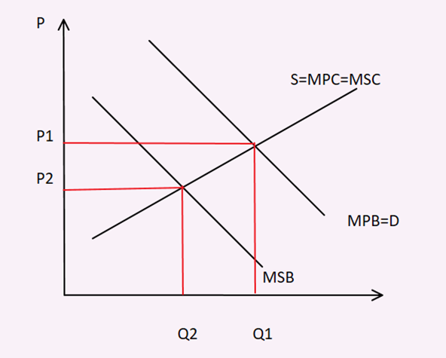

22) Actual economic growth is measured by the annual percentage change in a country’s real national output (GDP).
Potential economic growth is also known as trend growth and is measured by the estimated annual change in a country’s potential level of national output.

23) different methods of measuring GDP:
1- Product method:
This adds up the value of each good and service (P*Q) produced in the economy within a year, thus obtaining the value of all final goods and services.
The value of goods and services is calculated for each sector in the economy.
Eg: services in health sector

2- Expenditure method:
Adds up total spending to buy final goods and services within a year.
GDP = C + G + I + (X-M)

3- Income method:
adds up all income earned by the factors of production in the course of producing total output within a year.
Since GDP is the sum of all expenditures, it must also be the sum of all incomes generated.
GDP at basic prices = rent + wages + interest + profit

