Q1.
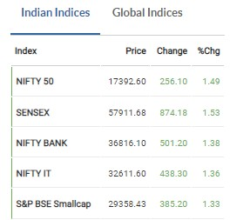
Indian market went up by 1.49%

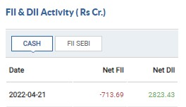
FII sold 713.69 Crores and DII bought 2823.43 Crores.
The market roses because of DII.

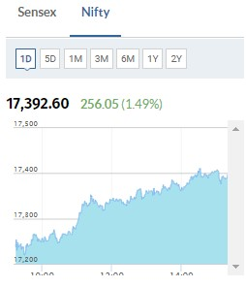

Nifty Bank stocks went up by 1.38% and Nifty IT stocks went up by 1.36% which contributed mostly in the up movement of the market.
The market rose by 1.49%

For question c
Top 5 Nifty gainers
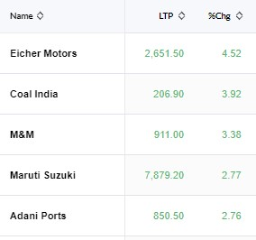

Top 5 Nifty Losers
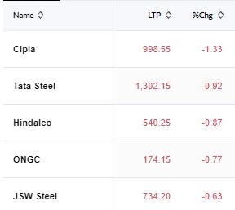
e). Worst performing sector was Nifty Metal

Advance to decline ration in Nifty 50
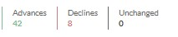

Indian VIX
India VIX indicates the degree of volatility trader expects over the next 30 days in Nifty 50 Index.
The change in the fear index is -4.39%.
It is below 20 which means that it is stable.

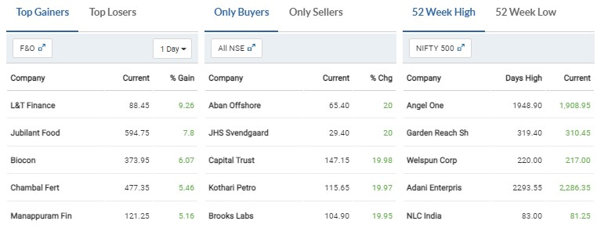

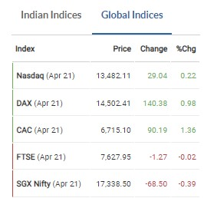

Sectoral Performance by Nifty 50
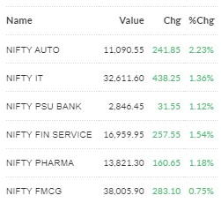

Best performing sector is Nifty Auto
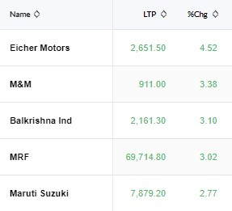

Worst performing sector is Nifty Metal
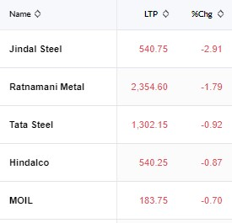

2.a). The market went up because FII sold 713.69 Crores and DII bought 2823.43 Crores.
The market roses because of DII.
The market roses by 1.49%
b). India VIX indicates the degree of volatility trader expects over the next 30 days in Nifty 50 Index.
The change in the fear index is -4.39%.
It is below 20 which means that it is stable.

c). Given above for top 5 Nifty gainers and losers

d). Nifty Auto is top performing sector
stocks are: Eicher Motors, M&M, Balkrishna Ind, MRF, Maruti Suzuki

e). Nifty metal is the worst performing sector
stocks are: Jindal steel, Ratnamani Metal, Tata steel, Hindalco, MOIL

KEY NEWS:
1.Trade Spotlight | What should investors do with ACC, Biocon, Vinati Organics, Astral, Fineotex Chemical on Thursday?

Fineotex Chemical is trading in an uptrend and has recently shown outperformance. The previous resistance of Rs 182 is now expected to become a support and hence any declines towards this support could be used as a buying opportunity

APRIL 21, 2022 / 07:19 AM IST
This influences the stock of Biocon.
2. ED conducts searches in JSPL premises: Sources

The searches are currently underway in Delhi and Gurgaon
APRIL 21, 2022 / 01:14 PM IST
This influences the stock of Jindal steel.
Q3.
5 Stocks which match all the 52 Week high criteria are:
- Power Grid Corp
- Oil & Natural Gas
- Adani Green energy
- Titan Company LTD
- Vedanta LTD

Qualification Criteria:
The chart should begin from the bottom left screen and end at the top right of the screen.
The size of the candles should be small.
There should be no big dips in the middle of the chart.
There should be a smooth shape on the chart. (Upward Trend)
There should be no circuits on the chart. (Blank candles)

Q4. PnL for Bata India
