BUSINESS FINANCE
ASSIGNMENT-1
By – Tarush Gupta
ANSWER-1 =IRR may give multiple solutions(d)
ANSWER-2 =market price per share/earning per share(a)
ANSWER-3 =All of the above(d)
ANSWER-4 =1000000(d)
ANSWER-5
- Sales –Costs = EBIT = 2500-1500 = 1000
Less Taxes (40% 0f 500) = 400
NOPAT = 600
- PV of Inflow 600/1.2 = 500
NPV = PV of Outflow – PV of Inflow
- NPV will go up
ANSWER-6
To measure the efficiency of any business we will calculate the profitability ratios. These include-
1.Gross profit ratio = Gross profit/Net sales*100
It tells us the gross profit that we earn on the sales of a single unit. It is always expressed as percentage .
When it is high it tells us that net sales are high with constant COGS
When it is low it tells us that net sales are low with constant COGS
In general a company with higher profitability ratio is better as it gives a higher chance for creation of reserve
2.Operating ratio = (Operating cost/Revenue from Operations) x 100
The main objective of the operating ratio is to assess the operational efficiency of the business.
Lower the ratio higher the efficiency of the company
3.Operating profit ratio = (Operating Profit/Revenue from Operations) x 100
,where operating profit = Gross Profit + Other Operating Income – Other Operating Expenses.
Its objective tells us the operational efficiency of the business
4.Net profit ratio = (Net Profit/Net Sales) x 100
Net Profit Ratio indicates the overall efficiency of the business. Higher the Net Profit Ratio, better is the business. An increase in the ratio over the previous year shows improvement in operational efficiency of the business.
5.Return on investment = (Net Profit before Interest, Tax and Dividend/Capital Employed) x 100
It tells us the overall return that we get on the investment that we have made in the business.
ANSWER-7
Historical information-The number and the information that we use in the calculation of the ratios are based on the past results, which may not reflect the company’s future performance.
Inflation-The results of the company are released quarterly or periodically and as a consequence there are time gaps between each release and as a result of that if inflation has occurred then real prices are not reflected in the financial statements.
Accounting policies- Different companies may use different accounting principles. This means comparing different companies ratios will be like comparing bananas and apples. For ex-one company may use one method of calculating depreciation while the other may use some other method of depreciation.
Operating changes-Business can go under drastic changes and thus taking the data form past will not be fruitful.
Ignorance of qualitative aspect-Ratios analysis only include the monetary aspect and exclude the qualitative aspect of the firm.
ANSWER-8
I - Beta indicates how volatile a stock's price is in comparison to the overall stock market. A beta greater than 1 indicates a stock's price swings more wildly (i.e., more volatile) than the overall market. A beta of less than 1 indicates that a stock's price is less volatile than the overall market.
II – Beta(geared) = Beta(ungeared)[1+debt/equity(1-tax rate)
1.1 = B(ug)[1+1/2(1-30%)]
1.1 = B(ug)[1+0.35]
B(ug) = 1.1/1.35
B(ug) = 0.8148
NOW,
B(g) = 0.8148[1+2/2(1-30%)]
=0.84148[1+0.7]
=1.3852

ANSWER-9 In general the market value of investment trust is not correlated to the net present value.
ANSWER-10
I – CONFLICTS OF INTRESTS
Managers have lots of information which they might use to benefit them but this might be against the interest of shareholders so it causes conflict of interest on the other hand,
Between lenders and shareholders they want more profit whereas lenders want interest and payment on time that is they want security.
So these problem can be resolved by agency theory, in which principal are known as shareholders and agent are managers and executives,
This result in,
Agency cost-if conflict arises between principal and agent then it result in monitoring and putting pressure on the agents to work according to the principal.
II – Dividend per share-10
Market price-70
Growth rate – 8%
Dividend yield = 10/70*100 = 14.2857%
Cost of equity = 8%+14.29% = 22.29%
Cost of equity=R(f)+MRP*Beta
22.29-0.06 = Beta*0.05
16.29/0.05 = Beta = 3.258
NOW,
B(new) = 1.8*B = 5.8644
Cost of equity = 6%+5%*B(new) = 35.32%
Cost of equity = D+G
35.32% = (10/x)*100+8%
27.32 = 1000/x =1000/27.32
=36.60
MRP = R(m)+(R(f)*B)
ANSWER-11
I - We can compare individual stock with the overall market by assessing the beta of the stock. Beta can be regarded as a measure of the systematic risk associated with a particular stock.
For company i: beta(i)=sigma(im)/sigma(m)^2
II – beta(i)=(p(im)*sigma(i))/sigma(m)) ,where
- P(im) is the correlation coefficient between the individual company stock return and that of the market.
- Sigma(i) and sigma(m) are the standard deviation of the company’s stock return and the market index respectively.
III - A value of beta in excess of 1 indicates a stock that has, historically, amplified the return of the whole market (positive or negative) and a negative beta would signify a stock whose performance was counter cyclical, offsetting the overall market experience. So as a conclusion I will invest in the stock whose beta is 1
IV – Government bond is considered a financial instrument with beta of 0.
ANSWER-12
A) Debt : Equity = 1:1
Risk-free rate = 7%
Market Risk Premium = 5%
Geared Beta = 1.5
Gross Cost of debt = 9%
Tax rate = 25%
i. Net cost of debt = gross cost of debt * (1-t)
= 9%*(1-25%)
= 6.75%
Cost of equity = risk-free rate + Geared beta (Market risk premium)
= 7% + 1.5 (5%)
= 14.5 %
WACC = [(1*Cost of equity) + (1*Cost of Debt)] / 2
= (14.5% + 6.75%) / 2
WACC = 10.625 %
ii. Geared beta = Ungeared beta * (1 + (debt: equity)*(1-tax rate))
1.5 = Ungeared beta * (1+ 0.75)
Ungeared beta = 0.85714
Cost of equity = Risk free rate + Beta (Market risk premium)
= 7% + 0.85714 (5%)
Cost of equity = 11.2857 %
Thus, the required return to equity is 11.2857 %.
ANSWER-13
I. At IRR, Present Value of Cash Outflows = Present Value of Cash Inflows Hence, cost of Project = ` 40,000 × 2.855 = `1,14,200.
II. Profitability Index at cost of capital = 1.064
1.064 = Present Value of Cash Inflows at cost of capital /1,14,200
Present Value of Cash Inflows at cost of capital = `1,21,509.
Net Present Value at cost of capital = `1,21,509 – `1,14,200 = `7,309
III. Cumulative P.V.A.F at cost of capital (1 - 4) = Present Value of Cash Inflows Annual Cash Inflows = 1,21,509 40,000 = 3.038 Reference to Cumulative P.V.A.F table gives us the cost of capital 12%
. IV. Payback Period = 1,14,200 40,000 = 2.855 years
ANSWER-14
I – a) Current ratio - It is type of liquidity ratio which measures the company ability to pay short-term obligations. To calculate current ratio we use the formula
CURRENT RATIO = CURRENT ASSET/CURRENT LIABLITY
- Debtor turnover ratio-It tells us the company ability to collect the its receivable from debtors. In other words it tells us the time it takes for the company to rotate a cycle of its debtors receivables. Formula to calculate it
DEBTORS RECEIVABLE RATIO- NET CREDIT SALES/AVERAGE ACCOUNTS RECEIVABLE
II - To meet its short term liabilities he should keep a regular track on the liquidity ratios which include a) Current ratio b) Quick ratio
CURRENT RATIO = CURRENT ASSET/CURRENT LIABLITY and QUICK RATIO= (Current Assets - Inventories - Prepaid Expenses) / Current Liabilities
ANSWER-15
A)
i. An investor might buy shares in this company because it provides a high dividend yield of 4%. Investment in equity provides an opportunity to the investor to earn high returns for high risks.
Assuming there are no taxes & the growth of the market price of the stock is neglected at the moment
d = 4%
Cost of equity = d + g
= 4%
This will be the minimum cost of equity.
Net cost of debt = gross cost of debt * (1-t)
= 8%
WACC = (1*cost of equity + 1*cost of debt) / 2
WACC = 6%
This will be the minimum cost of capital that the investor can expect.
ii. Traditional View
- In the traditional school the emphasis was on determining the amount of debt a company could safely carry without risking bankruptcy in a severe recession.
- Debt is cheaper than equity finance, so as gearing increases, the WACC should fall.
- However, increasing the proportion of debt finance increases the risk to shareholders so shareholders demand a greater return for this increased risk.
- Therefore beyond a certain level of gearing, the downward effect on the WACC of increasing the debt finance in the business will be more than offset (balanced) by the increase in the return required by shareholders.
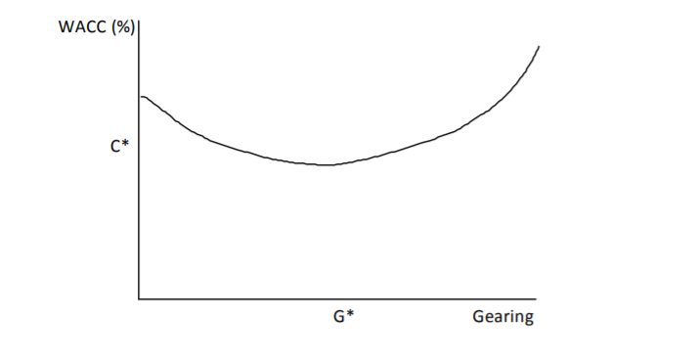
The WACC is lowest at C* when gearing is at G*.

- A key concept in corporate finance is expressed in Modigliani and Miller’s first irrelevance proposition:
The market value of any firm is independent of its capital structure.
- This is the basis of Modigliani and Miller’s second irrelevance proposition:
The expected rate of return on the common stock of a leveraged firm increases in proportion to the debt-equity ratio, expressed in market values.
- They began with a simple model with the following assumptions:
- there are no taxes
- unlimited personal and company borrowing is possible at the same rate of interest
- debt is risk-free
- there are no agency costs
- there are no information asymmetries.
- Modigliani and Miller argued that, under certain assumptions, gearing has no effect on the value of the company. Their view was that the value of the company lies in its ability to produce profits, not in the way that it is financed.
iv.
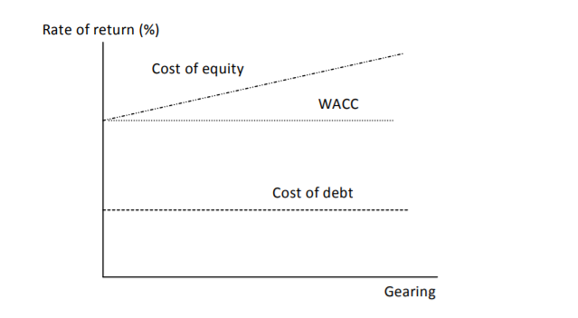
v.
a) Risk free rate = 6%
Equity risk premium = 5%
Ungeared beta = 1.4
Cost of equity = Risk free rate + (ungeared beta * Market risk premium)
= 6% + (1.4*5%)
= 13%
b)
Total market capitalisation = 100 m
Market value of debt = 50%
Ratio of debt to equity = 50/50
= 1:1
Tax rate = 30%
Geared beta = Ungeared beta * (1 + (debt:equity)*(1-tax rate))
= 1.4* (1+ (1/1)*(1-30%))
= 2.38
c.
Cost of equity = risk free rate + (Beta*market risk premium)
= 6% + 2.38*5%
= 17.9 %

