Non-life assignment 2
Unit 3 & 4

Q1
c) Earned Premium

Q2
b) Damage caused to another vehicle when hit by insured’s vehicle

Q3. What are the types of cover in motor insurance?
Motor Insurance broadly covers: -
- Own damage Cover: As the name suggests, it covers any damage or perils faced by the insured’s vehicle accidently.
- Third party Liability Cover: When in a road side accident, either death or damage that is caused to third party vehicle or property, is covered by the third-party damage aspect of the policy. In several places its important to take this cover.
- Comprehensive Policy: This is a mix cover for own damage and third-party liability along with getting aid in case of thefts or other immediate risks.

Q4. Mention few add-on coverages in motor insurance.
The popular add-ons which are usually preferred in motor insurance are: -
- Zero-depreciation Cover: This cover is beneficial as no depreciation is deducted at the time of claim and so a larger claim benefit is redeemed. Its also called bumper-to-bumper cover.
- Roadside-assistance: This cover is helpful when your vehicle is greatly damaged due to an accident and you need to be rescued from the place of accident or need to reach somewhere important. Moreover, the vehicle is also transported to an associated car repair center.
- Key replacement: This cover covers the cost of replacing the lock and car keys after meeting an accident.
- No-claim bonus (NCB): Insureds get bonus herein in terms of deduction in yearly premiums if no claims are made in the previous year.

Q5. What is covered under health insurance?
A basic Health insurance broadly covers the following:-
- Ambulatory patient services
- Emergency services
- Hospitalization (like surgery and overnight stays)
- Pregnancy, maternity, and newborn care (both before and after birth)
- Rehabilitative and habilitative services and devices (services and devices to help people with injuries, disabilities, or chronic conditions gain or recover mental and physical skills)
- Laboratory services

Q6. What are the underwriting factors in travel insurance, marine insurance, fire insurance and motor insurance?
The underwriting factors are: -
Travel insurance:
- Age
- Trip cost
- Trip length
- Destination
- Departure window - The amount of time between the date travel is booked and the date insureds depart on their trip
- Departure Month
- Number of destinations
Marine insurance:
- names and brief details of vessels covered
- value of vessels
- periods of cover
- deductions for brokerage, etc
- class and type of cover
- general conditions
Fire insurance:
- Type of construction
- Adjacent exposure data and general liability exposures
- Construction material
- Fire safety
- Protection and control systems
- Compliance with engineering recommendations
- Location of water sources
- Age of building and utilities, Estimated loss
- Estimated replacement cost
- Residential or commercial, if commercial, what business is being conducted
- Type of contents of the building
- Claims history
- Credit rating of the owner.

Motor insurance:
- Age of the proposer
- Sex
- Marital status
- Driving history of the proposer
- Address of the proposer
- Proposer’s history involving insurance in general
- Ownership of or financial interest in the motor vehicle
- Description of use and distance to be covered by the motor vehicle
- Particulars of the motor vehicle

7)
Health insurance:
- elective or cosmetic procedures
- beauty treatments
- Fertility treatments
- off-label prescriptions
- New technology in product or services
Travel insurance:
- Warfare
- Pre-existing ailments
- Sporting injury during travel
- Pregnancy
- When the tour operator cancels trip
Fire insurance:
- loss due to fire caused by earthquake, invasion, act of foreign enemy, hostilities or
- war, civil strife, riots, mutiny, martial law, military rising or rebellion or insurrection.
- loss caused by subterranean (underground) fire.
- loss caused by burning of property by order of any public authority.
- loss by theft during or after the occurrence of fire.
- loss or damage to property caused by its own fermentation or spontaneous combustion e.g. exploding of a bomb due to an inherent defect in it.
- loss or damage by lightening or explosion is not covered unless these cause actual ignition which spread into fire.
Marine insurance:
- Wilful, planned or intentional misconduct
- Strike, rioting, war
- Poor packaging quality of the cargo
- Delays
- General leakage or wear and tear of the cargo
- Financial distress or insolvency of the shipping line
- Removal of wreck
Motor insurance
- Third party liabilities
- Insured driving drunk
- Driving without a license - As a standard rule, no insurance can accept claims if the said
- person is driving illegally. Therefore, claims can only be made if you were rightly driving
- with a valid driver’s license.
- Add-ons not bought
- Consequential damages - Consequential damages refer to damages that take place after an
- accident. Unfortunately, those won’t be covered unless the damage has happened during
- the accident itself.

8)
Insurance fraud is an illegal act on the part of either the buyer or seller of an insurance contract. Insurance fraud from the issuer includes selling policies from non-existent companies, failing to submit premiums, and churning policies to create more commissions. Buyer fraud, meanwhile, can consist of exaggerated claims, falsified medical history, post-dated policies, viatical fraud, faked death or kidnapping, and murder.
Underwriting in HEALTH INSURANCE:
• Age
• Sum Insured
• Demography
• Medical Condition
• Gender
• Policy Type

Soft Fraud:
• Exaggerating damages/loss
• Deliberate or subtle lagging of claims resolution
Hard Fraud:
• Staging the occurrence of incidents
• Medical claims fraud

9)
Travel insurance
- Trip Cancellation: Reimbursement of costs previously paid, and not otherwise refunded, for a trip cancelled prior to departure.
- Trip Interruption: Reimbursement of additional costs, or of unused prepaid costs (e.g.,
excursions, hotel, etc.), incurred due to returning from a trip earlier than expected.
- Travel Delay: Reimbursement of costs incurred because travel did not occur at the time expected.
- Baggage Damage or Loss: Payments to replace personal items damaged or lost while on a trip.
- Baggage Delay: Reimbursement of additional costs incurred to replace personal items
that did not arrive at the intended destination when expected.
- Emergency Medical or Dental: Reimbursement of unexpected medical costs incurred
due to injury or illness while traveling.

- Emergency Evacuation: Providing specialized transportation (e.g., air ambulance),
typically, in response to a medical emergency or severe medical need.
- Repatriation of Remains: Providing transport for an insured who dies during travel from the travel destination to a family-designated funeral home.
- Rental Car Collision Damage: Reimbursement of amounts paid to a rental car agency
due to damage to, or loss of, a rental car.
Marine insurance:
- Hull - covers physical damage to vessels including machinery and fuel but not their cargo
- Cargo - covers physical damage or loss of goods while in transit
- Voyage – provides coverage for a specific voyage . It covers the cargo and not the ship.
- Freight – covers the loss of freight suffered by the vessel if the ship-owner cannot complete his contract.
- Liability - if the vessel collides with another vessel and there is damage, the liability suffered by the owner of the vessel for such collision is covered.
- Time policy – the policy provides coverage upto a specified time
- Mixed policy - this policy combines time policy and voyage policy and covers voyages
taken between specific destinations during a specific time period.
- Valued policy - under this policy the value of the cargo being transported is mentioned
beforehand which specifies the coverage level of the plan. In case of loss of
cargo, the value mentioned in the policy is paid as claim
- Unvalued policy – when the value of the cargo is not determined beforehand, it is called an unvalued policy. Under this policy, the loss suffered would be estimated
when the loss happens.
Personal accident insurance:
- Accidental damages caused by external means.
- Burglary, Theft and Housebreaking.
- Fire, Explosions, Implosions, Lightning, and self-ignition.
- Natural calamities like flood, typhoon, cyclone, hailstorm, etc.
- Earthquake, landslide and rockslides.
- Transit of vehicles by rail, road, air, or inland waterways.

10)
Another characteristic of travel insurance is the potential overlap with other insurance products. For example, automobile insurance may provide rental car collision damage insurance, homeowners insurance may cover lost or damaged baggage, and health insurance may cover emergency costs while traveling. Even in cases where a traditional policy may provide a benefit, travel insurance remains distinctive because it only covers exposures related to travel, and is usually tied to a specific trip.

11)
•Lloyd's Coffee House
• From 1961,in Lombard street , the coffeehouse became a place to discuss marine affairs
•Edward Llyod started giving out news –sheet . They pooled their money for insurance against risk connected with the sea.
The need for underwriting led to formation of Llyod’s of London. Contrary to popular belief, Lloyd’s of London was not the first group of people to offer a maritime commerce. The first form of marine insurance dates back to year 3000 BC when Chinese merchants dispersed their shipments amongst several vessels so as to abridge the possibility of damage to the products. The earliest account of insurance came in the form of ‘bottom’, a monetary payment that protects traders from debt if merchandise is lost or damaged.

¬Types of Policies

•Time policy – the policy provides coverage upto a specified time
•Mixed policy - this policy combines time policy and voyage policy and covers voyages taken between specific destinations during a specific time period.
•Valued policy - under this policy the value of the cargo being transported is mentioned
beforehand which specifies the coverage level of the plan. In case of loss of
cargo, the value mentioned in the policy is paid as claim
•Unvalued policy – when the value of the cargo is not determined beforehand, it is called
an unvalued policy. Under this policy, the loss suffered would be estimated
when the loss happens.
•Floating policy - Under this policy the policyholder buys the policy for a lump-sum value.
Nothing else is specified. When the goods are actually transported,
a declaration is made for the value of goods which is deducted
from the lump sum amount selected under the policy. The policy, therefore,
covers multiple voyages up to the lump sum limit.
• this policy is for businesses which transport goods frequently.

•Block policy - A block policy is an all-risk insurance policy providing coverage against risks

faced by goods transported or stored by third parties. It also covers
property in storage and the equipment required to make the
transportation and storage of goods possible.
• Companies wanting their products covered against a wide variety of perils
during transport and storage may buy a type of inland marine insurance or
block coverage.
•Composite policy - this policy is underwritten by multiple underwriters and each
underwriter has a fixed liability.
•Fleet policy - this policy is taken by the owner of the vessel to cover the fleet of vessels
which he owns i.e., a single policy for a group of vessels.
12) 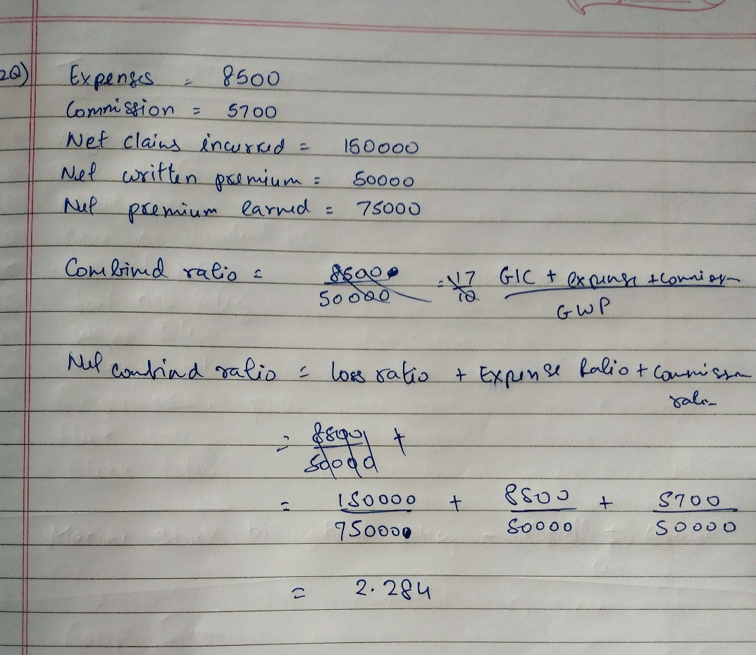

13)
Crop insurance is a means of protecting the agriculturist against financial losses due to uncertainties that may arise from crop failures/losses arising from named or all unforeseen perils beyond their control.

Coverages
•Localized calamities
•Sowing/ planting/ germination risk
•Standing crop loss – non-preventable risks such as hail storm, dry spells, flood, cyclon
•Post-harvest losses

Exclusions

•Losses arising out of war, nuclear risks
•Malicious damage and other preventable risk arising out of negligence by the farmer or the
manpower employed by the farmer
•Burning of the crop by order of a public authority
•Damage caused by birds or animals
•Ionizing radiations or contamination by nuclear waste
•Harvested crops bundled and heaped before threshing

14)
Underwriting for credit insurance is carried out on the basis of the quality of the customer base, previous loss records, expected future losses for the client's portfolio and sector, anticipated turnover, and trading expectations.

Q15. What is engineering insurance?
Engineering Insurance is an insurance policy that covers a wide range of engineering related risks. It is a comprehensive insurance that provides complete protection against risks associated with erection, resting and working of any machinery, plant or equipment.
Moreover, it refers to the insurance that provides economic safeguard to the risks faced by the ongoing construction project, installation project, and machines and equipment in project operation.

