11th January 2022
Dharini Shah
704
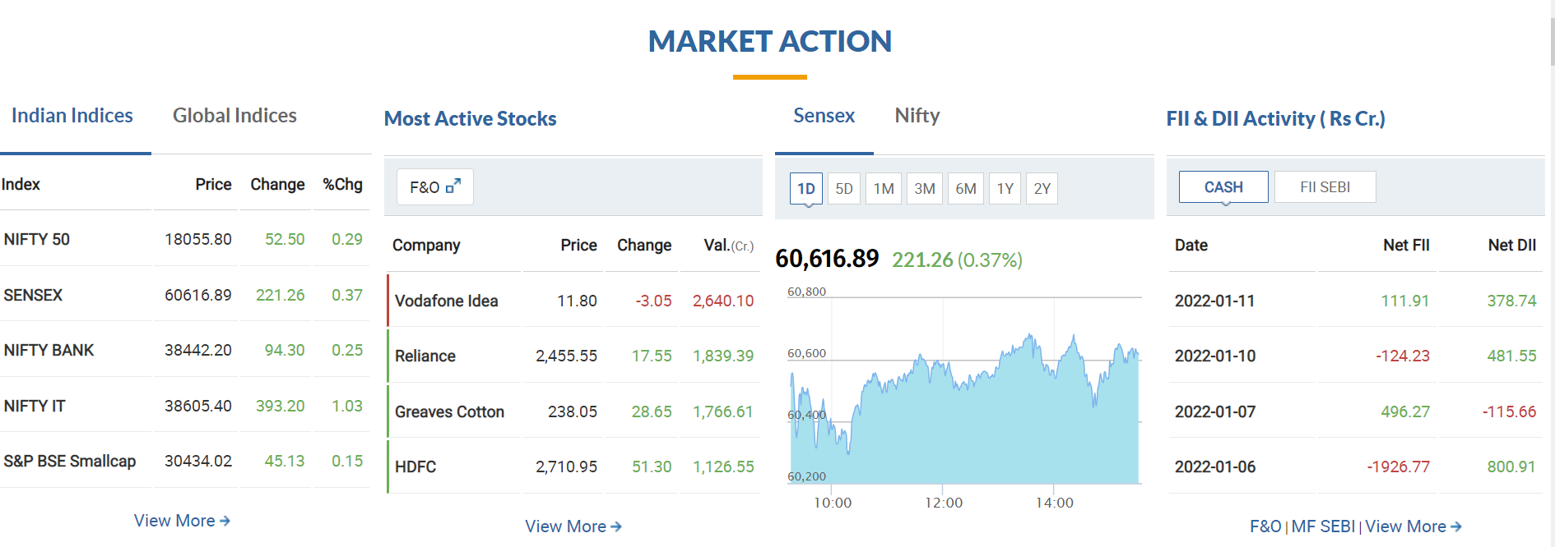
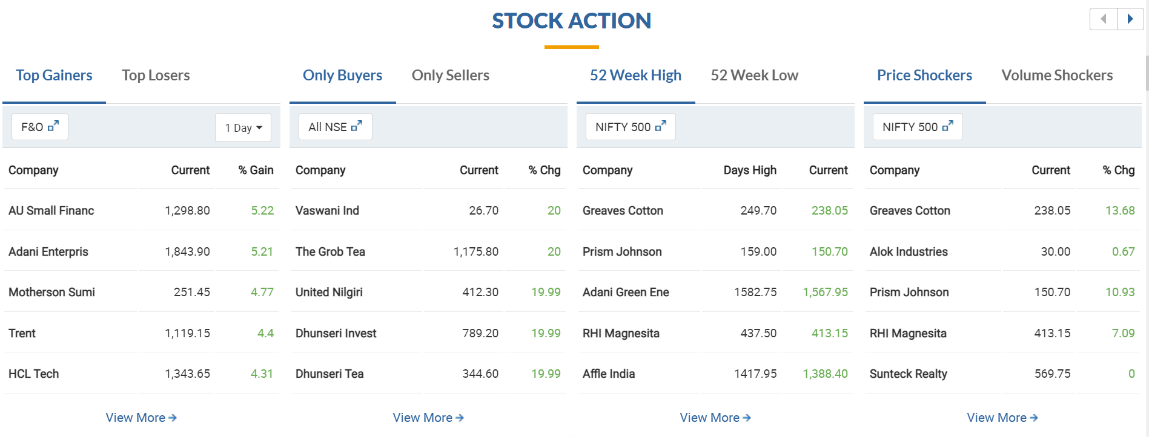
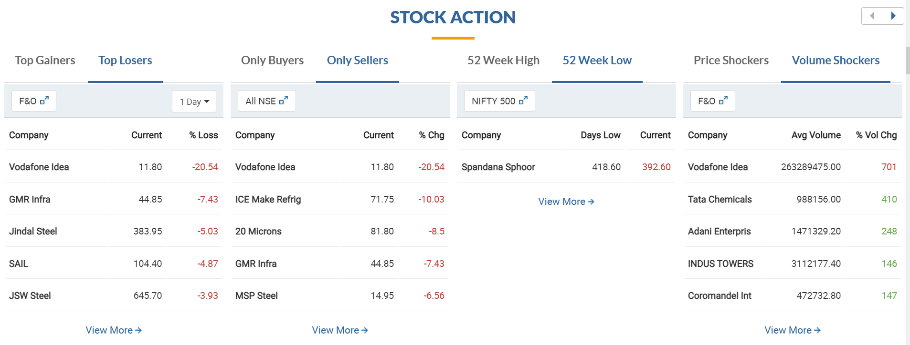

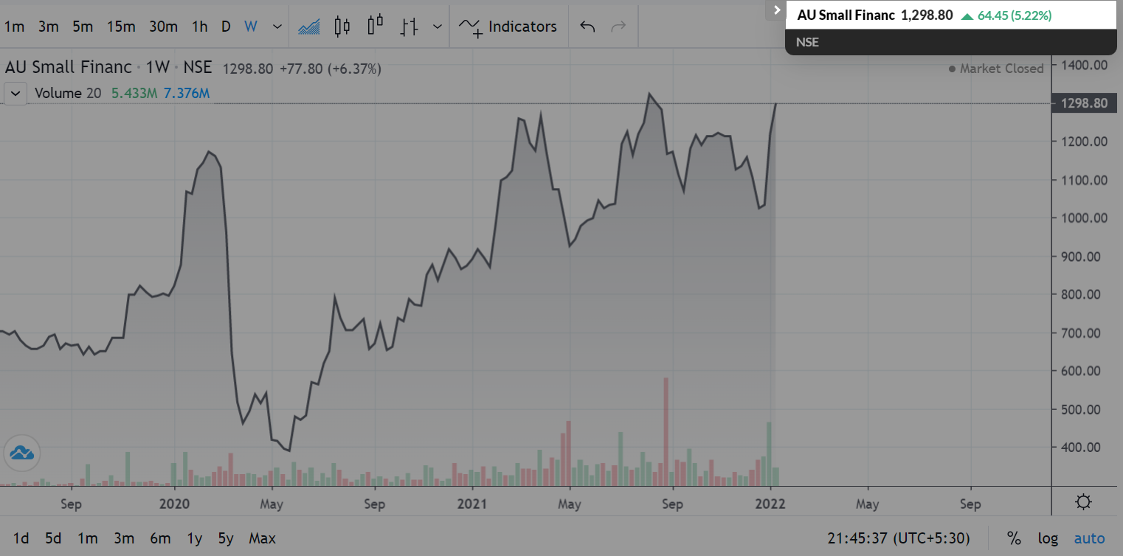
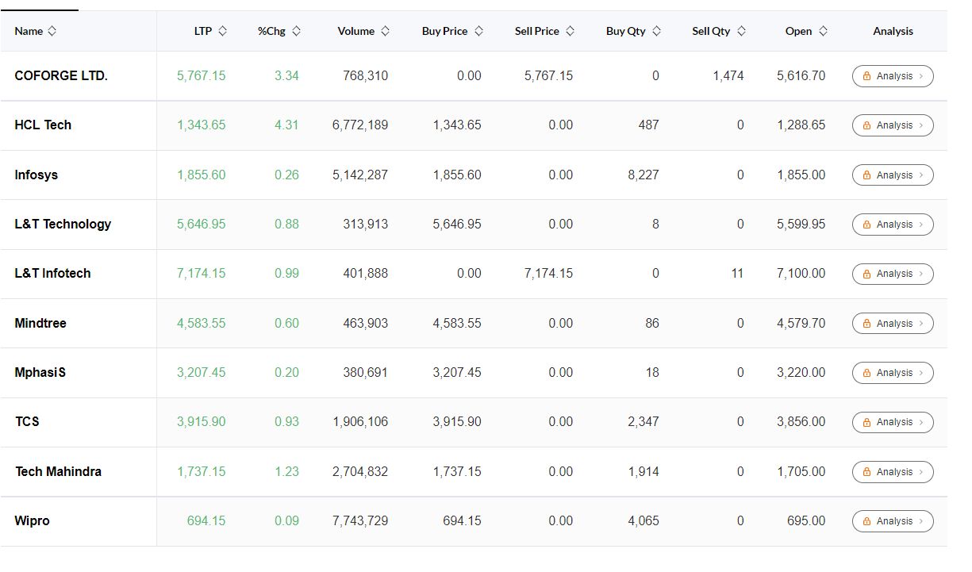
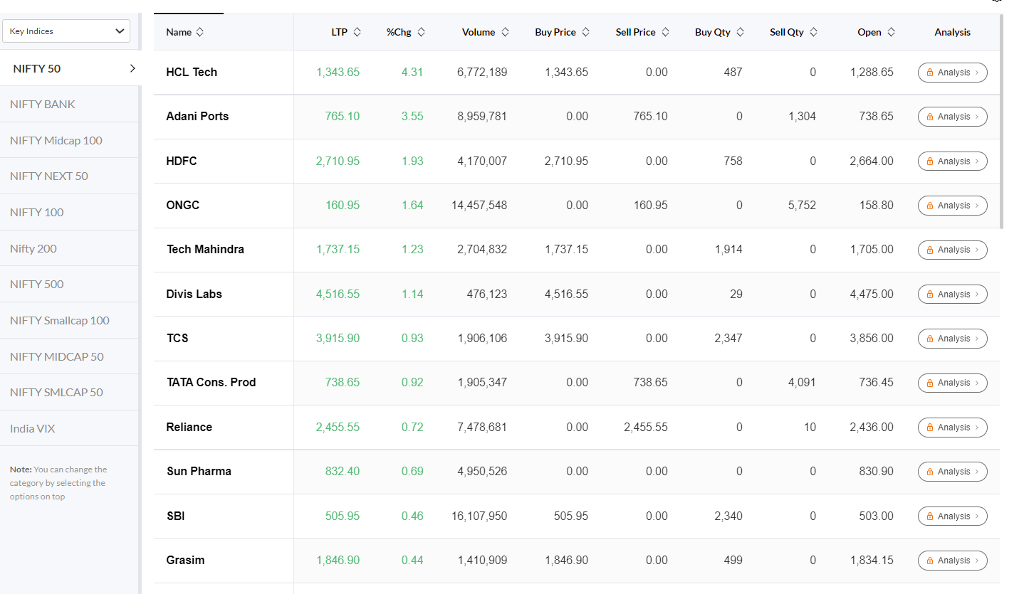

52 week high
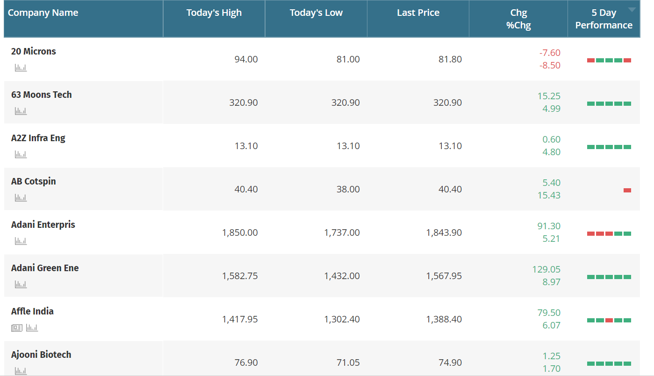

52 week low
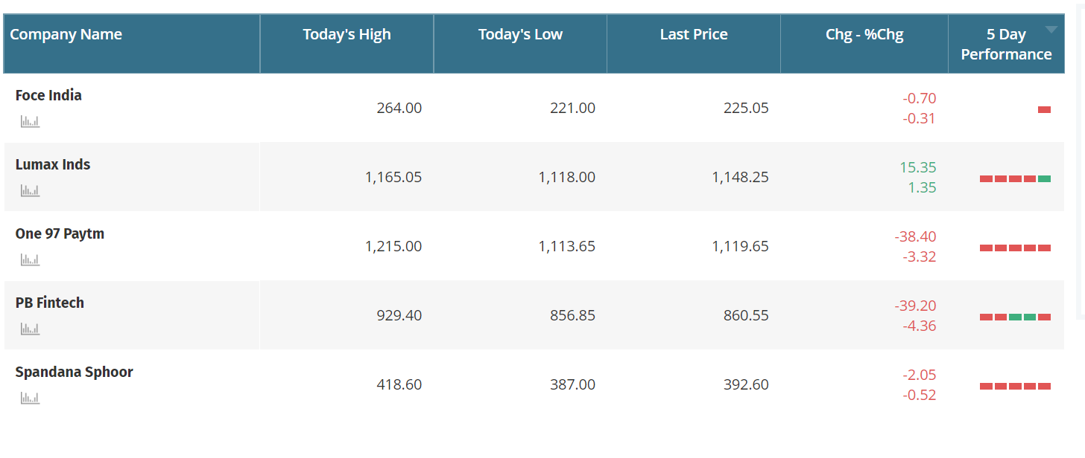
Dow theory : Stock – Au small finance bank
Buy @ 584.85
Hold till end @ 1279
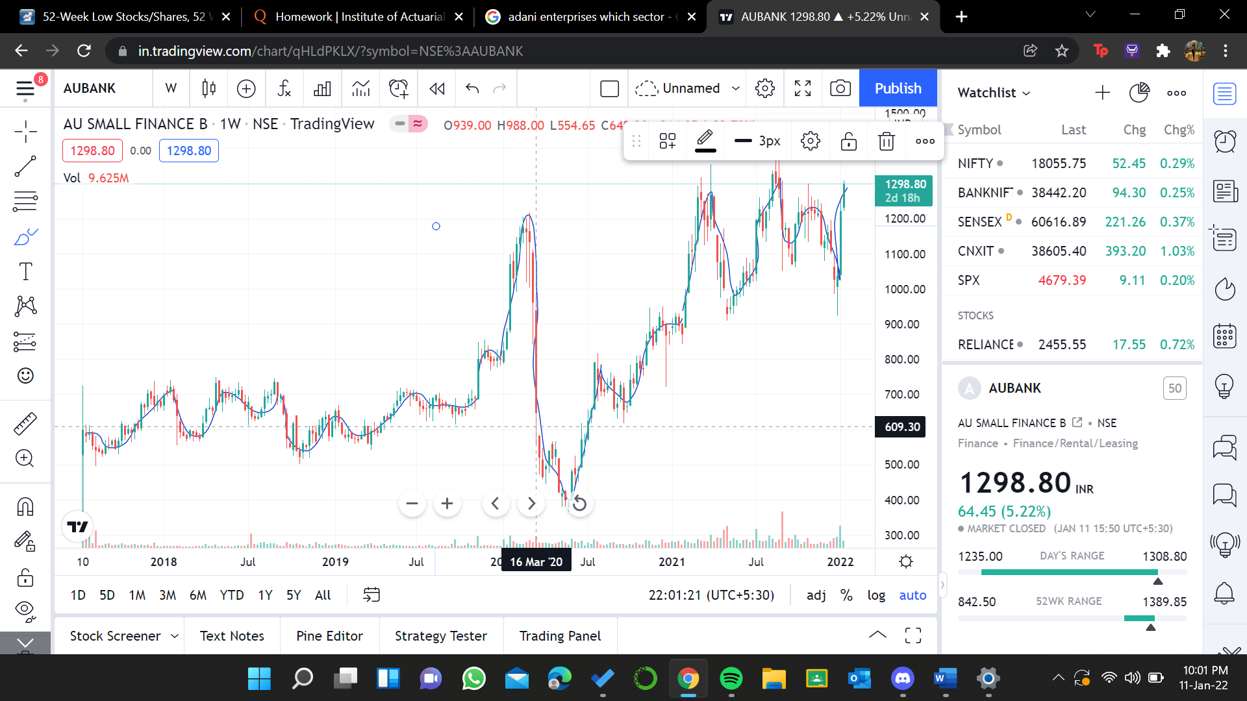

Dow theory : Adani enterprise
Buy @ 8.9
Sell @21.2
Buy @71.05
Sell @67
buy@ 77.55
sell @49.75
buy @107.8
sell@ 122.75
buy @258.45
hold till 1785

