Q1. Which of the following is not as argument against Government intervention in a market?
- If the Government reduces output below the free market level, consumer surplus will fall.
- If the Government reduces output below the free market level, producer surplus will fall.
- If the Government raises output above the free market level, consumers will get no benefit from the extra units of output.
- If the Government raises output above the free market level, some units of output will cost more to produce than the value placed on them by consumers.
Q2. Suppose the Government introduces a specific tax of Rs. 5 a unit on a product which has sloping supply and demand curves. Which of the following statements about the resulting curve S + tax is true?
- The gap between S +tax and S will be higher at quantities than at low quantities.
- The gap between S +tax and S will be higher at low quantities than at high quantities.
- The gap between S +tax and S will be Rs. 5 at each quantity.
- The gap between S +tax and S will be whatever is needed to show that the equilibrium price for consumers increases by Rs. 5.
Q3. In the absence of externalities, which of the following conditions characterizes the socially optimal output level?
- Marginal revenue = average cost
- Average revenue = average cost
- Marginal revenue = marginal cost
- Average revenue = marginal cost
Q4. A merit good:
- Provides benefits that are fully appreciated by user.
- Has strong negative externalities.
- Is rival and excludable.
- Cannot be supplied by the market.
Q5. All of the following are features of globalization EXCEPT which ONE?
- Rising trade ratios for countries.
- Increased international capital flows.
- Improved terms of trade for all countries
- Reduced barriers to international factor movements.
Q6. If the total output of goods and services increases and the price index remains constant nominal Gross Domestic Product (GDP) will:
- Rise and real GDP will fall
- Stay the same and real GDP will rise
- Rise and real GDP will rise
- Fall and real GDP will rise

Q7. Which of the following rules are NOT followed by WTO members?
- Provide trade concession to all members if extended to one of the member
- Provide consistency with regards to taxation and subsidies
- No alteration to tariffs without negotiation with their trading partners.
- The prohibition of quotas.
Q8. Which of the following is possible non – economic reasons to restrict trade
- To prevent the importation of harmful goods
- To reduce the influence of trade on consumer tastes
- To impose trade sanctions with which it disagrees politically
- To prevent “dumping” and other unfair trade practices.
Q9. The economic welfare case for governments increasing taxes on petrol to raise its real price is that:
- Oil is a scarce resource.
- It would reduce the imports of oil.
- There is a large demand for petrol.
- Petrol consumption involves external social costs
Q10. Which of the following best describes the distinction between real GDP and nominal GDP?
- Nominal GDP is calculated by deflating real GDP; real GDP is unadjusted for inflation.
- Nominal GDP is adjusted for changes in prices; real GDP is not adjusted for changes in prices
- Nominal GDP is calculated every year; real GDP is calculated only occasionally
- Nominal GDP uses current prices; real GDP uses constant prices.
Q11. The business cycle is defined as:
- the annual cycle of output
- the long run trend path of output after removing short run variations
- the periodic fluctuations of output around the long run trend
- none of the above
Q12. Which of the following does NOT form part of a country’s Gross Domestic Product?
- Company profits
- Investment expenditure
- Net income from abroad
- Salaries of Parliamentarians
Q13. The government of Greenland following a policy change has decided to privatize the LPG market and hence had opened the market for private players to produce and sell LPG cylinders to households. The government has decided to put a price ceiling of $10 per LPG cylinder. The equilibrium price through demand and supply for each LPG cylinder however is $12. Which of this following event could occur following the government decision?
- There will be excess supply of LPG cylinders in the in the market
- There will be no demand for LPG cylinders in the market
- This could lead to ‘black’ market where the cylinders are sold at more than ceiling price
- Both A and C
Q14. Given the following macroeconomic data:
Consumer expenditure Rs. 70 Cr
Investment expenditure Rs. 20 Cr
Government expenditure Rs. 40 Cr
Exports Rs. 20 Cr
Imports Rs. 30 Cr
Net income from abroad Rs. 10 Cr
What is the value of the Gross Domestic Product?
- Rs. 150 Cr
- Rs. 130 Cr
- Rs. 120 Cr
- Rs. 110 Cr
Q15. In a simple economy, consumption is given by the relationship C = 0.75 Y, where C is consumption expenditure and Y is Gross Domestic Product. If government expenditure is Rs. 150 Cr, investment is Rs. 50 Cr and there is no taxation or international trade, what will be the equilibrium value of Gross Domestic Product of the economy?
- Rs. 200 Cr
- Rs. 266.67 Cr
- Rs. 1.50 Cr
- Rs. 800 Cr
Q16. What is not an example of government intervention to correct market failures?
- Establishing legal frameworks, property rights and contracts
- Restrict printing of currency in inflationary times
- Efficient management in production to increase profits
- Protection of Consumers choice and their sovereignty
Q17. Which of the following is not a criticism of the principle of Maximum Social Advantage?
- Methodological inconsistency
- Unrealistic assumptions
- Corruption or misuse of public funds
- Zero net social benefit
Q18. Which of the following is incorrect with respect to externality?
- It has a spill – over effect
- Only negative externality exists
- It is kind of market failure
- It can occur during production and consumption
Q19. Which of the following is true for the two sector model?
- Y = C
- Y = C + I + G
- Y = C + I + G + X
- Y = C + I + G + X – M
Q20. Which of the following is an injection to the circular flow?
- Savings
- Government expenditure
- Taxes
- Imports
Q21. Calculate the Gross Domestic Product at Market prices from the data given in the table.
- 542 Billion
- 606 Billion
- 538 Billion
- 350 Billion
Q22. Calculate the Gross Domestic Product at Basic Prices from the data given in the table.
- 538 Billion
- 606 Billion
- 542 Billion
- 350 Billion
Q23. Calculate the Gross National Income at Market Prices from the data given in the table.
- 606 Billion
- 656 Billion
- 556 Billion
- 621 Billion
Q24. Calculate the Net National Income at Market Prices from the data given below.
- 606 Billion
- 656 Billion
- 556 Billion
- 621 Billion
Q25. Which of the following is not a problem in the calculation of National Income?
- Illegal transactions
- Shadow Economy
- Omission of Data
- Large population

Q26. Select the incorrect statement
- The National Statistical Office releases of Gross Domestic product in India.
- GDP at constant prices for 2021 is estimated with the base year as 2010 – 11.
- GDP for the second quarter at current prices for 2021 is estimated at 47.26 Lakh crore.
- There is growth of 8.4% in the second quarter of 2021 as compared to Q2 2020.
Q27. Assume two countries with the same level of technology and resources do not presently trade. In country X one unit of labour and one unit of capital can produce 5 mobiles or 2 laptops. In country Y one unit of labour and one unit of capital can produce 6 mobiles or 4 laptops.
Which of the following statements is FALSE?
- Country Y has an absolute advantage in the production of both goods
- Country Y has a comparative advantage in the production of mobiles
- Country X has a comparative advantage in the production of mobiles
- Country Y has a comparative advantage in the production of laptops
Q28. You are given the following data for an economy: (in Millions)
Consumer expenditure (including taxes on products) 120
Investment 60
Government expenditure (including transfer payments) 70
Exports 40
Imports 20
Taxes on products (Indirect taxes) 10
Capital depreciation 20
Transfer payments 10
Net Income from abroad 10
The value of the economy’s Gross National Income at market prices is:
- 250 million
- 260 million
- 270 million
- 280 million
Q29. Given the following data calculate the following:
- Net Domestic income
- Gross Domestic Income
- Net National Income

Q30. Research has shown that plastic is not biodegradable, therefore it always exists, crowding our landfills and polluting our oceans. Assess with the use of diagram, how the use of plastic will result in dead weight welfare loss to society.
Ans:
. 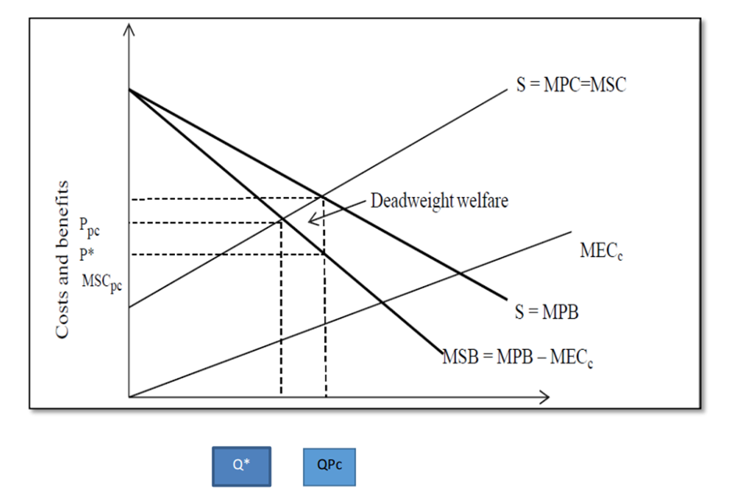
1. MSC- Marginal Social cost
2. MPC- Marginal Private Cost
3. MPB- Marginal Private Benefit
4. MSB- Marginal Social Benefit
5. MECc- Marginal External Cost of consumption
6. Q*- Socially optimum level of output at price P*
7. QPc- Market level of output at price Ppc.
8. Deadweight loss of social welfare happens when MSC> MPC
9. Social welfare loss occurs as QPc > Q*
As plastic is causing environmental pollution, it has social cost. Individuals are using plastic as it is convenient for them. Therefore, Marginal Social Cost (MSC) differs from Marginal Personal Cost (MPC). 2. Plastic usage cause environmental pollution and animals may die due to consumption of plastic bags. Therefore, there is Marginal External Cost which may be incurred to keep water bodies clean and to protect animals from consumption of plastic. 3. Therefore, MSB is lower than MPB. MSB= MPB - MECc. This is represented by MSB curve below MPB curve in the diagram. Market will have equilibrium position at QPc with Price Ppc. At socially optimal equilibrium at output Q* of price P*, MSB = MSC. 4. The external cost of consumption result in level of output above socially optimum level, QPc > Q* From society’s point of view, too many plastic bags are being produced and consumed. This results in a dead weight welfare loss caused by overconsumption and represented by a triangle in diagram A.

Q31. Define the short run aggregate supply curve and explain why it slopes upwards.
Q32. a. Define a negative externality. Outline an example of a negative externality that may be experienced by an individual in relation to the consumption of cigarette by another party.
b. Describe a price and non – price associated intervention that could be used to address this market failure.
c. Draw a diagram showing the marginal social benefit curve and marginal private benefit curve when a negative externality in consumption exists. You should show on your diagram, the quantity that would be consumed at the market price P1 by the private sector as Quarter 1 and the socially optimal level of consumption as Quarter 2.
Ans: Negative Externality Definition - Negative externalities occur when production and/or consumption impose external costs on third parties outside of the market for which no appropriate compensation is paid. This causes social costs to exceed private costs. An example of a negative externality: i. People may smoke in public places and ignore harmful impact of toxic passive smoking on non-smokers. ii. The passive smoking may harm health of non-smoker and may cause various respiratory diseases. iii. In young ladies passive smoking may cause pre-mature child birth and asthma. iv. Passive smoking increases the risk of respiratory illnesses in children, including asthma, bronchitis and pneumonia. v. Healthcare expenditure involved in treatment of smoking related illnesses
ii) Price Related Intervention: a) The Government imposes a tax on the producer that reflects the marginal cost of the externality. b) Fines are imposed if smoking is done in public places Non- Price Related Intervention: a) Smoking is banned in public places like gardens, restaurants, libraries, work places, etc. b) A law prohibiting any manufacturer, retailer, or distributor of tobacco from selling or distributing products to persons under age eighteen. c) Use of media / advertisements, public education to emphasize ill effects of smoking and motivate smokers to leave smoking d) Specially designed medical care and or programs for smokers to quit smoking. iii) Diagram- marginal social benefit curve and marginal private benefit curve when a negative externality in consumption exists
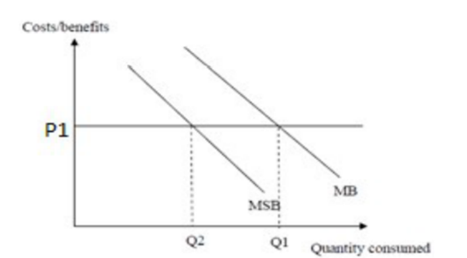
Q1- Consumption by private sector
Q2- Socially optimal level of consumption
MSB- Marginal Social Benefit
MB- Marginal Private Benefit
P1- Market price
Q33. Explain the difference between actual and potential economic growth.
Ans: Actual economic growth is also known as demand side economic growth since it is influenced by changes in an economy's demand. It represents a growth in output as measured by real GDP/national income. It is possible to do this by pushing AD (Aggregate Demand) to the right by raising AD, or by altering any of the aggregate demand parameters. (As shown below) •Consumption •Government Spending •Net Exports * Investment (However this is also a component of LRAS) On the other hand potential deals with the supply side of the economy. It is an increase in the productive capacity (potential). An increase in the short term/long term aggregate supply will cause potential economic growth. The short term deals with costs of production and the long term is affected by changes in the quality and quantity of the factors of production.

Q34. Outline three methods of measuring national income. For each method state the main point that needs to be considered in order to avoid double counting. Why will the answers produced by each of these methods be different?
Ans: Income measure: This measures the total of factor earnings. These are factor payments to land, labour and capital. Transfer payments are not included (to avoid double counting).
- Output measure: This measure the value of goods and services produced. To avoid double counting we only include the “value added” component of firms’ output.
- Expenditure method: This includes all expenditure (including exports minus imports) in the economy and also what would have to be spent to purchase increases in inventories (or stocks). To avoid double counting, we include only expenditure on final goods.
The three concepts are identically equal. However, in practice difficulties of measurement and collection of data (eg the black economy) mean that the three measures will not be equal.

