- C
- B
- C
- D
- D
- C
- C
- B
- C
- B
- D
- A
- C
- C
- A
- D
- C
- B
- A
- C
- D
- B
- D
- A

Ans 25)
Advantages of inflation:
- Credibility / Expectations = If an independent Central Bank makes a commitment to keep inflation at 2%, people will tend to have lower inflation expectations. Low inflation expectations make it easier to keep inflation low. It becomes a self-reinforcing cycle – if people expect low inflation, they don’t demand high wages; if firms expect low inflation, they are more conscious of increasing prices.
- Avoid Boom and Bust= The UK economy has suffered from boom and bust of economic cycles. We had a period of high inflationary growth, which later proved unsustainable and led to a recession. An inflation target places a greater discipline on monetary policy and prevents monetary policy becoming too loose – hoping there has been a ‘supply side miracle.
- Costs of Inflation= If inflation creeps up, then it can cause various economic costs such as uncertainty leading to lower investment, loss of international competitiveness and reduced value of savings.
- Clarity= An inflation target provides clarity for monetary policy. Alternatives have been tried with less success.

Disadvantages of Inflation:

- Cost-push inflation may cause a temporary blip in inflation. Just before the recession of 2009, the UK experienced cost-push inflation of 5% due to high oil prices. To target 2% inflation would have required higher interest rates, which leads to lower growth. Some economists argued interest rates should have been cut earlier, and inflation targets were a reason for the delayed easing of monetary policy.
- Sometimes you need a higher inflation rate
- Inflation targets are limited.
- A large output gap doesn’t necessarily lead to deflation.

Ans 26)
factors affecting the demand for money ARE :
a) The rate of interest on loans
b) The number / value of monetary transactions that we expect to carry out
c) The extent to which we also want to hold other financial assets, such as bonds, property, saving (this is also influenced by the rate of interest) – this is known as the speculative motive for holding money
d) Changes in GDP
e) The extent to which it is possible to use debit cards / credit cards i.e. the pace of financial innovation
f) The extent to which we might have to pay out large unexpected payments, for example, for i.e. the precautionary motive
g) The rate of anticipated inflation

Ans 27)
An exchange rate index is a way of measuring the performance of a currency against a basket of other currencies. An exchange rate index shows the percentage change in the value of the currency against its main competitors

Ans 28)
The direct effect of a rise in interest rates is to raise the cost of current government borrowing and so raise the fiscal deficit. In addition, it will raise the cost of financing the national debt to the extent that the debt has been financed by floating rate debt. The indirect effects of a rise in interest payments are also likely to widen the fiscal deficit initially since the interest rate rise will slow down the economy so increasing government expenditure on social security and dampening government tax revenues.
Ans 29)
(i)
a. Money supply will be unaffected because the public’s cash is withdrawn from banks and government spends it, so it is redeposited in the banking system.
b. Increase because there will be more cash deposited in banks, rather than being held outside of the banking system, which they can use to create credit.
(ii)
a. A fall in the national income leads to a decrease in the transactions demand for money. The demand for money curve will shift to the left.
b. A decrease in the expected value of domestic currency will cause a decrease in the demand for the currency, i.e., the demand for money curve will shift to the left.

Ans 30)
(i)
- Points on the IS curve show combinations of interest rates and national income at which injections equal withdrawals and consequently the total output equals total expenditure, giving equilibrium in the markets for goods and services.
- Points on the LM curve show combinations of interest rates and national income at which the demand for money equals the supply of money, giving equilibrium in the money markets.
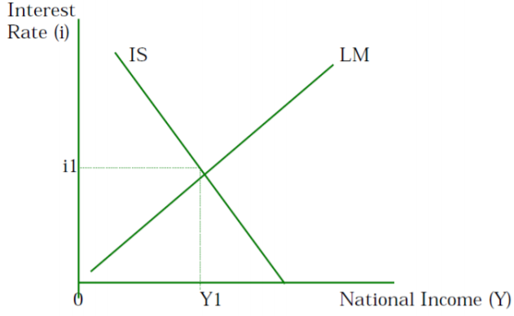

- The IS-LM curves are drawn on a graph with interest rates on the vertical axis and national income on the horizontal axis. The IS curve slopes downward from left to right showing that lower rates of interest lead to higher levels of national income. The LM curve slopes upward from left to right showing that in order to obtain equilibrium in the money market given the supply of money, higher levels of national income are associated with higher rates of interest.
(ii)
- Increase in the average price level will result in a reduction in the real value of the money supply. A reduction in the money supply will shift the LM curve to the left giving an increase in the equilibrium rate of interest and a fall in the equilibrium level of national income.

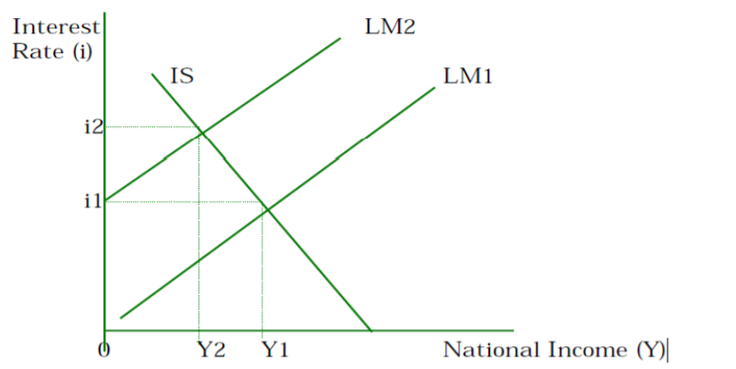

(iii)
- Expansionary fiscal policy financed by the sale of bonds, the government sells bonds and uses the proceeds raised to finance increased government expenditure. The effect on the money supply should be zero as the money raised from the bond sales is spent by the government.
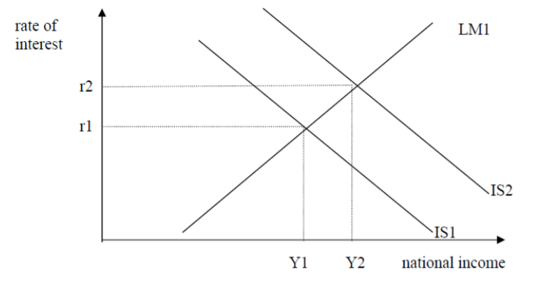

Ans 31)
(i)
Line 1 – Exports of goods
Exports =425 -40
= $385m
Line 6 - Balance of trade in services
165 - 185
= -$20m.
Line 8 - Income payments
190 - income payments = 15
Income payments -$175m.
Line 11 - Net income flows
15 - 50 = net income flows
= -$35m.
Line 12 - Current account balance
-40 -20 - 35
=-$95m.
Line 18 - Capital and financial account balance
Since the current account is -$95, the capital and financial account balance must be +$95m.

Ans 32)
- So the labour market model is also a model of the distribution of income in a simple economy in which there are just these two classes (employers, who are the owners of the firms, and workers), where some of the latter are without work. The labour market model assumes a perfectly competitive market where there are many workers in the market and many employers in the market, and they each have relatively the same bargaining strength. In the real world, this is often not the case.

Ans 33)

- Changes in the currency value would affect trade and investments. Governments, may wish to prevent such fluctuations in the currency value. The measures available to the central bank in this regard would depend on whether the aim is to curtail the day-to-day or longer term changes in the exchange rate
- To alleviate the downward pressure on the currency, a government could alternatively borrow foreign currency from other countries or international agencies such as IMF. It could use the loan to buy the domestic currency in the foreign exchange market. This will result in returning the demand and supply curves to the original positions and the currency value to resume its original level
- Another measure could be is to raise interest rates temporarily. This will encourage those abroad to deposit their money in the domestic country and the domestic residents to keep their money in their own country. Raising interest rates will result in an increase in the demand for, and decrease in supply of, the currency.

Ans 34)

(i) 30m surplus
(ii) 10m deficit
(iii) -40m
(iv) No, the country does not have a fully flexible exchange rate. We can deduce this from the entry decrease in official reserves” which indicates that the central bank has been purchasing the domestic currency

