11/23/2021
Sannidhya Upadhyay
Roll. No. - 404
SRM PROJECT 1

Graduation tests

Data - Graduation.csv was provided beforehand.

Exploratory Data Analysis

Number of Rows = 51
Number of Columns = 7

Q1) Entries for the CRUDE column:
Crude Rates = Deaths/Central exposed to risk for age x last birthday



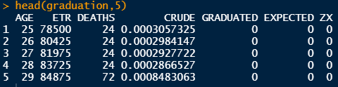

Q2) Use Gompertz law to fill entries in the GRADUATED column in the data.

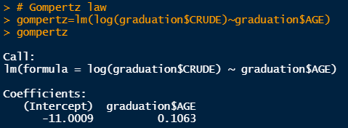

Parameters b and c:
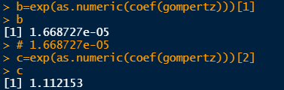

Graduated Rates = b*c^age

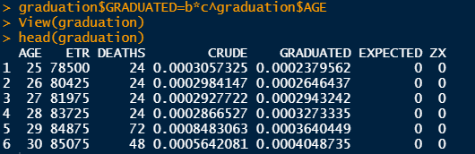
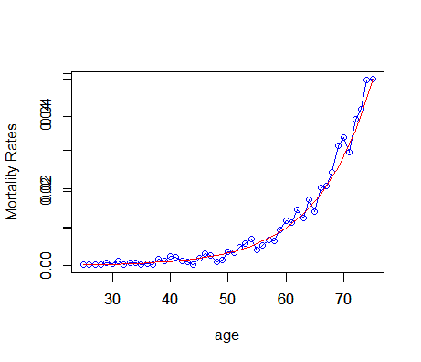

Q3) Check for smoothness by applying the third differences to the crude and graduated rates and
comment on your results.

Given : 1diff = function (x) x[-1] – x[-length(x)] )
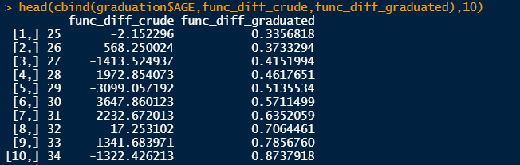

As you can see from the table crude rates are much larger in magnitude than graduated rates. Crude rates are having irregular moment while Graduated rates are having regular progress.

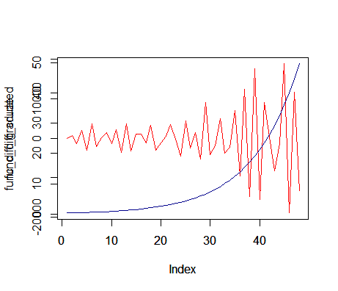

Q4) Calculate the values in EXPECTED and ZX values in the table. Hence, perform a chi-squared test to check goodness of fit between DEATHS and EXPECTED. You should specify the degrees of freedom used.

Expected Rates = Graduated Rates* Central exposed to risk for age x last birthday
Zx = (Deaths – Expected)/sqrt(Expected)

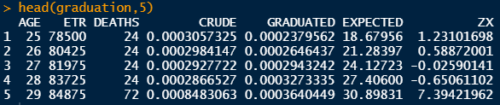

Chi-Squared test
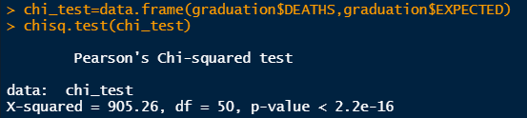
Degree of Freedom = 50

Standardised Deviations Test

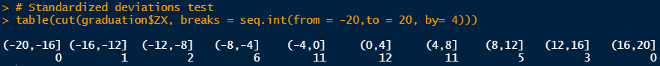

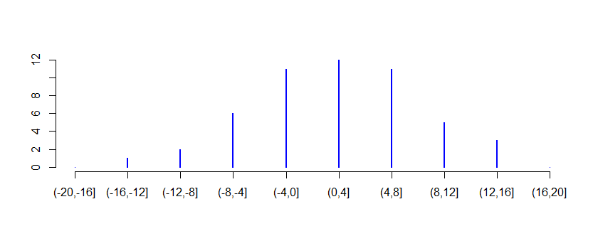

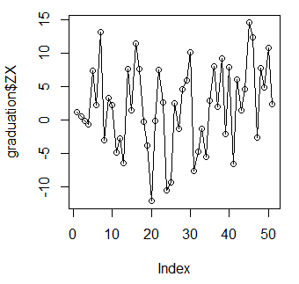

i. Overall shape: from the graph above we can say that is graph is wide compared to our normal graph
ii. Absolute deviations: the values in the tails are very high.
iii. Outliers: from the above graphs there are many outliers.
iv. Symmetry: we can say that our graph is slightly positively skewed.
v. Final conclusion about Null hypothesis: We reject our null hypothesis that the data is a true representation of the underlying mortality rates. We reject our null hypothesis at 5%.

5b) Sign test
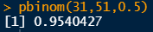
H0 : There is no bias in the data.
We accept the NULL hypothesis that the data is a true representation of the underlying mortality rates.

5c) Cumulative deviations test
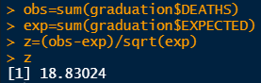
H0 : Graduated rates are not biased.
We reject the NULL hypothesis.

5d) Serial Correlations test
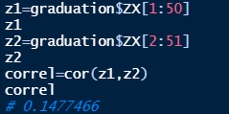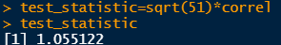

H0 : Grouping of signs is absent.
At 5% significance level test statistic is <1.6449, we accept the NULL hypothesis.

