ABT Project Roll no – 713
- Money Control Newsletter

Indian markets fall close to 0.80% down In spite of net selling combined of FIIs
and DIIs. Mostly the market goes down
because of DIIs.
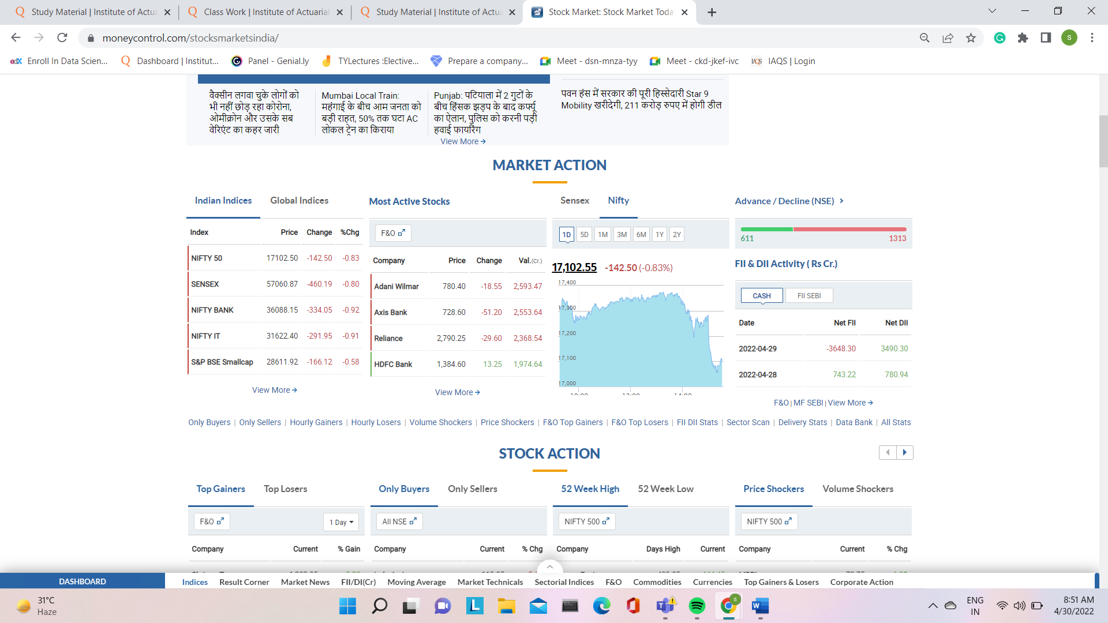

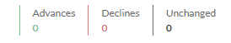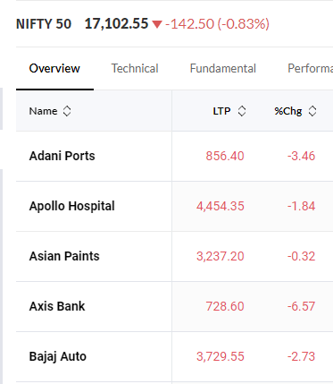
Market is closed so no active trading yet
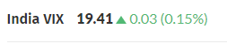
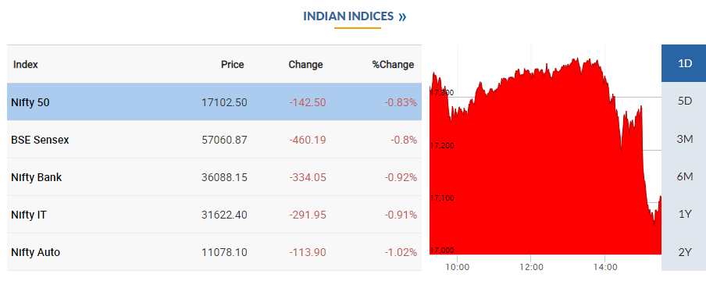
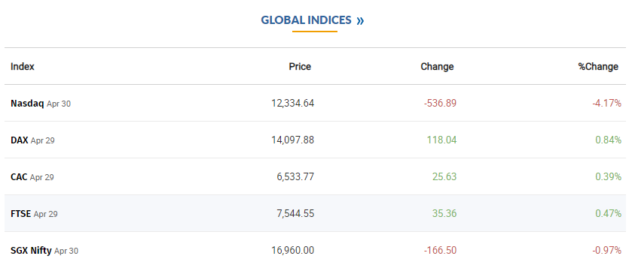
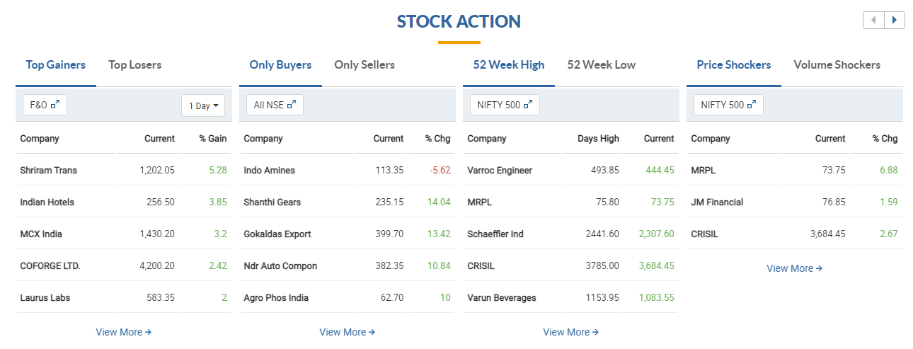

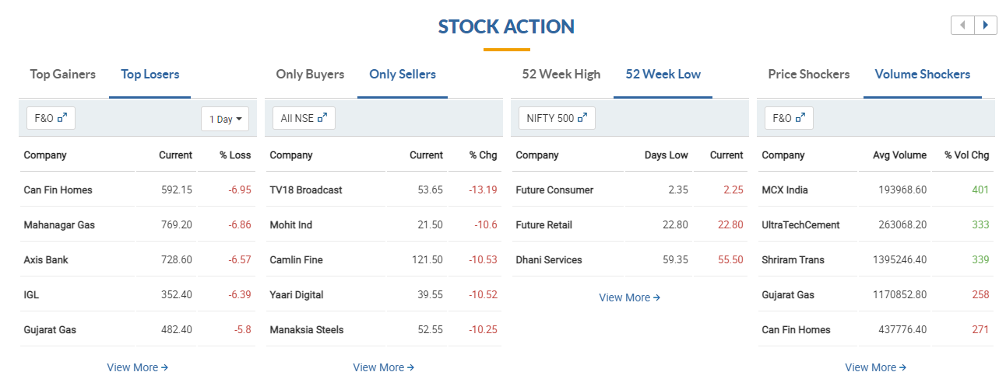

- Stock Screening
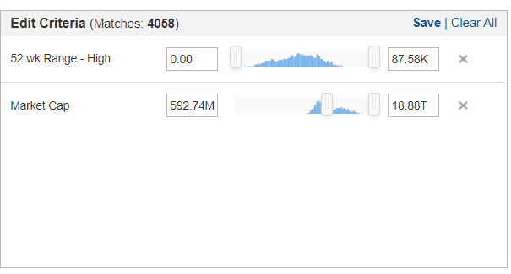
The selected 5 stocks are :-
- Reliance Industries
- Tata Consultancy
- HDFC Bank
- Infosys LTD
- Adani Green Energy
Qualification Criteria:
• Chart beginning from the bottom left of the screen and ending at the top right of the screen
• Size of the candles is small
• No circuits (blank candles) on the chart
• No big dips in the middle of the chart
• Smooth shape (upward trend) on the chart

